QPA #13090
Quick Reference Guide for PeopleSoft Users

The quick Reference Guide for PeopleSoft users will assist you in ordering products from Fastenal’s online catalog and then returning to PeopleSoft. This process of one Web site directing users to another is also referred to as ‘PunchOut’.
Creating a New MRO Supply Request
To buy MRO products from Fastenal follow these simple steps:
1. You can edit items under the Line Defaults sections
These items are:
- Accounting Defaults: Edit if necessary all chartfields as required by your department.
- Ship to location: Enter the 3 –digit agency number and click the Look Up button for listing of all locations.
- Due Date (not required): Enter date in MM/DD/YYYY

Do not modify ship to address and/or dispatch method (EDX)
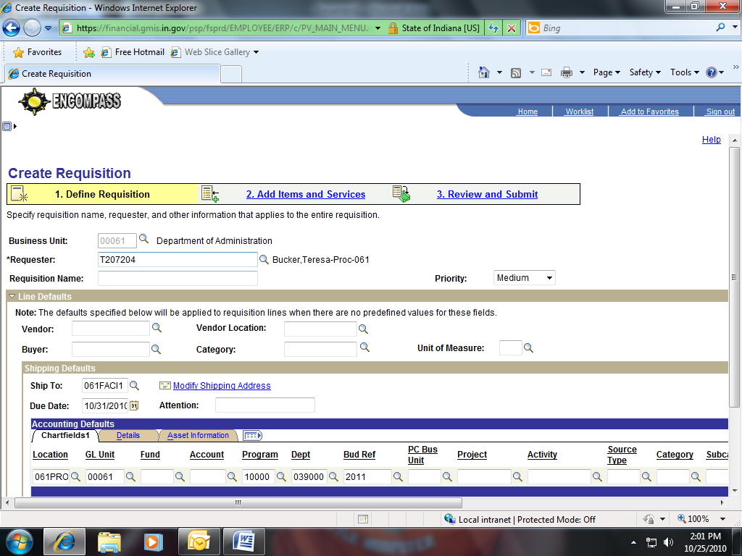
C
A
B

Add Items and Services
2. Once you have navigated to the Add Items and Services screen you will have to select the Web tab.
A. Click on the Fastenal Punchout to access your new Fastenal ordering website.
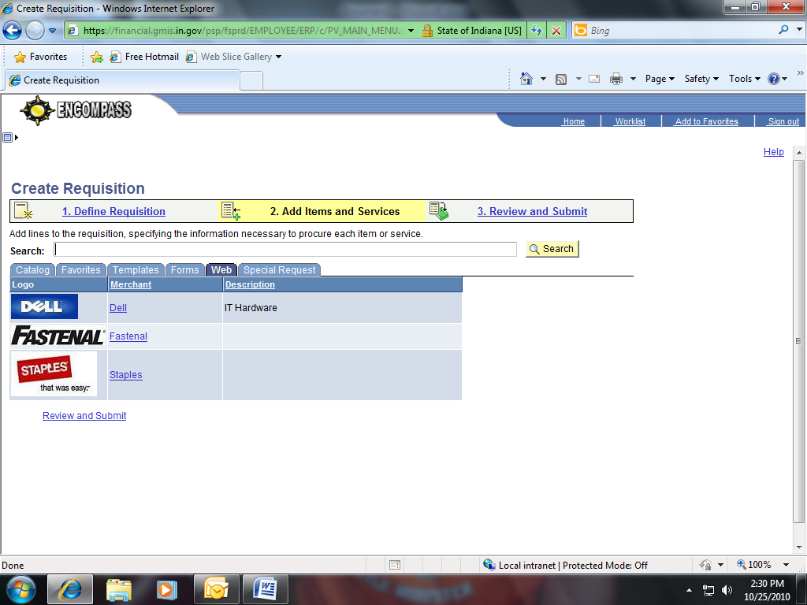
A
Shopping the Site
- Click on your product category or insert keyword/item number in search area and click search. If you have requested an eVMI quote click on eVMI requests to add the items to your cart. (Please see the eVMI guide for detailed information on eVMI quotes)
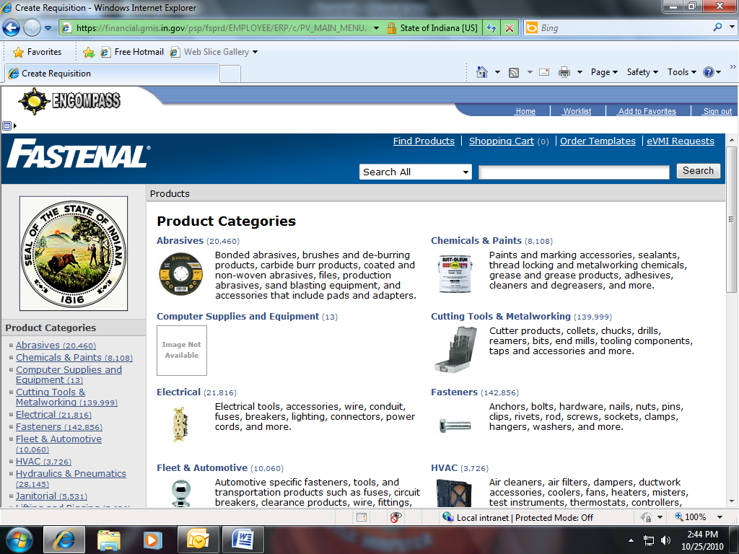
A
B. Items will show in-stock or in-store availability. Choose your items and click on add to cart. A pop up screen will display allowing you to enter the quantity, then click on add to cart. Once all selections have been made click on Shopping Cart to view your order.
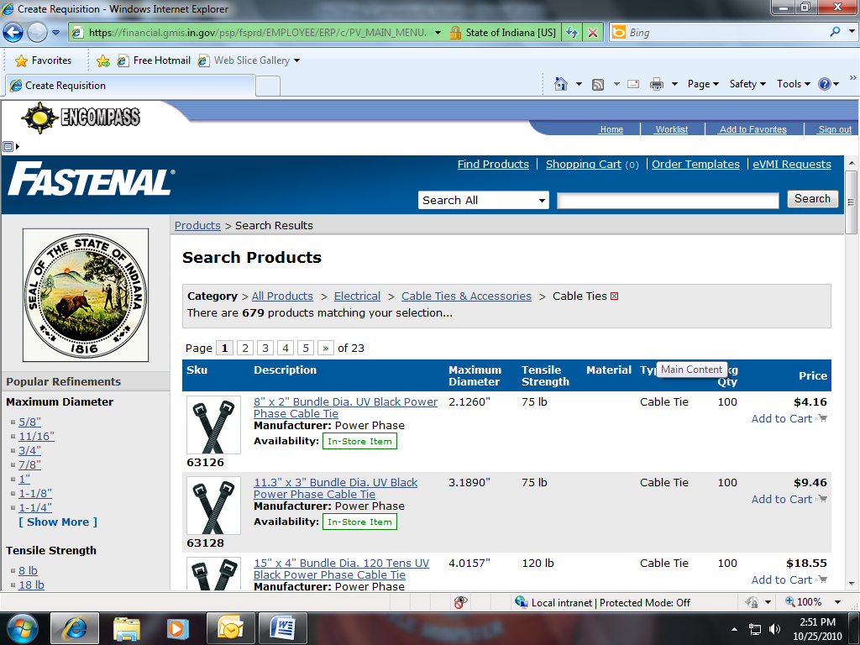
B
Viewing and Submitting Your Order
A. After clicking on Shopping Cart you will have the opportunity to edit your order again, or do a fast order pad (which enables you to pick a known SKU number to add). You can also create a template for future use.
B. You can either continue shopping by selecting another category from the menu on the left or click on check out. Once you click checkout you can go back to the cart or click complete checkout to be directed into PeopleSoft to finalize your requisition.
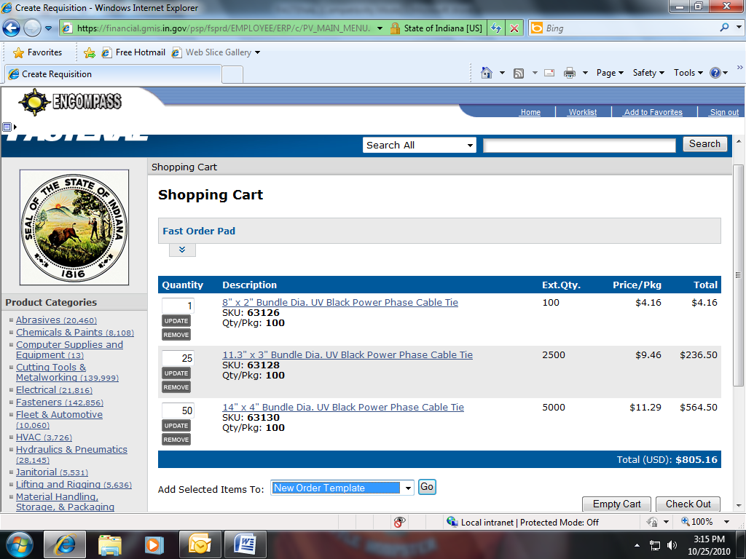
B
A
Completing Your Order
All items that you placed into your Fastenal order will be transferred to PeopleSoft. Review your order same as before. If necessary:
- Add line Comments
- Modify Line/Shipping/Accounting information
- Choose Requisition Type
- Add a detailed justification. (Failure to supply a detailed justification of your purchase may result in the requisition being denied).
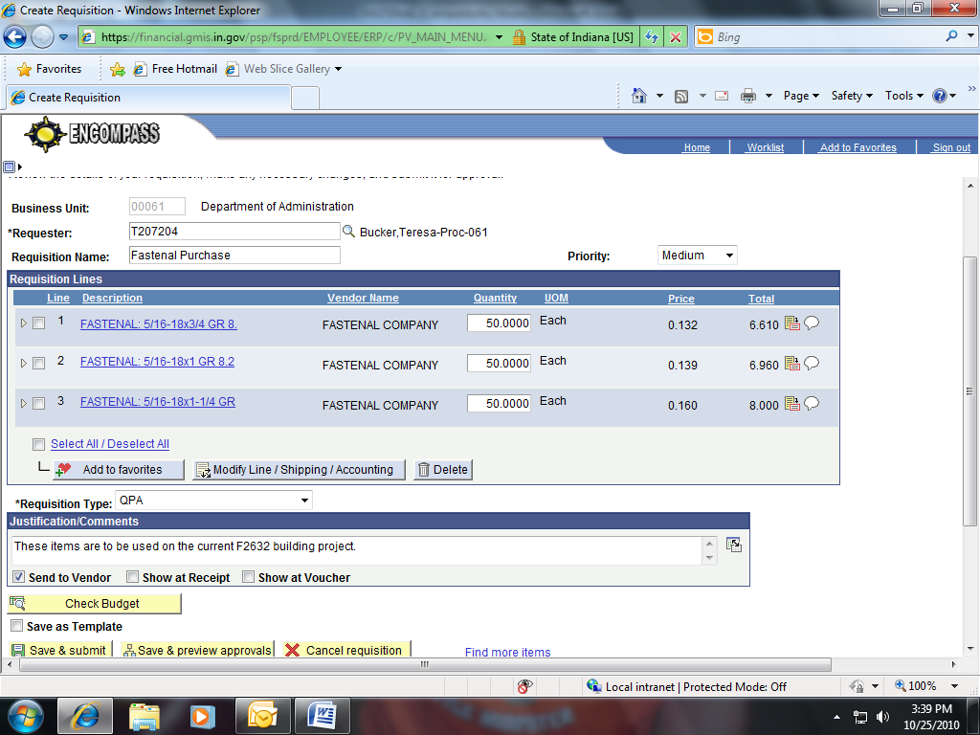
A
D
C
B

Confirmation
- Add more items to requisition
- Assigned Requisition Number
- Save & submit requisition to workflow
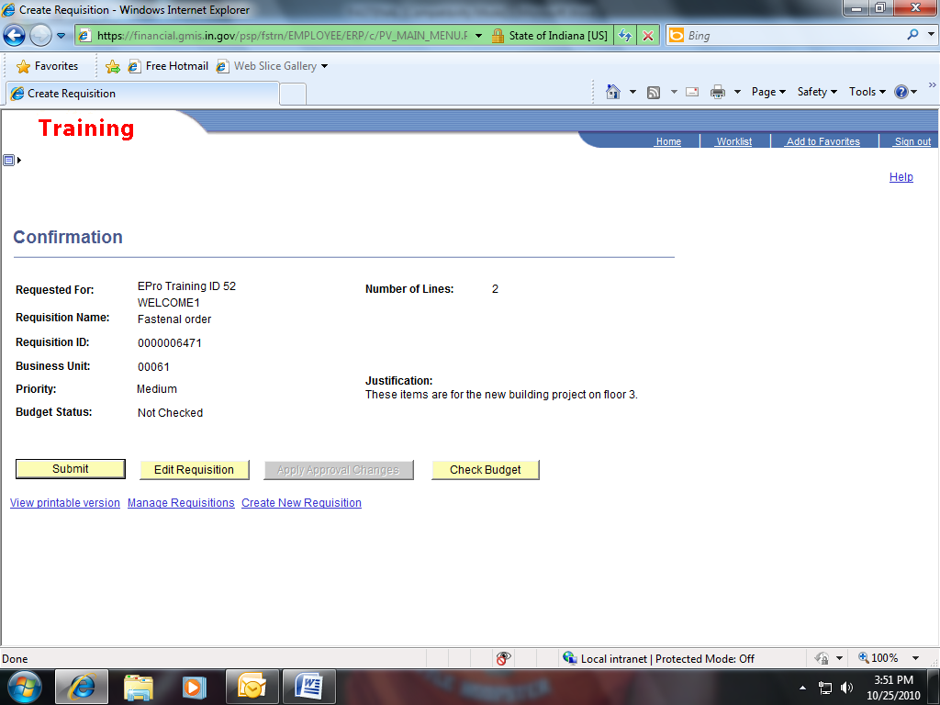
C
B
A

