STATE OF INDIANA

Request for Proposal 20-011

Addendum #1

INDIANA DEPARTMENT OF ADMINISTRATION

On Behalf Of
Indiana Family and Social Services Administration,
Office of Early Childhood and Out of School Learning

Solicitation For:
Quality Assurance (QA) System

Response Due Date: July 17th, 2019

Teresa Deaton-Reese, Strategic Sourcing Analyst
Indiana Department of Administration
Procurement Division
402 W. Washington St., Room W468
Indianapolis, Indiana 46204

Summary of Changes
Deletions in the RFP 20-011 documents are indicated via strikethrough, and additions in all documents have been made in red.

The proposal due date has been extended by one week, from July 10th, 2019 to July 17th, 2019. The State has also added a second-round of written questions due June 26th. These changes impact the following documents:

- RFP 20-011 Document (changes in Sections 1.7, 1.24, and 2.3.6 demonstrated below):

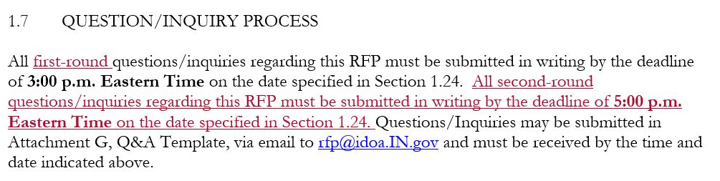

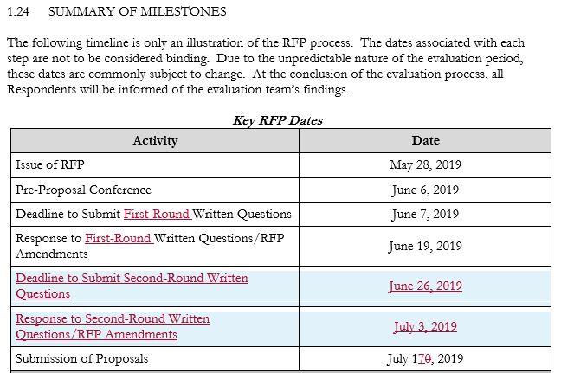
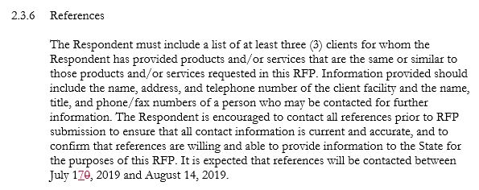

- RFP 20-011 Attachment A, M/WBE Participation Plan Form

- RFP 20-011 Attachment A1, IVOSB Participation Plan Form

- RFP 20-011 Attachment D, Cost Proposal Template

- RFP 20-011 Attachment E, Business Proposal Template

