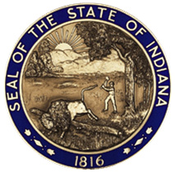

STATE OF INDIANA

Request for Proposal 20-010

Addendum #2

INDIANA DEPARTMENT OF ADMINISTRATION

On Behalf Of
Family and Social Services Administration
Division of Mental Health and Addiction

Solicitation For:
Evidence-Based School Social Services Program

Response Due Date: July 22, 2019 @ 3:00 PM EST

Teresa Deaton-Reese, CPPO
Indiana Department of Administration
Procurement Division
402 W. Washington St., Room W468
Indianapolis, Indiana 4620
The questions and answers has been updated. Please review the new document.

