

STATE OF INDIANA

HCM - PAYROLL MODERNIZATION

Request for Information 19-105

INDIANA DEPARTMENT OF ADMINISTRATION

On Behalf Of:
Indiana’s Auditor of State (AOS), State Personnel Department (SPD) and the Indiana Office of Technology (IOT)

In Support Of:
Modernize the Human Resources and Payroll Business Processes and Technologies

Response Due Date: May 15 20, 2019 by 3:00 PM EST

Sean Cooper, Strategic Sourcing Analyst
Indiana Department of Administration
Procurement Division
402 W. Washington St., Room W478
Indianapolis, Indiana 46204

Table of Contents
1.0 Introduction 2
2.0 RFI General Information 3
2.1 RFI Description 3
2.2 RFI Purpose 3
2.3 Vendor Qualifications 3
2.4 RFI Outline 4
2.5 Summary of Milestones 5
2.6 Pre-Response Meeting 5
3.0 HCM – Payroll Modernization Overview 7
3.1 Overview of Key Organizations 7
3.2 HCM and Payroll Business Challenges 11
3.3 Project Background 11
4.0 Current Business and Technology Footprint 13
4.1 Overview 13
4.2 Business Processes 13
4.3 Current Solutions Technology 16
4.4 Current Technology Infrastructure 18
5.0 Future Requirements 19
5.1 Functional Requirements 19
5.2 Technical Standards and Requirements 19
5.3 Project Related Requirements 20
6.0 Implementation Alternatives 21
7.0 Submission Requirements 22
7.1 Intent to Respond 22
7.2 Written Response Format 22
7.3 Vendor Presentations 23
7.4 Bidder’s Library 24
7.5 Documents Submission 24
8.0 Future RFP Information 25
8.1 Overview 25
8.2 Planned Content 25
8.3 Planned Timeline 25

1.0 Introduction
The Auditor of State (AOS), State Personnel Department (SPD) and the Indiana Office of Technology (IOT) have launched an initiative to modernize the human resources and payroll business processes and technologies.
The HCM-Payroll Modernization project is focused on achieving a complete, efficient implementation of the State’s PeopleSoft HCM solution including the following objectives:
- Transforming HCM from the current 9.1 version to 9.2 eliminating all unnecessary customizations
- Implementing PeopleSoft HCM payroll capabilities, replacing the GEAC legacy payroll solution, and integrating with other PeopleSoft functions
- Transforming the HR and Payroll processes throughout State government to support the most efficient, effective implementation of the PeopleSoft HCM solution, with integration to PeopleSoft Financials 9.2
- Implementing tools and support processes to facilitate and maintain future HCM product updates and facilitate continuous improvement
- Potentially implementing additional value-added HCM-housed functional capabilities such as Management of Accruals and Leaves, Benefits Administration and Compensation

The State has assembled a team of dedicated members from three branches of government, multiple State agencies and quasi-agencies, boards, commissions, the State Budget Agency (SBA), AOS, SPD and IOT to guide the future of the integrated HCM/Payroll solution in order to bring meaningful change to State operations.

2.0 RFI General Information

2.1 RFI Description
This Request for Information (RFI) is issued by the Indiana Department of Administration (IDOA) in conjunction with the AOS, SPD and IOT. This RFI is issued solely for information and planning purposes only, and does not constitute a solicitation. Responses to the RFI will not be returned. Responses to this RFI are not an offer and cannot be accepted by the State to form a binding contract. There will not be a contract resulting from this RFI. The State of Indiana and IDOA are not liable for any cost incurred by the vendor in response to this RFI.

2.2 RFI Purpose
The purpose of this RFI is to request responses from qualified vendors that enable the State to meet important objectives including the following:
- Introduce the HCM-Payroll Modernization Project and the potential mandatory requirements for qualified implementers
- Provide significant, near-RFP level information to enable qualified vendors to begin consideration and preparation of information
- Receive responses to this RFI that introduce the potential strategies, approaches, timelines, costs and considerations for implementing a PeopleSoft HCM modernization roadmap as outlined in this RFI
- Request feedback on RFP content that can help respondents submit high-quality, executable proposals
- Communicate the anticipated RFP content, evaluation criteria and selection process to potential respondents
The information gained from this RFI may be used in the development of a competitive solicitation process, leading to the selection of an integrator best suited to lead and facilitate the HCM – Payroll Modernization implementation.
During the review of RFI responses, the State may request clarifications on information submitted to the State and may initiate further discussions, either oral or written, with respondents per the dates listed in Section 2.5 of this RFI. These discussions could include requests for additional information. Additionally, in conducting discussions, the State may use information derived from responses submitted by competing respondents only if the identity of the respondent providing the information is not disclosed to others. The State will provide equivalent information to all respondents which have been chosen for discussions.

2.3 Vendor Qualifications
Qualified vendors must have the ability to lead all aspects of the HCM – Payroll modernization project in order to achieve the State’s objectives including those introduced in Section 1.0.
Qualified vendor will be required to have significant experience implementing and upgrading PeopleSoft HCM, and implementing Payroll capabilities for state governments with requirements, size and complexity similar to those outlined in this RFI.
Please provide the Vendor Qualification Response Template (Appendix M) with the Intent to Respond Template (Appendix L).

2.4 RFI Outline
The following table outlines this RFI by section:
Section | Description
Section 1.0 - Introduction | This section provides an introduction to the RFI and the mission statement for the modernization project.
Section 2.0 – General Information | This section provides a description of the RFI including the purpose, process time table and milestones. It also explains who should participate in this RFI.
Section 3.0 – HCM - Payroll Modernization Overview | This section provides an overview of AOS, SPD and IOT including brief descriptions, organization charts, locations, statistics and the modernization project background.
Section 4.0 – Current Business and Technology Footprints | This section describes the current HCM and Payroll business and technology footprints including business functions, solutions and infrastructure components.
Section 5.0 – Future Business and Technology Standards and Requirements | This section provides an overview of the business and technology requirements for HCM and Payroll modernization.
Section 6.0 – Implementation Strategy, Approach, Timeline and Cost Options | This section describes the implementation information the State is requesting. Those options can include any combination of upgrades, re-implementations or implementations required to achieve the modernization goals and objectives explained in this RFI.
Section 7.0 – Submission Requirements | This section describes the submission requirements for this RFI including an Intent to Respond template, the written RFI response instructions, and potential vendor presentations. This section also provides the details for accessing the Bidder’s Library.
Section 8.0 – Future RFP Information | This section provides information on the planned RFP process including the expected contents and timeline.
Appendix A1: Technical Requirements Workbook | This spreadsheet provides a solid draft of technical requirements that can be expected in the RFP. These requirements may be updated or expanded for the RFP.
Appendix A2: Functional Requirements Workbook | This spreadsheet will provide the preliminary functional requirements for the human resource and payroll processes. The payroll requirements are nearly completed and indicative of what can be expected in the RFP. The human resource requirements are either in initial draft form or in development. These requirements may be updated or expanded for the RFP.
Appendix A3: Project Related Requirements Workbook | This spreadsheet will provide the nearly completed project related requirements that can be expected in the RFP. These requirements may be updated or expanded for the RFP.
Appendix B1: HCM Compare Report Chart and Data | This section depicts the current system from a high level. The PeopleSoft Compare Reports tool was used to generate this chart, and the result is a comparison between the HR DEMO and the SOI HR QA environment. There are omitted approximately 11000 additional portal registry objects present in QA from the calculation. Those objects are delivered by Peoplesoft and present in State of Indiana (SOI) QA but not DEMO.
Appendix B2: HCM Fit – Gap 9.2 RTM Documentation | This document will show the current requirements of the system, and includes solutions for gaps, documenting for each gap whether the solution is a workaround, or the 9.2 functionality will resolve the gap, or if any current customizations will be brought forward.
Appendix B3: HCM and Payroll Targeted Business Process Improvements | Discussions regarding implementing new 9.2 functionality with the SOI team, along with decisions regarding the reduction of customizations will be taken into account in the creation of a recommendation for potential business process improvements using 9.2. A high-level definition of targeted and potential process and system changes to be implemented in version 9.2 will be shown in this document.
Appendix C: Question Submission Template | This spreadsheet provides the template for vendors to utilize when submitting questions.
Appendix D: State of Indiana Vendor Confidentiality Agreement | This is the Confidentiality Agreement that must be signed by vendors who require access to the Bidder’s Library.
Appendix E: Preliminary Contract Terms and Conditions | This is the preliminary Indiana contract terms and conditions that can be expected in the RFP.
Appendix F: Payroll Process Definitions | This provides the detailed current Payroll business process flows and narratives that build on the summary provided in section 5. These process definitions may be updated or expanded for the RFP.
Appendix G: HCM Process Definitions | This provides the detailed current human resources business process flows and narratives that build on the summary provided in section 5. These process definitions may be updated or expanded for the RFP.
Appendix H1: Payroll Technology Solutions Description | This document provides current Payroll technology solutions information to build on the summary provided in section 4.
Appendix H2: Payroll Technology Solutions Detail | This spreadsheet provides more detailed current Payroll technology solutions information concerning interfaces, forms, reports and conversion sources.
Appendix I: HCM Technology Solutions Definition and Information | This provides more detailed PeopleSoft HCM technology solutions information to build on the summary provided in section 4.
Appendix J1: Payroll Technology Infrastructure Description | This provides more detailed Payroll technology infrastructure information to build on the summary provided in section 4.
Appendix J2: Payroll Technology Infrastructure Diagrams | This provides Payroll current infrastructure diagrams.
Appendix K1: HCM Technology Infrastructure Description | This provides more detailed HCM technology infrastructure information to build on the summary provided in section 4.
Appendix K2: HCM Technology Infrastructure Diagrams | This provides current HCM infrastructure diagrams.
Appendix L: Intent To Respond Template | This provides the template vendors must fill out in order to get access to the Bidder’s Library.
Appendix M: Vendor Qualification Response Template | This provides the template vendors must fill out to explain their ability to meet the possible mandatory vendor qualifications.
Appendix N: Definition of Terms | This provides a definition of terms and acronyms that are used throughout this RFI.
Table 1 - RFI Outline

2.5 Summary of Milestones
The following table outlines the timeline for all RFI related activities:
Activity | Date(s)
Issuance of RFI | April 15, 2019
Pre-Response Meeting | April 23, 2019
Deadline to Submit Written Questions using Question Log in Appendix C | April 26 24, 2019 3:00 PM EST
Response to Written Questions | May 1, 2019
Deadline to Submit Intent to Respond & Vendor Qualification Response Templates | May 6, 2019 3:00 PM EST
Deadline to Request Access the Bidders Library | May 6, 2019 3:00 PM EST
Submission of Written RFI Responses | May 15 20, 2019 3:00 PM EST
1-2 hour phone conference for vendor response clarifications discussion (as needed) | May 28, 2019 – May 31, 2019
Table 2 - Summary of Milestones

2.6 Pre-Response Meeting

The pre-response conference meeting will be held on April 23, 2019 at 9:00 10:00AM in Indiana Government Center South Conference Center, Room (s) 4 & 5. At this conference, potential respondents may ask questions about the RFI and the RFP process. “Respondents” are reminded that no answers issued verbally at the conference are binding on the State and any information provided at the conference, unless it is later issued in writing, also is not binding on the State.

To join meeting via phone:
Dial: 240-454-0887 - Enter Access Code: 737 255 369

To view Presentation Slide Deck during meeting via video:
https://indiana.webex.com/meet/procurementwebex

Vendors that will be joining the Pre-Response Meeting via phone are required to submit via email to SeCooper@idoa.IN.gov a completed Pre-Response Meeting Attendance Roster (Appendix O) and Pre-Response Meeting Internal Data Tracker (Appendix P) prior to 10:00AM on April 23, 2019.

3.0 HCM – Payroll Modernization Overview

3.1 Overview of Key Organizations

3.1.1 State of Indiana

Many organizations throughout the State partner with, or are serviced by, the AOS, SPD and GMIS departments through their technology systems and business processes. The following is an organization chart and listing showing the broad reach of human resource and payroll services:

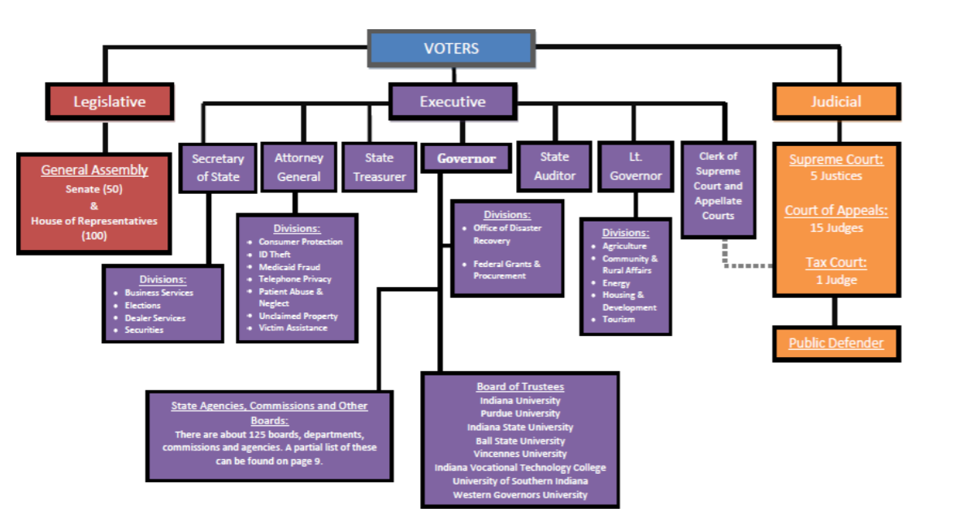

3.1.2 Auditor of State (AOS)

The Indiana AOS is responsible for paying all State employees; State police pension recipients; accounting for State funds, creating the State's Comprehensive Annual Financial Report (CAFR); overseeing and disbursing county, city, town, and school tax distributions; and, paying the State's bills. The AOS is also the Administrator of the State of Indiana Deferred Compensation Plan, known as Hoosier S.T.A.R.T.

The AOS Payroll Department pays 30,000+ State employees, including all elected officials,1,600+ police pension recipients and retired governor’s and governor’s widows and several other unique groups. Payroll encompasses all three branches of State government and five additional State entities with separate tax ID numbers (State of Indiana, Bureau of Motor Vehicles, Indiana State Museum, Indiana State Lottery Commission and the Indiana State Police Pension Trust). Payments to employees are made primarily by direct deposit or pay card, although weekly checks and manual warrants are processed. There are close to 150 payroll deduction or other earnings codes (DOE Codes) utilized. The department also calculates, withholds, and reports taxes to the appropriate tax authorities and is responsible for federal and state compliance reporting to various entities. All payroll processes are processed in-house, including but not limited to W-2 creation and distribution, garnishment processing, all tax reporting and filing, and retirement wage and contribution reporting.

The following is the organization chart for AOS:
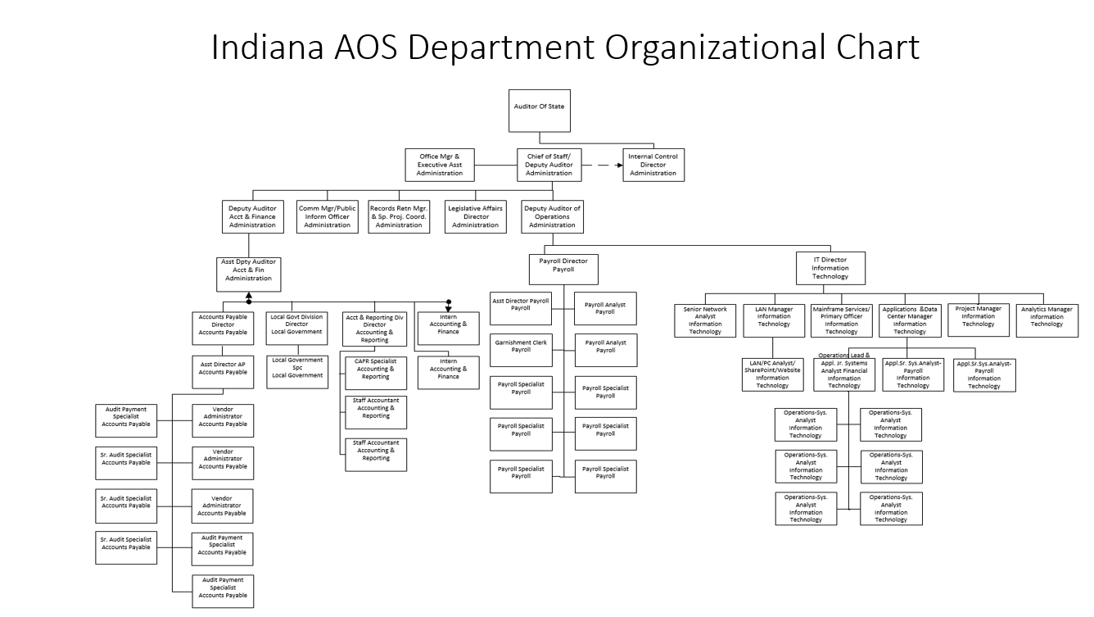

3.1.3 State Personnel Department (SPD)

The Indiana State Personnel Department (SPD) is responsible for providing human resources services for the executive branch of Indiana State Government; administering medical, dental, vision, life, and disability plans and wellness programs for 30,000 State employees and their eligible dependents; developing and administering the classification and compensation plans; recruiting, hiring, and onboarding new employees; setting standards and implementing pay increases related to performance management; managing and reporting on data for employees through the enterprise-wide ERP system; developing and applying standardized policies governing the employment relationship; processing requests for family and medical leave and new parent leave; overseeing drug and alcohol testing programs; and providing advice and counsel to managers.

The SPD employs a staff of 206 FTEs and assigns HR Generalist field staff to provide services directly within partner locations and HR Specialist staff within the central office to accomplish the responsibilities listed above. The SPD Finance division manages the budget and costs allocated for field services provided directly to partner organizations, core responsibilities for SOI as an enterprise, and dedicated benefits funds related to health care plans. The State civil service law, Ind. Code §§ 4-15-2.2, et seq., identifies entities not under SPD’s jurisdiction; however, many of those entities do use benefit plans administered by SPD, and data on their employees is housed and managed in the PeopleSoft 9.1 enterprise-wide ERP system. SPD staff also provide advice and counsel on best practices and options to those non-supported entities.

The following is the organization chart for SPD:
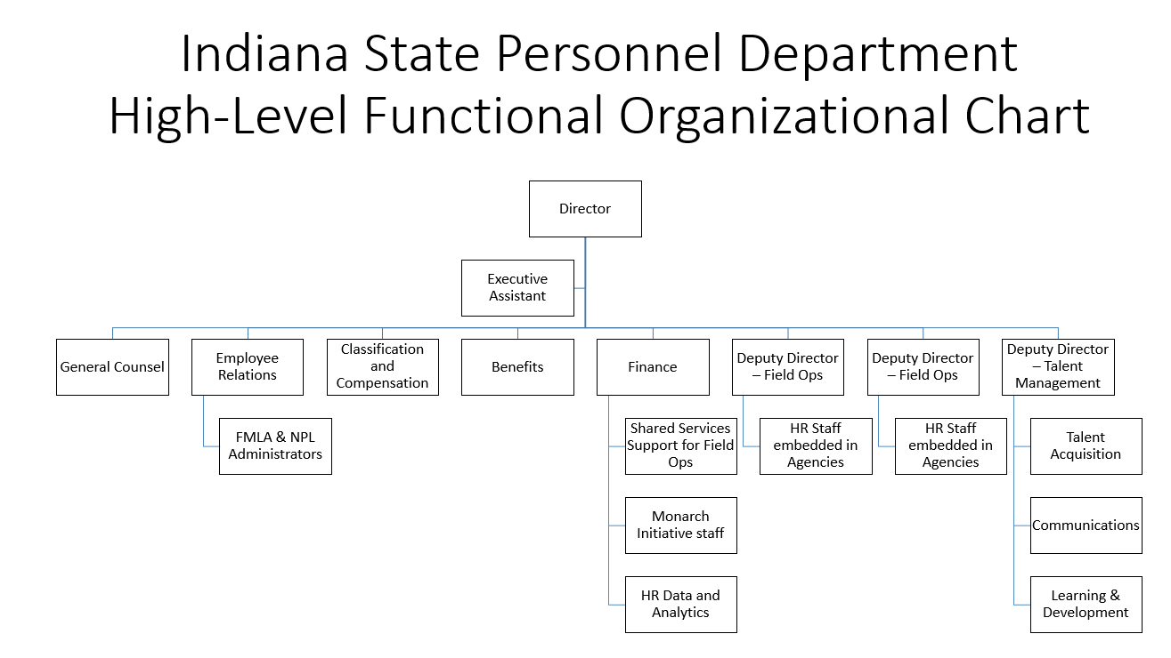

3.1.4 Government Management Information Services (GMIS)

GMIS, a department within IOT, provides services for the PeopleSoft Financials, Human Capital Management, and Hyperion ERP systems for all State organizations using PeopleSoft ERP services, as de-fined by Indiana Code. These services include System Administration, Development, Configuration, as well as troubleshooting and break-fixes in partnership with our Business Owners, the ERP Steering Committee, and the ERP Governance Committee.

The following is the organization chart for GMIS:

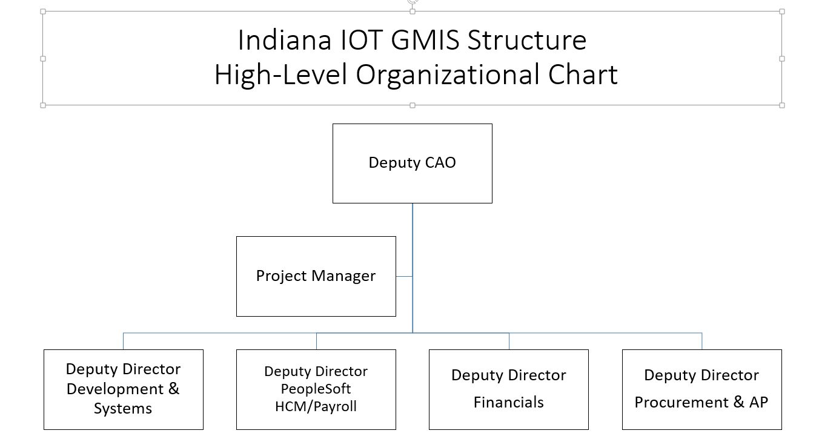

3.1.5 Project Team and Governance

Due to the size, complexity and potential impact, the project will be executed as two major initiatives, 1) the definition of future state business processes, solutions, and implementation services including the selection of service providers (Implementation Preparation Initiative), and 2) the implementation of the defined future state business processes, solutions, and services (Implementation Initiative).

The State has established a cross-functional project team and two-tiered governance structure to ensure the current initiative is managed in an efficient and effective manner and remains focused on achieving the objectives.

The following is the organization chart for the HCM-Payroll Modernization project:

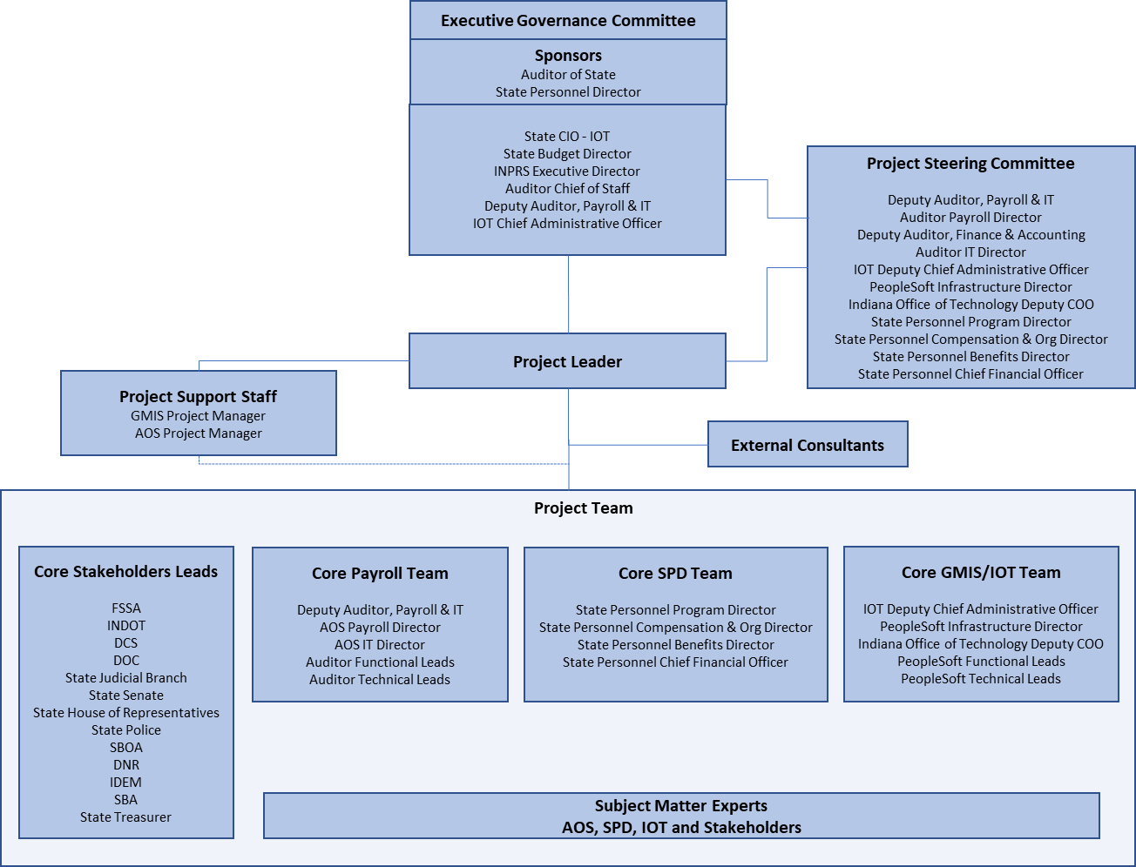

3.2 HCM and Payroll Business Challenges
3.3.1 Payroll Business Challenge
The AOS implemented a Payroll and General Ledger system in 1992 which had very little integration to the State Personnel Department’s Human Resources System that was in place at that time. The Human Resources and General Ledger Systems were replaced by PeopleSoft solutions in 1999 and 2009 respectively.
The payroll solution of 1992 has not been effectively enhanced by the vendor over the past few years and the vendor has announced the solution support will no longer be provided past 2023. Even if basic support can be secured through a third-party provider, the capabilities of the solution will become static in the future and the vendor will most likely see the best members of the support staff leave for more stable opportunities. This poses an unacceptable risk for this vital service and solution.
The current solution’s constrained processes have limitations that drive operational inefficiency, higher cost and a higher risk of errors within the AOS and throughout State government. In addition to the operational inefficiencies and risks, it is very cumbersome, if not nearly impossible, to meet new employment and reporting standards without customized, tedious work-arounds.
While AOS and partner organizations continue efforts to improve processes, achieve efficiencies and drive taxpayer benefits, the current solution does not provide an acceptable near-term or long-term foundation.
3.3.2 HCM Business Challenge
The PeopleSoft Human Capital Management system (HCM) was first implemented by the State in 1999. The functionality includes Core HR capabilities, HR data, and Time & Labor. The HCM functionality integrates with PeopleSoft Financials which is used by all State Organizations.
The currently installed HCM version 9.1 will be no longer be able to be part of mainstream Oracle support beginning in September 2019. The non-mainstream Oracle support beginning in September will be more expensive and less comprehensive.
The new PeopleSoft HCM version 9.2 modules have expanded significantly in functionality, scalability, usability, and mobility, along with reduced cost of ownership over the past few releases. Due to the magnitude of customizations, the State has not been able to implement the expanded HCM functionality since version 8.9. As a result, modules are missing numerous enhancements and software “bug” fixes which prevent SOI from moving forward with critical solutions and infrastructure updates and improvements.
The SOI needs to transition to the most current PeopleSoft HCM version which provides the functionality required to eliminate unnecessary customizations and facilitate streamlined and efficient HR and Payroll processes throughout State government. To avoid falling into the same update problems described previously, a sustainable resource plan for implementing updates and expanded functionality as it becomes available is required.

3.3 Project Background
In June of 2018, the AOS embarked upon an initiative (Payroll Modernization Project) to modernize and transform business processes, technology, and services supporting State payroll targeting significant tangible and intangible benefits, as well as reduced risk. During Q3 of 2018, the Payroll Modernization team initiated the project and launched efforts to define State-wide current payroll process and future requirements. In October, the team recommended and executive leadership approved alignment of the future payroll solution with the State’s PeopleSoft ERP strategy.
During the 2nd half of 2018, SPD and the Government Management Information Systems (GMIS) revised plans and initiated efforts to assess and evaluate the work necessary to successfully upgrade or re-implement PeopleSoft HCM 9.1 to PeopleSoft HCM 9.2. The assessment identified an initial need for a Fit/Gap effort to evaluate past customizations, socialize the improvements available within the 9.2 product, and design potential solutions with best practices in mind. The Fit-Gap RFS was issued in December of 2018 and the initiative launched in January 2019.
Given the AOS decision to align the future Payroll solution with the State’s PeopleSoft ERP strategy and the realization that both projects targeted an efficient, effective implementation of the State’s PeopleSoft HCM solution on the latest PeopleSoft version, the executive sponsorship approved the merger of the HCM 9.2 Project and Payroll Modernization projects in November of 2018 to create the HCM-Payroll Modernization Project. This alignment was focused on ensuring the funding, resources, business process redesign, communication, training, change management, and implementation timeline are integrated and appropriately supported. A single governance committee will provide the oversight and mechanism of escalation to best position this modernization program for success.

4.0 Current Business and Technology Footprint

4.1 Overview
The AOS team launched an initiative during the second half of 2018 to analyze and document current Payroll processes and future Payroll requirements within AOS and throughout the many stakeholder organizations with whom they partner and serve. That initiative was completed in March 2019 and the results are summarized in Section 4.2.
The GMIS organization, in partnership with SPD and AOS, launched a PeopleSoft HCM Fit-Gap initiative in January 2019 to 1) define the current state of the PeopleSoft HCM 9.1 solution including customizations and configuration, 2) define the current HCM related human resources processes, and 3) identify recommended improvements during movement to PeopleSoft HCM 9.2.
As a result of an analysis of PeopleSoft HCM capabilities not currently implemented, the state identified two additional HCM related human resources capabilities that may provide future benefits. An initiative is underway to define the current processes and future requirements for Management of Accruals and Leaves, and Classification and Compensation.

4.2 Business Processes
This section provides an list of the current AOS Payroll and HCM business processes that are in various stages of development. Since the AOS Payroll and HCM business process definition activities were executed independently, some overlap of process definition should be expected.
4.2.1 AOS Payroll Business Processes
This section summarizes the current Payroll processes that are further defined in Appendix F which includes detailed process maps and narratives.

Business Processes and Sub-Processes
- HCM Payroll Centric Processes | New Hires  Terminations  Transfer  Salary Adjustments
- Benefits | Enrollment  Changes
- Agency Payroll | Time Capture Approval & Submission  Legislator Pay  Senior Judge Pay  Statutory Payments  Leave Accrual Use  Paid & Unpaid Leaves  STD & LTD  Retiree Leave Conversion  Allocating Labor Expense
- AOS Payroll | Incoming File Loads  Unique Pay Groups  Process Payroll  Process Retiree Payments  Fringe Benefits  Earning Adjustments  Reversals Paper Check & Direct Deposits  Payroll Adjustments  AS47 (Non PS Deductions)  Garnishment Processing  IRS Lock Ins  Mass Changes  Payfake Processing  Post Payroll Processing  Bank Changes  Interrogatories/Subpoenas  Employment Verifications  Ad hoc Inquiries  Table Maintenance  Compliance Reporting
- Retirement | Employer Reporting Maintenance  Leave Conversion

4.2.2 HCM Business Processes
This section summarizes the current HCM related human resources processes that will be further defined in Appendix G at the conclusion of our current Fit/Gap exercise which will include detailed process maps and narratives. Some of the following processes are completed and included currently.

Business Processes and Sub-Processes
- Management of Accruals and Leaves | Leave Workbook  - Leave types and reasons  - Leave eligibility  - Leave requests and approvals  - Planned vs. unplanned leave  - Earning / accruing leave  - Using leave  - Paid / unpaid leave  - Leave at year end  - Leave on the employment anniversary date  - Leave payouts  New Parent Leave  FML  Workers Comp  Line of Duty
- Classification and Compensation | Job Classifications  Pay for performance (P4P) and Mass Salary  Changes, including distribution  Minimum Wage Changes/Compliance  Fair Labor Standards Act (FLSA) Compliance  Bonus Payments  Overtime/Comp Time  Promotions  Lateral Transfers  Demotions  Table updates  Default pay components  Salary studies (workforce analysis), Classification studies and Job studies  Position Audits  Salary Administration  Salary Adjustments  Forms/Reports/Interfaces  Excel based salary Modeling
- Organization Management and Position Control | Establish Org  Abolish Org  Re-Org  Establish position  Delete position  Change position  Fill vacancy  Move position  Manage labor forecast
- Personnel Administration | New Hire/Onboarding  Specialty Employees (POIs)  Inter-Agency Transfers  Intra Agency Transfers  Employee Data Changes  Promotions  Demotions  Disciplinary Actions  Suspension  Terminations/Retirements  Mass Changes  Rehires  Other personnel actions  Furloughs / layoffs
- Time and Labor | Time Reporter Enrollment  Time Capture  Special Leave  Create Payroll  Apply Payroll Results  Post Payroll to Finance
- Benefits | Open Enrollment  New Hire Enrollment  Family Status Changes  Arrears / Catch-up Deductions  COBRA  Deferred Comp  Retirement/Pension  Maintain benefit tables  Wellness  Event Maintenance/Reprocessing  Generating Benefit Reports
- Self Service | Employee Self Service  Manager Self Service

4.3 Current Solutions Technology
4.3.1 Payroll Solutions Technology

The current GEAC payroll solution has been in place since 1992. While AOS Payroll has maintained payroll and tax compliance, the system has not been effectively enhanced over the past few years. Infor (who acquired GEAC in 2006) has announced it will discontinue solution support for GEAC E-Series for z/OS MVS release 17.15 in 2023. GEAC-related payroll processes have been constrained, due to lack of integration with PeopleSoft HCM 9.1. This has resulted in increased complexity and higher costs for the State’s Payroll solutions.

The current AOS solutions footprint is further defined in Appendices H1 and H2.

4.3.2 HCM Solutions Technology

The PeopleSoft HCM solution was implemented in 1999. The State currently uses PeopleSoft 9.1 HCM (Bundle 3) and have applied many customized enhancements to support Family Medical Leave Act (FMLA), Personnel Payroll Action Form (PPAF), New Parent Leave (NPL), and other business processes. The State currently uses base functionality only and has not leveraged many of the HCM 9.1 enhancements (e.g. Compensation Administration, Benefits Administration, etc.).

The PeopleSoft HCM current state customizations and solutions footprint are included in Appendices B1 and I respectively. Future 9.2 transition recommendations are currently being defined in an HCM Fit/Gap exercise that is scheduled to conclude in May 2019. The Oracle PeopleSoft modules that are licensed and supported within GMIS for HCM are included in the following matrix.

Module Name | Licensed | In Use/Supported
Benefits Administration | X | X
Recruiting Solutions | X | Migrated to SuccessFactors
eBenefits | X | X
eProfile | X | X
eProfile Manager | X | X
HRMS Portal Pack | X | X
Reporting Tools for HR | X | X
Time and Labor | X | X
Enterprise Learning Management | X | Migrating to SuccessFactors
Strategic Hiring Management Workforce Administration | X | X
ePerformance | X | Migrating to SuccessFactors
eRecruit | X | Migrated to SuccessFactors
Fundamentals for Human Capital Management | X | X
Payroll Interface | X | X
Talent Acquisition Management | X | Migrated to SuccessFactors
Community Portal | X
North American Payroll | X
HCM Warehouse | X
eDevelopment | X
Workforce Scorecard | X
Help Desk for Human Resources | X
ePay | X
Directory Interface | X

4.4 Current Technology Infrastructure
4.4.1 Payroll Technology Infrastructure
The current AOS Payroll technical infrastructure is centered around an IBM Mainframe zEnterprise BC12 (zBC12) managed, operated and supported by the AOS IT Team. The AOS IT team also manages, operates and supports an email environment and server farm. All of the AOS Payroll related infrastructure is separate from the State’s IOT infrastructure at this time, however, a project is underway to transition the AOS Payroll related infrastructure to the State’s IOT infrastructure footprint.
The State also hosts the infrastructure for the AOS PeopleSoft Financials solution which is supported by the IOT GMIS team.
For more detailed information concerning the AOS Payroll Technology Infrastructure, refer to
Appendices J1 and J2.
4.4.2 HCM Technology Infrastructure
The HCM infrastructure landscape is managed by the GMIS team within IOT. IOT reports independently to the Office of Management and Budget and manages the infrastructure for much of State government.
The current HCM infrastructure footprint is planned to be replaced as part of this project. Therefore, as part of the vendor responses described in Section 7.2, please provide your summary recommendations for the optimal future architecture footprint.
For a more detailed description of the HCM technology infrastructure, refer to Appendices K1 and K2.

5.0 Future Requirements

5.1 Functional Requirements
The State is following a process driven approach toward defining requirements. This includes the documentation of current human resource and payroll related processes as well as future requirements based on known leading practices, industry standards, and Indiana specific legislative and policy mandates. This documentation includes current state process narratives and business process flow diagrams, as well as detailed functional requirements. The intent of this effort is to define the requirements needed to realize State’s objectives outlined in Section 1 and throughout this RFI. Along with the requirements, this effort will provide a list of current Forms (correspondence), Reports, Interfaces, and Conversion Sources (Appendices H1 and H2) that may be required to support the transformation and modernization of the HCM and Payroll processes and solutions.
The baseline process and sub-process mapping descriptions are provided in Section 4. Each sub process will include a process flow that highlights the expected tasks necessary to deliver the sub-process. The processes are then further decomposed into specific requirements. The process definitions and requirements are provided within the Bidder’s Library.
Note that non-functional requirements (Testing, Training, Project Management, etc.) are described below and provided separately in the Project Related Requirements, Appendix A3.
The development of functional requirements remain in progress as of the release of this RFI. The information provided in this section is subject to ongoing development and refinement. The Payroll related requirements included in Appendix A2 are at a “near-final” status while the human resource related requirements range from “draft” to “not included” status. All requirements will be completed and provided in the future RFP. They should include at least the following requirement groupings:
Personnel Admin Classification and Compensation Benefits Admin
Payroll Time Leaves
Allocations Reports Forms

5.2 Technical Standards and Requirements
The solution’s upgrades and implementations will be implemented in the State’s IOT data center and therefore will be required to conform and comply with all IOT Infrastructure and Security Standards. IOT standards are posted here: http://iot.in.gov/architecture/.
Please refer to Appendix A1 for more information on the technology infrastructure standards as well as HCM and Payroll related technical, service level, and capacity requirements.
The Technical Requirements included in Appendix A1 are at a “near-final” status. All requirements will be completed and provided in the future RFP. The current requirement groupings are as follows:
- General
- Security
- Service Level
- Reporting and Query
- Interface

5.3 Project Related Requirements
The State has requirements for certain project related methodologies including project management, testing, training, and change management. For each of the service categories below, the State requests that the vendor provide an overview on the approach to providing the required service. While the areas are broad, the State believes that each is a critical area to meeting the end state objectives of the modernization.
The Project Related Requirements included in Appendix A3 are at a “near-final” status. All requirements will be completed and provided in the future RFP. The current requirement groupings are as follows:
- Project Management
- Organizational Change Management
- Training
- Testing
- Vendor Team Experience
- Project Design and Build
- Cutover and Support

Implementation Alternatives
The State requests vendors provide insights and recommendations for potential implementation strategies and approaches. We understand there are several available approaches including a) separate upgrade of HCM and new implementations including Payroll, b) re-implementing HCM and new implementations including Payroll, c) re-implementing total HCM including Payroll, and many other alternatives and combinations. We are requesting vendor insight into the pros and cons for implementation approaches considered to be viable. We are also requesting initial vendor input on the implementation timeline, phases, resource requirements, cost, risk, and value for 1 or 2 of the most viable approaches. If there are any particular approaches that vendors would recommend the State not adopt, please include an explanation.
It is the State’s intent to understand a vendor’s ability to shorten the implementation timeline and/or reduce the costs while maintaining an acceptable risk level. The timeline, resourcing and costs should be based on the assumptions that a) the State will provide the key leader and SME resources to support an aggressive plan and timeline, and b) the State will provide the technical infrastructure and resources to support the PeopleSoft HCM solution modules once they are upgraded or implemented.
The options and recommendations for each implementation approach should include the following:
Description: A one-page summary explaining the approach including the pros and cons.
Timeline: A one-page graphic timeline (by calendar quarter starting with Q1) showing the major implementation phases throughout the project life.
Resourcing: A one-page graphic timeline (by calendar quarter) showing the projected vendor and State resources required for each implementation phase shown on the timeline.
Cost Summary: A one or two-page cost summary explaining the expected vendor related one-time implementation and recurring support/maintenance cost ranges (low & high based on current understanding) and any assumptions or considerations.
These cost items should include, but not be limited to, software license, integration/implementation services, project management, data transition, third party products and services, training, facilities and supplies, hardware and sizing, recurring license fees, upgrade/patches, and recurring vendor support/staffing. The cost definitions should include also the cost drivers (e.g., driver for software license cost could be number of users or citizens.)
Risk and Value: A one-page description of the risks and value proposition for each approach.

7.0 Submission Requirements
The State requests responses for this RFI from qualified vendors. Vendor qualifications are outlined in Section 2.3. The responses for this RFI will potentially be comprised of two (2) components. The first component is a mandatory written response described in Section 7.2. The second component is a potential vendor on-site presentation described in Section 7.3. The presentations may be scheduled for some or all vendors at the State’s sole discretion.

7.1 Intent to Respond
Vendors that wish to reply to this RFI are asked to submit both “Intent to Respond” and “Vendor Qualification Response” templates presented in Appendix L and M respectively. Both templates must be submitted in writing via email to SeCooper@idoa.IN.gov no later than 3:00 p.m. EST on May 6, 2019 to qualify for potential vendor response clarification discussions or presentations. To receive access to the Bidder’s Library, vendors must provide a signed Confidentiality Agreement, provided in Appendix D. Any vendors who submit these templates shall include the following phrase in the email subject line: “Intent to Respond to RFI 19-105, HCM-Payroll Modernization Implementation Services”.

7.2 Written Response Format
In the interest of time, the State has a strong desire to receive and review condensed, content-rich responses. In order to maintain objectivity and brevity, the State has established a structured format for vendor written responses to the RFI requirements. All narrative responses must be provided to the State in a PDF, Microsoft Word, Excel, or PowerPoint formats and narrative responses should be single-spaced pages written with a font size no smaller than eleven (11) point. Supplemental materials can be submitted in the response as exhibits, and will not count against the page number limits outlined below for the narrative response; however, the State may choose not to review these items, so every attempt should be made to include a full and complete response in the allocated page limits.
Vendors must submit narrative responses for each of the Required Sections below:
Section | Required Information | Page Limit
Corporate Contact Information | Vendor’s contact information for this RFI opportunity:  - Contact Person  - Corporate Address  - Contact Person’s email address  - Contact Person’s phone number | 1 page
Company Structure | Vendor’s Company Structure to include:  - Description of the types of business ventures in which the organization is involved  - Chart of the organization | 2 pages
Corporate Capabilities | Summary of corporate capabilities as they relate to this RFI including a description of experience serving state governments in the capacity requested in this RFI | 4 pages
Response To Current Business Process Definitions | Provide a description of any issues or concerns with the business process definitions and describe additional information that would be helpful to be included in the RFP. | 3 pages
Response to Current Technology Solutions Definitions  (Appendices H1, H2 and I) | Provide a description of any issues or concerns with the technology solutions definitions and describe additional information that would be helpful to be included in the RFP. | 3 pages
Response to Current Technology Infrastructure Definitions  (Appendices J1, J2, K1, and K2) | Provide a description of any issues or concerns with the technology solutions and infrastructure definitions and describe additional information that would be helpful to be included in the RFP. | 3 pages
Response to Technical Requirements  (Appendix A1) | Provide a summary description of any major issues or concerns you have with the ability of the PeopleSoft 9.2 solution capability or your ability to configure the solution to satisfy the provided technical requirements in Appendix A1. Please include your recommendations around the optimum future HCM technical footprint. | 5 pages
Response to Functional Requirements  (Appendix A2) | Provide a summary description of any major issues or concerns you have with the ability of the PeopleSoft 9.2 solution capability or your ability to configure the solution to satisfy the provided functional requirements in Appendix A2. | 5 pages
Response to Project Related Requirements  (Appendix A3) | Provide a summary description of any major issues or concerns you have with your ability to satisfy the project and methodology requirements in Appendix A3. | 5 pages
Response to Implementation Alternatives | Provide a description of your implementation approach, timeline, costs, risks and rewards for at least the recommended approach you believe to be most viable for the State as outlined in Section 6. | 6 pages per approach
Response to Preliminary Contract Terms and Conditions | Provide any issues or concerns you have with the preliminary terms and conditions outlined in Appendix E. | 1 page
Comments on RFP Process | Provide any issues or concerns you have with the proposed RFP process in section 8.0 and summarize the information that would be helpful to be included in the RFP. Also, please provide the internal preparations the State should consider making during the RFP process in order to be better prepared to aggressively launch the implementation activities that will follow. | 2 pages
Table 3 – RFI Response Format

7.3 Vendor Presentations
IDOA and the State may hold vendor presentations or discussions from May 28 through May 31, 2019 at the Indiana Government Center in Indianapolis, Indiana. IDOA may contact some or all qualified vendors to identify a date and time that is mutually acceptable to both parties, upon receipt of the Intent to Respond template and preliminary review of the RFI response. At this time, IDOA will also work with the vendors to agree upon the content and length of each presentation or discussion. In general, the length of sessions will range from one (1) to two (2) hours, depending on the complexity of the content presented. The vendors are required to adhere to the presentation structure and agenda defined and communicated by IDOA during the scheduling process.

7.4 Bidder’s Library
The State has assembled several supporting documents in their Bidder’s Library. Access to the Bidder’s Library will be limited to vendors who express an Intent to Respond. Interested vendors are required to submit a signed “Confidentiality Agreement” provided in Appendix D with a request to access this secured Bidder’s Library. To obtain a username and password to access the library, contact SeCooper@idoa.IN.gov, no later than 3:00 p.m. EST on May 6, 2019. Please refer to Section 7.1 of this RFI.

7.5 Documents Submission
All questions in regards to RFI 19-105 must be submitted in writing to SeCooper@idoa.IN.gov no later than 3:00 PM EST on April 26, 2019. The email subject line should contain the following phrase:
“Questions for RFI 19-105, HCM – Payroll Modernization Services”.
All responses must be received at the address below by the Procurement Division no later than 3:00 pm EST on May 15 20, 2019. Each vendor must submit one (1) original CD-ROM or USB “flash drive” (marked "Original") and five (5) complete copies on CD-ROM or USB’s of the response, including other related documentation.

Indiana Department of Administration
Procurement Division
402 West Washington Street, Room W468
Indianapolis, IN 46204

It is important to note that all information submitted in vendors’ proposals to this RFI 19-105 will be kept confidential and will not be made available to the public unless this RFI results in the release and award of an RFP at a later date. If an RFP results from this RFI 19-105, then the information contained in the response submissions for this RFI 19-105 must be available to the public once the resulting RFP has been awarded and the protest period has ended. However, any proprietary information can be kept confidential as long as it is marked clearly in your response submission as “CONFIDENTIAL MATERIAL”. It is the responsibility of the vendor to ensure that all confidential information is easily identifiable to ensure it is not released as non-confidential material. It is recommended that vendors submit two responses; one public and one confidential for accurate archiving.

8.0 Future RFP Information

8.1 Overview
The State has launched a very aggressive plan targeting the selection of an integrator to lead the implementation of the State’s HCM-Payroll Modernization objectives by the end of 2019. In order to ensure we receive the best possible responses from all qualified vendors and meet our goal to make solution and service decisions this year, the State is executing a multi-step process which includes this RFI followed by an RFP in June.
While this RFI contains a significant amount of near-RFP level content, some content is being defined concurrently with this RFI process. Our goal is to maintain our mid-August vendor RFP response target by providing as much information during the RFI process to remove the impact of having some information later during the RFP process.

8.2 Planned Content
The current planned content for the RFP will be very similar to the content in this RFI. The State does expect to provide additional information explaining the evaluation process, mandatory vendor qualifications, contract preferences, and current PeopleSoft HCM process and solutions information. As stated throughout this RFI, the State also plans to update, revise and complete process definitions, technology definitions, requirements and other information for the RFP.
The State expects to include several additional requests for information as part of the RFP including the following:
- Mandatory Requirements Template: This will include the final mandatory vendor qualification requirements. We have outlined several possible vendor qualifications in Appendix M.
- Indiana Economic Impact Form: A form capturing the economic impact the project will have on the State.
- Cost Proposal Template: This template will be a spreadsheet that includes worksheets to capture all pricing and descriptions for vendor and third-party products and services required to lead and implement the scope of the HCM-Payroll Modernization initiative.
- Business Proposal Template: This template will request proposal information including business information, contract terms, references, sub-contractors, evidence of financial responsibility and experience providing similar services to similar clients.
- Detailed Project Plan Request: The request will be for a Microsoft Project plan documenting the detailed vendor plan for implementing the scope of the HCM-Payroll Modernization initiative including phases, tasks, schedule, resources and dependencies.
- Detailed Staffing Plan Request: This request will be a spreadsheet that includes worksheets to capture all staffing allocations for recommended SOI staffing as wells as proposed vendor and third-party staffing required to the scope of the HCM-Payroll Modernization initiative. The State expects to identify the resource availability and expected allocation for key internal State resources.
- Initial Statement of Work (SOW) Request: This request will be for the initial SOW that the vendor expects to be the starting point for negotiations and collaboration on a final SOW with the State. This should include the strongest performance standards and SLAs the vendor believes they can accept.
- Future-State Process Definitions: The State expects to include a list of potential and targeted HCM and Payroll process and solution improvement opportunities and concerns. Vendors will be required to provide future-state process definitions and maps that address the opportunities and concerns.
The State will also consider vendor RFP improvement recommendations submitted as part of RFI responses and may include additional content for the RFP.

8.3 Planned Timeline
The following is the planned timeline from the submission of the initial RFP to the selection:
Target Begin Date Target End Date
RFP Published June 14, 2019
Q&A With Vendors June 20, 2019 June 30, 2019
RFP Responses Due August 15, 2019
Proposal Evaluation and Shortlisting August 15, 2019 September 13, 2019
Vendor Presentations & Clarifications September 14, 2019 November 1, 2019
BAFO Proposals Due November 8, 2019 November 20, 2019
BAFO Evaluation and Scoring November 11, 2019 December 9, 2019
Approval and Vendor Notification December 16, 2019 TBD

While the State is confident of these dates, they are subject to change and updated as part of the RFP.

