August 9, 2022
INVITATION TO BID

City of Fort Wayne, IN –Brown Street CSO 007/056 Consolidation Sewer
Engineer –-City Utilities Engineering Dept
Bids Due –Thursday, August 18th, 2022 @ 2:00 pm EST
Thieneman Construction, Inc. has purchased plans and proposals to bid as a prime contractor for the project listed below. We are inviting quotes from MBE/WBE contractor/supplier firms that might be interested in working with us on this project.
PROJECT LOCATION: City of Fort Wayne, IN
COUNTY: Allen
Scope of Work:
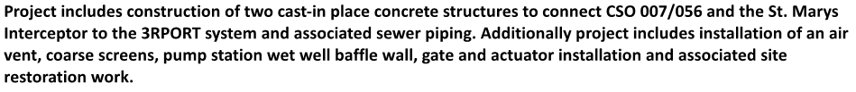
Plans and Specifications are available for view at the office of Thieneman Construction, Inc. between the hours of 8am and 5pm Monday through Friday. Plans and Specifications are also available via free download by sending a request to: estimating@t-c-i.net.

We would request that this form, any quotes AND minority certifications from Subcontractors and Suppliers to be delivered to our office no later than Thursday, July 18th^{th} by 1:00 PM. You may send quotes via email: estimating@t-c-i.net .
Please complete, sign and date and return by email: estimating@t-c-i.net
BUSINESS NAME:________________________________________________________________
CONTACT PERSON:______________________________________________________________
ARE YOU QUOTING? Yes or No
Will you be using UNION labor? Yes or No
Is your Company a certified: DBE / WBE / MBE / VBE / OTHER Subcontractor/Supplier?
* Please indicate type of Certification (or if none, please mark N/A):
*PLEASE BE SURE THAT OUR OFFICE HAS A COPY OF YOUR CURRENT CERTIFICATE ON FILE
For questions please call: 317-867-3462, ext 602 -the Estimating Dept.

