Indiana Death Registration System (IDRS)

WEB ELECTRONIC DEATH
REGISTRAION PROJECT
IDRS ISDH SCENARIO TRAINING DOCUMENT
Version 1.2
November 5, 2007

The Industry Standard in Vital Records Integrated Systems

TABLE OF CONTENTS

1.0 Introduction 6
1.1. Scope 6
1.2. Management/Technical Issues 6
2.0 Glossary 7
2.1. Cause of Death Data Entry (COD) 7
2.2. De-certify/De-verify 7
2.3. Decline 7
2.4. Demographic Data Entry 7
2.5. Demographic Verification 8
2.6. Designation 8
2.7. Drop-To-Paper 8
2.8. Fully Electronic 9
2.9. General Data Entry (GDE) 9
2.10. Local Acceptance 9
2.11. Local Registration 9
2.12. Medical Certification 9
2.13. Medical Data Entry 9
2.14. Paper Based 10
2.15. Presumed data fields 10
2.16. Record Locking 10
2.17. Registration Level 11
2.18. Relinquish 11
2.19. Trade Calls 11
3.0 Notification Mechanisms 12
3.1. Medical Certifiers: Physicians, Coroners, Medical Examiners 12
EMAIL: 12
TEXT MESSAGING: 12
3.2. Funeral Service Provider 12
BEGIN NEW RECORD: 13
3.3. Local Health Departments (LHD) 13
WORK QUEUE: 13
3.4. Indiana State Department of Health (ISDH) 13
WORK QUEUE: 13
4.0 Record Access and Permissions 14
4.1. Physicians Acting as Medical Certifiers 14
4.2. Physician Associated Staff (Office Staff) 14
4.3. Place of Death Location Based Staff 14
4.4. Funeral Directors 14
4.5. Funeral Home Staff 14
4.6. Coroners 15
4.7. Medical Examiners 15
4.8. Coroner/Medical Examiner Office Staff 15
4.9. Local Health Department Locations 15
4.10. ISDH 15
5.0 Performing Local Acceptance (LHD only) Error! Bookmark not defined.
5.1. Local Acceptance Error! Bookmark not defined.
6.0 Performing In-House Data Entry 16
6.1. Local Registration Error! Bookmark not defined.
6.2. General Data-Entry (GDE) 17
6.3. Cause of Death Data Entry (COD) 27
7.0 Batch Printing Fully Electronic Records (ISDH only) 31
7.1. Batch Print 31
8.0 Performing Medical Queries and Cause of Death Coding 34
8.1. Medical Query Review 34
8.2. Performing Cause of Death Coding 38
9.0 Participant Driven Workflow Scenarios 41
9.1. All Participating (Medical Certifier, Funeral Home and LHD) 42
Record Initiated by Medical Certifier 42
Record Initiated by Funeral Home 43
9.2. Medical Certifier and LHD Participating (Funeral Home Not Participating) 45
Record Initiated by Medical Certifier 45
Record Initiated by Funeral Home 46
9.3. Funeral Home and LHD Participating (Medical Certifier Not Participating) 48
Record Initiated by Medical Certifier 48
Record Initiated by Funeral Home 49
9.4. LHD Participating (Medical Certifier and Funeral Home Not Participating) 50
Record Initiated by Medical Certifier 50
Record Initiated by Funeral Home or Mortuary 50
9.5. Medical Certifier Participating, Funeral Home Participating, LHD NOT Participating Error! Bookmark not defined.
Record Initiated by Medical Certifier Error! Bookmark not defined.
Record Initiated by Funeral Home Error! Bookmark not defined.
9.6. Medical Certifier Participating, Funeral Home Not Participating, Local Health Department Not Participating Error! Bookmark not defined.
Record Initiated by Medical Certifier Error! Bookmark not defined.
Record Initiated by Funeral Home Error! Bookmark not defined.
9.7. Medical Certifier Not Participating, Funeral Home Participating, Local Health Department Not Participating Error! Bookmark not defined.
Record Initiated by Medical Certifier Error! Bookmark not defined.
Record Initiated by Funeral Home Error! Bookmark not defined.
9.8. Medical Certifier Not Participating, Funeral Home Not Participating, Local Health Department Not Participating Error! Bookmark not defined.
10.0 Trade Calls, Decline and Relinquish Scenarios 52
10.1. Trade Calls 52
Funeral Home of Record Uses Services of Another Funeral Home 52
10.2. Relinquish 53
Funeral Home of Record Relinquishes Record 53
New Funeral Home Unable to ‘Pick up’ Record Because Original Funeral Home Has Not Relinquished the Record 53
10.3. Reject 54
Local Health Department ‘Rejects’ Record 54
10.4. Decline 55
Coroner/ ME/Physician Declines (‘no case’) 55
Local Health Department ‘Declines’ Record Because the Record is Not in its Jurisdiction 55
11.0 Participant Query Scenarios 57
11.1. ‘Medical Certifier’ Questions Demographic Data 57
11.2. ‘Demographic Certifier’ Questions Data Entered by Medical Data Entry 57
12.0 Other Scenarios 57
12.1. Donation as Final Disposition (willed body) 57
12.2. Unidentified Cases (John/Jane Doe Cases) 58
12.3. Unidentified Becomes Identified 58
13.0 Other In-House Functions 59
13.1. Birth – Death Matching 60
Performing Manual Birth Death Matching 60
13.2. Checking the Record Status 62
Checking the Record Status for Records With a Specific Issue 62
Checking the Record Status for a Specific Record or Group of Records 65
13.3. Performing Legal View Screen Functions 68
Retrieving a Record in Legal View Screen 68
Printing Forms in Legal View Screen 71
Issuing or Printing Certificates 72
Performing a Demographic Correction 73
Performing a Medical Amendment 77
Viewing a Record’s Net Change History 82
Viewing a Record’s AOF History 83
Viewing a Record’s Issuance History 84
Viewing Flags Associated with a Record 85
Setting or Removing a Record Flag 86
13.4. Generating File Extracts, Exports and Imports 87
Generating an Extract, Export or Import File 87
Locating an Extract, Export or Import File 88
13.5. Printing Reports 89
13.6. Performing Medical Correction Review Error! Bookmark not defined.
13.7. Performing Demographic Correction Review Error! Bookmark not defined.
13.8. Performing Occupation/Industry Coding 91
13.9. Performing Overrides 93
Overriding a Record 94

Introduction

Scope
This document serves as a training scenario document for ISDH users of the Indiana Death Registration System (IDRS). The topics covered in this document address record flows and processes specific to the scope of responsibility of ISDH users within the IDRS. This is not a full User Manual, but a document for training users already familiar with the IN EBRS functionality. Therefore, aspects of the system that are shared with the Birth System (such as Security) or are identical to the Birth system (such as Library Maintenance, Utilities, or Add On the Fly) are not discussed in this document.

The document organized in the following fashion.
  - Section 1 is the introduction.
  - Sections 2 through 4 describe the terms and entities involved in with IDRS.
  - Sections 5 through 7 explain the In-House processes that death records undergo at ISDH. These are the processes ISDH users will perform on each record.
  - Sections 8 through 11 describe the scenarios that a record could undergo, from creation to completion. These are the potential record flows of a death record.
  - Section 12 describes other In-House processes that ISDH users may need to execute on records.

NOTE: This document describes the way the system will function when the system is fully implemented. When the In-House portion of IDRS goes live, no funeral directors or medical certifiers will be participating. Consequently, every record will function as a paper-based record (LHD participating, Medical Certifier and Funeral Home NOT participating) until the next portion of the system is implemented.

Management/Technical Issues
Any management issues and/or problems that may affect the implementation and/or use of the In-House Scenario Workbook should be reported immediately to the following Genesis team members for the development of counter measures, solutions and/or alternatives:
Project Manager: Waseem Ahmad
Technical Lead: Thomas Young

Glossary

Cause of Death Data Entry (COD)
‘Cause of Death data entry (COD)’ is the function by which some LHD’s and the ISDH enter the data in a death record. The COD function captures data about the cause of death. On a fully electronic record, the COD data are entered by the Medical Certifier. Cause of Death Data Entry is used if the Medical Certifier has completed his/her portion of the record outside the IDRS.

De-certify/De-verify
‘De-certify/De-verify’ refers to a mechanism that will allow a funeral director to undo a demographic verification or the medical certifier to undo a medical certification on a record. All data fields are locked when a record is certified or verified, and de-certification or de-verification enables the editing of data on the record again.

- The De-certify or De-verify process unlocks the respective portion of the record to allow it to be edited again.
- De-certify or De-verify option is available until the record is considered ‘Filed’ (both demographic and medical portions have been submitted and verified/certified), which will be indicated by the presence of a State File Date on the record.
- This process will require that the user who certified/verified must be the same user that de-certifies/de-verifies.

Decline
‘Decline’ refers to the option that allows the medical certifier to ‘decline’ the record in cases where the record does not actually fall under their jurisdiction.

- When a ‘decline’ option is executed, the system captures a reason that the case is being declined.
- The record remains in the Funeral Home queue and when selected, the ‘Reason Declined’ displays.
- The Funeral Home can re-designate a different entity or may manually reconcile with the original entity (contacts the medical certifier by phone to clarify/agree on the case.)

Demographic Data Entry
‘Demographic Data Entry’ is the portion of the record completed by the funeral director in the IDRS. Demographic Data Entry captures information about the decedent and family. If the funeral director is not participating in the IDRS, this data will be filed on a paper based or Drop to Paper record. The data is then entered by the LHD or ISDH in the General Data Entry function of the application.

Demographic Verification
‘Demographic Verification’ is the process by which the funeral director listed on a death record signifies that the demographic portion of a record is complete and accurate. To verify a record, the funeral director enters a pin number into the system. Demographic Verification on an electronic record takes the place of the signature on a paper-based record.

Designation
‘Designation’ relates to a process that will support identifying the medical certifier office on the record so that the record becomes accessible to that entity for continued processing.

- Designation will be a distinct process rather than the act of data entry to indicate the correct entity invoke by clicking the ‘Designate’ icon and initiating a search process to designate the Attending Physician Practice associated with the physician who will serve as the medical certifier.
- Allows a Funeral Director who has already verified (and released) the demographic part of the record to still change the designated medical certifier on the record if the case was “declined” by a Coroner or Medical Examiner.
  - Any time the designated location is changed regarding a medical certifier, a new e-mail or text message will be generated as described for notification.
- In some cases rules will exist regarding the type of entity that can be designated as the Medical certifier:
  - Force a case designation to Coroner or ME if presumed manner of death is not ‘Natural’.
  - The system will prevent the record type of ‘Unidentified’ and the designation of the medical certifier who is a Physician rather than a Coroner or Medical Examiner.

Drop-To-Paper
‘Drop-to-Paper’ refers to the mechanism for handling records that are partially completed electronically, but then encounter a provider who is not using the electronic system.

- Data entry of the remaining portion of these records will be performed at the Local Health Department or State Office, depending on the participation level of the LHD.
- If a participating Funeral Home has been identified on the record, then demographic data entry and demographic verification must be done before the record can ‘Drop-to-Paper’.
- If a Medical Certifier’s Office has been designated on the record that is participating, then medical data entry and medical certification must be complete before the record can ‘Drop-To-Paper’.
- If a participating funeral home and a participating medical certifier and a participating Local Health Department are all identified on the record then Drop-To-Paper will not be an option.
- The ‘Drop-To-Paper’ form that prints under these rules will become the death certificate that will ultimately be filed.

Fully Electronic
A ‘Fully Electronic’ death record is one where the medical certifier and the funeral director have both completed their portion of the record using the IDRS. The record is said to be ‘fully electronic’ because it can be processed without transferring a signed paper copy of the record from office to office.

General Data Entry (GDE)
‘General Data Entry (GDE)’ is the function that allows some LHD’s and the ISDH to enter the data in a death record. GDE captures most of the data about a death and contains fields entered by the funeral director and the medical certifier when the funeral director and medical certifier are participating in the IDRS. GDE also captures In-House specific fields such as the Local File Number, the file date and the State File Number. Every record that is not fully electronic must have data entered in GDE at either the LHD, or, if the LHD does not perform General Data Entry, at the ISDH.

Local Acceptance
‘Local Acceptance’ is the process by which a LHD accepts a fully electronic record from the medical certifier and funeral director. Local Acceptance assigns a Local File Number and file date to a record. It then makes the record available for processing at ISDH.

Local Registration
‘Local Registration’ is the function that allows LHD’s to begin a paper based or drop to paper record electronically before filing the record with ISDH. Local Registration captures basic information about the death and records the Local File Number and file date.

Medical Certification
‘Medical Certification’ is the electronic process by which the medical certifier listed on a death record signifies that the medical portion of a record is complete and accurate. To certify a record, the medical certifier enters a pin number into the system. Medical Certification on an electronic record takes the place of the signature on a paper-based record.

Medical Data Entry
‘Medical Data Entry’ is the portion of the record completed by the medical certifier in the IDRS. Medical Data Entry captures information about the cause and time of death. If the medical certifier is not participating in the IDRS, this data will be filed on a paper based or Drop to Paper record. The data is then entered by the LHD or ISDH in the General Data Entry and Cause of Death data entry functions of the application.

Paper Based
A record is said to be ‘Paper Based’ when it is initiated by the Funeral Director or Medical Certifier on paper, outside the IDRS. Paper based records will not undergo electronic demographic verification or medical certification. To process a paper based record, the original paper copy of the death certificate must be transferred between the Funeral Director and the Medical Certifier and then be sent on to the LHD and the ISDH office.

Presumed data fields
‘Presumed data fields’ refer to data items that are captured in duplicate for the purpose of supporting record identification and matching. Each field falls under the distinct responsibility of either the Funeral Director or the Medical Certifier.

‘Presumed data fields’ will be stored on the record twice with one set being referred to as ‘presumed’ and the other set referred to as ‘actual’. The ‘actual’ items will be those completed by the entity that is in fact responsible for the item. The ‘presumed’ set will be entered by the entity that is not responsible, but from whom the item is needed for record identification, matching, or other functional purposes.

Example: ‘Date of Birth’ field. Ownership of this item would rest with the funeral director so the funeral director actually provides the ‘Date of Birth’. The medical certifier would provide the ‘Presumed Date of Birth’.

The complete list of fields that will be captured to create a NEW record are as follows:

- Decedent’s Name
- Type of Place of Death
- Place of Death
- Date of Death
- Decedent’s Social Security Number (if known)
- Date of Birth
- Gender
- EDR Number (when applicable)
- Coroner/Medical Examiner Case Number (when applicable)
- BTP Number

Record Locking
‘Record Locking’ refers to the mechanism that will prevent editing of data once ‘released’ from medical data entry and certification and/or demographic data entry and verification.

- Each will have its own ‘release’ point that is related to the respective ‘certification’ or ‘verification’ component.
- Once a given portion (medical or demographic) has been ‘certified’ or ‘verified’, that portion of the record is locked from further change by the respective participant.
- The following circumstances will permit de-certification or de-verification of a record to allow the respective portion of the record to be edited again:

  - The de-certification or de-verification can only occur if the record has not been assigned a State File Number.
  - De-certification or De-verification will also not be permitted once a record has ‘Dropped-To-Paper’.

Registration Level
‘Registration Level’ refers to the level of participation of a Local Health Department. A registration level of ‘1’ means that an LHD performs Local Registration, but not general data entry or cause of death data entry. A registration level of ‘2’ means that an LHD performs general data entry, but not Local Registration or cause of death data entry. A registration level of ‘3’ means that an LHD performs general data entry and cause of death data entry, but not Local Registration.

Relinquish
‘Relinquish’ refers to a process that removes ‘ownership’ by a Funeral Home from the death record so that it can be turned over to a different Funeral Home.

- The ability to ‘Relinquish’ a record to allow a different Funeral Home to ‘pick up’ the record will be a distinct process under security and will be performed at the State Office or by the Funeral Home that needs to surrender the record.
  - Note that this is not related to ‘Trade Call’ circumstances where a second funeral home is involved in providing some of the services.

Trade Calls
‘Trade calls’ refer to a Funeral Home adding an Additional Funeral Service Provider on a record. The Funeral Home who has ‘ownership’ of the death record will be known as the ‘Funeral Home of Record’, while the additional Funeral Service Provider is the Funeral Home that provide additional services that may include the Funeral Service and/or interment.
- Notation of the Funeral Home of Record and the Additional Funeral Service Provider is available for printing on the death certificate:
  - License number of the funeral home that prints will be that of the funeral home of record.
  - The Funeral director and the license number will reflect a funeral director associated with the funeral home of record.

Notification Mechanisms

Notification refers to the manner in which a given participant becomes aware that there is a record that needs to be worked on. The following describes the notification means for each entity described below:

Medical Certifiers: Physicians, Coroners, Medical Examiners

Genesis assumes that the medical certifier could and would be identified on the death record regardless of who (whether by medical data-entry or demographic data-entry) initiates the record in the IDRS. The system will facilitate notification of Medical Certifiers via the following methods:

EMAIL:
- The e-mail message will be sent to one or more recipients identified on a “TO” email address line stored with the participant’s record in library maintenance.
- An optional “CC” e-mail address line will also be supported to identify one or more additional recipients for the e-mail message.
- The e-mail message will alert the participant and identify the decedent, the place of death, the funeral home, the date of death and the unique key number (either the EDR case number, Medical Examiner’s case number or Hospital Medical Record Number) entered when the death certificate was initiated in the system.
- The e-mail message will also provide the following instruction: ‘If you received this email in error, please contact the identified funeral home directly. This is an automatically generated E-mail. Please do not ‘Respond’ to this E-mail as a response by E-mail will not be processed.’

TEXT MESSAGING:
- ‘Text Messaging’ is identical to the e-mail process (see above) except that the recipient will receive the message on their cell phone rather than in an e-mail client.
- Messages can also be sent to text enabled pagers.

Funeral Service Provider
Unlike Medical Certifiers, if a record is initiated at the time of death, it cannot be assumed that the funeral home or service provider would be identified. Therefore, the system cannot rely on a work-queue or electronic notification as a means of passing the electronic record to the demographic certifier (funeral director.), nor is it prudent to provide a mechanism to conduct a ‘wide open’ search of all records without designated funeral service providers due to confidentiality and ethical considerations. The system will facilitate notification via the following method:

BEGIN NEW RECORD:
- The participating funeral service provider will need to begin a NEW record in the system to ‘pick up’ the record for demographic data entry and verification. Unique identifiers have been determined to facilitate this as described in the scenarios included in this document.

Local Health Departments (LHD)

WORK QUEUE:
- Fully electronic records will be available in the Local Acceptance Queue.
- Paper based or Drop to Paper records will arrive on paper at the office.
- E-mail notifications will not be sent to the LHD.

Indiana State Department of Health (ISDH)

WORK QUEUE:
- Notification of new records and the associated tasks will be a product of work-queues related to the State Office functionality.
- Paper based or Drop to Paper records will arrive on paper at the office.

Record Access and Permissions

Physicians Acting as Medical Certifiers

- Physicians associated with a given practice location will have access to all death records that are associated with their practice location.
- Medical certification can only be performed by the individual identified on the record as the medical certifier for that record.
- Medical certifiers will be able to initiate a ‘medical amendment’ to amend the medical info.
- If a medical certifier is associated with multiple locations, new records associated with a medical certifier will be available at all related locations in the work queue (not searchable). Once a record has been accessed and saved at a location, the record will be available only at that location, and it will be available through the work queue or the search function.

Physician Associated Staff (Office Staff)

- Physician office staff associated with a given practice location will have access to all death records that identify the practice (location) as the practice associated with the medical certifier.
- Allows a physician’s office staff to initiate data entry of the medical portion of the death certificate to support the physician in the process of medical certification.

Place of Death Location Based Staff

- Relates to Hospitals, Nursing Homes and Hospice Facility staff.
- Facility staff associated with a given place of death location will have access to all death records where the place of death is that location.
- Allows facility staff to initiate data entry of the medical portion of the death certificate to support the physician in the process of medical certification.

Funeral Directors

- Funeral Directors (demographic certifiers) will have access to death records that are associated with the Funeral Home that the Funeral Director is associated with.

Funeral Home Staff

- Funeral Home staff will have access to death records that identify that Funeral Home on the record.

Coroners

- Coroner will have access (read) to any death record where the death occurred in their county of jurisdiction and any death record that specifies them as the medical certifier.
- Coroners will be able to perform ‘Medical Data Entry’ and ‘Medical Certification for records where they are designated as the medical certifier, but not on records in their county (that they can view) for which they are not designated as the medical certifier.
- Coroners, as any medical certifier, will be able to initiate a ‘medical amendment’ to amend the medical info.

Medical Examiners

- Medical Examiner will have access (read) to any death record where the death occurred in their county of jurisdiction and any death record that specifies them as the medical certifier.
- Medical Examiners will be able to perform ‘Medical Data Entry’ and ‘Medical Certification for records where they are designated as the medical certifier, but not on records in their county (that they can view) for which they are not designated as the medical certifier. To alter these records, they will change first list themselves as the medical certifier on the record.
- Medical Examiners, as any medical certifier, will be able to initiate a ‘medical amendment’ to amend the medical info.

Coroner/Medical Examiner Office Staff

- Coroner/Medical Examiner office staff associated with the Coroner/Medical Examiner office location will have access to all death records that identify the office (location) as the office associated with the medical certifier.
- Allows Coroner/Medical Examiner office staff to initiate data entry of the death certificate to support the coroner/medical examiner in the process of certification/verification as applicable.

Local Health Department Locations

- The LHD association to a death record will be determined according to the LHD designated on the record.
- A given LHD Office will only have access to death records that contain that office as the designated health department on the death record.

ISDH
- ISDH will have access to all records, but actions that can be taken against any given record are dictated by the status of the record. (Records must be released to the ISDH before the state office can act on a record.)

Performing In-House Data Entry

Different records will require different In-House data entry processes at the ISDH based on the registration level of the ISDH that processed the record. For more information about which steps are required, see the Participant Driven Workflow Scenarios section of this document.

Different entities perform different data entry processes:
Local Registration – some LHD only – NOTE: This is not discussed in this document because it is not an ISDH function.
General Data Entry – some LHD, ISDH
Cause of Death Data Entry - some LHD, ISDH

General Data-Entry (GDE)
General Data Entry is performed by ISDH users on records that come from LHD’s that do not have access to General Data Entry. Every paper based or drop to paper record must be processed through GDE at either the LHD or at ISDH. ISDH users will process a record in GDE only when the LHD that processed the record does not perform GDE.
Different amounts of data will already be entered in GDE depending on whether the record is:
  - Paper based – no data previously entered
  - Dropped to paper by funeral director – demographic data previously entered
  - Dropped to paper by medical certifier – medical data already entered
  - ISDH ONLY: Medical certifier and funeral director participating, LHD not participating – all data but LFN, file date and SFN previously entered.

Follow the following steps to perform GDE.
- Login to the IDRS using your username and password.
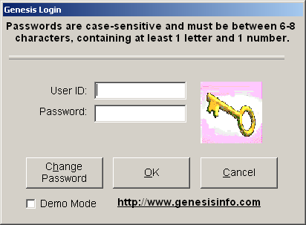

- If associated with more than one office, select the appropriate location.
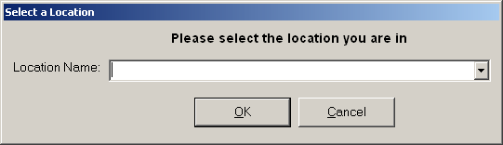

- The Main Menu screen will open.
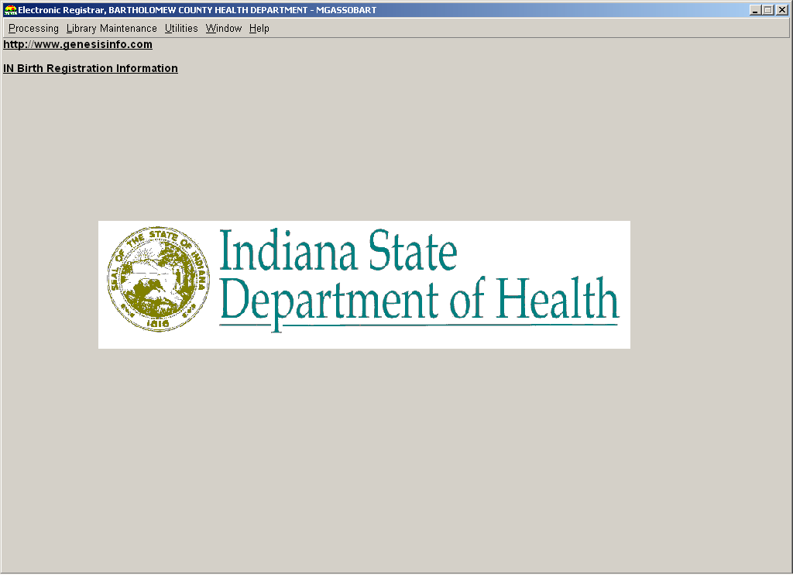

- Navigate to the Processing Menu and select the ‘Death’ option.
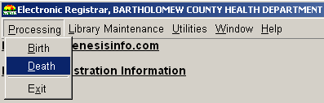

- The Death Menu screen will open.
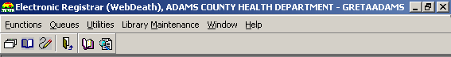
NOTE: The icons available on the Death Menu screen will differ depending on the log-in location.

- Click on the General Data Entry icon in the Death menu toolbar.

- The GDE screen will open.
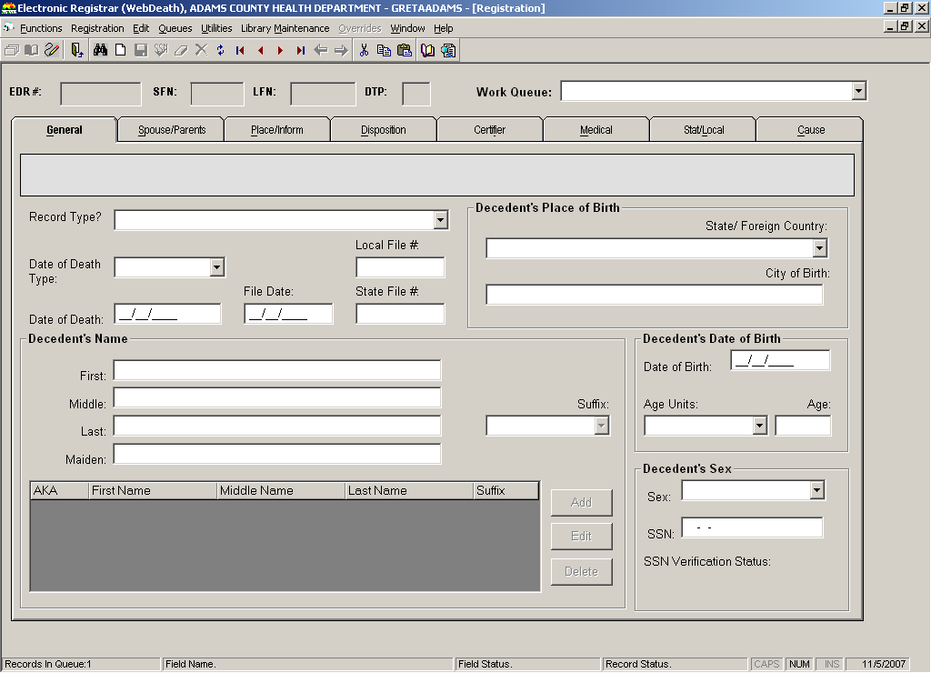

- Click on the ‘NEW record’ icon to initiate or ‘pick up’ a death record.

- The Record Information screen will open.
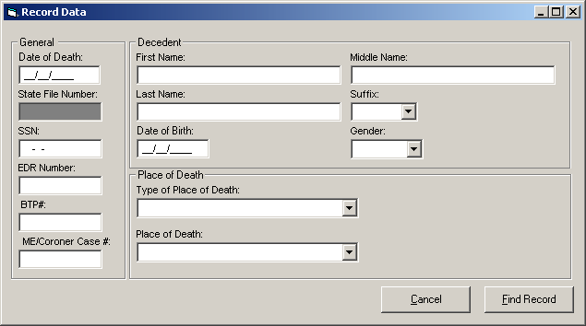

- Enter the following information whenever available about the decedent into the following fields:
  - Name
  - Type of Place of Death
  - Place of Death
  - Date of Birth
  - Key Fields (SFN, SSN, EDR Number, BTP Number, Coroner/ME Case Number) – mandatory minimum: 1 key field
  - Presumed Date of Death - mandatory
  - Gender – mandatory

- Click the FIND RECORD button.

- The IDRS will perform a search to see if the record has already been created in the system.
- If no match is found, the IDRS will display a message of ‘New Record’ and will ask if a NEW record should be created.
- If a match is found (IDRS finds a record that matches on one of the key fields and consistent with other provided information), the IDRS will issue a notice ‘Match Found’.
- If a match is found on demographic items, but does not match on the one of the key fields, the IDRS will notify and instruct the user to try again with the correct key field or contact the place of death to obtain correct key field information before continuing.
- If the key field is correct despite the IDRS warning, the user can indicate the information is correct and that a NEW record should be created even though it appears to match an existing record.
- If more than one match is found, the IDRS will ask the user to enter more of the initial information and to try again.

- Once step 12 has been resolved, click OK to proceed with General Data Entry on a NEW record or to accept and continue with the matching record.

- The record will be displayed in the data entry fields of the General tab.
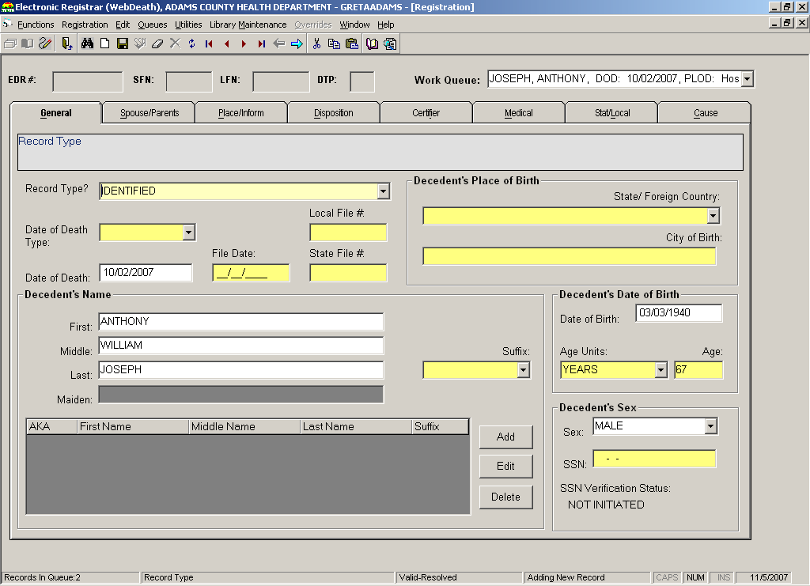

- Type the LFN and file date listed on the paper form.

- If the year of death on the record is the current or previous year:
NOTE: If the year of death is prior to the previous year, the SFN must come from outside the system.

- Click on the Utilities menu and select the ‘Bump Process – State File Number’.
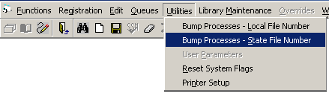

- The Bump State File Number Process Window will open.
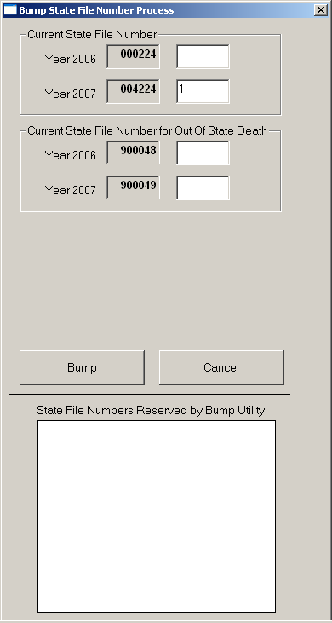

- Enter ‘1’ beside the applicable year of death.

- Click the BUMP button.

- The system will display the bumped number in the ‘State File Numbers Reserved by Bump Utility’ field and will ask if you want to commit the changes.
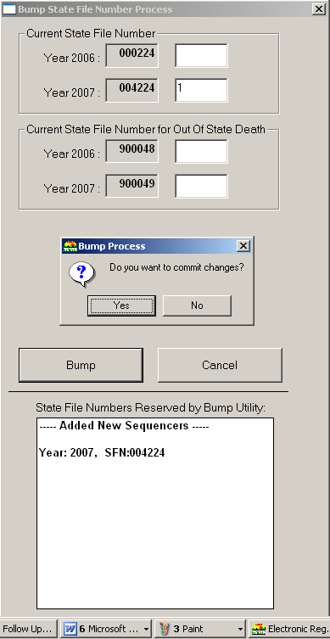

- Click YES.

- Type the ‘bumped’ SFN in the State File Number field on the General tab.
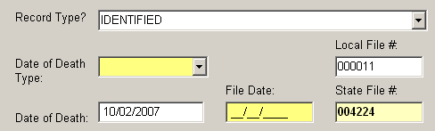

- The IDRS will perform an automatic SSN Verification Process and provide response codes, instructions and notifications to the user, as applicable.

- Proceed with general data entry by completing the information requested on the following tabs:
General
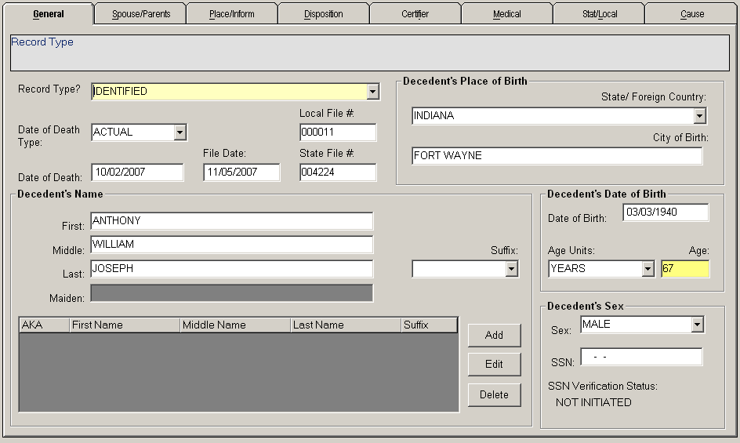

Spouse/Parents
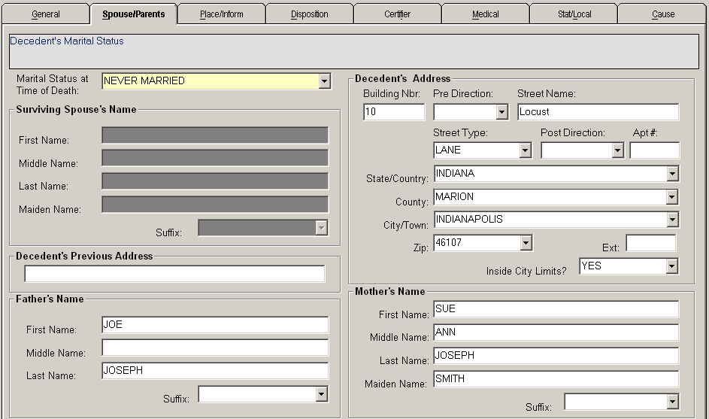

Place/Inform
NOTES:
  - The address of the facility will load into the Place Death Occurred fields if a hospital is the place of death.
  - The informant’s mailing address will load into the informant’s mailing address fields if the ‘Same as Decedent Address toggle box is checked.
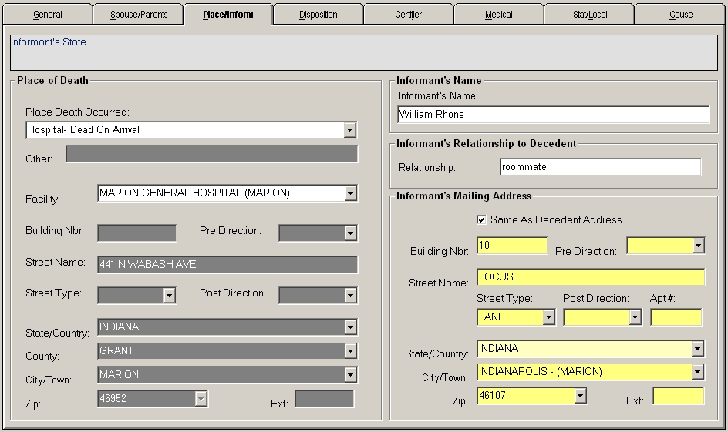

Disposition
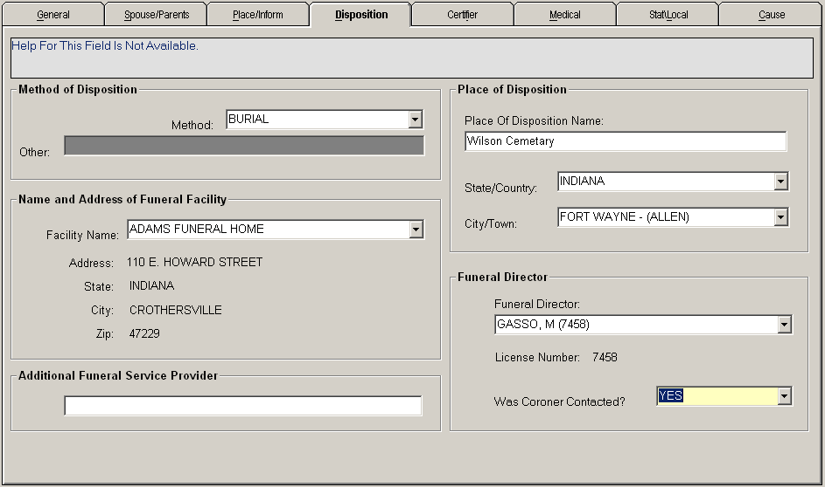

Certifier
NOTE: The Certifier information will display when a name is selected in the Medical Certifier field.
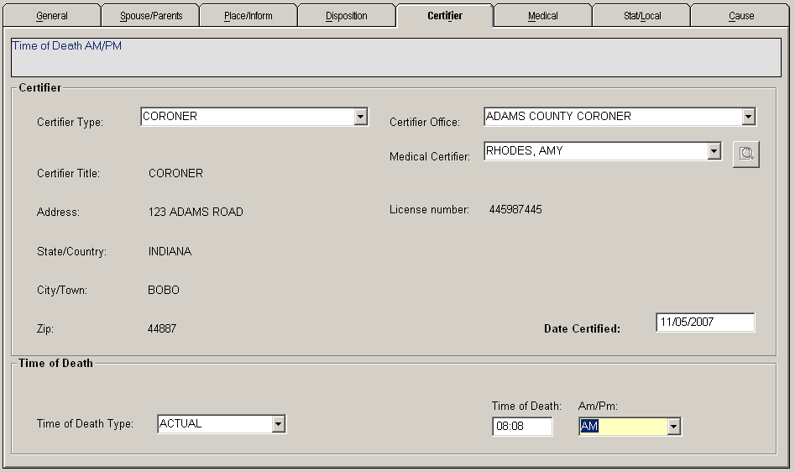

Medical
NOTE: If the reported ‘Manner of Death’ is ‘NATURAL’, the Injury fields will be locked. If the value in the ‘Any Injury Information to Report’ field is ‘NO’, the Injury fields will be locked. If the value in the ‘Any Injury Information to Report’ field is ‘YES’, the Injury fields will be enabled.
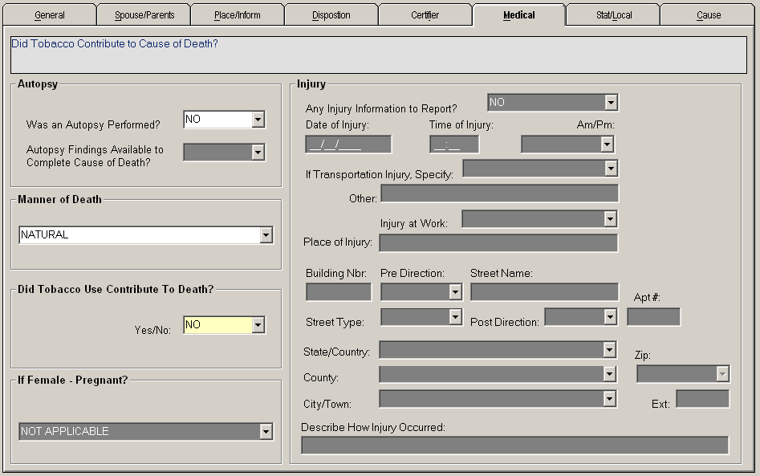

Stat/Local
NOTE: The ‘Decedent’s Origin’ and ‘Decedent’s Race’ fields are not displayed at the same time. When a button is selected, the related fields will display on the right side of the data entry screen.
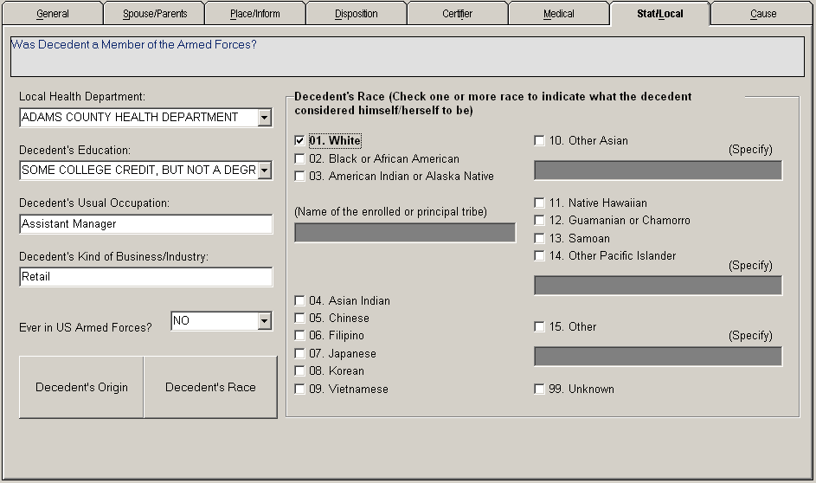

Cause
NOTE: The Cause tab will be unavailable. It can only be utilized during Cause of Death data entry.

- Click the ‘Save’ icon in the Death Menu toolbar to save the record.

- When all fields are complete, the system will offer to release the record. Click YES.

- The record will be locked from further editing.
- The record will be available in the Cause of Death work queue if needed. If COD data entry is not needed, the record will be available in Legal View Screen.

Cause of Death Data Entry (COD)
Cause of Death data entry is used when an ISDH user receives a paper based record or a record dropped to paper by the Funeral Director. ISDH users process records through the COD function when a record is filed by an LHD that does not perform COD data entry or by an LHD that is not participating in the IDRS system.

Follow the following steps to perform COD data entry.
- Login to the IDRS using your username and password.

- If associated with more than one office, select the appropriate location.

- The Main Menu screen will open.

- Navigate to the Processing Menu and select the ‘Death’ option.

- The Death Menu screen will open.
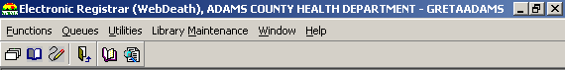
NOTE: The icons available on the Death Menu screen will differ depending on the log-in location.

- Click on the ‘Cause of Death Data Entry’ icon in the Death Menu toolbar.

- The Cause of Death data entry screen will open.
NOTE: This screen is the Cause tab of the data entry screens. The other tabs will be available for viewing, but not for editing.
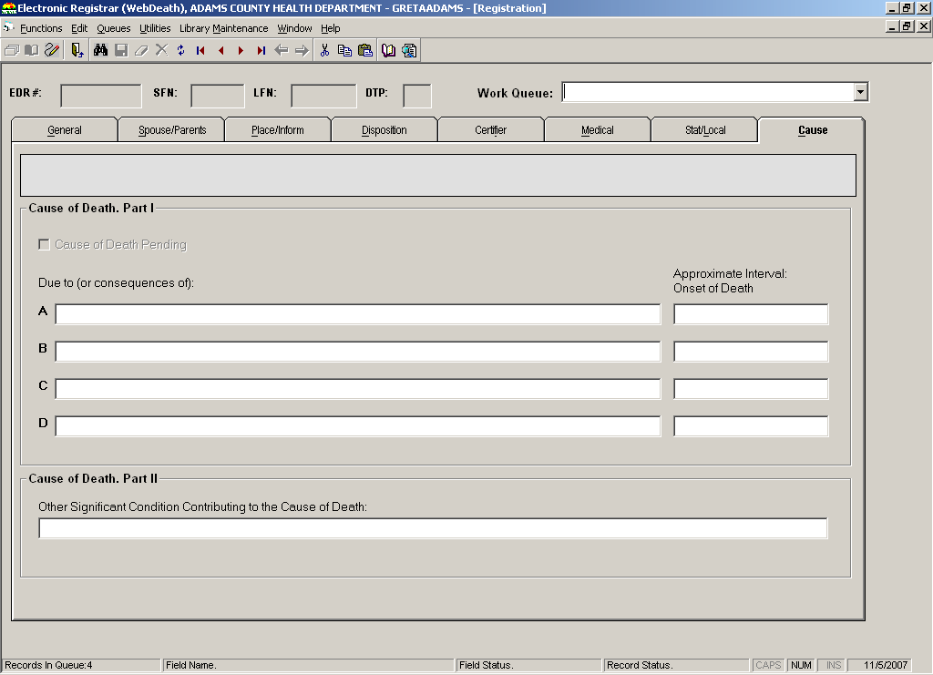

- Select the desired record from the work queue.
NOTE: Only records released from GDE will be available in COD data entry.
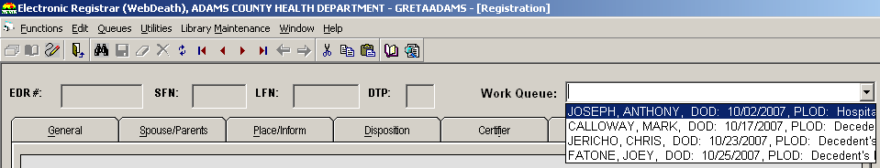

- The record will load into the COD screen. Five fields located just below the toolbar will identify the record: EDR#, SFN, LFN, and BTP.
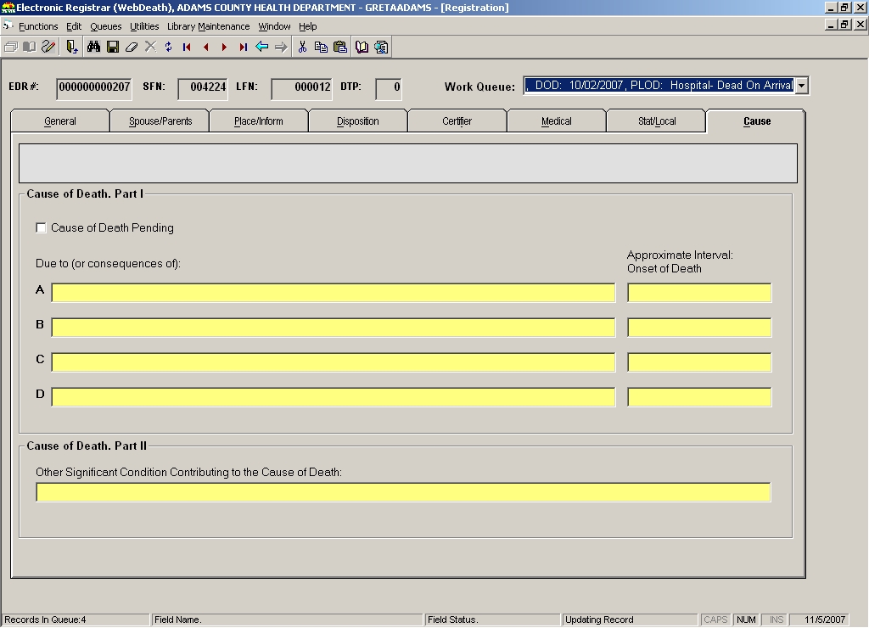

- Enter the data into the fields.

- Click on the ‘Save’ icon in the Death Menu toolbar.

- The system will offer to legally release the record.
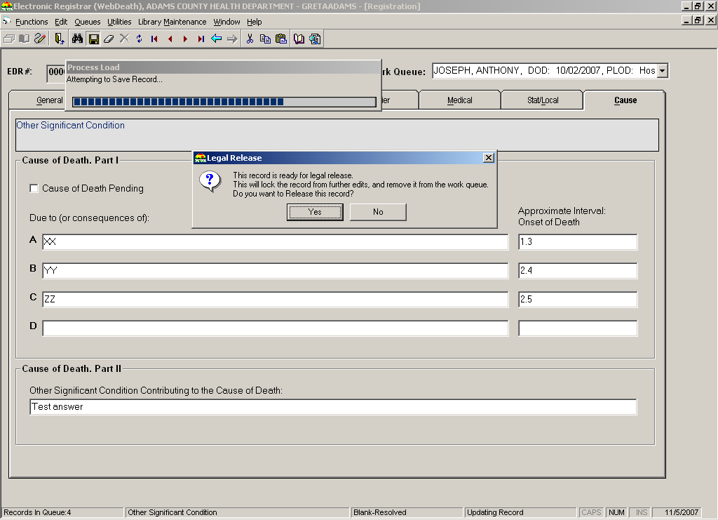

- Click YES.

- The record will be locked from editing. It will be available in Legal View screen for issuance and further processing.

Batch Printing Fully Electronic Records

Batch Printing is performed on fully electronic records to generate a physical copy of the death certificate. It is not necessary for paper based or drop to paper records to batch print because the paper copy is kept on file ay ISDH. All batch printed records will have undergone Local Acceptance at an LHD office before batch printing.

Batch Print
All fully electronic death records will be batch printed at the ISDH office. There is no local batch print of death records.

Follow the following steps to batch print death records.
- Login to the IDRS using your username and password.

- If associated with more than one office, select the appropriate location.

- The Main Menu screen will open.

- Navigate to the Processing Menu and select the ‘Death’ option.

- The Death Menu screen will open.
NOTE: The icons available on the Death Menu screen will differ depending on the log-in location.

- Click on the ‘Batching Process’ icon in the Death Menu toolbar.

- The Batch Printing screen will open.
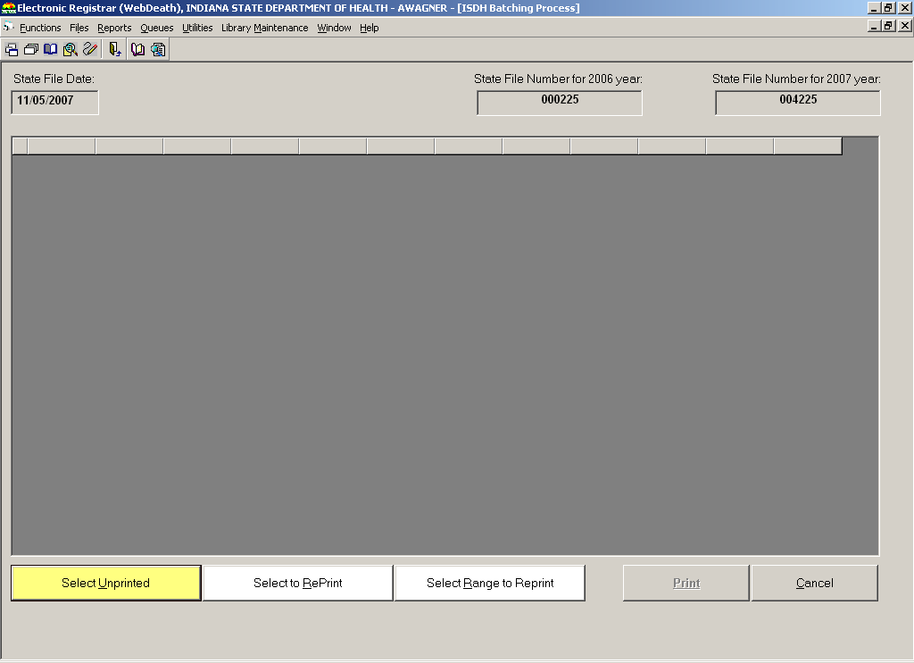

- Click the SELECT UNPRINTED button.

- Click the PRINT button.

- A message stating that this will assign a State File Number (SFN) to each record will display and ask if you wish to continue.

- Click YES.

- The records will be assigned SFN’s and copies of each death certificate will print at the printer designated in the Printer Setup Utility.

Performing Medical Queries and Cause of Death Coding

Once a record has been batch printed at the State or released from Cause of Death data entry, it is officially registered. At that point, each record undergoes Medical Query Review to review the Cause of Death data. Once the Cause of Death data has been verified, the record is coded with the Supermicar export and the Acme/Transax import so that its data is ready for export to NCHS.

Medical Query Review
Medical Query Review allows the Cause of Death data on each to be reviewed for accuracy and formatting.

Follow the following steps to perform Medical Query Review.
- Login to the IDRS using your username and password.

- If associated with more than one office, select the appropriate location.

- The Main Menu screen will open.

- Navigate to the Processing Menu and select the ‘Death’ option.

- The Death Menu screen will open.
NOTE: The icons available on the Death Menu screen will differ depending on the log-in location.

- Navigate to the ‘Queues’ menu and select ‘Medical Query Review’.
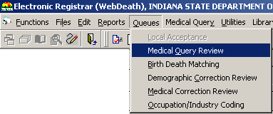

- The Medical Query Review toolbar will display, and the work queue will be populated with the records that have not undergone ‘Medical Query Review’.
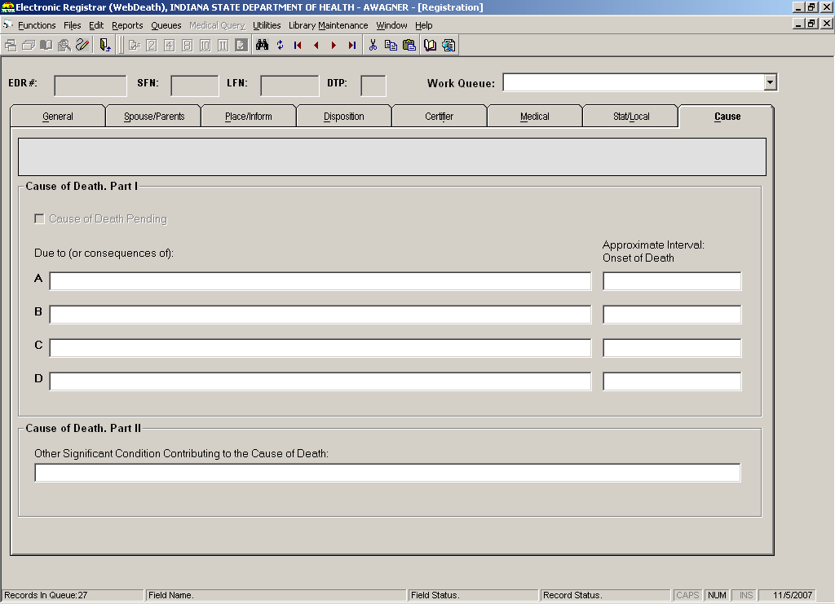

- Select the desired record from the work queue.
NOTE: Records are listed alphabetically by the last name of the decedent and sub-sorted by the decedent’s first name. The date of death and place of death will also be listed.
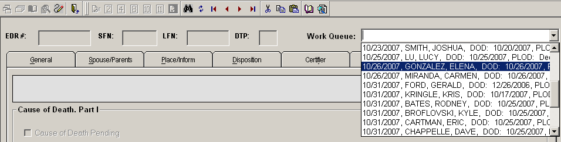

- The record will display on the Cause of Death screen with all fields locked.
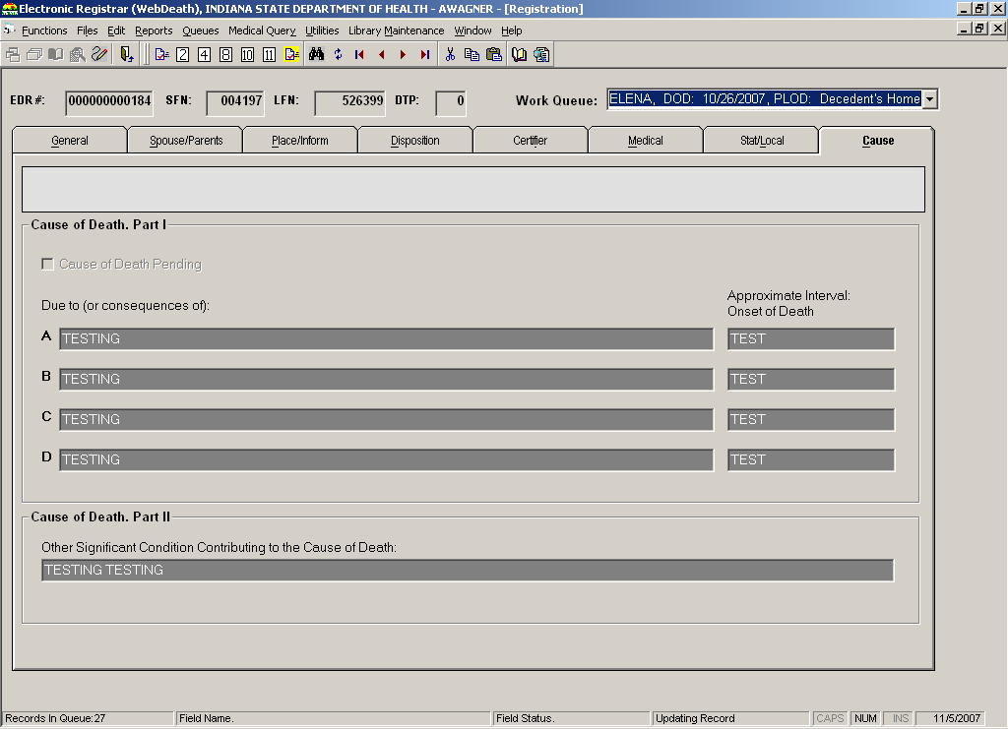

- Choose the appropriate icon from the toolbar:
- Release Record - Click this icon if the data on the screen is correct as displayed. The record will be removed from the queue.
- Query Letter 2 - Click this icon to print a letter requesting information about the primary site of the carcinoma.
- Query Letter 4 - Click this icon to print a letter requesting information about underlying cause of the death.
- Query Letter 8 - Click this icon to print a letter requesting information about a specific disease or condition of the injury.
- Query Letter 10 - Click this icon to print a letter requesting information about the circumstances of the injury.
- Query Letter 11 - Click this icon to print a letter requesting clarification of the cause of death.
- Bulk Release - Click this icon to release all records from the Medical Query Review work queue.

- The system will ask if you want to flag and release the record.
NOTE: If the ‘Release Record’ option is selected, the record will release but will NOT be flagged.

- Click YES.

- The record will release and be removed from the queue. If the record was flagged, the flag will display when the record is opened in Legal View Screen.

Performing Cause of Death Coding
Once the Medical Query review has been completed (and resolved if necessary), the Cause of Death data must be coded. Cause of Death Coding occurs via the Supermicar export and Acme/Transax import.

Follow the following steps to perform Cause of Death Coding.
- Login to the IDRS using your username and password.

- If associated with more than one office, select the appropriate location.

- The Main Menu screen will open.

- Navigate to the Processing Menu and select the ‘Death’ option.

- The Death Menu screen will open.
NOTE: The icons available on the Death Menu screen will differ depending on the log-in location.

- Navigate to the ‘Files’ menu and select ‘Supermicar Export.’
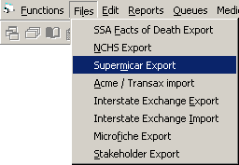

- The Supermicar File Creation window will open.
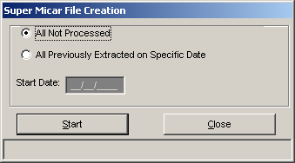

- Select one of the following radio buttons:
- ‘All Not Processed’ – Select this option to code all records that have not been previously coded.
- ‘All Previously Extracted on Specific Date’ – Select this option to code records that have been previously coded. When selecting this option, enter the start date in the ‘Start Date’ field.

- Click the START button.

- The system will indicate that the export file was created successfully.

- Click OK.
NOTE: The coding occurs outside the IDRS. Do not proceed until it is complete.

- Once the coding is complete, navigate to the ‘Files’ menu and select ‘Acme/Transax Import’.
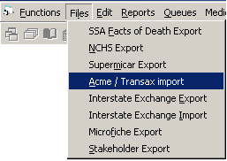

- The Acme Import window will open.
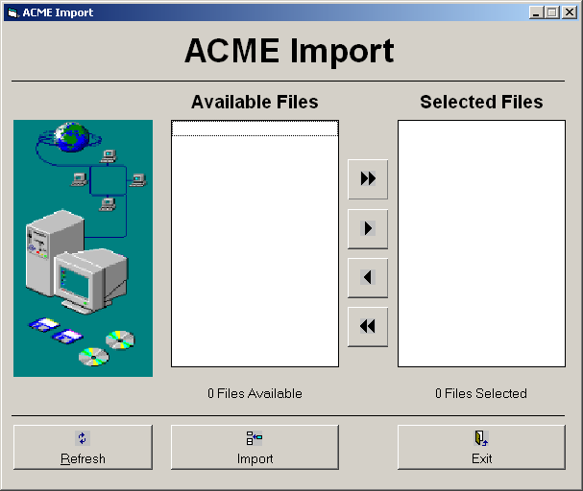

IN007.dat

IN007.dat

- Click on the desired file in the Available Files frame to highlight it.

- Click the arrow button > to move the file to the Selected Files frame.

- Repeat steps 14 and 15 as necessary. Once the desired files are listed in the Selected Files frame, click the IMPORT button.

- The system will indicate the file was imported successfully.

- Click OK.

- Click EXIT to return to the Death Menu screen.

Participant Driven Workflow Scenarios

This section includes the following participant driven workflow scenarios that are possible when processing death records. The scenarios outline the multi-threaded processes and successions involved, from initiation to registration.

- All Participating (Medical Certifier, Funeral Home and LHD)
- Medical Certifier and LHD Participating (Funeral Home Not Participating)
- Funeral Home and LHD Participating (Medical Certifier Not Participating)
- LHD Participating (Medical Certifier and Funeral Home Not Participating)
- Medical Certifier and Funeral Home Participating (LHD Not Participating)
- Medical Certifier Participating (Funeral Home and LHD Not Participating)
- Funeral Home Participating (Medical Certifier and LHD Not Participating)
- All NOT Participating (Medical Certifier, Funeral Home and LHD)

The term ‘PARTICIPATING’ as used in this document refers to participating in the use of the Indiana Death Registration System.

All Participating (Medical Certifier, Funeral Home and LHD)

Record Initiated by Medical Certifier

- Medical certifier (Physician) or other user (Physician Office Staff) at the place of death with access to Medical Data Entry process initiates death record.

- The Medical Certifier accesses the ‘Medical Certification’ process to review and certifies the medical items.

- The medical section becomes locked upon medical certification.

- The Funeral Home begins NEW record by following the Demographic Data-Entry procedure.

- Within the Demographic Data Entry process the SSN verification process will be invoked.

- When the demographic data entry is complete, the demographic verification process is accessed for the funeral director to apply their PIN to the record. This locks the demographic portion.

- The record appears in the appropriate (based on LHD indicated in demographic data entry) Local Health Department’s Local Acceptance queue.

- The LHD processed the record through Local Acceptance, which assigns a LFN and file date.

- The record is available at ISDH for batch printing.

- ISDH batch prints, assigning a State File Number and making the record is available for issuance.

- ISDH performs Medical Query Review and, if necessary, issues a medical query letter.

- If necessary, ISDH corrects the record to incorporate and feedback received from the medical query letter.

- ISDH performs Cause of Death coding on the record.

Record Initiated by Funeral Home
- The funeral director or staff at the funeral home creates a NEW record and no match is found. The funeral director or office staff complete the demographic data entry and also designate a medical certifier.

- The medical certifier receives an e-mail or text message to notify them that a case has been added to their queue.

- Within the Demographic Data Entry process the decedent’s name and Social Security Number, gender and date of birth are validated by the SSN verification process.

- The funeral director reviews and ‘Verifies’ the demographic information by ‘Electronic Verification’ involving entry of a PIN.

- The demographic portion of the record becomes locked but the record remains in the funeral home work queue until the medical certification has occurred.

- The record also appears in the funeral home’s view of the ‘Record Status Screen’ showing that medical certification has not occurred. A warning appears when anyone accesses the demographic data entry screen if there are records in the queue where the date of death is five or more days prior to the system date.

- Medical certifier (Physician) or other user (Physician Office Staff) at the place of death picks up the record from the work queue or by creating a NEW record with matching data.

- The certifier’s staff completes medical data entry.

- The Medical Certifier accesses the ‘Medical Certification’ process to review and certifies the medical items.

- The medical section becomes locked upon medical certification.

- The record appears in the appropriate (based on LHD indicated in demographic data entry) Local Health Department’s Local Acceptance queue.

- The LHD processed the record through Local Acceptance, which assigns a LFN and file date.

- The record is available at ISDH for batch printing.

- ISDH batch prints, assigning a State File Number and making the record is available for issuance.

- ISDH performs Medical Query Review and, if necessary, issues a medical query letter.

- If necessary, ISDH corrects the record to incorporate and feedback received from the medical query letter.

- ISDH performs Cause of Death coding on the record.

Medical Certifier and LHD Participating (Funeral Home Not Participating)

Record Initiated by Medical Certifier
- The participating medical certifier will initiate the electronic death record.

- Medical certifier must print the ‘Drop-to-Paper’ death certificate since Funeral Home is not participating in the IDRS.
Printing of the ‘Drop-to-Paper’ death certificate will be by process when the Funeral Director contacts the medical certifier. Since the record will be accessible at either the place of death, the Local Health Department, or at the medical certifier’s office, the funeral director can go to any of these locations to obtain the ‘Drop-to-Paper’ death certificate.
When the Drop-to-Paper option is selected, the user will receive a warning page that reads as follows: ‘To print a “File Copy” – choose the option “Death Abstract”; Choosing the option “Drop to Paper” will prohibit the electronic filing of the death certificate. Are you sure you wish to “Drop to Paper”? Only do this at the request of the Funeral Director.’

- Since the record will have already been medically certified, the funeral director will have the incentive to get the ‘Drop-to-Paper’ death certificate. Otherwise the medical certifier would need to be contacted to manually sign the manually produced form.

- The drop to paper form is completed and signed by the Funeral Director and delivered to the LHD.

- The LHD staff enters data in Local Registration or General Data Entry, depending on the LHD’s registration level.

- Within the General Data Entry or Local Registration, the decedent’s name, Social Security Number, gender and date of birth are validated by the SSN verification process.

- Within the General Data Entry or Local Registration, a Local File Number and file date are assigned. (If GDE is completed, a SFN is assigned.)

- The LHD saves the record and releases it to ISDH.

- ISDH searches for the record in GDE or Legal View, depending on the registration level of the LHD.

- If needed, the ISDH completes GDE. (If GDE is completed, a SFN is assigned.) The record is available for issuance.

- ISDH performs Medical Query Review and, if necessary, issues a medical query letter.

- If necessary, ISDH corrects the record to incorporate and feedback received from the medical query letter.

- ISDH performs Cause of Death coding on the record.

Notes:
- It is assumed that the non-participating FD will contact either the LHD or the Medical Certifier to determine if the medical certification has been done at time of death and/or whether or not the physician participating electronically and the record will be electronically certified. This will prompt the Funeral Director to request and obtain the Drop-To-Paper form.
- If the Funeral Director does start a paper record not knowing that the medical certifier had already electronically started it, the Funeral Director can redo the demographic section on the Drop-To-Paper form. After being completed by the funeral home, the ‘Drop-to-Paper’ death certificate will be taken to the Local Health Department for filing. The form will be used by the LHD to generate the initial certified copies. The LHD (participating) will initiate the record in the electronic system by entering the data associated with providing an electronic index and supporting both the SSN verification process and the SSA Fact of Death Extract. The paper will be forwarded to the state office.
- The record will not need to appear in the ISDH (or LHD, if applicable) cause-of-death data entry work queue in the state because no additional cause-of-death data entry would be needed.

Record Initiated by Funeral Home

- The Funeral Home begins the death certificate on a paper form.

- The Funeral Director signs the certificate to verify the demographic information and delivers the form to the Medical Certifier.

- The Medical Certifier’s office completes the form and certifies the medical information by signature on the form. The paper document is sent to the Local Health Department Office.

- The Local Health Department (participating) will initiate the record in the electronic system in Local Registration or GDE, depending on the LHD’s registration level.

- Within the General Data Entry or Local Registration, the decedent’s name, Social Security Number, gender and date of birth are validated by the SSN verification process.

- Within the General Data Entry or Local Registration, a Local File Number and file date are assigned. (If GDE is completed, a SFN is assigned.)
- The record is saved and released from GDE or Local Registration. If the LHD does not perform COD data entry, the record is released to ISDH.

- If the LHD performs Cause of Death Data Entry, it is performed at this point, and the record is released.

- The paper form is forwarded to ISDH.

- If necessary, ISDH recalls the record in GDE or COD data entry and completes data entry. (If GDE is completed, a SFN is assigned.)

- ISDH performs Medical Query Review and, if necessary, issues a medical query letter.

- If necessary, ISDH corrects the record to incorporate and feedback received from the medical query letter.

- ISDH performs Cause of Death coding on the record.

Funeral Home and LHD Participating (Medical Certifier Not Participating)

Record Initiated by Medical Certifier

- The Medical Certifier begins the death certificate on a paper form.

- The Medical Certifier signs the form to certify the medical information and the Funeral Director retrieves the form.

- The Funeral director completes the form and verifies the demographic information by signature on the form, and the paper document is delivered to the Local Health Department Office.

- The Local Health Department (participating) will initiate the record in the electronic system in Local Registration or GDE, depending on the LHD’s registration level.

- Within the General Data Entry or Local Registration, the decedent’s name, Social Security Number, gender and date of birth are validated by the SSN verification process.

- Within the General Data Entry or Local Registration, a Local File Number and file date are assigned. (If GDE is completed, the SFN is assigned.)

- The record is saved and released from GDE or Local Registration. If the LHD does not perform COD data entry, the record is released to ISDH.

- If the LHD performs Cause of Death Data Entry, it is performed at this point, and the record is released.

- The paper form is forwarded to ISDH.

- If necessary, ISDH recalls the record in GDE or COD data entry and completes data entry. (If GDE is completed, the SFN is assigned.)

- ISDH performs Medical Query Review and, if necessary, issues a medical query letter.

- If necessary, ISDH corrects the record to incorporate and feedback received from the medical query letter.

- ISDH performs Cause of Death coding on the record.

Record Initiated by Funeral Home
- The funeral director or staff at the funeral home creates a NEW record and no match is found. The funeral director or office staff complete the demographic data entry and also designate a medical certifier.

- The medical certifier receives an e-mail or text message to notify them that a case has been added to their queue.

- Within the Demographic Data Entry process the decedent’s name and Social Security Number, gender and date of birth are validated by the SSN verification process.

- The funeral director reviews and ‘Verifies’ the demographic information by ‘Electronic Verification’ involving entry of a PIN.

- Since the designated Medical Certifier is not participating, the system will force the record be dropped to paper as part of the verification process.

- Medical data entry and certification are completed on the drop to paper form and the document is sent to the Local Health Department Office.

- The Local Health Department (participating) will pick up the record in the electronic system in Local Registration or GDE, depending on the LHD’s registration level.

- Within the General Data Entry or Local Registration, the decedent’s name, Social Security Number, gender and date of birth are validated by the SSN verification process. Also, a Local File Number and file date are assigned. (If GDE is completed, the SFN is assigned.)

- The record is saved and released from GDE or Local Registration. If the LHD does not perform COD data entry, the record is released to ISDH.

- If the LHD performs Cause of Death Data Entry, it is performed at this point, and the record is released.

- The drop to paper form is forwarded to ISDH.

- If necessary, ISDH recalls the record in GDE or COD data entry and completes data entry. (If GDE is completed, the SFN is assigned.)

- ISDH performs Medical Query Review and, if necessary, issues a medical query letter.

- If necessary, ISDH corrects the record to incorporate and feedback received from the medical query letter.

- ISDH performs Cause of Death coding on the record.

LHD Participating (Medical Certifier and Funeral Home Not Participating)

Record Initiated by Medical Certifier
- The Medical Certifier begins the death certificate on a paper form.

- The Medical Certifier signs the form to certify the medical information and the Funeral Director retrieves the form.

- The funeral director completes the form and verifies the demographic information by signature on the form, and the paper document is delivered to the Local Health Department Office.

- The Local Health Department (participating) will initiate the record in the electronic system in Local Registration or GDE, depending on the LHD’s registration level.

- Within the General Data Entry or Local Registration, the decedent’s name, Social Security Number, gender and date of birth are validated by the SSN verification process.

- Within the General Data Entry or Local Registration, a Local File Number and file date are assigned. (If GDE is completed, the SFN is assigned.)

- The record is saved and released from GDE or Local Registration. If the LHD does not perform COD data entry, the record is released to ISDH.

- If the LHD performs Cause of Death Data Entry, it is performed at this point, and the record is released.

- The paper form is forwarded to ISDH.

- If necessary, ISDH recalls the record in GDE or COD data entry and completes data entry. (If GDE is completed, the SFN is assigned.)

- ISDH performs Medical Query Review and, if necessary, issues a medical query letter.

- If necessary, ISDH corrects the record to incorporate and feedback received from the medical query letter.

- ISDH performs Cause of Death coding on the record.

Record Initiated by Funeral Home or Mortuary
- The Funeral Home begins the death certificate on a paper form.

- The Funeral Director signs the certificate to verify the demographic information and delivers the form to the Medical Certifier.

- The Medical Certifier’s office completes the form and certifies the medical information by signature on the form. The paper document is sent to the Local Health Department Office.

- The Local Health Department (participating) will initiate the record in the electronic system in Local Registration or GDE, depending on the LHD’s registration level.

- Within the General Data Entry or Local Registration, the decedent’s name, Social Security Number, gender and date of birth are validated by the SSN verification process.

- Within the General Data Entry or Local Registration, a Local File Number and file date are assigned. (If GDE is completed, the SFN is assigned.)

- The record is saved and released from GDE or Local Registration. If the LHD does not perform COD data entry, the record is released to ISDH.

- If the LHD performs Cause of Death Data Entry, it is performed at this point, and the record is released.

- The paper form is forwarded to ISDH.

- If necessary, ISDH recalls the record in GDE or COD data entry and completes data entry. (If GDE is completed, the SFN is assigned.)

- ISDH performs Medical Query Review and, if necessary, issues a medical query letter.

- If necessary, ISDH corrects the record to incorporate and feedback received from the medical query letter.

- ISDH performs Cause of Death coding on the record.

Trade Calls, Decline and Relinquish Scenarios
This section details the processes when entities other than the original funeral director, medical certifier and Local Health department have contact with a death record.

Trade Calls

Funeral Home of Record Uses Services of Another Funeral Home
This is referred to as a ‘Trade Call’ and involves situations where the funeral home that first takes possession of the body is not the provider recognized by the family and not the provider who arranges final disposition. One of these entities will be responsible for filing the death certificate and will be referred to on the record as the ‘Funeral Home of Record’. The other entity will also be recorded on the record as ‘Additional Funeral Service Provider’. The Funeral Home of Record will be the only one of these two entities who will have access to the electronic record. The ‘Additional Funeral Service Provider’ is captured for information purposes and for printing as needed.

- Data entry of the record occurs as described in one of the scenarios in section 8.

- During Demographic data entry (or GDE if the Funeral Home is not participating), list the Additional Funeral Service Provider in the ‘Additional Funeral Service Provider’ field.

- When the record is printed, ‘Funeral Home of Record’ and ‘Additional Funeral Service Provider’ will print in designated fields.

Relinquish

Funeral Home of Record Relinquishes Record
- Data entry of the record occurs as described in one of the scenarios in section 8.

- The current ‘Funeral Home of Record’ is contacted by the family and notified that they desire the services of a different funeral home.

- The Funeral Home of Record will ‘Relinquish’ the record, removing their designation on the record as the Funeral Home of Record.

- The new funeral home of record will ‘pick up’ the electronic record by entering a NEW record and having the NEW record match the existing record as noted for medical certifier initiated scenarios.
NOTE: If the new funeral home is not participating, the new funeral home can obtain a ‘Drop-to-Paper’ death certificate at the place of death or at the medical certifier location following the existing ‘Drop-to-Paper’ rules. Alternately, a non-participating funeral home could start the form on paper and it would be picked up by the system when filed at the LHD office.

New Funeral Home Unable to ‘Pick up’ Record Because Original Funeral Home Has Not Relinquished the Record

- The new funeral home begins data entry of the record as described in one of the scenarios in section 8.

- When the funeral home worker clicks OK in the Record Information box to pick up the record, a message will indicate that the record appears to exist but that it is owned by a different funeral service provider.

- The new funeral home contacts the funeral home of record and requests that they ‘Relinquish’ the record.

- If the funeral home of record and does not ‘Relinquish’ the record, the new funeral home contacts the LHD or ISDH. The LHD or ISDH overrides the record to force the relinquish. See the Overriding a Record section of this document for details.

- The new funeral home clicks the New icon in data entry and is able to pick up the record.

- Data entry continues as described in one of the scenarios in section 9.

Reject

Local Health Department ‘Rejects’ Record

- Data entry of the record occurs as described in the ‘All Participating’ scenario in section 8.1.

- The record is demographically verified and medically certified and released to the LHD.

- The record is reviewed in Local Acceptance.

- The LHD user detects a problem with the record and wishes to reject it back to the funeral home.

- Click the ‘Reject’ icon.

- The Comment window will open.

- Type the reason the record was rejected.

- The record re-appears in the work queue of the Funeral Home.

- The Funeral Home retrieves the record, and the message from the LHD is displayed.

- The Funeral Home takes action to account for the reason for rejection.
NOTE: This may include contacting the medical certifier for possible de-certification to allow correction of the medical portion if applicable. It may also involve the Funeral Director ‘De-Verifying’ the demographic portion to allow changes to be made and then ‘Re-Verifying’ the record.

- Once the record has been re-verified and re-certified (if applicable) it again appears in the Local Acceptance work queue at the appropriate LHD.

- Data entry of the record continues as described in the ‘All Participating’ scenario in section 8.1.
NOTE: Rejecting the record for either demographic or medical reasons will cause the record to appear back in the funeral directors queue for resolution.

Decline

Coroner/ ME/Physician Declines (‘no case’)
- The Funeral Director initiates data entry in IDRS and designates a participating Medical Certifier, as described in section 8.1.2.

- The Medical Certifier designated on the record determines that the case does not fall under their jurisdiction and executes the ‘decline’ process which requires entry of a comment to explain why they are declining the case.

- An entry is made to the audit log to record this event.

- The designated Medical Certifier is removed from the record.
NOTE: The record remains in the Funeral Home’s work queue.

- When the record is retrieved by the funeral home, the comment entered by the Medical Certifier who declined the case is displayed.

- The Funeral Home investigates and designates a different medical certifier on the record.
NOTE: A Funeral Home can change the designated Medical Certifier on the record whether or not the case is DECLINED up to the point that medical certification has taken place.

Local Health Department ‘Declines’ Record Because the Record is Not in its Jurisdiction

- Data entry of the record occurs as described in the ‘All Participating’ scenario in section 8.1.

- The record is demographically verified and medically certified and released to the LHD.

- The record is reviewed in Local Acceptance.

- The LHD user clicks the ‘Decline’ icon.

- The Comment window will open.

- Type the reason the record was rejected.

- The record re-appears in the work queue of the Funeral Home.

- The funeral home retrieves the record, and the message from the LHD is displayed.

- The funeral home designates the correct LHD and re-releases the record.
NOTE: If the new LHD is not participating, the funeral home will be required to drop to paper.

- The processing of the record continues as described in the appropriate scenario above.
NOTE: This will be ‘All Participating’ unless the new LHD is not participating.

Participant Query Scenarios
This section details the process when participating medical certifiers or funeral directors question data on a death record.

‘Medical Certifier’ Questions Demographic Data
- Data entry of the record occurs as described in the ‘All Participating’ scenario in section 8.1.

- The medical certifier and the funeral home enter different values in the decedent’s name fields.

- The name is considered a demographic field (meaning it is ‘owned’ by the funeral home), so the value entered by the funeral home is retained when the record is released to the LHD.

‘Demographic Certifier’ Questions Data Entered by Medical Data Entry
- Data entry of the record occurs as described in the ‘All Participating – Record Initiated by Medical Certifier’ scenario above.

- The record indicates that an autopsy was performed, but the Funeral Director sees no evidence of such on the body.

- The funeral director manually contacts the medical certifier ‘de-certifies’ the record and make the change (if needed).

- Data entry on the record is completed as described in the ‘All Participating – Record Initiated by Medical Certifier’ scenario, above.
NOTE: If the Medical Certifier has not yet entered the autopsy field while the funeral home is performing demographic data entry, the funeral home user will indicate whether or not an autopsy was been performed.

Other Scenarios
These additional scenarios represent known circumstances that may suggest the need for specific functionality.

Donation as Final Disposition (willed body)
- Data entry of the record occurs as described in the appropriate scenario in section 8.

- The educational facility is listed as the funeral home and an individual from the facility is designated as the funeral director.

- Data entry continues as described in the appropriate scenario above.

Unidentified Cases (John/Jane Doe Cases)
- An unidentified and unclaimed body falls under the jurisdiction of a Medical Examiner or Coroner.

- The ME/Coroner initiates a NEW record in the system and designates the record type as ‘Unidentified’.

- Data entry of the record occurs as described in the appropriate scenario above, except the ME/Coroner serves as the Funeral Home to complete the demographic portion but may also indicate an ‘Additional Funeral Service Provider’ that identifies the funeral home that arranges the final disposition.

Unidentified Becomes Identified
- A ME/Coroner initiates a NEW record in the system and designates the record type as ‘Unidentified’.

- The ME/Coroner retrieves the record and either:
  - changes the record type from ‘Un-identified’ to ‘Identified’
  - OR attempts to enter a Decedent’s Name.

- The system will:
  - De-certify and de-verify the record
  - Clear all data on the record except for medical record number (if present), medical examiner case Number (when applicable), and EDR case number.

Other In-House Functions
Any processing of a record not described above will occur at an ISDH or LHD office after the record is available for issuance. The entity performing the actions is listed after the process below.

Birth Death Matching – LHD and ISDH
Checking Record Status – LHD and ISDH
Legal View Screen Functions - LHD and ISDH
  - Retrieving Records in Legal View Screen
  - Printing
  - Issuing Certificates
  - Viewing Net Change History
  - Viewing AOF History
  - Viewing Issuance History
  - Viewing/Managing Record Flags
Generating File Extracts, Exports and Imports – Some LHD, Some ISDH
Generating Reports – Some LHD, Some ISDH
Medical Correction Review – LHD NOTE: This is not discussed in this document because it is not an ISDH function.
Demographic Correction Review –LHD NOTE: This is not discussed in this document because it is not an ISDH function.
Occupation/Industry Coding – ISDH
Overrides – LHD and ISDH
  - De-verify Demographic
  - De-Certify Medical
  - Relinquish Funeral Home Ownership
  - Redesignate Medical Certifier
  - Redesignate Local Registrar

Birth – Death Matching
In IDRS, death records are matched to birth records when the death records meet the following conditions:
  - The record has not already been matched
  - The decedent’s date of birth is on or after January 1, 1935
  - The record contains a State File Number (indicating that SSN verification and all data is complete)
  - State of the decedent’s Birth is Indiana

During off-peak hours, a process is run by ISDH to automatically match birth and death records. Once the match is made, the birth record is updated with the following information:
  - State of Death
  - Date of Death
  - Death State File Number

Records that cannot be matched automatically will be put in the queue for the manual birth death matching process at the LHD and at ISDH. Either one of these entities may manually match the record.

Performing Manual Birth Death Matching
- From the Death Menu screen, click on the Utilities menu and select Birth Death Matching.
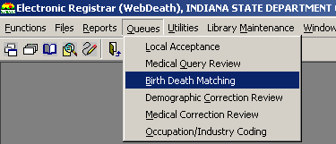

- The Birth Death Matching screen will open.
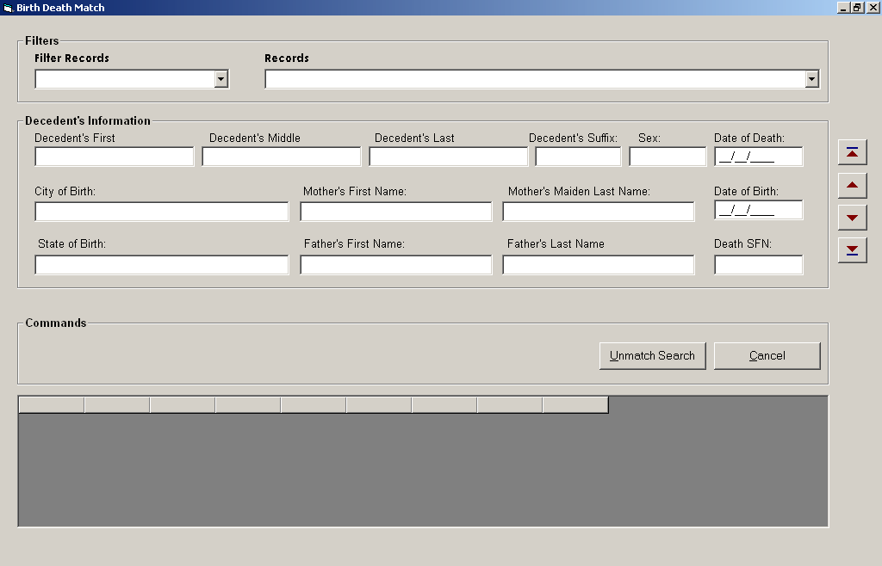

- Set the filter to the desired value:
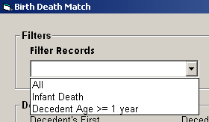

- The ‘Records’ drop-down list will populate with all unmatched records that meet the criteria selected in the filter.

- Select a record from the ‘Records’ drop-down list.

- The Decedent’s Information fields will load the record’s information, and the grid at the bottom of the screen will populate with the birth records that are potential matches for the record selected.

- Click on the correct birth record in the grid to highlight it.

- Click the MATCH button.

- The records will be matched, and the death record will be removed from the work queue.

- Click the [X] in the upper right-hand corner of the screen to return to the Death Menu screen.

Checking the Record Status
Because several circumstances can arise that affect the processing a record requires, a Record Status utility exists so that ISDH users can see what has or has not been completed for any records.

Checking the Record Status for Records With a Specific Issue
- From the Death Menu screen, click on the ‘Utilities’ option and select Record Status.
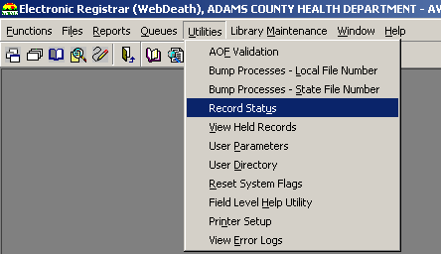

- The Record Status screen will open.
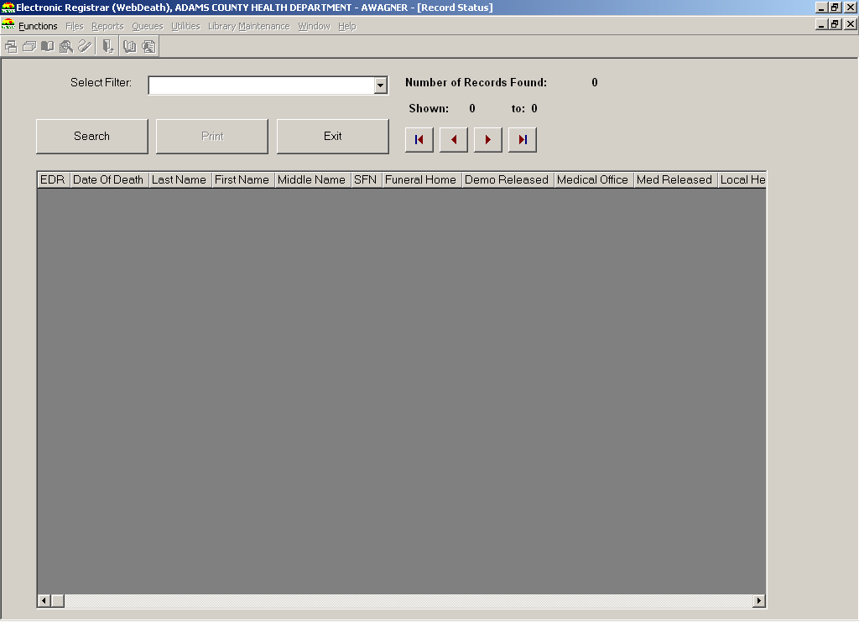

- Select the appropriate filter to view the type of incomplete records desired.
ISDH Choices include:
  - ACME/Transax incomplete
  - AOF Validation incomplete
  - Cause of Death not released
  - Cause of Death pending
  - GDE not released
  - Manner of Death pending
  - Medical release incomplete
  - Medical Query pending
  - NCHS Extract not sent
  - Possible duplicate
  - Query Review not released
  - SSA Fact of Death not sent
  - SSN Verification incomplete
  - Super Micar Extract not sent
  - Waiting for Batch Print
  - Search Result

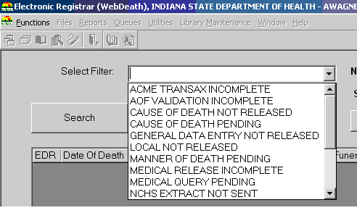

- The records matching the description selected in the filter will load into the screen, organized by date of death.
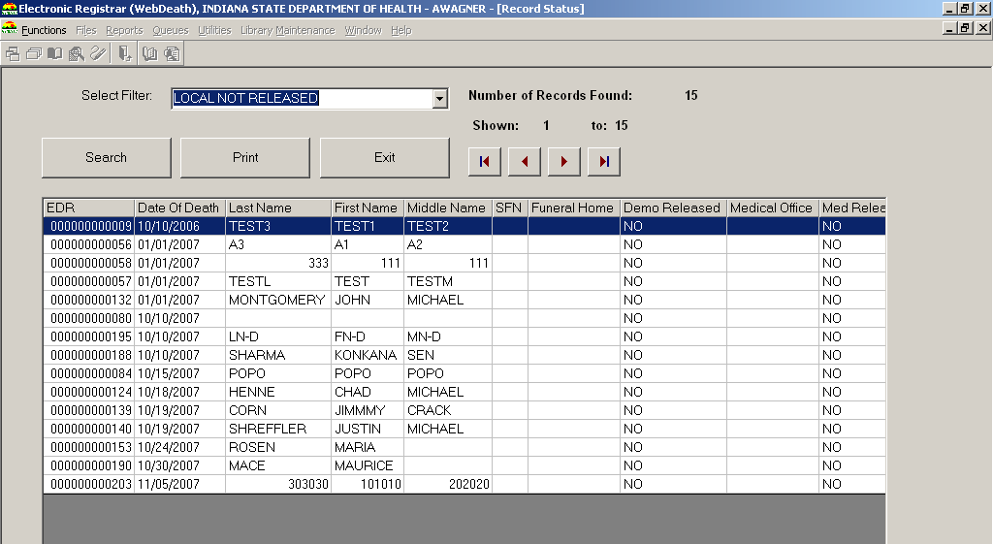

- By using the horizontal scroll bar at the bottom of the screen, users can see whether different processes are complete for each record.
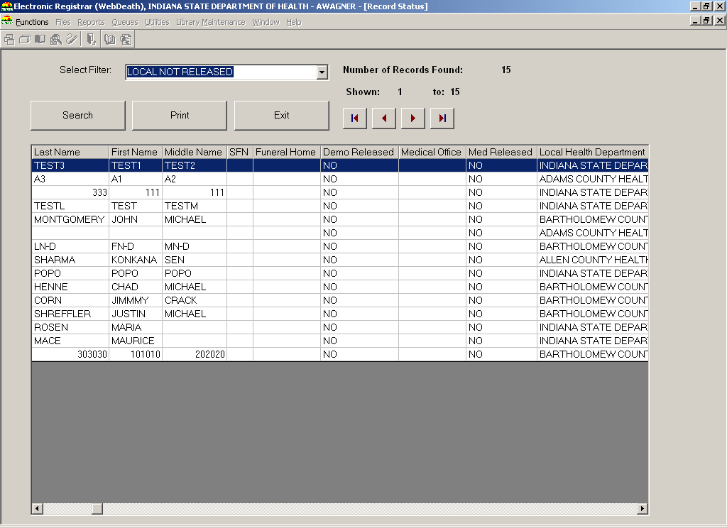

- Click the EXIT button to return to the Death Menu screen.

Checking the Record Status for a Specific Record or Group of Records

- From the Death Menu screen, click on the ‘Utilities’ option and select Record Status.

- The Record Status screen will open.

- Click the SEARCH button.

- The Search Screen will open.
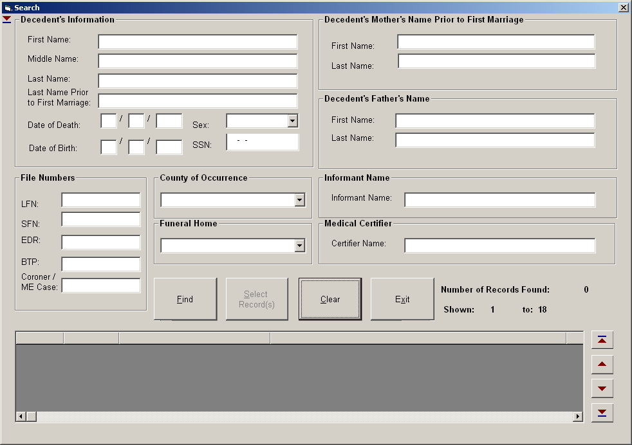

- Type the desired criteria in the search fields and click FIND.

- The record(s) that match the criteria will be displayed in the grid at the bottom of the Search screen.
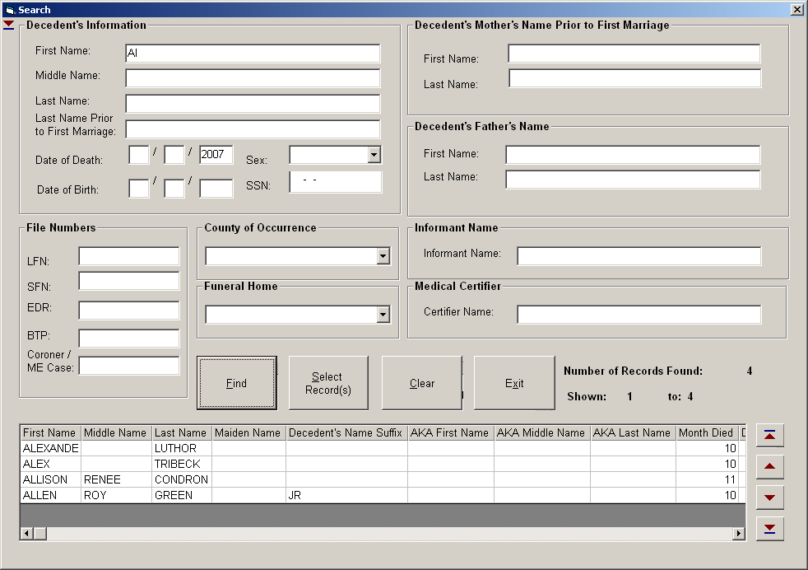

- Click on the desired record(s) to highlight them.

- Click SELECT RECORD(S) to open the record(s) in the Record Status Screen.
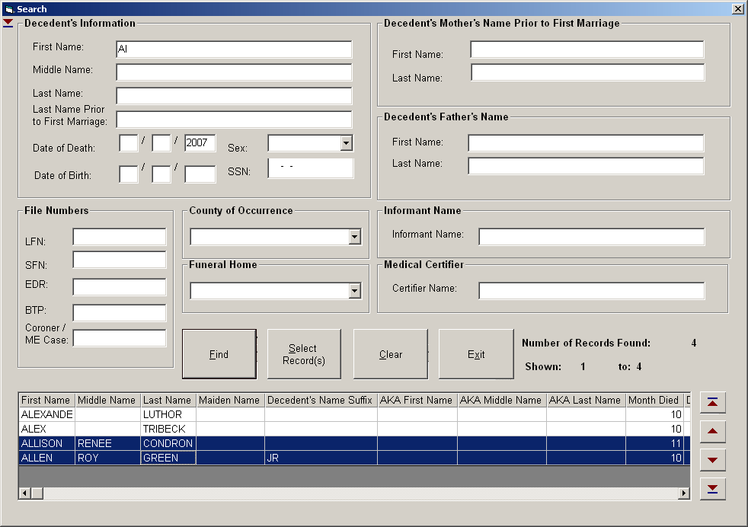

- The Records will be listed on the Record Status Screen in order by date of death.

- By using the horizontal scroll bar at the bottom of the screen, users can see whether different processes are complete for each record.
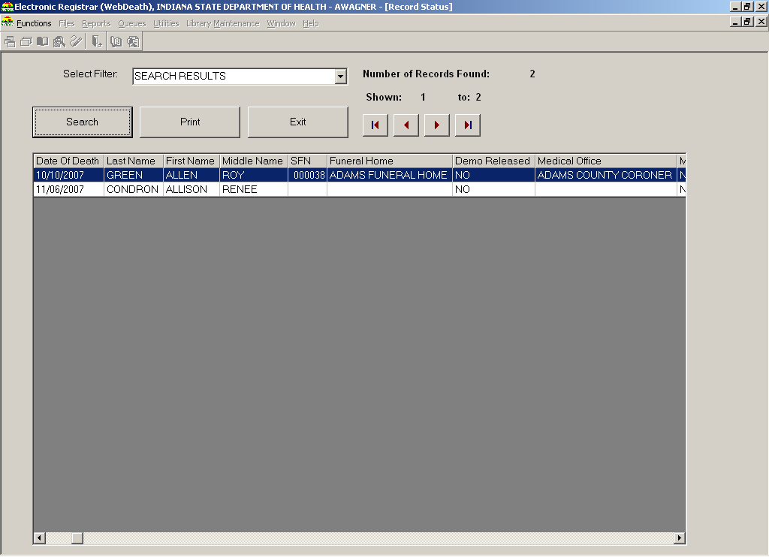

- Click the EXIT button to return to the Death Menu screen.

Performing Legal View Screen Functions
The Legal View Screen provides you with functionalities related to Customer Service and Issuance for eligible records. The system supports access to the following functionalities from the Legal View Screen:
  - Retrieving Records in Legal View Screen
  - Printing forms
  - Issuing Certificates
  - Performing Demographic Corrections
  - Performing Medical Amendments
  - Viewing Net Change History
  - Viewing AOF History
  - Viewing Issuance History
  - Viewing Record Flags
  - Setting or Removing Record Flags

It is important to note that a record must be retrieved to the Legal View Screen first, in order to use/apply the functionalities listed above.
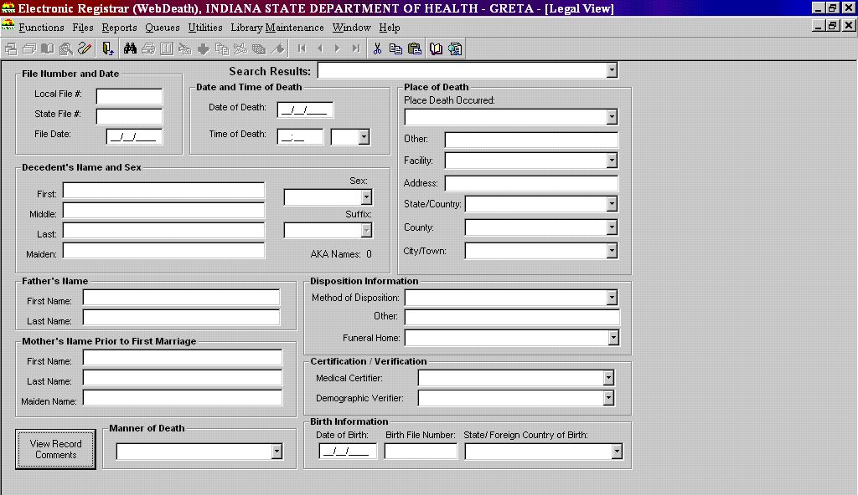
NOTE: Not all records available to the Legal View Screen will have all customer service and/or issuance processes available to them as the system will disable links based on the status of the record.

Retrieving a Record in Legal View Screen
- From the Death Menu, click on Legal View icon to access the Legal View Screen.
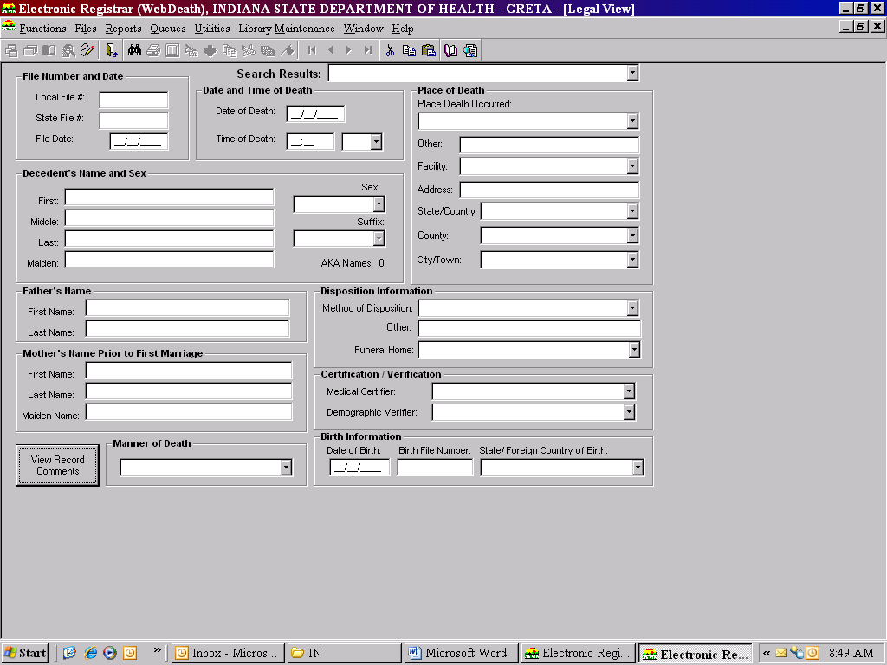

- Click on the Search icon to access the Legal View Search screen.
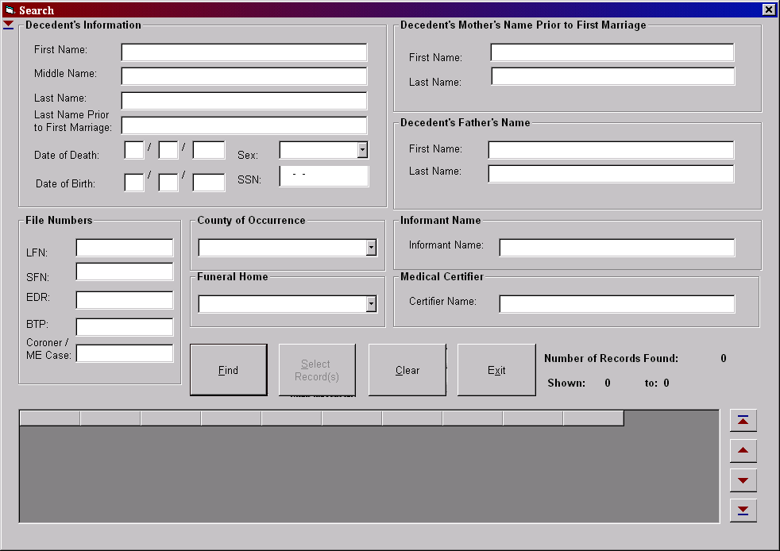

- Enter identifying information about the death record you wish to view and/or retrieve and click on the FIND button.
NOTE: More complete information entered into the search screen will generate faster searches and more accurate results. Using record specific fields like the LFN combined with the year of death can narrow the search to one record.

- Records that match the search criteria will be displayed in the record grid.
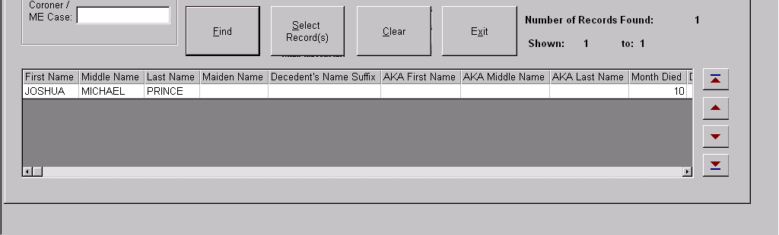

- Select the appropriate record from the grid (single-click to highlight) and click on the SELECT RECORD(S) button.

- The system will retrieve the record from the database and display it on the Legal View screen for viewing and/or processing.
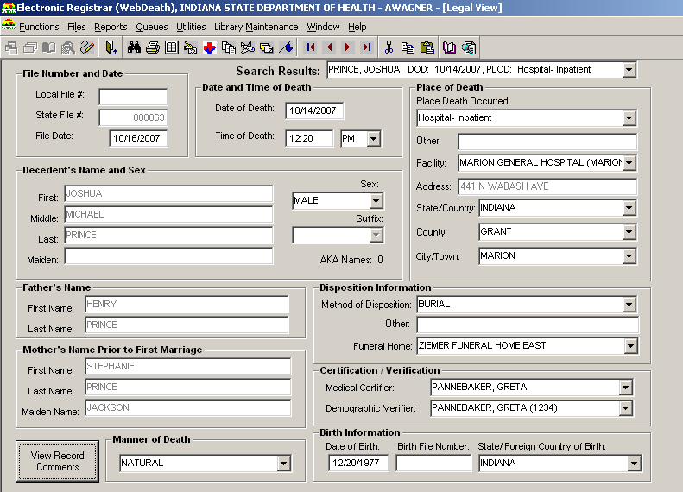

Printing Forms in Legal View Screen
The following forms are available to print from Legal View Screen:
  - Death Transcript
  - Authority to Cremate

- Please follow the steps to retrieve a record in Legal View Screen. See section Retrieving a Record in Legal View Screen.

- Click on the Print icon.

- Select the proper form to print.
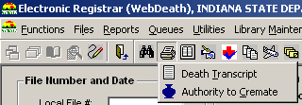

- The form will print on the printer specified in the Printer Setup utility.

Issuing or Printing Certificates
The Issuance Bridge function provides the means for authorized users to print certified copies of forms/certificates using the Issuance Bridge in the Legal View Screen.
The following certificates can be issued using the Issuance Bridge function:
  - No Record Found
  - Confidential Verification of Death
  - Death Abstract
  - Death Certificate

- Please follow the steps to retrieve a record in Legal View Screen. See section Retrieving a Record in Legal View Screen.

- Click on the Issuance Bridge icon to initiate the issuance process.

- Select from the list of certificate types to print.
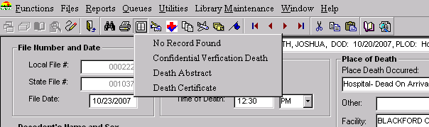

- The Issuance Bridge screen will display the window below:
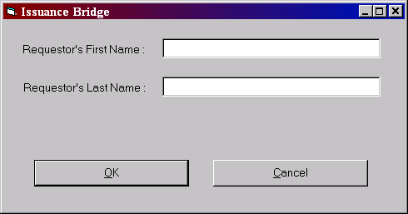

- Enter the Requestor’s Last and First Names (if available).

- Click the OK button to print the requested certificate to the printer specified in the Printer Setup utility.

Performing a Demographic Correction
The IDRS provides the ISDH user with ability to perform demographic corrections to eligible records on demand. Demographic Corrections pertain to modifications that are made to demographic items on a death record.
Demographic Corrections are recorded in the record’s Net Change History. If the user entering the change has the Enhanced Demographic Corrections security process, the correction will be immediately accepted. If the user does not have the Enhanced Demographic Corrections security process, the changes are not applied to the record until they are reviewed in the Demographic Correction Review process.

The following types of Demographic Corrections are available:
  - Authorization
  - Amendment
To perform a Demographic Correction please follow the steps below:
- Retrieve the record that requires a correction to the Legal View Screen using the Legal View Search. See section Retrieving a Record in Legal View Screen.

- Click on the Demographic Correction icon and select ‘Authorization’ or ‘Amendment’ as appropriate.
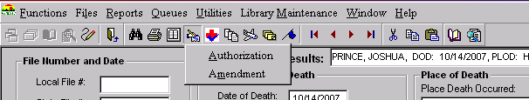

- The Corrections Screen will be displayed:
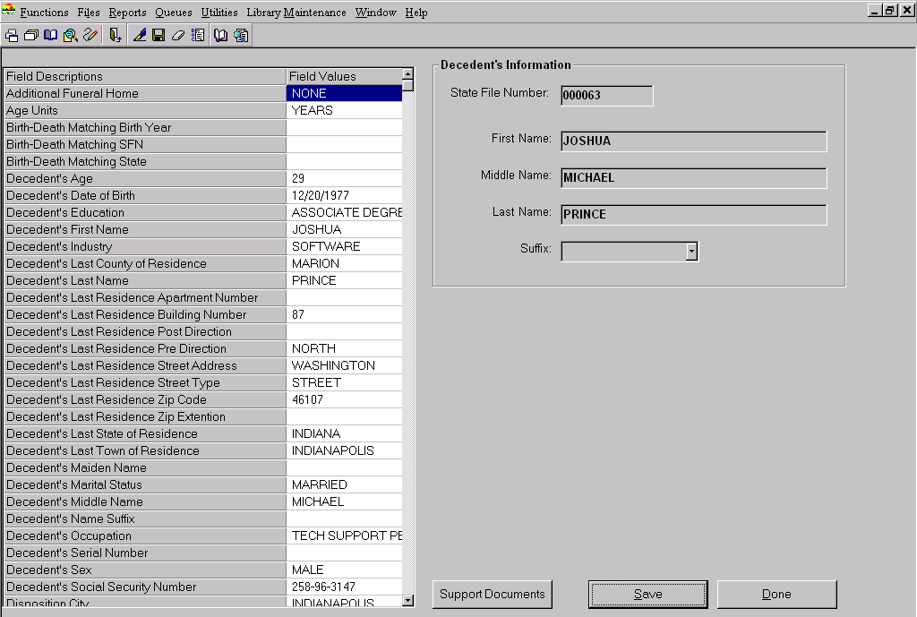
- Double-click on the field value to display the Field Edit frame and modify:
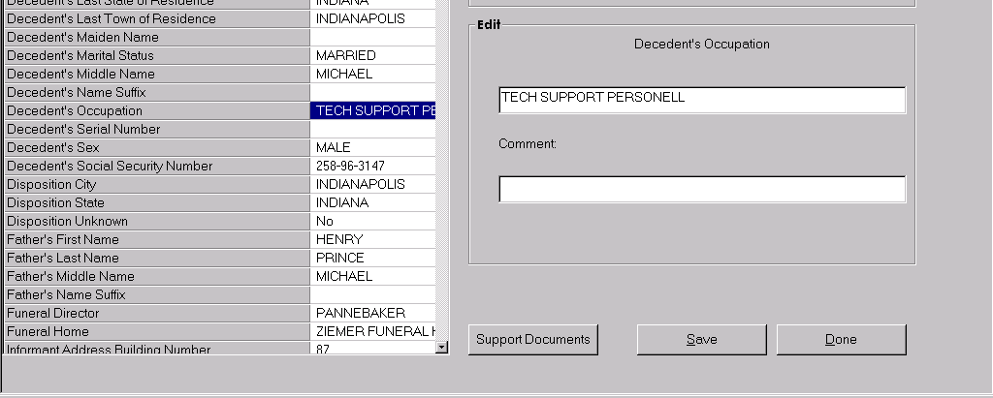
1. Double-click on Field Value
3. Add Comment
2. Edit Field

- Modify the applicable data and enter a comment in the Comment box (as needed).

- If supporting documents are available, click on the SUPPORT DOCUMENTS button to open the Document Control screen:

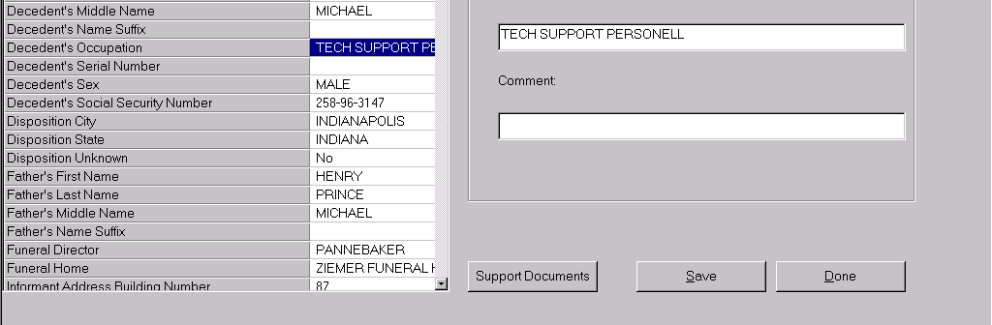

- Click on the ADD NEW button to add supporting documents for the current correction.
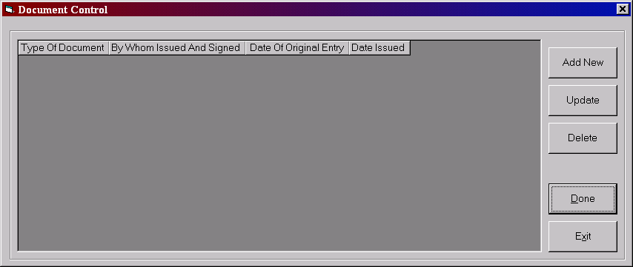
- This will open a data entry section for the Supporting Documents information:
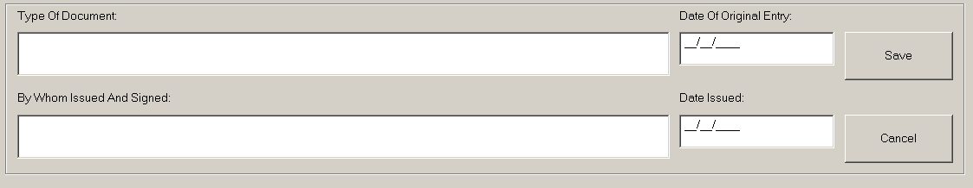

- Enter the applicable data in the fields provide and click on the SAVE button.
NOTE: You can add up to six (6) supporting documents for each correction session.

- Press the DONE button on the Document Control screen when you are finished entering the supporting documents.
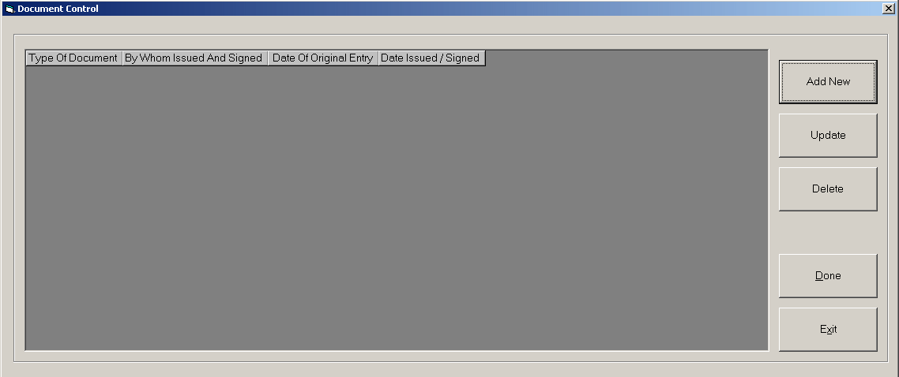

- Click SAVE and then DONE on the Corrections screen to apply the modification and complete the correction session.
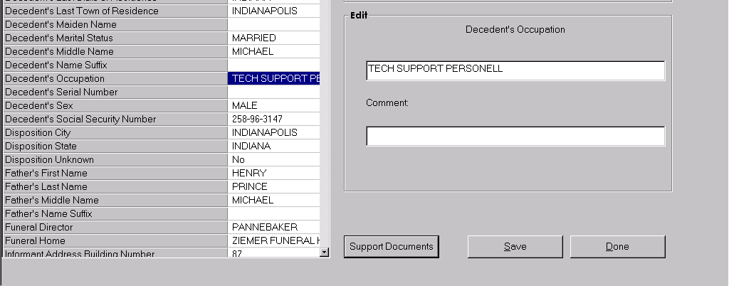

- The system will issue a correction session number to acknowledge that a correction has taken effect.
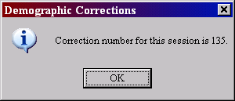

- Click on the OK button to close the Corrections screen and return to the Legal View Screen.

- If the correction is entered by a user without the Enhanced Demographic Corrections security process, it will not be applied to the record until it has undergone Demographic Correction Review. If the correction is entered by a user with the Enhanced Demographic Corrections security process, it will be accepted and two copies of the death certificate will print at the printer designated in the Printer Setup utility. One copy is to be filed at the LHD, the other at ISDH.

Performing a Medical Amendment
The IN EDRS provides the ISDH user with ability to perform Medical Amendments to eligible records on demand. Medical Amendments pertain to modifications that are made to Medical items on a Death record. Medical Amendments are recorded in the record’s Net Change History. If the user entering the change has the Enhanced Medical Amendment security process, the change will be immediately accepted. If the user does not have the Enhanced Medical Amendment security process, the changes are not applied to the record until they are reviewed in the Medical Correction Review process.

To perform a Medical Amendment please follow the steps below:
- Retrieve the record that requires a Medical Amendment to the Legal View Screen using the Legal View Search . See section Retrieving a Record in Legal View Screen.

- Click on the Medical Amendment icon found in the Legal View Screen menu.
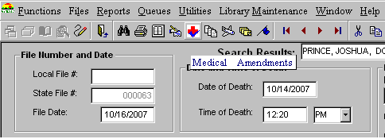

- Select ‘Authorization’ or ‘Amendment’ as appropriate from the menu that appears.
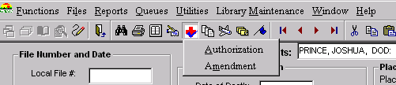

- The Medical Amendment Screen will be displayed.
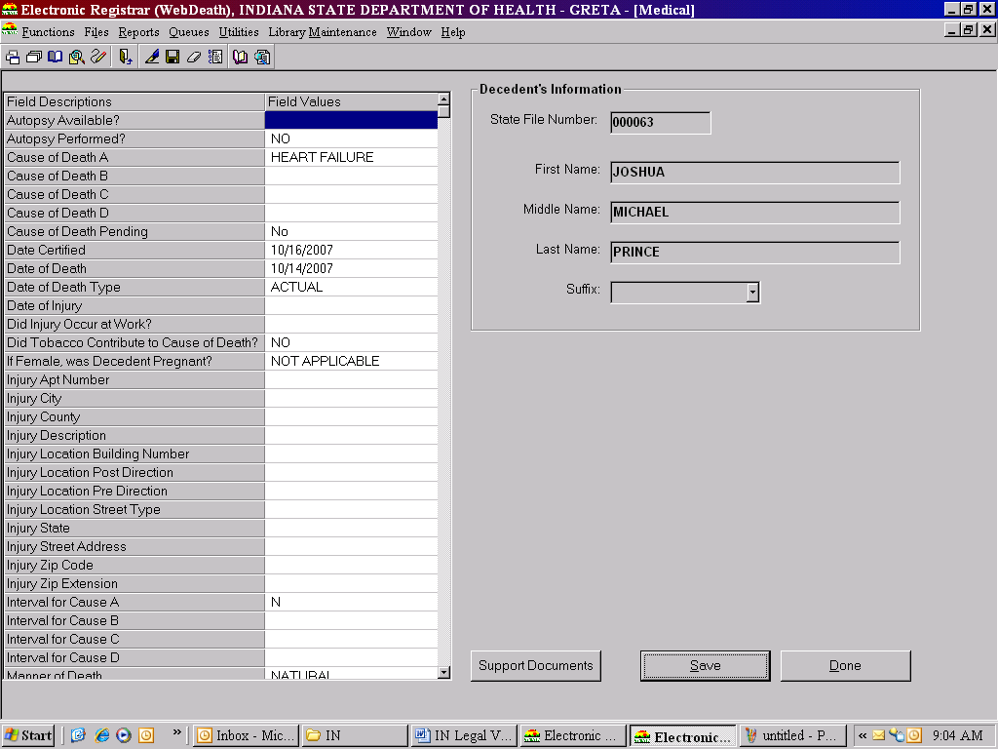

- Double-click on the field value that you would like to change to display the Field Edit frame and modify as appropriate.
2. Edit Field Edit
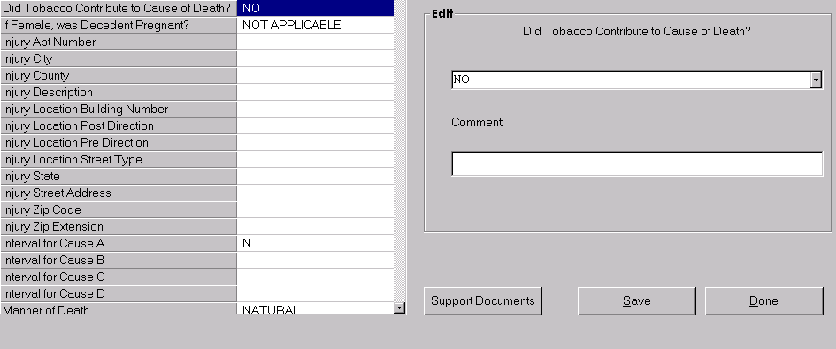
1. Double-click on Field Value
3. Comment Field

- Modify the applicable data and enter a comment in the Comment box (as needed). Then Click the SAVE Button to save changes.

- If supporting documents are available, click on the SUPPORT DOCUMENTS button to open the Document Control screen:
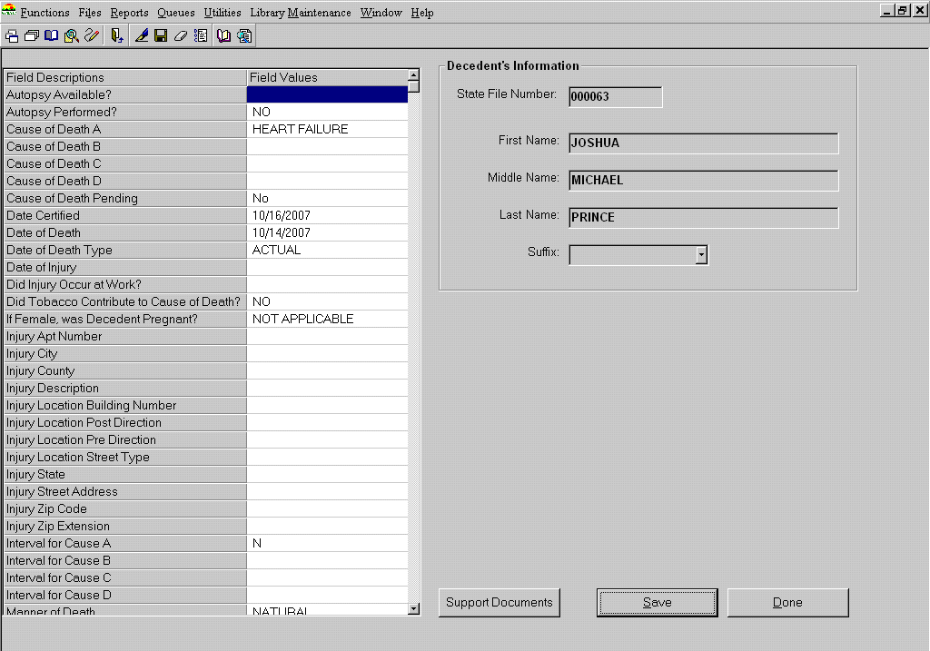

- Click on the ADD NEW button to add supporting documents for the current correction.

- This will open a data entry section for the Supporting Documents information:

- Enter the applicable data in the fields provide and click on the Save button.
NOTE: You can add up to six (6) supporting documents for each correction session.

- Press the DONE button on the Document Control screen when you are finished entering the supporting documents.

- Click SAVE and then DONE on the Medical Amendment screen to apply the modification and complete the correction session.

- The system will issue a correction session number to acknowledge that a correction has taken effect.
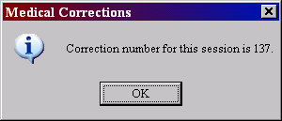

- Click on the OK button to close the Corrections screen and return to the Legal View Screen.

- If the correction is entered by a user without the Enhanced Medical Amendment security process, it will not be applied to the record until it has undergone Medical Correction Review. If the correction is entered by a user with the Enhanced Medical Amendment security process, it will be accepted and two copies of the death certificate will print at the printer designated in the Printer Setup utility. One copy is to be filed at the LHD, the other at ISDH.

Viewing a Record’s Net Change History
The Net Change History screen displays all demographic corrections and medical amendments performed on a record.

- To view a record’s Net Change History, please follow the steps to retrieve a record in Legal View Screen. See section Retrieving a Record in Legal View Screen.

- Once the record is retrieved in Legal View Screen, click on the Net Change History icon to view a record’s Net Change History.

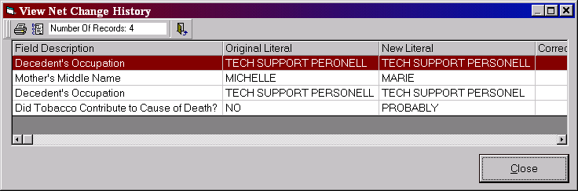

- Click on the CLOSE button to close the View Net Change History screen.

Viewing a Record’s AOF History
Records with library maintenance table entries that were ‘added on the fly’ (AOF) during the data entry process at facilities or during In House/Registration and were verified in the AOF Validation process at the ISDH are included in a record’s AOF History.

- To view a record’s AOF History, please follow the steps to retrieve a record in Legal View Screen. See section Retrieving a Record in Legal View Screen.

- Once the record is retrieved in Legal View Screen, click on the AOF History icon to view a record’s AOF History.

- Click on the CLOSE button to close the AOF History screen.

Viewing a Record’s Issuance History
A record’s Issuance History reflects details related to the issuance (printing) of certificates, including Requestor’s First and Last Name, Type of Certificate printed, UserID of the person who issued (printed) and the date/time the issuance was performed.

- To view a record’s Issuance History, please follow the steps to retrieve a record in Legal View Screen. See section Retrieving a Record in Legal View Screen.

- Once the record is retrieved in Legal View Screen, click on the Issuance History icon to view a record’s Issuance History.

- Click on the CLOSE button to close the Issuance History screen.

Viewing Flags Associated with a Record
Record Flagging refers to a process of marking a record to indicate a special circumstance. Each ‘flag’ is associated with a corresponding message and in some cases will cause the system to restrict some functions from being performed on the record (i.e. Issuance). The message associated with a given flag will appear on screen when a record is retrieved on the Legal View Screen or when you click on View Flag Comments.
- To view a record’s Issuance History, please follow the steps to retrieve a record in Legal View Screen. See section Retrieving a Record in Legal View Screen.

- Once the record is retrieved in Legal View Screen, click on the Record Flag icon.

- The Record Flags screen will open.
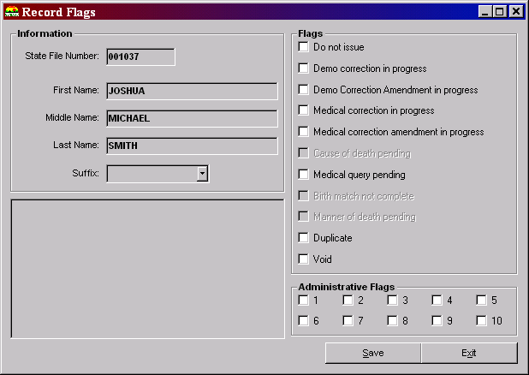

- Click EXIT to return to the Legal View Screen.

Setting or Removing a Record Flag
Many Record Flags are set automatically by processes throughout IDRS. For example, when a user prints a medical query letter, the ‘Medical query pending’ flag is automatically set. Most flags can be managed manually, as needed. For example, a user can manually turn off the ‘Medical query pending’ flag. Flags that cannot be managed manually will be locked (gray) when a user accesses the Record Flags screen.

- To set or remove a record flag, please follow the steps to retrieve a record in Legal View Screen. See section Retrieving a Record in Legal View Screen.

- Once the record is retrieved in Legal View Screen, click on the Record Flag icon to view a flags associated with the record.

- Click on the check box of each applicable flag to set or remove and enter comments as necessary.

- Click on the SAVE button to save your changes.

- Click on the EXIT button to exit the Record Flags screen.

Generating File Extracts, Exports and Imports
The following File Extracts, Exports and Imports can be generated from the IDRS by authorized users of the system:

NCHS Demographic Extract – LHD and ISDH
Microfiche Extract – LHD and ISDH

SuperMicar Export – Marion County LHD and ISDH
Acme/Transax Import - Marion County LHD and ISDH
SSA Fact of Death Extract –Marion County LHD and ISDH

ISDH Statistical Close Extract - ISDH
Interstate File Exchange Export – ISDH
Interstate File Exchange Import – ISDH

For detailed information about executing the SuperMicar Export and Acme/Transax Import, see the Performing Cause of Death Coding section of this document.

Generating an Extract, Export or Import File
To generate an extract, export or import, follow these steps:
- Click on the ‘Files’ menu option and select the appropriate file to generate:
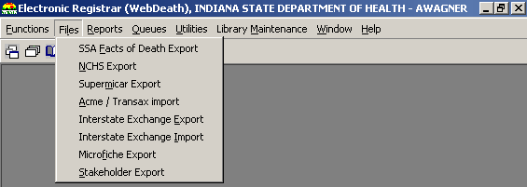

- A window will open that gathers the parameters for the file (for example the start date). Fill in the requested information and click the START or IMPORT button to create or import the file.

- The file will be available in the directory specified in the User Parameters utility. See the Locating an Extract, Export or Import File section for details.

Locating an Extract, Export or Import File
To locate an extract, export or import, follow these steps:
- From the Death Menu screen, click on ‘Utilities’ in the Death Menu and select User Parameters.
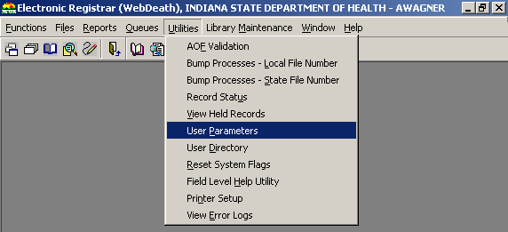

- The location (directory) of extract, export and import files are specified on the Parameters screen, in the Directories tab.
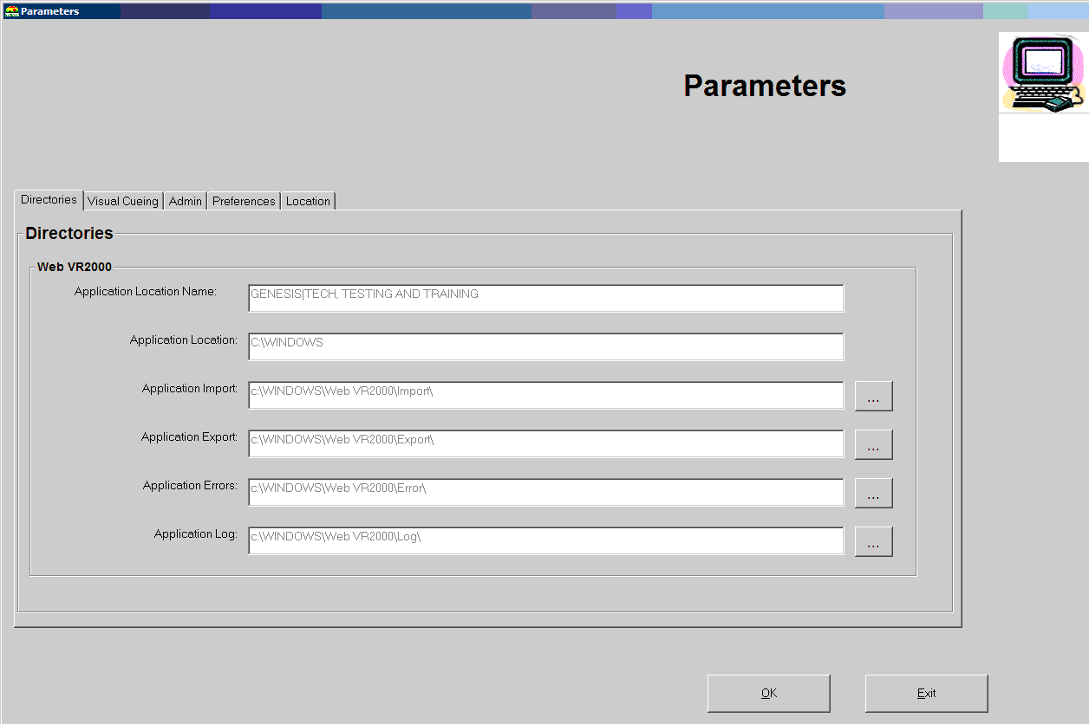

- If the paths are blank, or if you do not know how to retrieve the file, please see you local administrator.

Printing Reports
The following reports are available for printing using the IN EBRS at ISDH:
  - Death Index/ Quarterly Report of Deaths for the Auditor
  - Birth/Death Match Exception Report
  - Deaths by Residence County
  - Duplicate Records Resolution Report
  - Missing SFN Report
  - Out of State Abstract –Natality
  - Out of State Abstract –Residence
  - Out of State Listing – Natality
  - Out of State Listing – Residence
  - Rare Cause Listing
  - Sex/Age Cause Edit Listing
  - SSN Verification Report
  - Unresolved or Abandoned Records
  - Void (SFN) Listing Report

To Print a Report, follow these steps:
- From the Death Menu screen, click on the ‘Reports’ option and select the desired report.
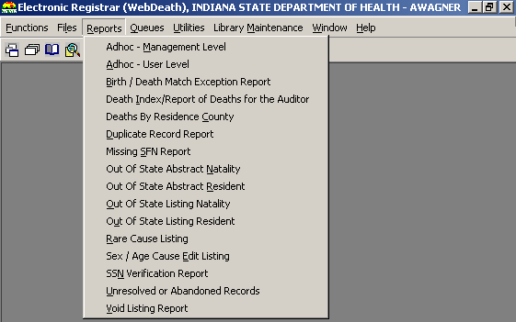

- If parameters need set (like a date range for the report), enter the data in the pop-up box.

- The system will display the report in Print-Preview mode.

- Click on the Print Icon found on the top left corner of the screen.
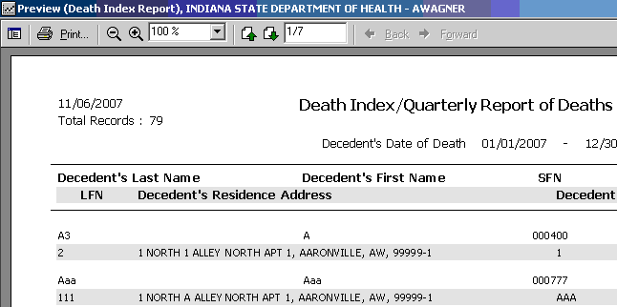

- Click on OK to print.
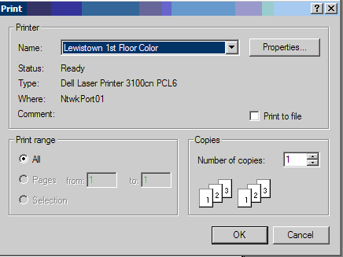

- The report will print at the printer specified in the Printer Setup utility.

Performing Occupation/Industry Coding
Occupation/Industry Coding applies three digit, numerical codes to decedents’ occupations and industries.

To perform Occupation/Industry Coding:
- From the Death Menu screen, click on the Queues menu and select Occupation/Industry Coding.
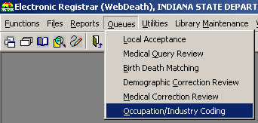

- The Industry/Occupation Coding screen will open.

- Select the county that the desired records originate in from the County drop-down list.
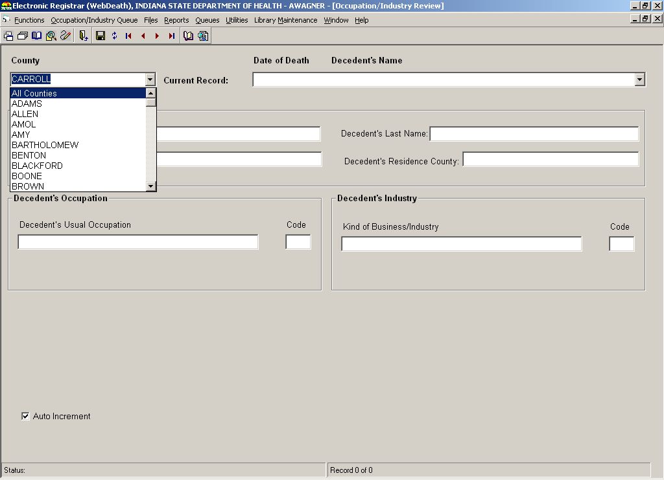

- Select the desired record from the Current Record drop –down list.
NOTE: Records are organized by date of death. Decedent’s first and last names are also listed.
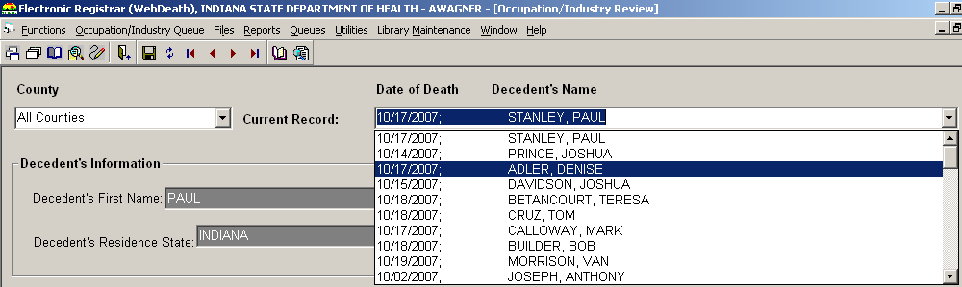

- The record selected will load into the Decedent’s Information fields.

- Type the appropriate occupation code in the Code field in the Decedent’s Occupation frame.

- Type the appropriate industry code in the Code field in the Decedent’s Industry frame.
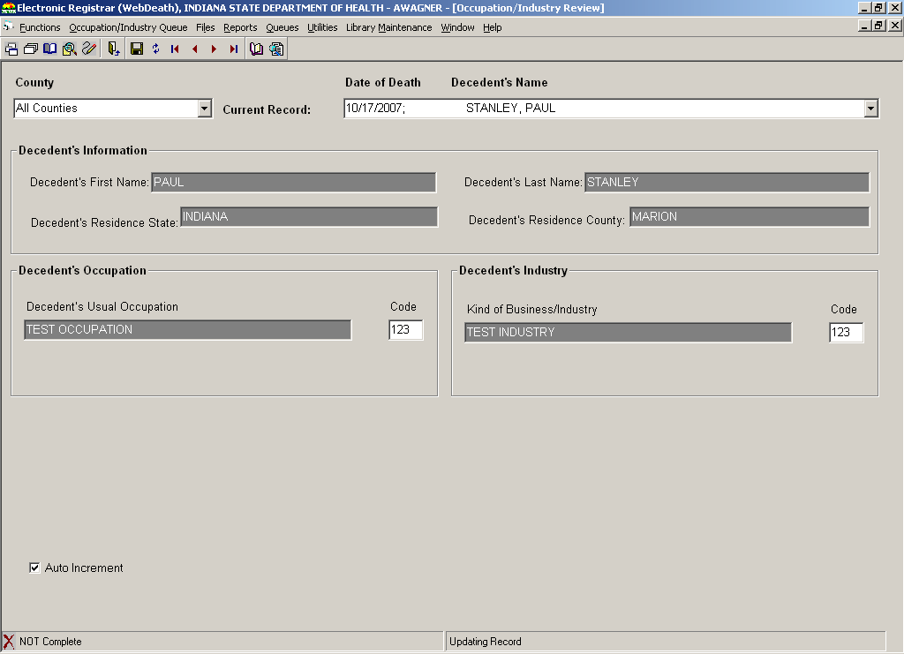

- Click the Save icon in the toolbar.

- The message ‘Would you like to mark this record as complete?’ will display.

- Click YES.

- The record will be removed from the Current Record queue, and the next record will load into the Decedent’s Information fields.

- Click the lower [X] in the upper right-hand corner of the screen to return to the Death Menu screen.

Performing Overrides
The override processes exist to address scenarios where a record has passed ownership to an entity that should not possess it at that time. Overrides are a separate security process that must be a part of someone’s security profile before he/she can execute them.
NOTE: No overrides are possible once a record has been assigned a State File Number.

The following types of overrides are available in IDRS:
  - De-Verify Demographic
  - De-Certify Medical
  - Relinquish Funeral Home Ownership
  - Redesignate Medical Certifier
  - Redesignate Local Health Department

De-Verify removes the verification performed by a participating Funeral Home.
De-Certify removes the certification performed by a participating Medical Certifier.
Relinquish Funeral Home Ownership de-verifies the record (if necessary) and removes the Funeral Director and Funeral Home information from the record. The original funeral home will no longer have access to the record in their work queue.
Redesignate Medical Certifier de-certifies the record (if necessary) and removes the certifier type, certifier office and certifier ID information from the record. The original medical certifier’s office will no longer have access to the record in their work queue.
Redesignate Local Health Department removes the local release from the record (if necessary) and removes the LHD designation, the Local File Number and the file date from the record.

Overriding a Record
The De-certify Medical, De-verify Demographic and Relinquish Local Health Department processes are available in General Data Entry for records that have NOT been assigned a State File Number.

The Relinquish Funeral Home Ownership and Redesignate Medical Certifier processes are available in General Data Entry for records that have NOT been assigned a Local File Number or State File Number and that have not been dropped to paper.

To perform an override:
- From the Death Menu screen, click on the General Data Entry icon.

- The General Data Entry screen will open. Select the record that needs De-Certified or De-Verified from the work queue.
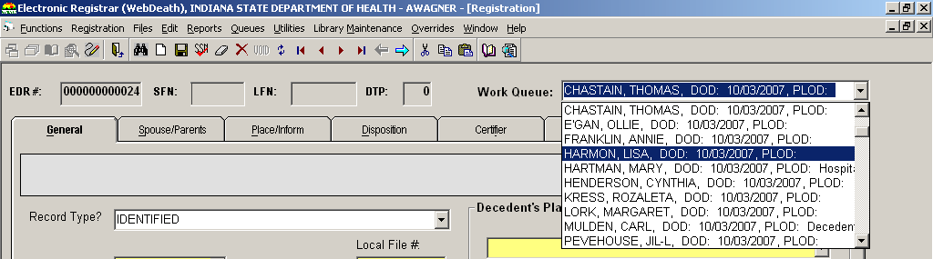

- The selected record will load into the data entry fields, and the Overrides menu will become enabled.
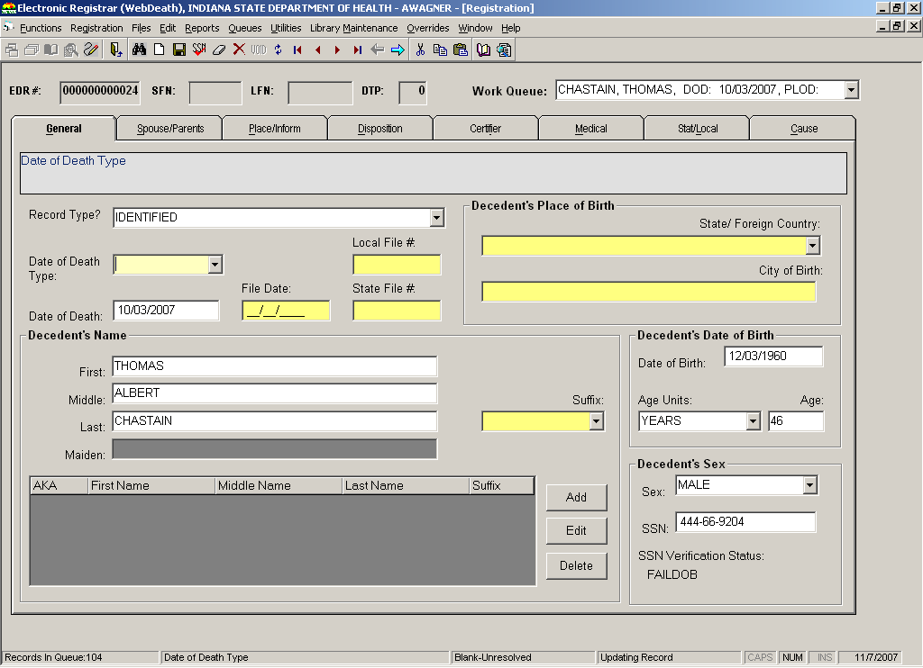

- Click on the Overrides option in the menu and select the appropriate override.
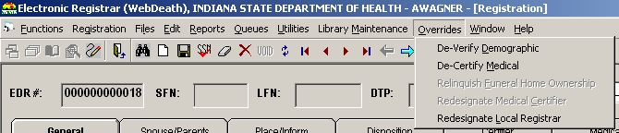

- One of the following messages will be displayed:
  - If De-Verifying, the system will warn that De-Verify will clear Demographic Release and that record ownership will pass back to the Funeral Home.

  - If De-Certifying, the system will warn that De-Certify will clear Medical Release and that record ownership will pass back to the Medical Certifier.

  - If Relinquishing Funeral Home Ownership, the system will warn that Relinquish will clear Medical Release and remove the Funeral Home information from the record. The record will need to be picked-up by a new funeral home.

  - If Redesignating the Medical Certifier, the system will warn that Redesignating will clear Medical Release and remove the Medical Certifier’s information from the record. The Funeral Director will need to designate a new medical certifier.

  - If Redesignating the Local Health Department, the system will warn that the record will be removed from the LHD’s work queue.

- Click YES.

- The message ‘Record Update Successful’ will display.

- Click OK.

- One of the following will occur:
- If De-Verifying, the record will be available in the funeral home’s work queue and will need to be Re-Verified before it can be processed at the LHD.

- If De-Certifying, the record will be available in the Medical Certifier’s work queue and will need to be Re-Certified before it can be processed at the LHD.

- If Relinquishing Funeral Home Ownership, the record will need to be picked-up by a new funeral home. The new funeral home will complete demographic data entry as necessary and verify the record before it can be released to the LHD or Medical Certifier as appropriate.

- If Redesignating the Medical Certifier, the Funeral Director will need to designate a new medical certifier (and drop to paper if the new medical certifier is not participating). The new medical certifier will need to complete medical data entry and certify the record before it can be released to the LHD.

- If Redesignating the Local Health Department, the record will be available in the funeral home’s work queue. It will need to have a new LHD designated on the record before the record can be released to the new LHD.

