Click on https://www.in.gov/access/
Or Enter above URL in your browser to see below screen.

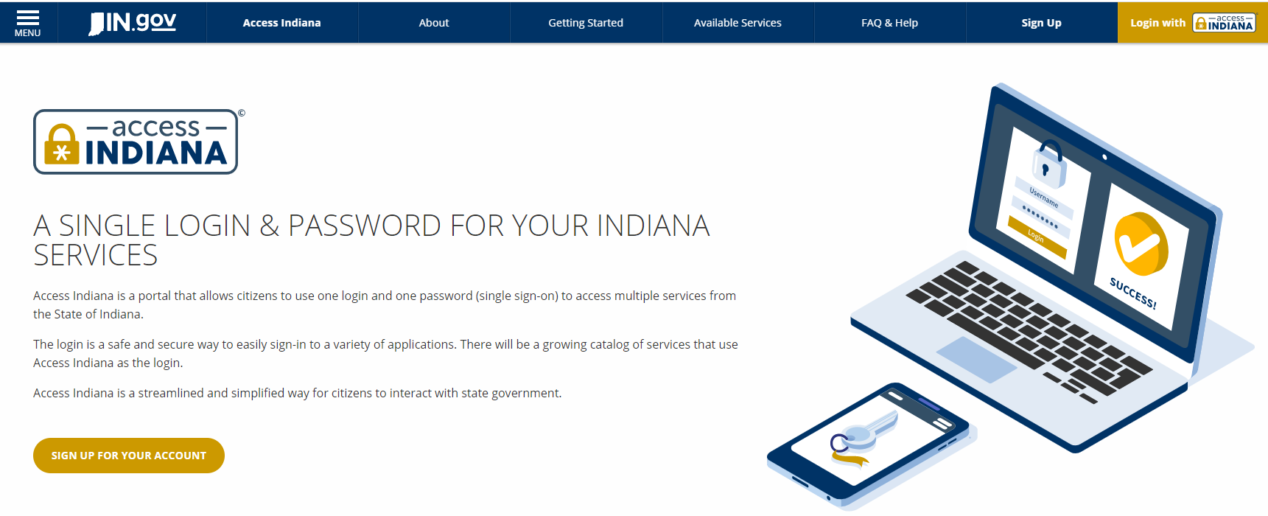

Then, click “Sign up for your account button” at bottom left of the screen.
Enter the email address and click on ‘Send Verification code’ button.
Follow instructions on the right side of the screen.
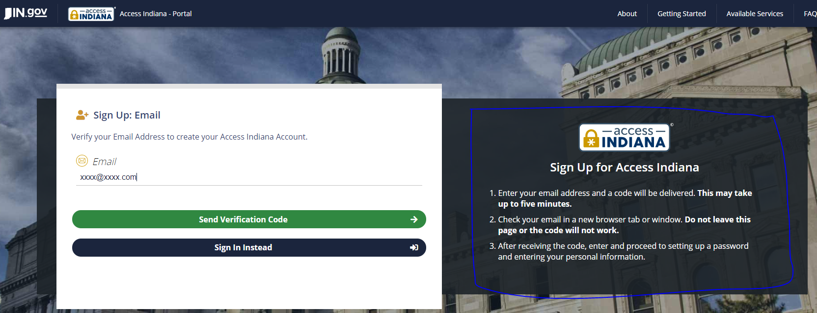
You will see below screen up on clicking ‘Send Verification Code’ button:
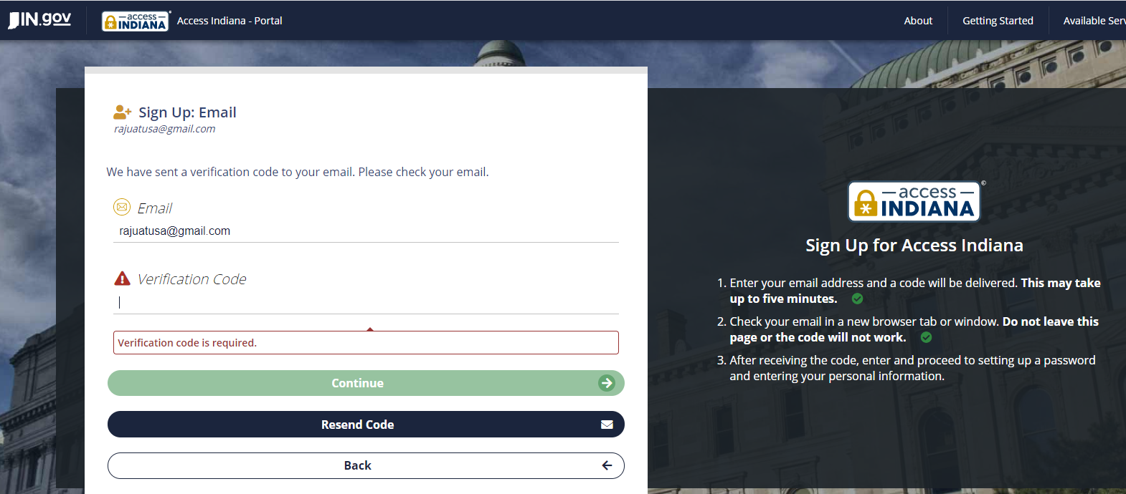
Enter the Code you received in the email. Check Spam/Junk email box if you don’t see in inbox folder.
Create the Password and click on Continue ( Please remember the password you enter).
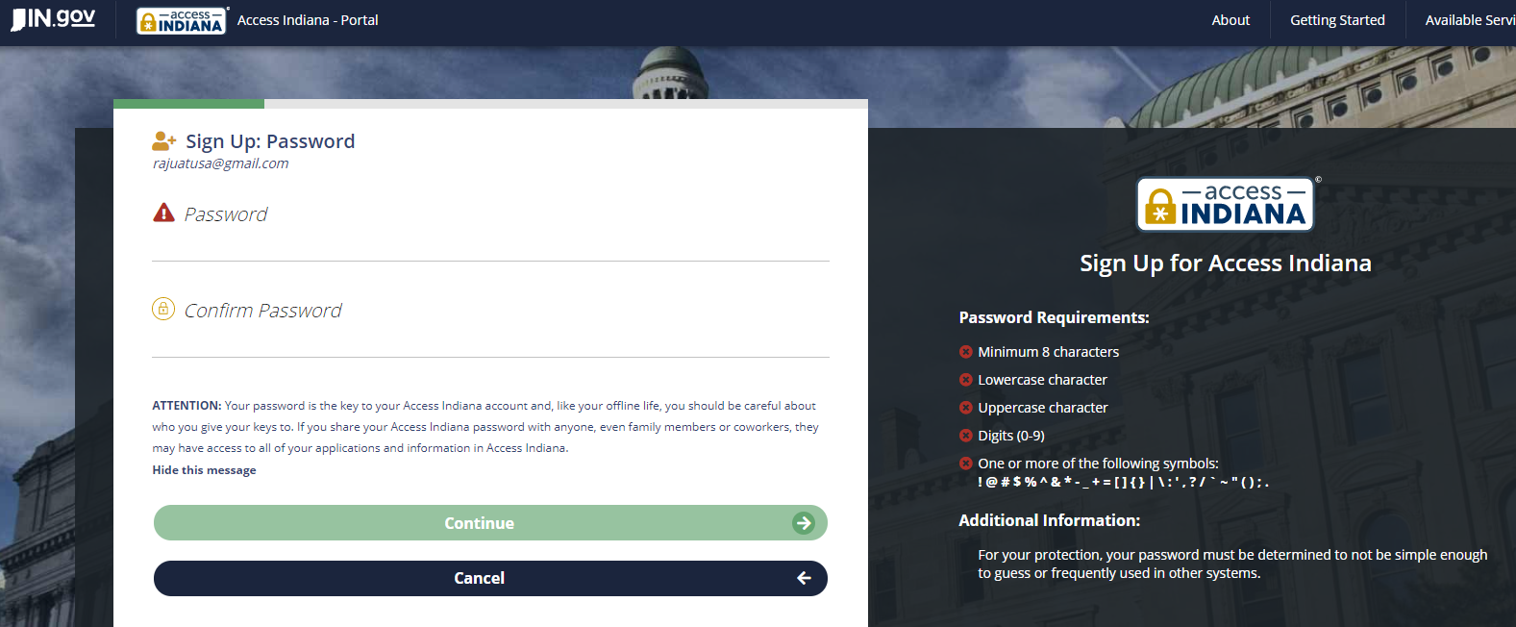
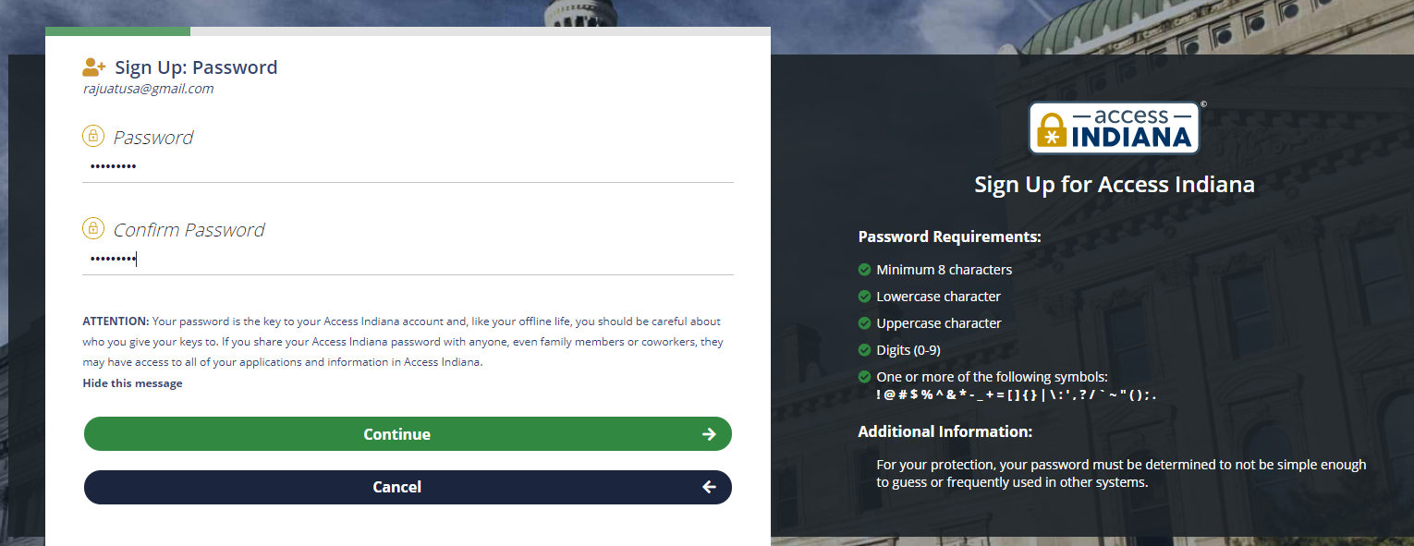
Click on Continue button to see below screen:
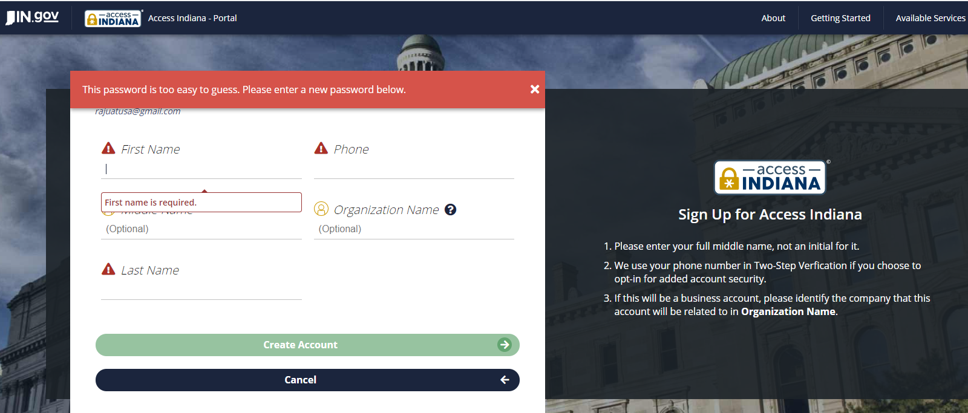

Enter all required fields and click on ‘Create Account’ button. You will see below page to select next option:
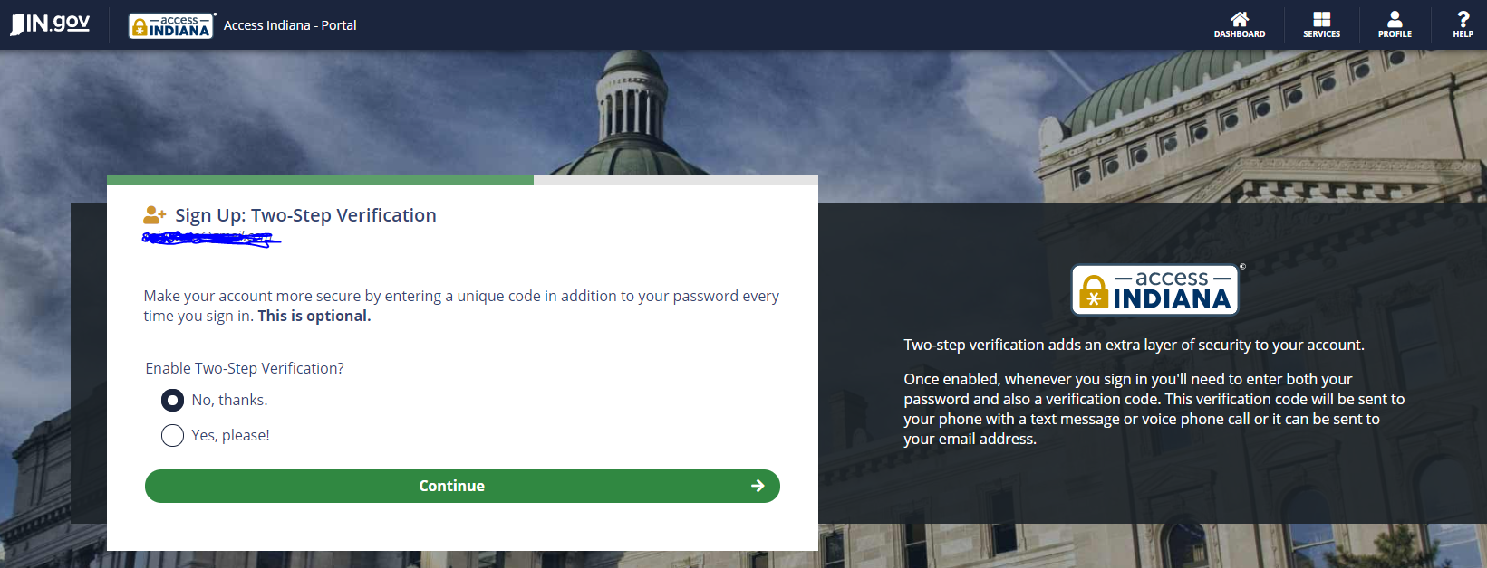
Select Yes if you want to add additional layer of security (Two step verification with your phone number), select No, Thanks if you don’t want. Then click on Continue button.
You will see Recovery Email option at below screen:
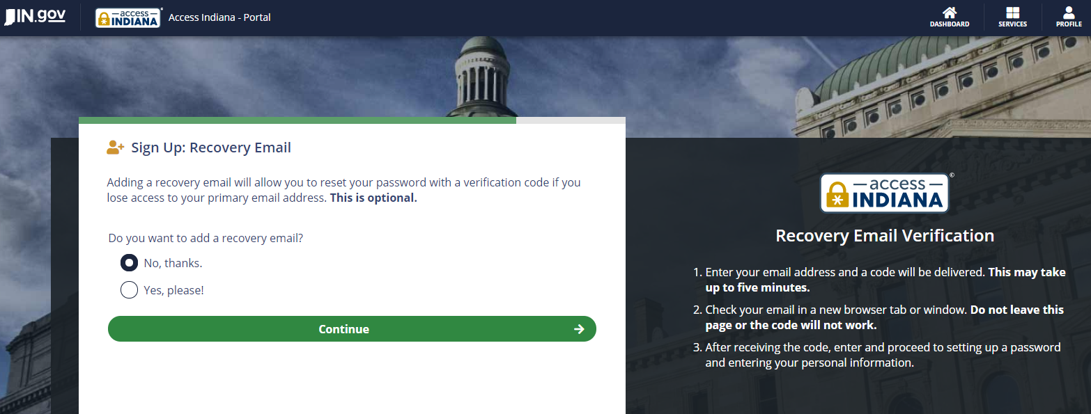
Select Yes, Please if you want to add Recovery email id else No, Thanks and click on continue button.
You will see below screen with account creation :
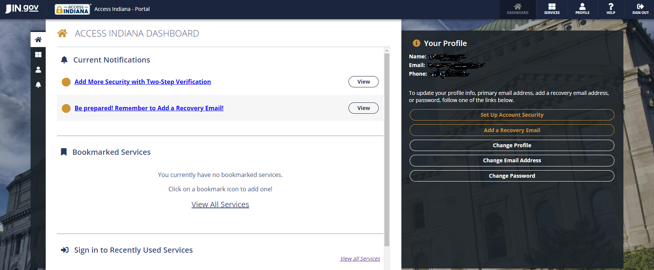
Click on 4 squares Icon on left side of the screen. See the below screenshot for details. And enter ‘Drive’
In the Search box.
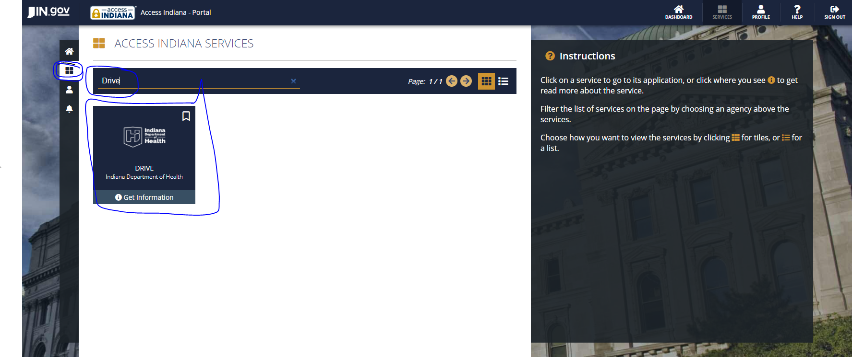
Then click on DRIVE bookmark to start your Enrollment form. Enter the keywords to see your facility name.
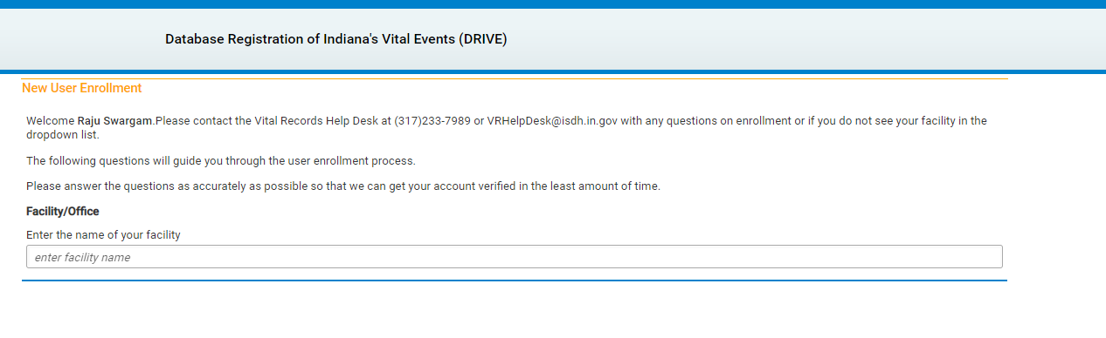
Next you will be asked a question if you are a Medical Certifier y/n
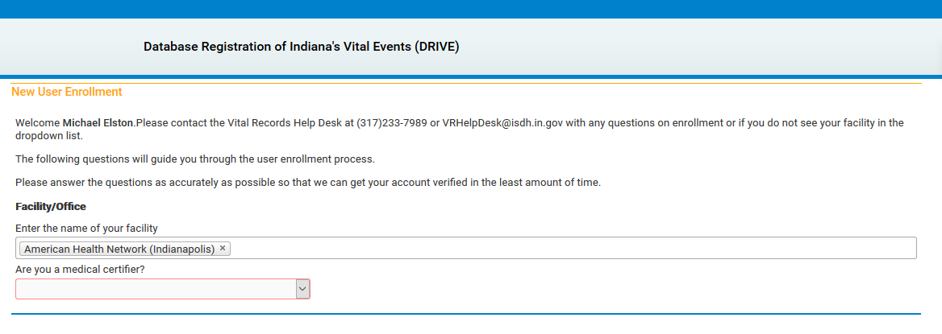
Fill the form and click on Save button.
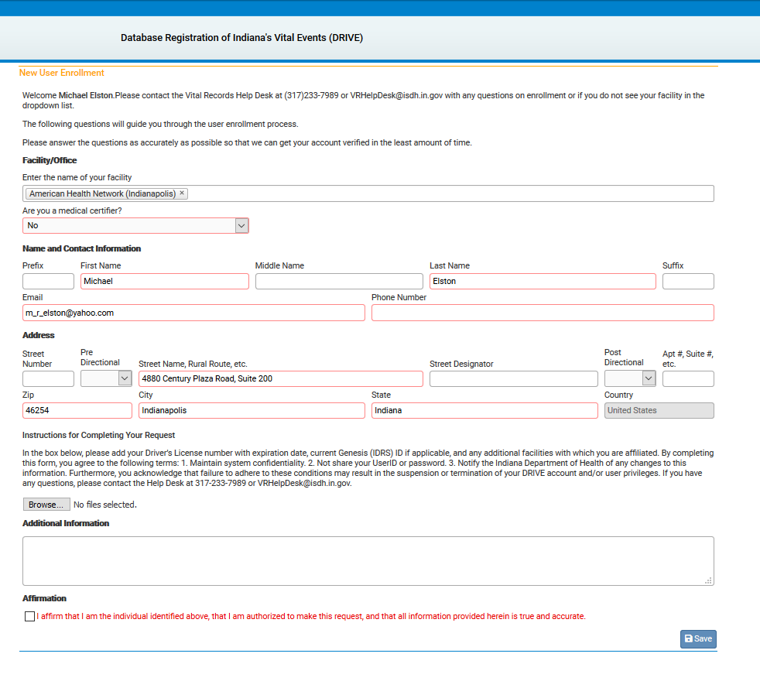
If signing up with a personal email please upload a copy of your Driver’s License for verification. See Highlighted sections below
