Guides

Looking Up A Contract in Document Management
- Go to Purchasing WorkCenter > Go to SCM tab > Documents Management
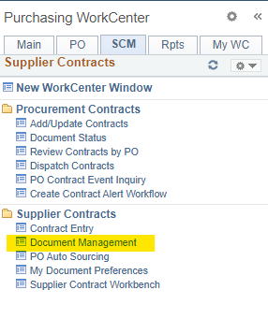
- Once you click on Document Management, click on Find an Existing document on the right side of the page.
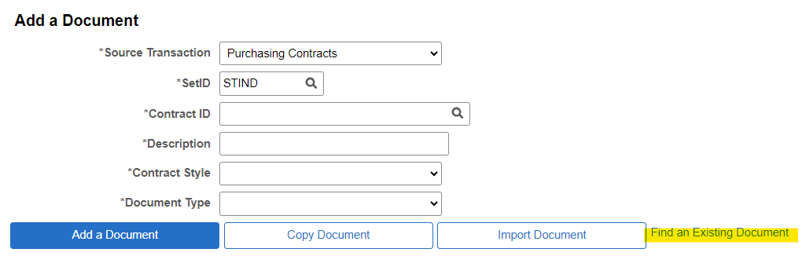
- Insert the SCM # you are working on under Contract ID and click search:
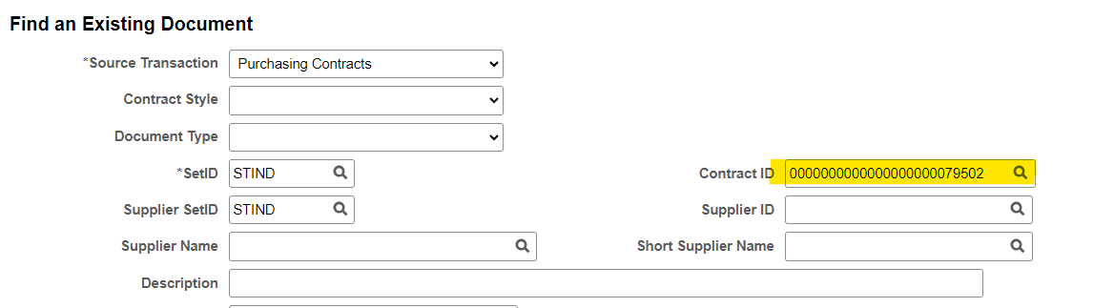
- Click on the blue hyperlink containing the SCM # on the bottom of the page:
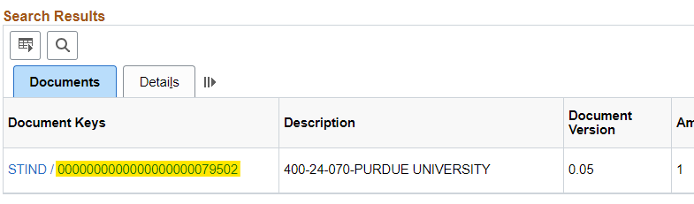
- Click View Original Document to see the original contract or View Amendment File button to look at the newest amendment to the contract.
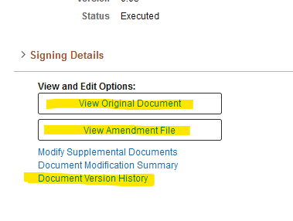
- Click Document Version History
  - The Document Action shows you any actions that have been made so you can see approvals, if something has been revised, or when it was executed.
  - If you click the paper clip icon it shows the attachments for the contract, original and amendments.
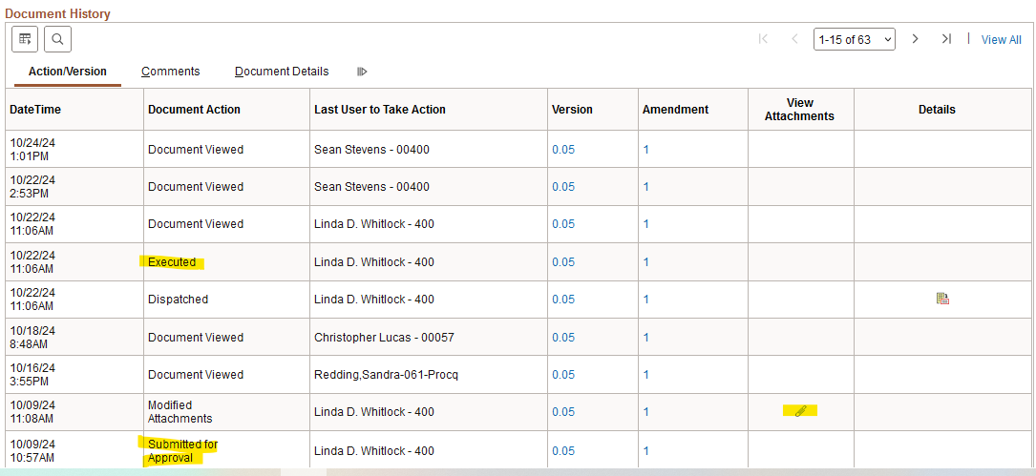

Look Up Requisition Number
- Go to Purchasing WorkCenter > Go to PO tab > Manage Requisition
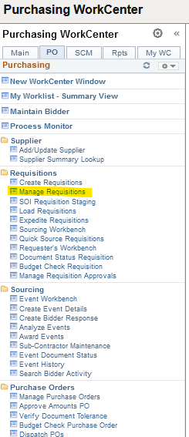
- Enter the Business Unit & REQ ID
  - You can remove the dates, change the drop down menu, look up by just business unit & REQ Name, etc. to find what you’re looking for
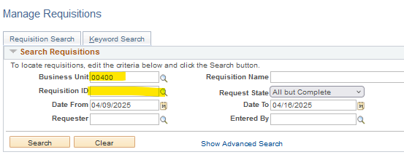

- Your search pulls up REQ’s & you have different things you can look at:
  - If you click ‘Requisition’, it pulls up the description, amount, funding, etc.
  - If you click ‘Approvals’, it pulls up the approval chain so you can see who it is pending with/who has approved.
  - If ‘Purchase Order’ is colored in then you can click this to find the PO # tied to that REQ.
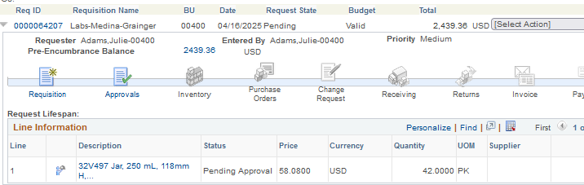

Look Up Purchase Order Number
- Go to Purchasing WorkCenter > Go to PO tab > Review PO Information
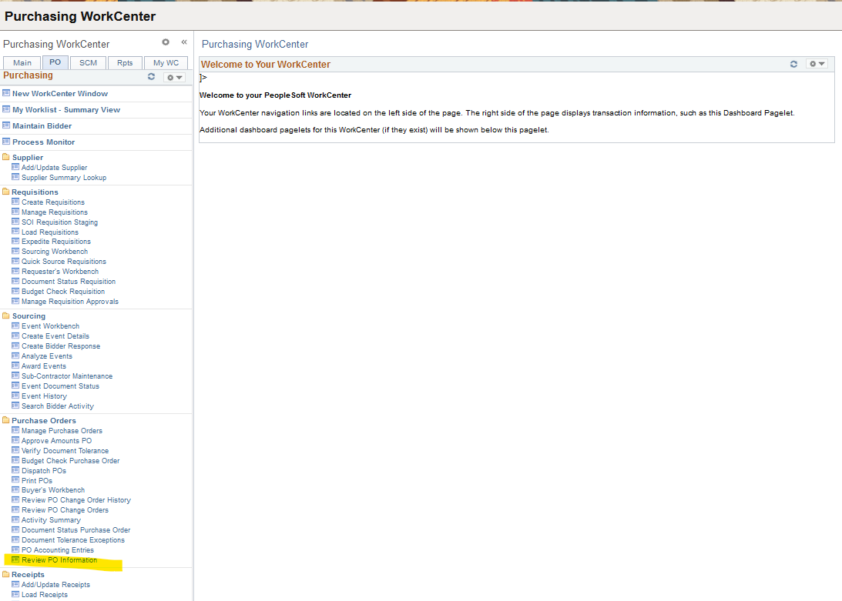
- Change the Contracts ID drop down option to ‘Contains’ and insert the Contract ID (SCM #). Click Search.
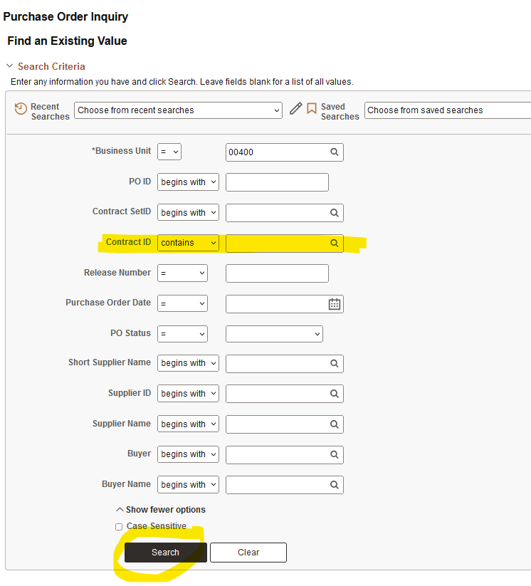
- You’ll scroll down & there will be lines for any purchase orders tied to that contract.
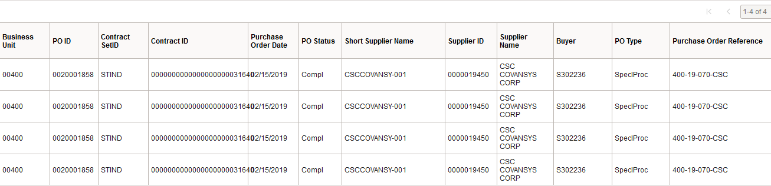
- You’ll click the most recent line and this will bring up the purchase order page showing the PO lines & their descriptions, encumbrance balance (how much is remaining on the PO), and the status of each PO line.
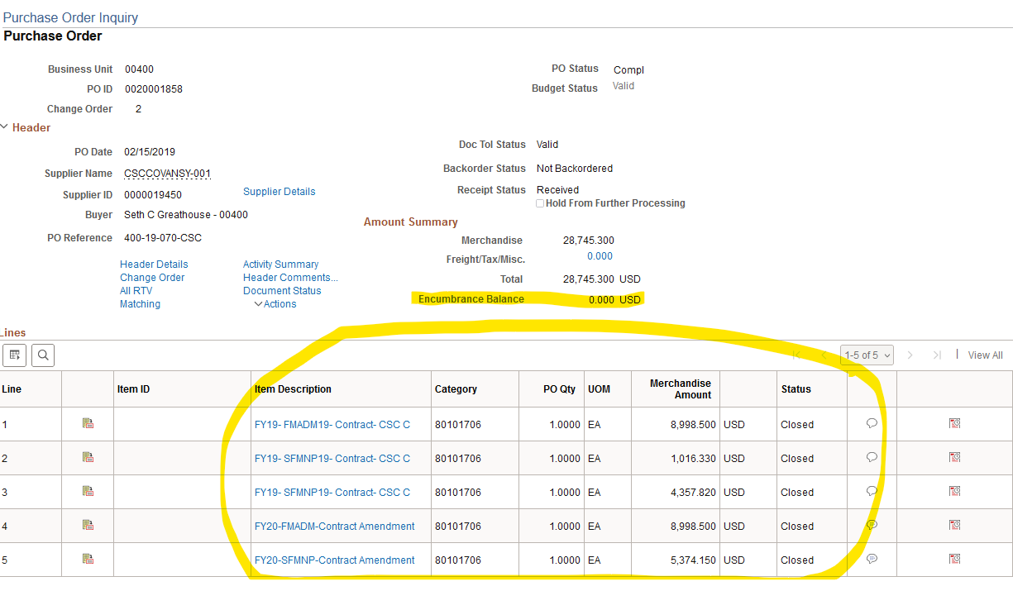

Look Up Supplier & Bidder ID
- Go to Purchasing WorkCenter > Go to PO tab > Supplier Summary Lookup:
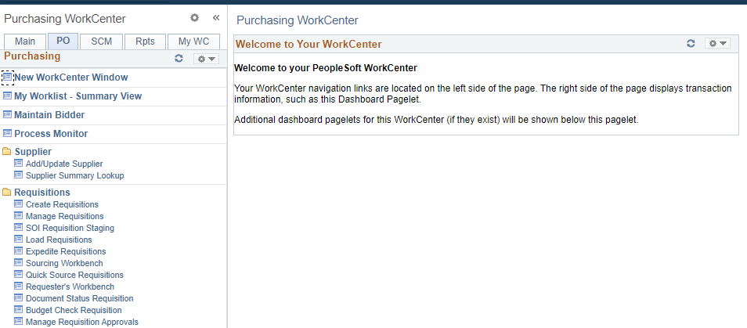
- Enter the EIN in the Taxpayer ID field & click Search:
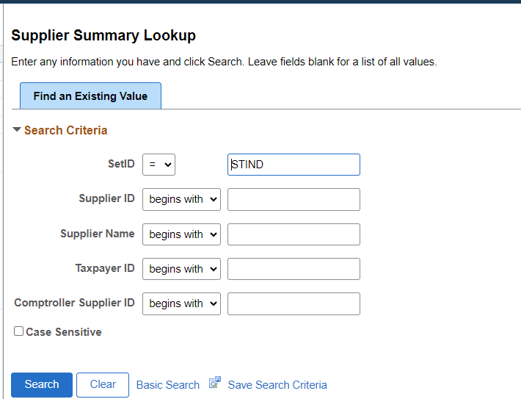
- Locate the Supplier ID and Bidder ID. The Supplier ID should be entered as the AOS Supplier ID on the RFC form and the Bidder ID should be entered as the IDOA Bidder ID on the RFC form. Take note of the supplier status, it should be in approved status.
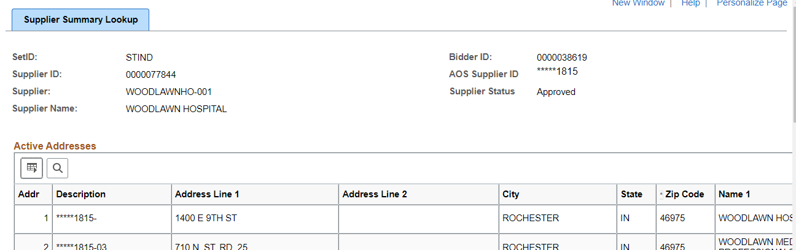

NOTES
- When EIN is entered and no results are shown, double check to make sure the EIN was entered correctly. If the EIN provided is correct and no results are shown, the supplier does not have a supplier file and will need to submit a W-9 and direct deposit form to the Comptroller’s Office.
- If there is no bidder ID provided, the supplier will need to go to the IDOA Bidder registration site and register for a bidder ID. https://www.in.gov/idoa/procurement/supplier-resource-center/requirements-to-do-business-with-the-state/bidder-profile-registration/
- If the supplier file is in INACTIVE status, the supplier will need to submit a W9 and direct deposit form to the Comptroller’s Office to reactivate the file.
- The Comptroller’s Office only accepts W-9 and direct deposit forms from State agencies/programs. The supplier will need to provide completed forms for the program they are doing business with for submission. The program will need to submit forms to the Comptroller’s Office via ENCRYPTED email to Suppliers@comptroller.in.gov

