- During the same period in 2019 (January – December), there was a 41% increase in drug overdose deaths in 2020.
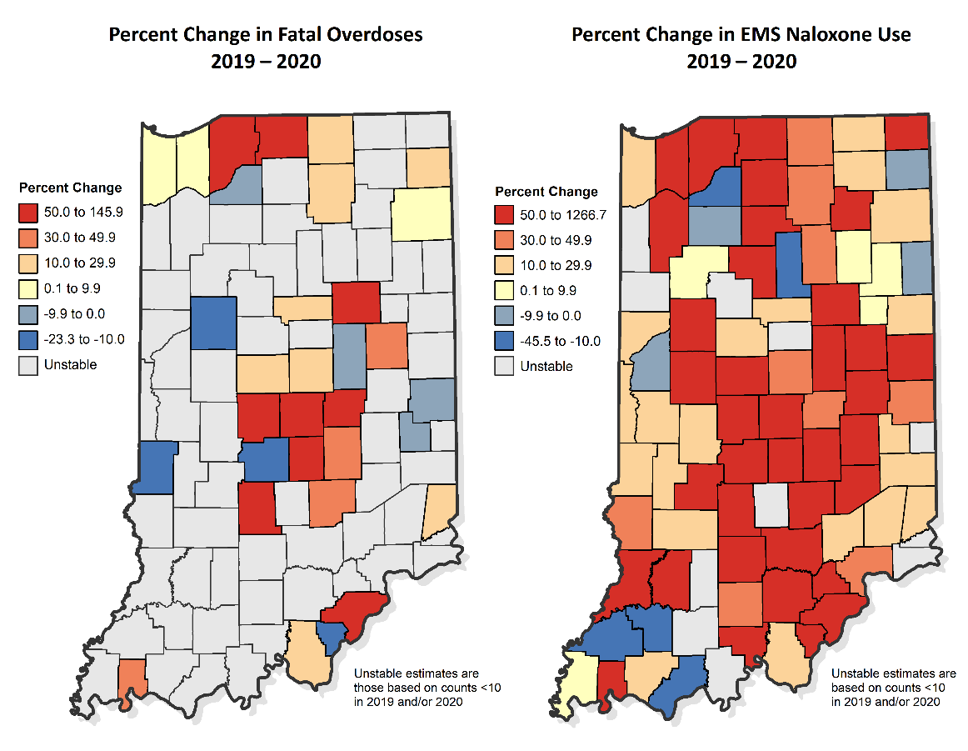
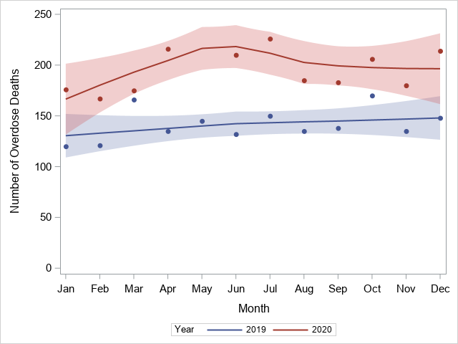
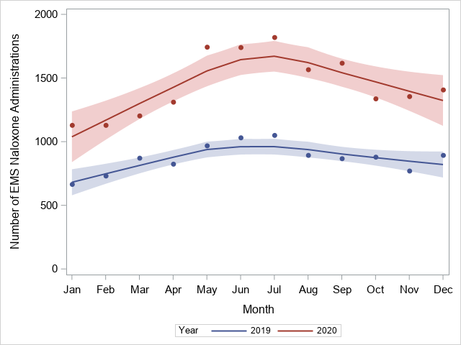
- EMS naloxone administrations across Indiana were 66% higher in 2020 compared to the same period in 2019 (January – December).
Figures 3 and 4: Percent Change in Fatal Overdoses and EMS Naloxone Use** by County
Figure 2: Indiana EMS Naloxone Administration Counts in 2019 vs. 2020*
Figure 1: Indiana Fatal Drug Overdoses by Month in 2019 vs. 2020 (Preliminary Counts)*
*The line on both graphs represents a smoothed trajectory and the shading represents a pointwise 95% confidence interval superimposed. All overdose fatality counts are preliminary and should be used with caution as they are subject to change.
- Across Indiana, there were several counties that had large increases in overdose deaths, especially in the Central region.
- There were widespread increases in naloxone use in many counties, indicating a potential increase in the number of nonfatal overdoses seen in 2020 compared to 2019**.
**EMS was approved to bill for naloxone on July 1, 2020 (see official guidance here http://provider.indianamedicaid. com/ihcp/Bulletins/BT202063.pdf ). This may have contributed to the increased use seen.
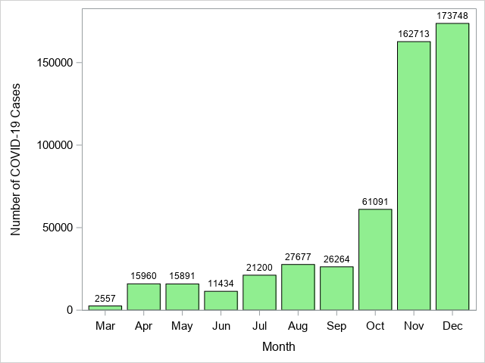
Indiana saw a steady increase of total COVID-19 increases from the beginning of the pandemic in March 2020 through the end of the year.
Figure 5: 2020 Statewide COVID-19 Case Counts by Month
As seen on the previous page, Indiana also saw a steady increase of overdose deaths and naloxone usage across the state in 2020 compared to 2019.
This has led to speculation that the COVID-19 pandemic has led to an increase in overdose deaths seen across Indiana. This relationship is investigated below.

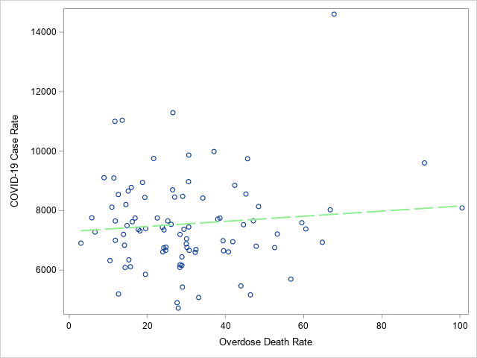
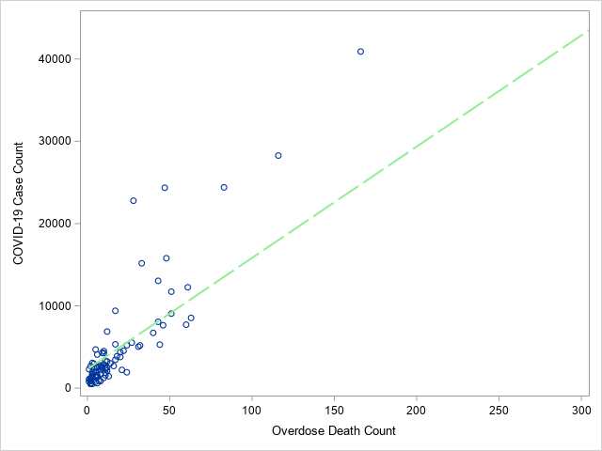
When examining the relationship between overdose deaths and COVID-19 cases by county, there was a significant positive correlation (0.91, p<.0001) for counts, such that counties with higher cases of COVID-19 also had higher counts of overdose deaths. However, when we examine the relationship between COVID-19 rates and overdose death rates, this significant correlation no longer exists (0.10, p=0.35). This may reflect the fact that population size is adjusted for in the rates’ correlation, which is a known confounder in correlations between counts.
This analysis is correlative and therefore not necessarily indicative of causation. Ultimately, further study within IDOH and overdose stakeholders across Indiana is needed to better understand how COVID-19 directly or indirectly affected overdose incidence in 2020.
Figure 7: Correlation Between COVID-19 Case Rate and Overdose Death Rate by County, 2020
Figure 6: Correlation Between COVID-19 Case Count and Overdose Death Count by County, 2020

Sources
- Indiana Vital Records Mortality Data
- COVID-19 Case Data from Indiana Management Performance Hub, https://hub.mph.in.gov/dataset/6b57a4f2-b754-4f79-a46b-cff93e37d851/resource/46b310b9-2f29-4a51-90dc-3886d9cf4ac1/download/covid_report.xlsx
- EMS Naloxone Administration Data from Indiana Management Performance Hub, https://www.in.gov/recovery/data/

RELATED REPORTS
- “COVID-19 and Mental Health in Indiana: Examining How Hoosiers Are Adjusting to the New Normal” – Division of Trauma and Injury Prevention, September 2021

Acknowledgements
Sydney Whiteford, MPH Drug Overdose Prevention Epidemiologist
Robert Gottlieb, MS GIS Data Analyst
Courtney Lambert Data Analysis Team Director
Shelby Nierman, MPH Overdose Surveillance Systems Epidemiologist
For more information or questions about this data, please contact Sydney Whiteford, the Division of Trauma and Injury Prevention’s Drug Overdose Prevention Epidemiologist at SWhiteford@isdh.in.gov.

