Division of Trauma and Injury Prevention June 2021

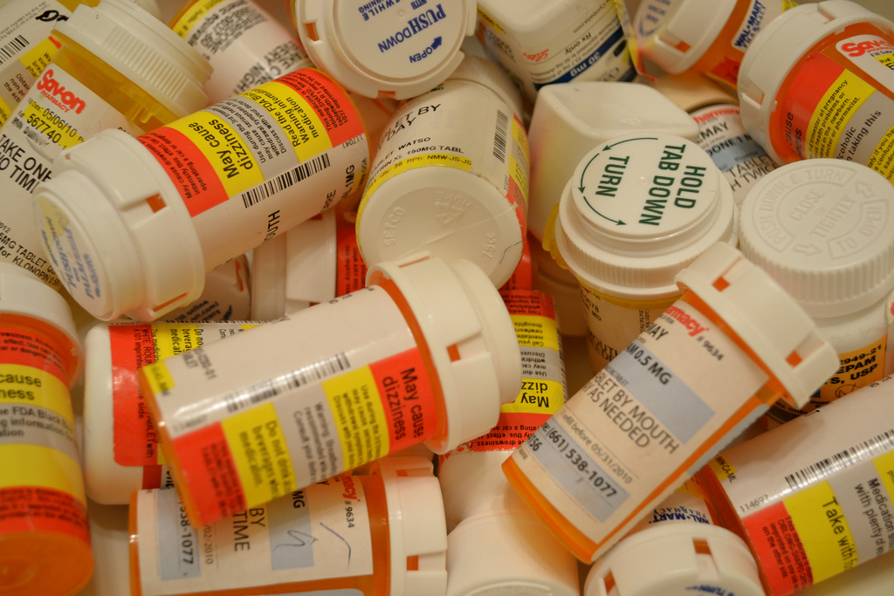

Drug Overdose Epidemic in Indiana: Behind the Numbers
Published April 2019; Revised June 2021

Executive Summary

Key points:

Drug overdose deaths, more specifically opioid-involved deaths, have continued to rise in Indiana and impact people of all races, sexes, ages and locations.

The drug epidemic, driven mainly by opioid-involved deaths, has evolved over the last decade in three distinct waves: an increase in prescription opioid-involved deaths, a spike in heroin involved deaths and a surge in synthetic opioid-involved deaths primarily consisting of illicitly manufactured fentanyl (IMF).

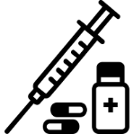
Opioids continue to be the most frequently found substance in overdose deaths. Public health officials, law enforcement and other stakeholders should also be concerned about polysubstance use and the rise in deaths involving non-opioid substances, such as cocaine, benzodiazepines, and amphetamines.

The state of Indiana is comprised of 92 counties, and the Indiana Department of Health’s Drug Overdose Prevention (DOP) team is primarily responsible for conducting surveillance on non-fatal and fatal overdoses, monitoring disease trends, providing early detection of outbreaks and implementing evidence-based practices to effectively manage limited resources. Additionally, the DOP Team provides technical assistance to local health departments and local organizations across the state who are focused on overdose prevention efforts.
While this report focuses on fatal overdoses, it is important to note that these data underscore the larger issue of the driver behind the drug and opioid epidemic ― substance use disorder (SUD). Communities are encouraged to recognize SUD as a disease, understand that treatment is available and that recovery from the disease is possible. SUD impacts every county, and to address this problem, the risk and protective factors associated with this disease must be understood.
This report was created to disseminate useful and pertinent data to Indiana residents and community leaders to promote dialogue about overdose deaths and SUD disease prevention in their communities to improve the health of all Hoosiers.

Behind the Numbers

Drug overdose deaths in Indiana have been on the rise for almost two decades, with a loss of more than 15,000 Hoosiers due to drug overdoses since 1999. In 2019, Indiana saw an age-adjusted drug overdose rate of 26.6 per 100,000, a statistically significant 4% increase from 2018. The Indiana 2019 rate was also statistically higher than the national rate of 21.6 per 100,000. From 2018-2019, Indiana had a higher drug overdose rate increase than more than half of the United States according to the CDC¹.
The primary driver of overdose deaths is opioids as almost three out of the four Hoosiers who died from an overdose each day involved an opioid.
In 2019, there were 1,695 drug overdose deaths in Indiana averaging to over four Hoosiers a day.

Indiana has consistently placed in the top half of U.S. states and territories for the highest drug overdose death rate since 2013 and consistently has a higher overdose death rate than the U.S. average.
Opioid-Involved Overdoses
74%
Overdoses without Opioids
26%

Gender differences exist between male and female overdose rates. Males made up 64% of all overdose deaths in 2019 and are at a higher risk of overdose than females. The risk for women has increased over the years, suggesting that both sexes struggle with SUD. This same trend is seen for opioid-involved overdose deaths.
Age distribution among all overdose deaths show that the majority of deaths are among those who are of the primary working ages of 18 to 60. This has resulted in the overall decline of the U.S. life expectancy since 2016.
Racial disparities exist among overdose death rates in Indiana. While the white population made up more than 84% of overdose deaths in 2019, the black population made up only 13% and had the highest race-specific overdose death rate². Increases for all races were seen but the black population saw a more aggressive rise in recent years. These data suggest SUD is wide reaching and barriers to prevention measures and treatment access should be understood in a cultural context.
Location differences exist for overdose death rates on the county level in Indiana. While both rural and urban counties have seen high rates over the past five years, rural counties such as Wayne, Fayette and Scott counties have stood out with disproportionately high rates of overdoses. Despite having smaller populations than larger urban areas, they are having higher rates of overdoses. Overdose mortality prevention such as access to treatment resources and social support services for recovery can be difficult to accrue for rural populations and can in turn impact their burden of overdose deaths.
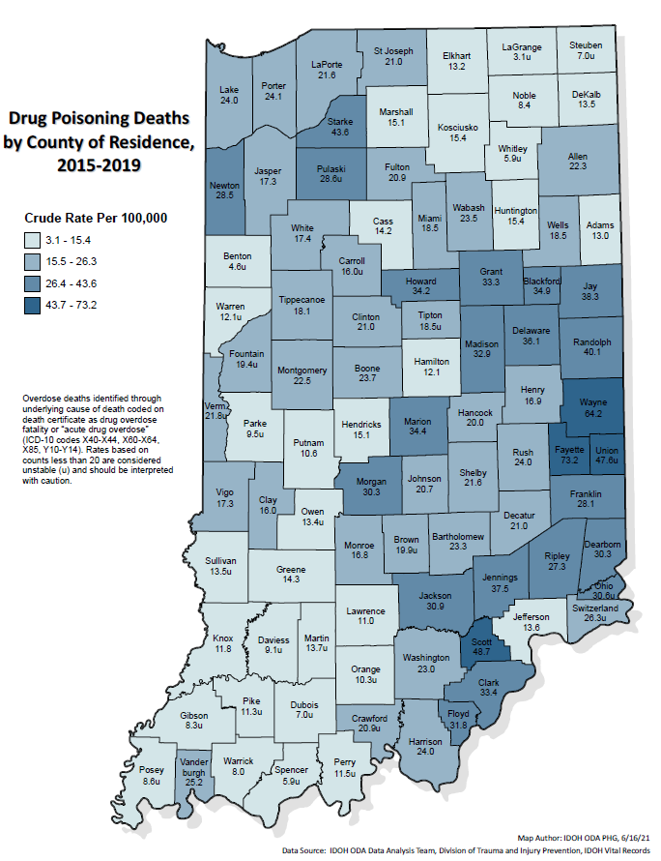

The rise in opioid-involved overdose deaths on both the national and state levels has been attributed to multiple factors. The first wave of the epidemic began in the late 1990s with the increased prescribing of opioids. The second wave began in the middle to late 2000s when individuals who could no longer receive legal medications chose to opt for the cheaper alternative of heroin. The third wave, beginning in Indiana primarily in 2014, was likely driven by IMF and fentanyl analogs that are an even cheaper and more potent alternative to heroin. An increase in drug case submissions of fentanyl and its analogs were seen by the Indiana State Police prior to the third wave. The IMF market continues to change, and IMF is now found in combination with heroin, cocaine, and counterfeit pills ³. The influx of IMF into non-opioid substances places all substance users at risk of overdose death as IMFs are more potent.
894

The drug overdose epidemic that has occurred both nationally and in Indiana has been primarily driven by opioids, but the involvement and co-use of synthetic opioids specifically, such as fentanyl, and other non-opioid substances cannot be ignored. The number of drug overdose deaths involving synthetic opioids has increased sharply over the past few years. These data indicate the importance of examining toxicology reports to better understand the specific opioids causing the most overdose deaths. Outside of opioids, psychostimulants as a cause for overdose have also greatly increased from 2016 to 2019. Taken together, these findings suggest that overdose prevention be comprehensive in its approach to address all types of substance users.

Polysubstance use has been on the rise across the nation. Toxicology data has become an important tool in better understanding the overdose epidemic in Indiana. In 2019, 64% of all drug overdose deaths in Indiana had more than one drug class present. Additionally, 43% of all deaths with IMFs identified as the cause of death had another drug present, with heroine being the most common.
*The spaces in the graph denote the exclusion of the drug listed as cause of death.
In 2019, 75% of individuals who died from a drug overdose had a history of current or past substance use/misuse².
As past substance misuse has been tied with an increased risk of fatal overdose, resources must continue to be dedicated to this population to decrease overdose deaths. Thirty-five percent of individuals had at least one potential opportunity for linkage to care prior to death². SUD treatment offered at various institutions create more access for those to begin their path to recovery and avoid overdose.
In 2019, Naloxone was administered in 22% of deaths². With the majority of overdose deaths occurring in the decedents home, an increase in the distribution of naloxone and trainings on administration is crucial in decreasing overdose fatality. Making Naloxone more freely available may increase the likelihood of individuals having the overdose reversal drug on hand in their homes when they need it.
71% of overdose deaths occurred in the decedent’s home².
Are we changing the tide of the overdose epidemic?
Final data from 2018 indicated a slight decrease in the annual number of drug overdose deaths, but this decrease did not persist into 2019. However, the overdose rates seen in 2019 were below their peak in 2017, potentially indicating the impact of prevention efforts. Additionally, with the onset of the COVID-19 pandemic in 2020, overdose rates are anticipated to rise, however preliminary data for 2020 is not yet available. Based on this, it is imperative that overdose prevention efforts be continued to remain ahead of the epidemic and to ensure future annual increases do not occur.

Sources
- CDC/NCHS, National Vital Statistics System, Mortality. CDC WONDER, Atlanta, GA: U.S. Department of Health and Human Services, CDC; 2018. https://wonder.cdc.gov/
- Indiana’s State Unintentional Drug Overdose Reporting System (SUDORS)
- Drug Enforcement Administration, Strategic Intelligence Section. Counterfeit Prescription Pills Containing Fentanyls: A Global Threat. 2016.
- Jones CM, Einstein EB, Compton WM. Changes in Synthetic Opioid Involvement in Drug Overdose Deaths in the United States, 2010-2016external icon. JAMA. 2018;319(17):1819-1821.
- All icons created by the Noun Project. https://thenounproject.com/

DOP Team Contacts
Katie Hokanson  Director  Division of Trauma and Injury Prevention  317.234.2865 Office  KHokanson@isdh.in.gov | Murray Lawry  Deputy Director / Operations Manager  Division of Trauma and Injury Prevention  317.233-.695 Office  MLawry@isdh.in.gov
Carrie Bennett  DOP Program Director  Division of Trauma and Injury Prevention  317.233.7411 Office  CBennett1@isdh.in.gov | Sydney Whiteford  DOP Epidemiologist  Division of Trauma and Injury Prevention  317.234.9656 Office  SWhiteford@isdh.in.gov
Laura Hollowell  DOP Community Outreach Coordinator  Division of Trauma and Injury Prevention  317.234.2811 Office  LHollowell@isdh.in.gov | James Carroll  DOP Community Outreach Coordinator  Division of Trauma and Injury Prevention  317.233.7021 Office  JCarroll1@isdh.in.gov
Cassidy McNamee
Naloxone Program Manager
Division of Trauma and Injury Prevention
317.234.6425 Office
CasMcnamee@isdh.in.gov

