ORAL HEALTH PROGRAM:
Activities of the Oral Health Program
T
he OHP currently has four courses listed on its website under the menu item Non-CE Courses. These include:1)Infection Control in Dental Facilities in Indiana; 2) Dentistry and Basic Non-Opioid Prescribing in Pain; 3) The Opioid Crisis and Orofacial Pain Management; and 4) Oral Health for Mothers, Infants, and Children. These courses may be found online at:https://www.in.gov/isdh/27761.htm.The courses are meant to be used as additional resources for information related to dentistry.

Continuing Education
T
he courses listed above are also available forcontinuing education using IN-TRAIN. These are at no cost to the participants. The instructions for taking these courses are available on the Oral Health Program website: http://www.in.gov/isdh/26868.htm. Please email any questions on completing these courses to Linda Hillers at LHillers@isdh.IN.gov.

Upcoming Events
T
he next Indiana Oral Health Coalition (IOHC) meeting will be Friday, September 11, from 10 a.m. to Noon. Depending on the COVID-19 circumstances in September, the meeting may either be conducted online or in-personat the Indiana State Department of Health, Fifth floor,Conference Room 5T.

Health Awareness Eventsas They Pertain to Dental Care
J
uly is National UV Safety Month. If you are considering a tooth whitening procedure, you should consult with a knowledgeable health care provider to determine which procedure is best for you. Some providers use UV light to help whiten teeth, while others do not. Non-UV light procedures are available.

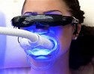
Teeth whitening is one of the most popular cosmetic procedures in dentistry. Visit the following website for additional information on UV Safety: https://www.oglf.org/does-uv-light-whiten-your-teeth/.

A
ugust is National Eye Health and Safety Month. An eye injury during a dental visit is a rare occurrence, as is contracting aneye infection during a dental visit. However, patients, doctors, hygienists and technicians can all be injured or receive infections. It is important for everyone in a dental facility to protect their eyes. More information about eye protection in the dental office is available at: https://blog.safetyglassesusa.com/eye-safety-in-a-dental-office/.

S

eptemberis National Gum Care Month. When it comes to your mouth’s health, it’s not all about how straight your teeth are or how bright your smile is. Even if you’re cavity-free and have the pearliest teeth in town, you can still have, or develop, gum disease. For more information on keeping your gums healthy, check out this website: https://www.healthline.com/health/dental-and-oral-health/ways-to-keep-gums-healthy

ORAL HEALTH TOPIC:
Flossing/Interdental Cleaning
U
se of an interdental cleaner (like floss) is an essential part of taking care of your teeth and gums. The U.S. Department of Health and Human Services reaffirmed flossing as "an important oral hygiene practice" in an August 2016 communication to the ADA.
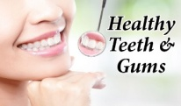
Plaque that is not removed by brushing and cleaning between your teeth can eventually harden into a rough substance called tartar (or calculus). Tartar collects along your gum line and can contribute to gum disease. Once tartar forms, only your dentist can remove it.
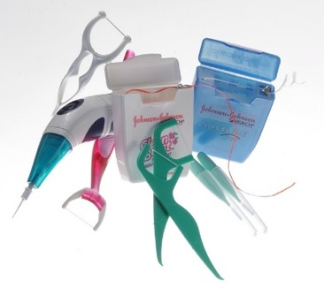
More information for this topic may be found at the links below:
How to Floss Correctly
https://www.verywellhealth.com/how-to-floss-your-teeth-correctly-1058984
5 Steps to Flawless Flossing
https://www.mouthhealthy.org/en/az-topics/f/flossing-steps
Floss to Fight Gum Disease
https://www.webmd.com/a-to-z-guides/news/20060809/flossing-needed-to-fight-gum-disease
____________________________________________
REFERENCES:
- Floss/Interdental Cleaners.ADA. Retrieved 6/12/2020
- Flossing.ADA.Retrieved 6/12/2020

REMINDERS:
The Oral Health Topicsection of the newsletter is suitable for the general public and may be shared with your patients or people in your community interested in oral health. We welcome any suggestions for topicsyou would like to see covered in this section. Suggestions may be made to Linda Hillers at LHillers@isdh.IN.gov.
These newsletters are archived on the OHP website at:http://www.in.gov/isdh/18695.htm under the section entitled Newsletters. This website contains other information about oral health that may be of interest to you.
Note: If you do not want to receive this newsletter in the future, please contact Linda Hillers at LHillers@isdh.IN.govor Patty Morris at PMorris@isdh.IN.gov .
Disclaimer: The materials provided in the Oral Health Topic’s section are for informational purposes only. Individuals should see an oral health professional to discuss any specific oral health issues.

