Dashboard/Home Page before Login
Click on the “Certificate of Free Sale (COFS) Request Form” link
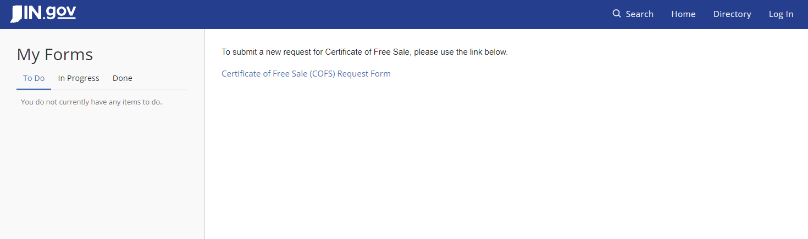
Click on “Log in” or “Login to Start Form”.
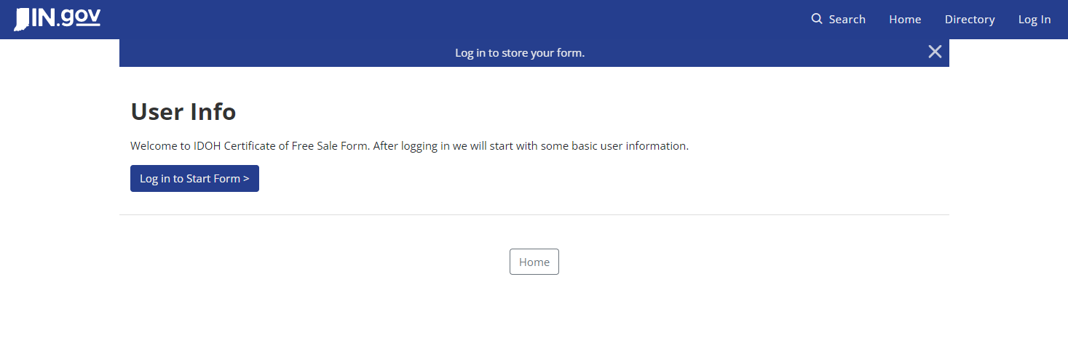

It redirects to the Access Indiana Login page.
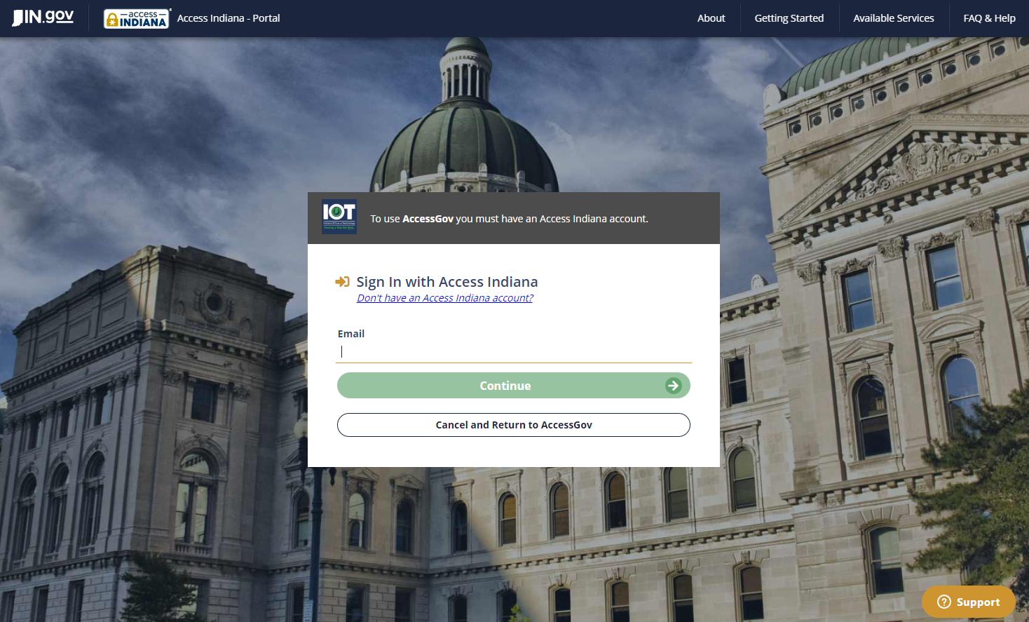
Enter your credentials and click “Continue”.
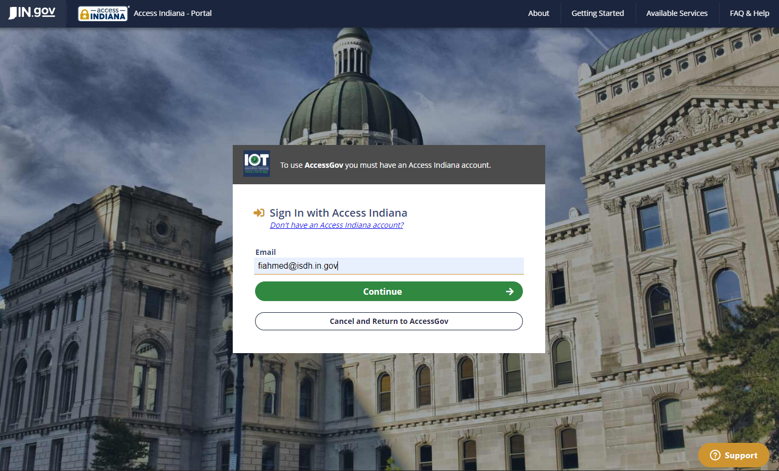

COFS submission starts with a User Info form. Click on “Start Form”.
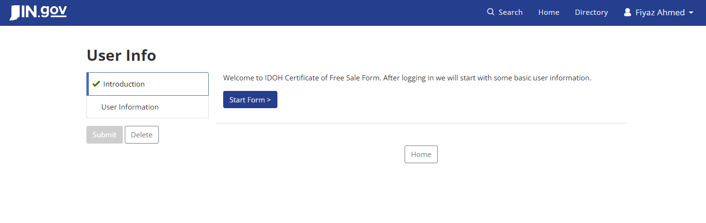
Enter your Email id and Name and click on “Submit”.
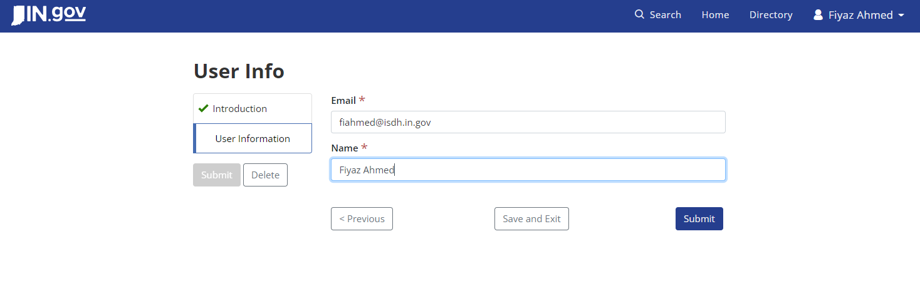
User will receive a Confirm Submission pop up. Click on “Submit”.
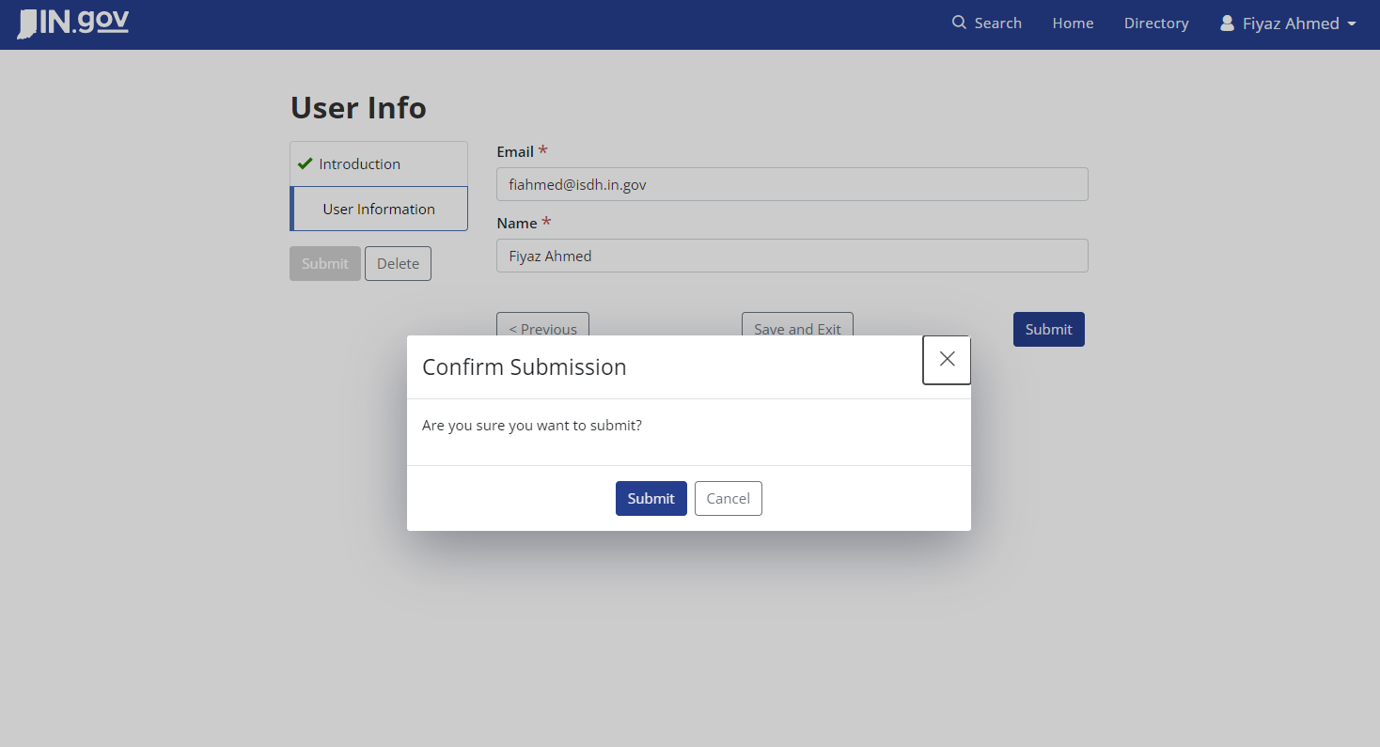
Form submitted successfully message will be shown.
For the first time users it will prompt to contact the Food Protection Division to set up your account. Click “Close”.
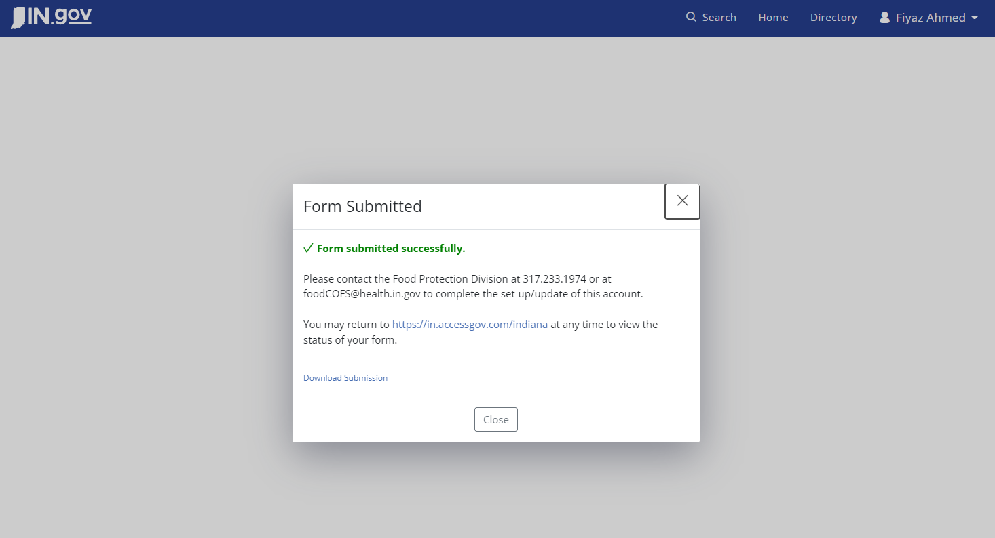
Existing users with mapped facility will receive below message. They can click on “Close” and will proceed from “Step after Facility mapping”.
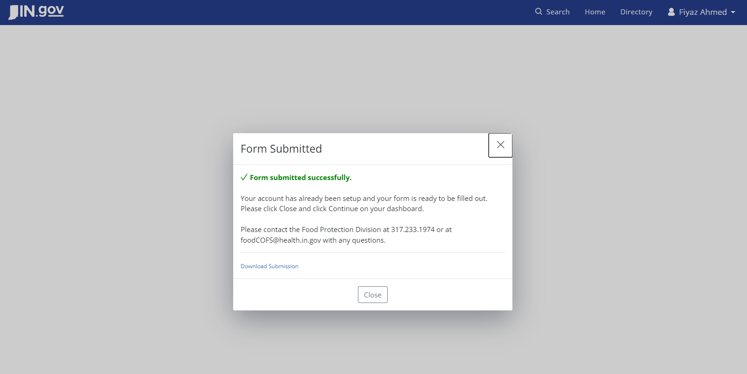

User can see his initiation in the “In Progress” tab with the status as “Under Review”. User need to call/contact FPD and request for mapping their facility to their account. FPD will review, verify and will add the respective facility to user account.
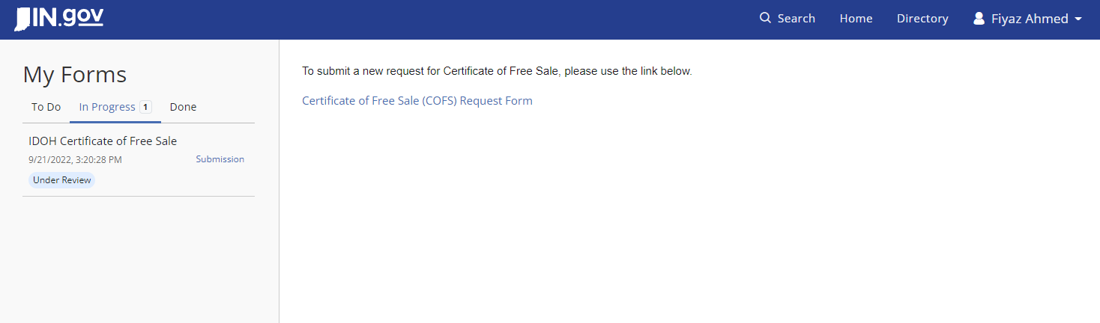
Once facility is added, for the first time users, an email will be generated with the details of the facilities that are added to the user’s account.
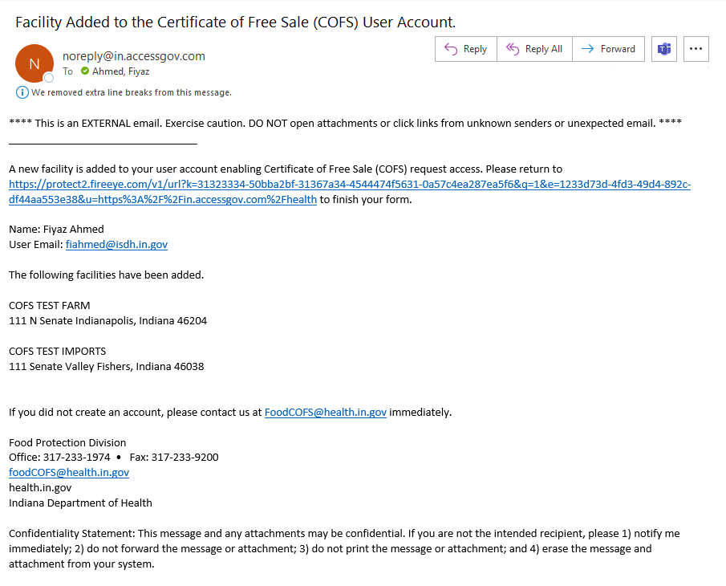

Step after Facility mapping
Returning to the home page, the user can see the requested item under “To Do” tab with a “Finish Form” status. Users need to click on the “Continue” link to proceed.
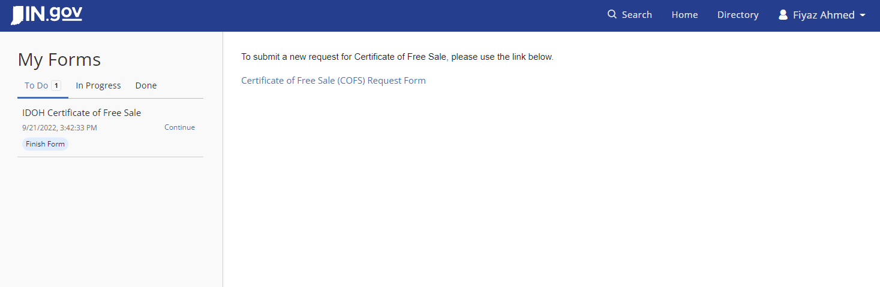

User will be redirected to the “Introduction” page for the IDOH Certificate of Free Sale form. Click on “Start Form” to begin.
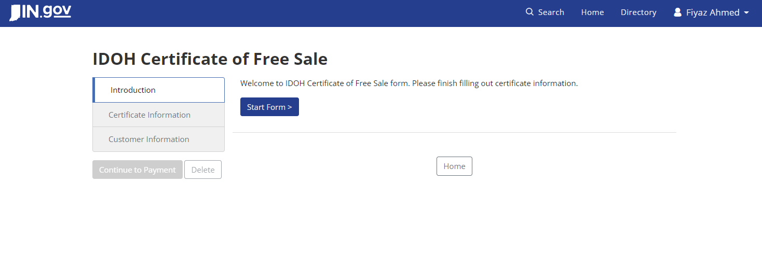

User will see the actual form that collects details for the certificate.
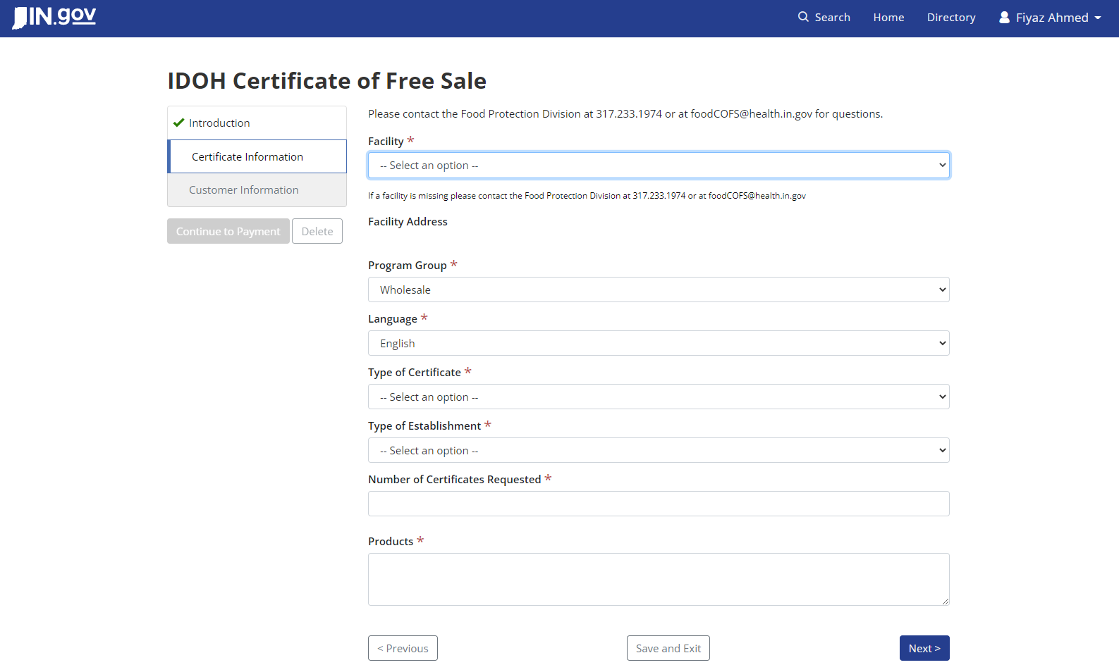
User will see the facilities tagged to them in the dropdown list. User can only choose from the options provided. If any new facility needs to be added, user need to contact FPD.
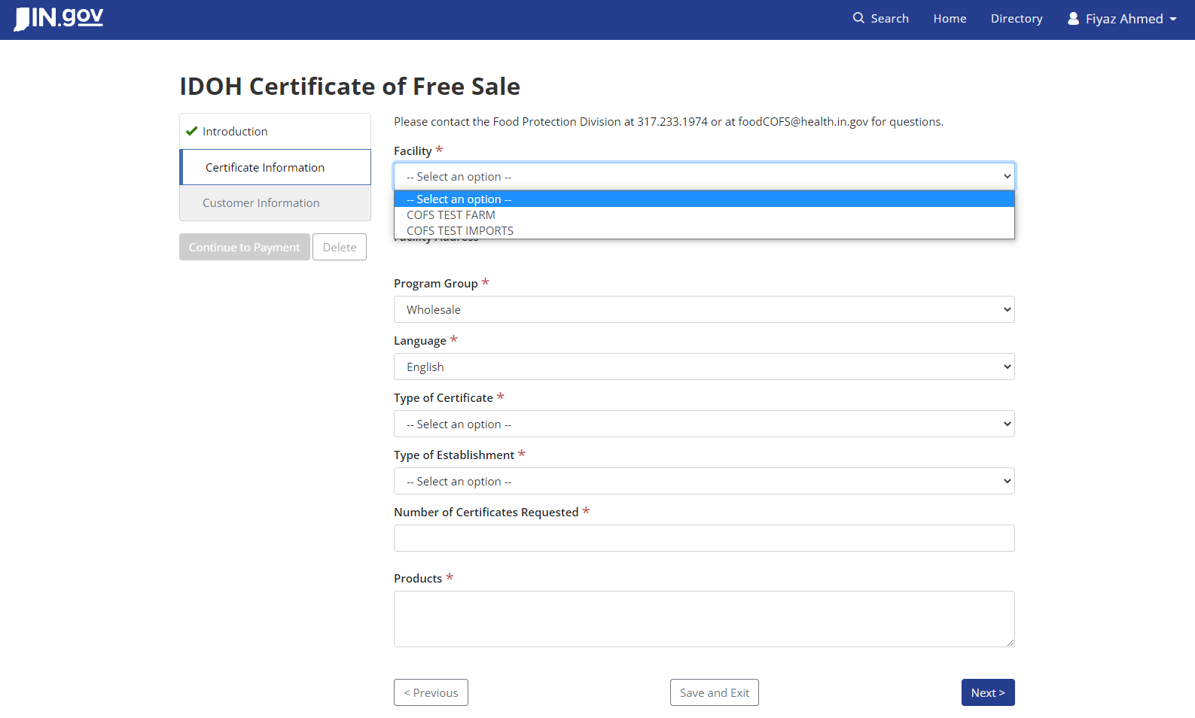
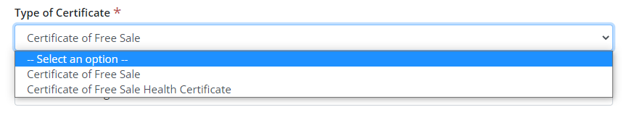

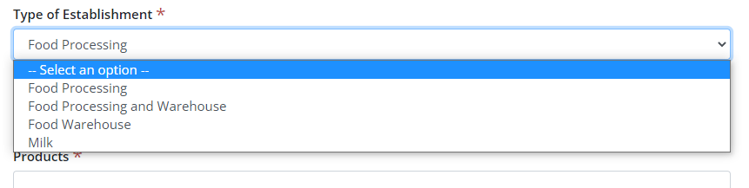
Number of Certificates Requested is limited to 25 max.
Products field is a plain multiline text and no formatting is allowed. A new line can be introduced. The maximum character limit is 1000. Fields marked with red asterisks (*) are mandatory. After filling the “Certificate Information” section click on “Next”.
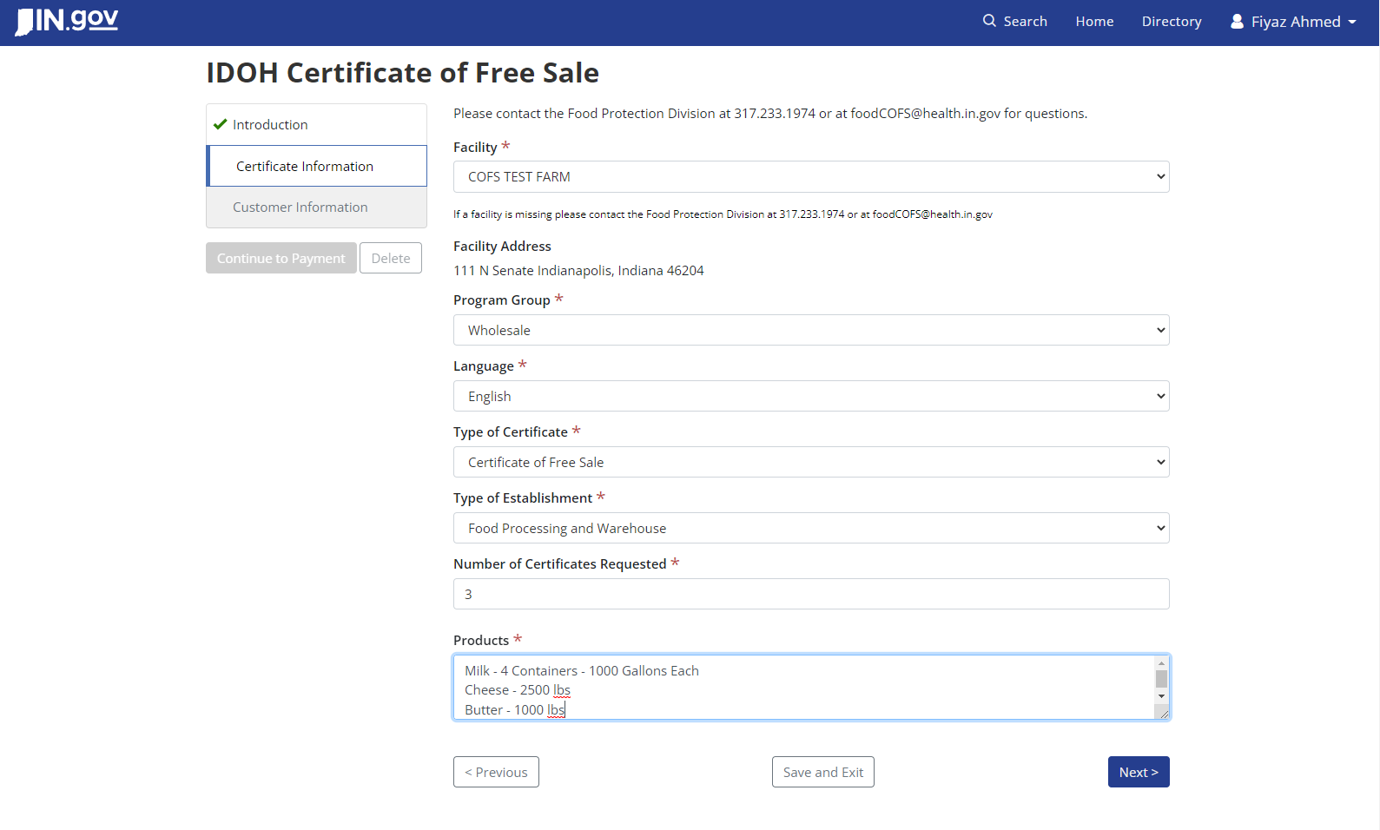

Fill in all details in the “Customer Information” page. Click “Continue to Payment”.
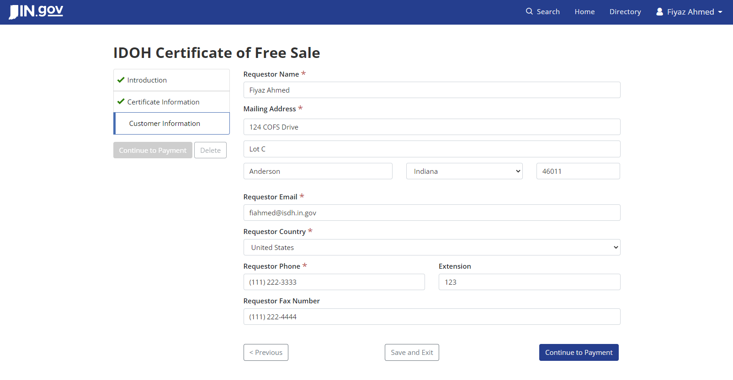
Transaction Details will be listed. Total amount with Credit Card Service Fee will be listed in the Transaction summary.
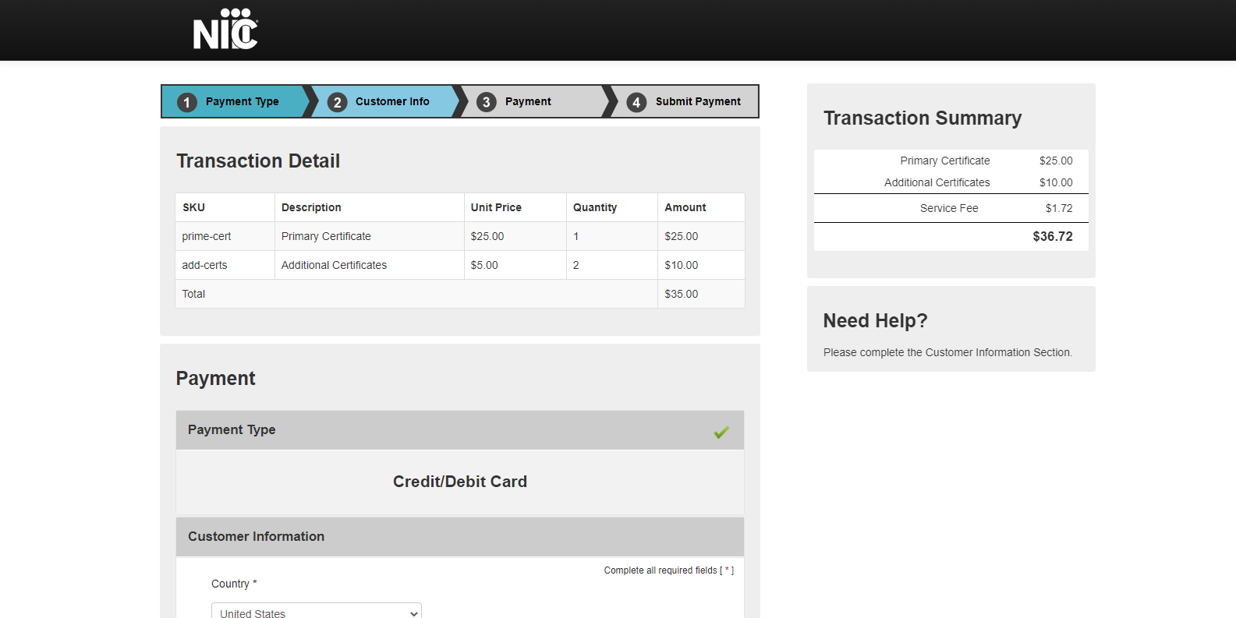

Customer Information will be mostly populated from your previous inputs. Fill in the rest and click on “Next”.
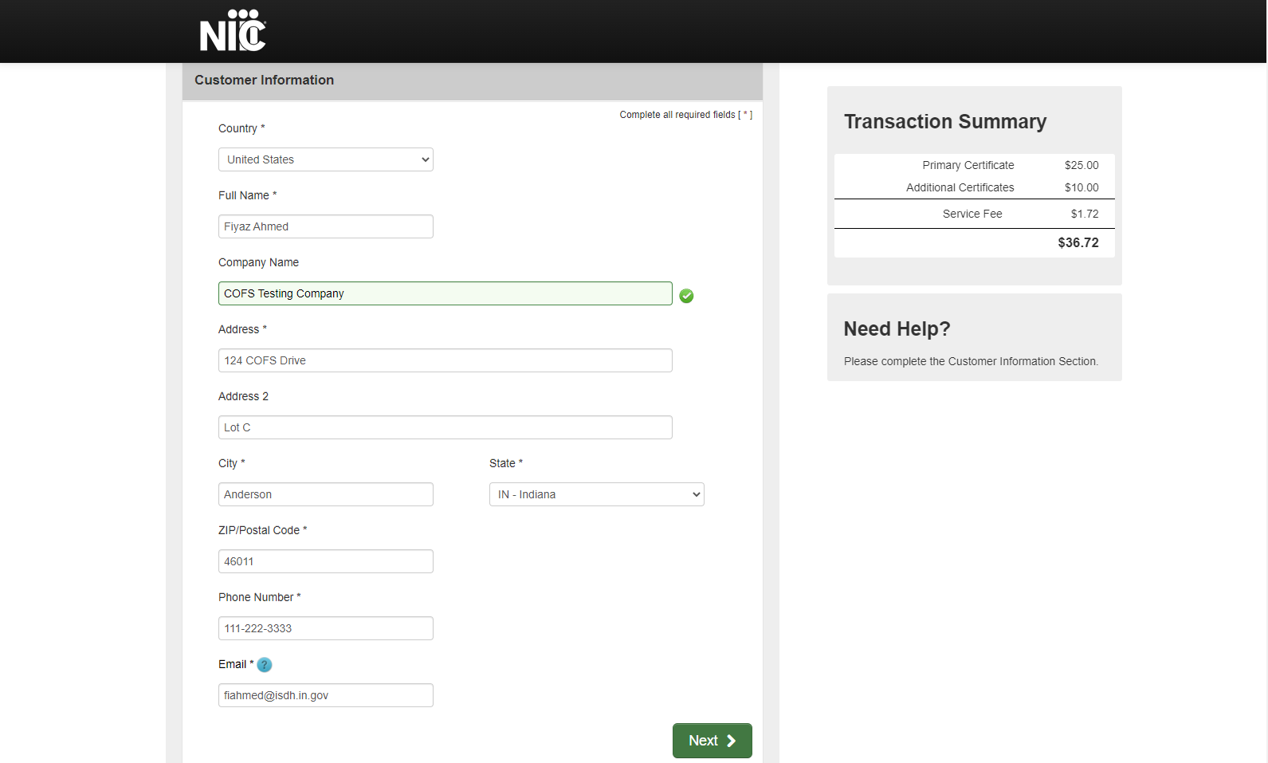
Under Payment Information fill in the credit card details and click “Next”.
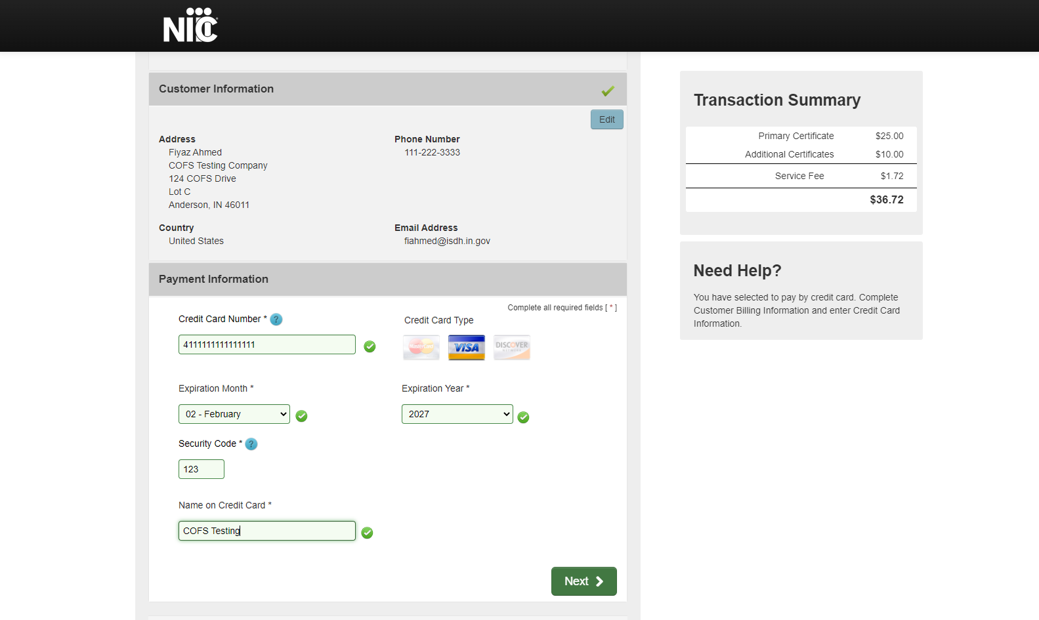
Once you review all the details click on “Submit Payment”.
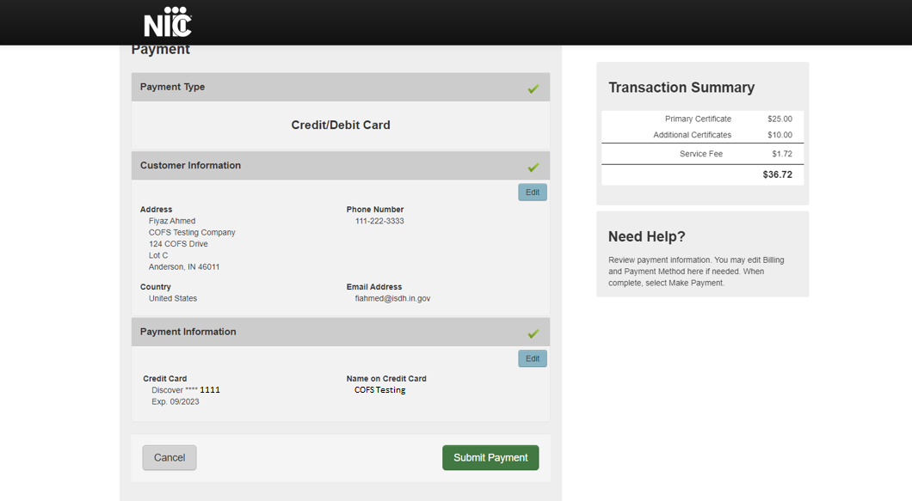
Once the payment is successful, the Payment Receipt Confirmation will be displayed. You can Print or Save the receipt by clicking on “Print”. User will also receive an email of the Payment Receipt Confirmation.
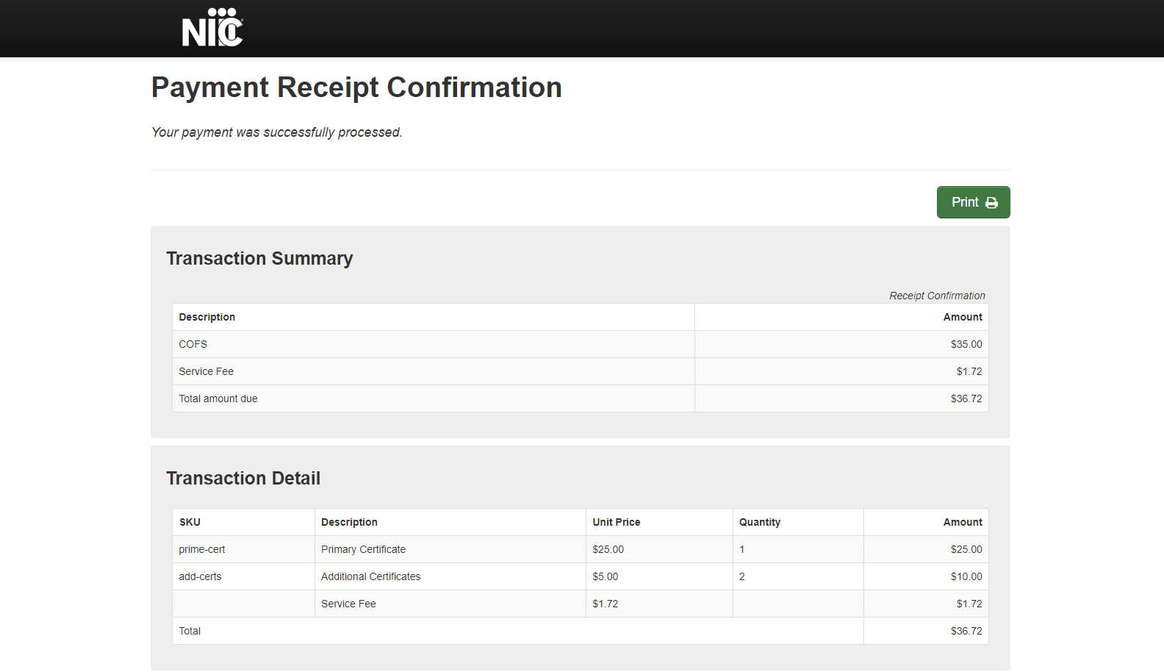

Click on “Continue”.
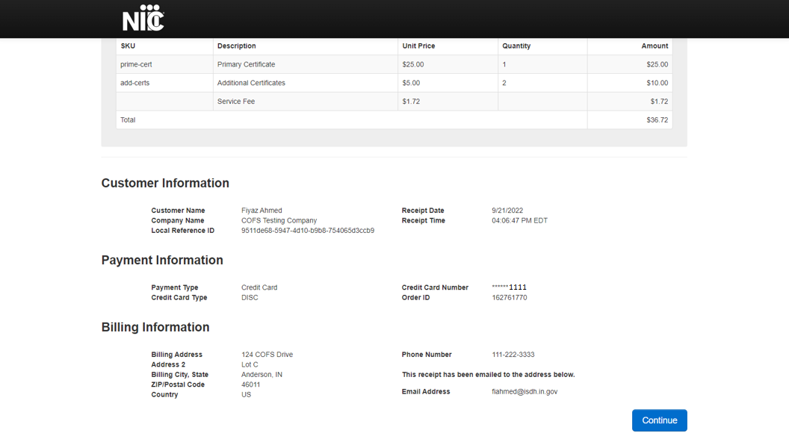

Form submitted successfully pop up will be displayed. Click “Close”.
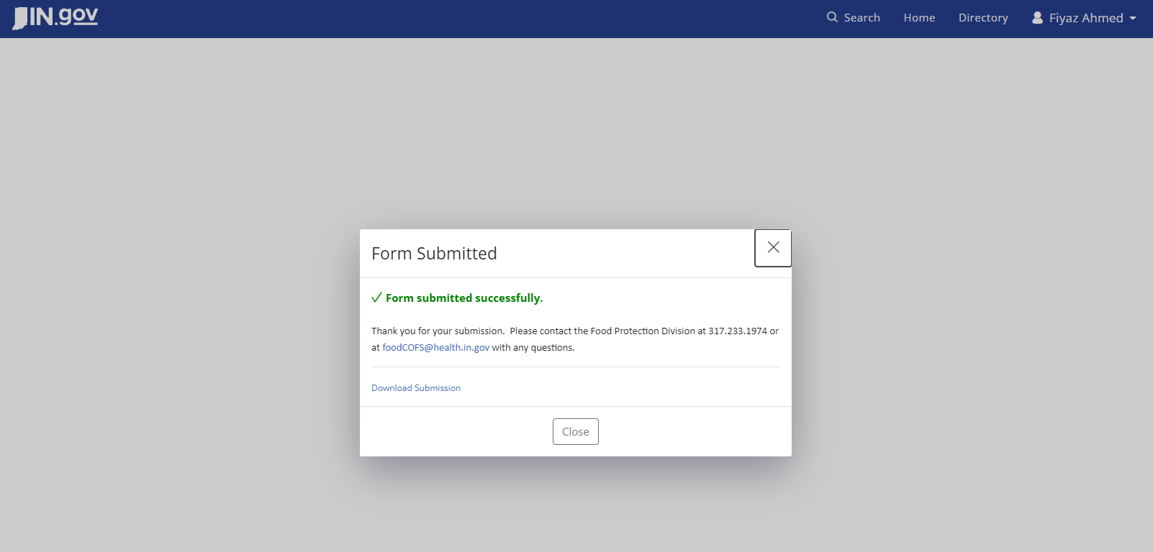

The request can be seen under the “Done” tab in the Home page with a “Done” status.
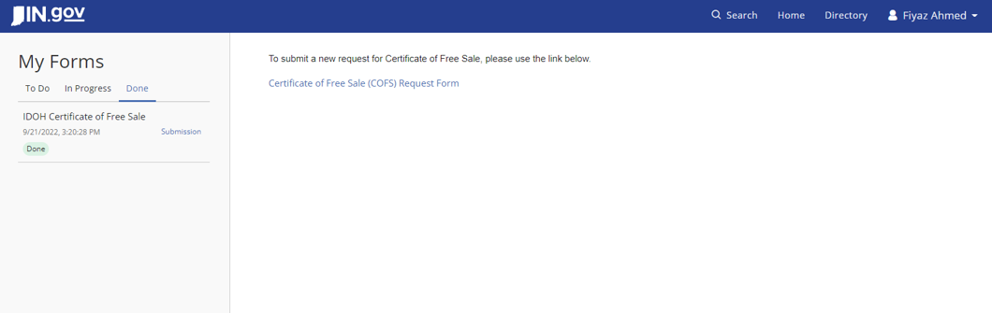

User will receive two emails as below.
