Who Gets Colorectal Cancer?²
Sex and age are the two greatest risk factors for developing colorectal cancer.² Additional risk factors include:
- Race. In Indiana, during 2012–2016, African-Americans had a 7 percent higher incidence rate [Figure 1] and a 33 percent higher mortality rate [Figure 2] when compared with whites.³
- Smoking. Smoking causes colorectal cancer, and the association appears to be stronger for rectal cancer than for colon cancers.² Smoking is also associated with lower survival rates, particularly for current smokers.²
- Diabetes. Studies have found that individuals with Type 2 diabetes are at higher risk.² Although diabetes and colorectal cancer share similar risk factors, this increased risk remains even after those are taken into consideration.²
- Personal or family history. Although a majority of colorectal cancer cases occur when there is no family history, risk may be increased by having a personal or family history of colorectal cancer or polyps, a personal history of chronic inflammatory bowel disease, or certain inherited genetic conditions – for example, Lynch syndrome.²
- Modifiable risk factors. Obesity, physical inactivity, a diet high in red or processed meat, and moderate to high alcohol consumption have a strong link to increased colorectal cancer risk.²

Common Signs and Symptoms of Colorectal Cancer²
- Early Stage: Often has no symptoms, which is why screening is so important.
- Late Stage:
  - Bleeding from the rectum
  - Blood in stool or toilet after bowel movement
  - Dark or black stools
  - Change in bowel habits or shape of stool (e.g., more narrow than usual)
  - Cramping or discomfort in the lower abdomen
  - Urge to have bowel movement when bowel is empty
  - Constipation or diarrhea that lasts more than a few days
  - Decreased appetite
  - Unintentional weight loss
COLORECTAL CANCER is the third most commonly diagnosed cancer and cause of cancer-related death among both males and females in the United States, according to the American Cancer Society (ACS).¹ In 2019, the ACS estimates that 3,360 Hoosiers will be diagnosed with colorectal cancer, and 1,110 will die because of the disease.² During 2012-2016, Indiana’s colorectal cancer incidence rate was 42.9 per 100,000 people, and the mortality rate was 15.4 per 100,000 people. In Indiana, African-Americans have higher colorectal cancer incidence and mortality than whites, and men have higher rates than women.³

Figure 1. Colorectal Cancer Incidence Rates by Sex and Race*—Indiana, 2012-2016
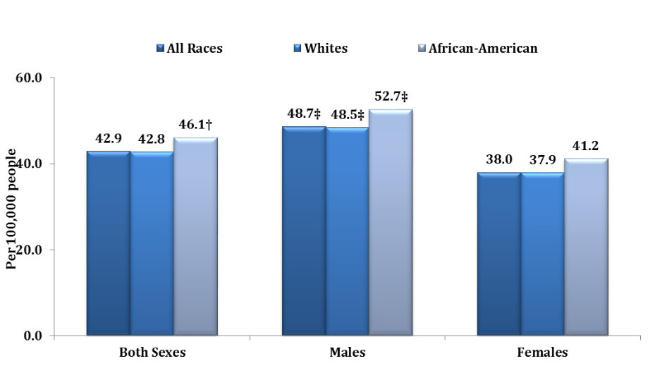
*Age-adjusted to the US 2000 Standard Population.
†Rate among African-Americans is significantly higher (P<.05) than rate among whites
‡Rate among males is significantly higher (P<.05) than rate among females
Source: Indiana State Cancer Registry
SEX AND AGE are the two greatest risk factors. During 2012-2016, colorectal cancer incidence rates were 25 percent higher among Indiana men than women [Figure 1].³ In addition, 90 percent of colorectal cases diagnosed in Indiana were among residents age 50 and older during this same time period.³

Figure 2. Colorectal Cancer Mortality Rates by Sex and Race*—Indiana, 2012–2016
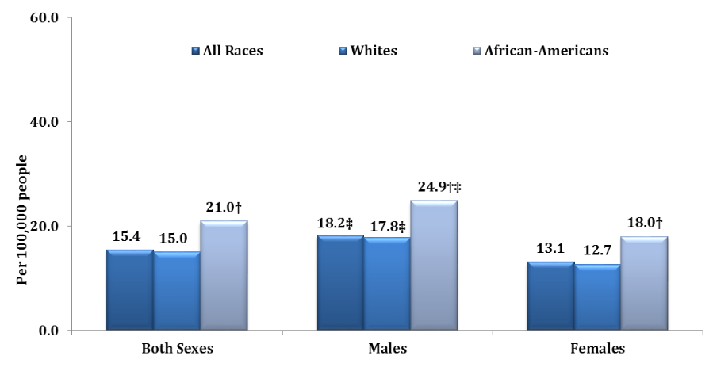
*Age-adjusted to the US 2000 Standard Population.
†Rate among African-Americans is significantly higher (P<.05) than rate among whites
‡Rate among males is significantly higher (P<.05) than rate among females
Source: Indiana State Cancer Registry
Can Colorectal Cancer Be Detected Early?
- Overall, colorectal cancer incidence has decreased over the past several decades, due to increased screening, resulting in the detection and removal of precancerous polyps, and changes in risk factor exposures.²
- When detected at the local stage, the five-year survival rate is 90 percent.⁵ In Indiana, during 2012-2016, only 37.7 percent of colorectal cancers were identified in the local stage.³ If the cancer has spread regionally, the five-year survival rate drops to 71 percent.⁵ If the cancer has spread distantly, the five-year survival rate drops to only 14 percent.⁵
- According to the Indiana Behavioral Risk Factor Surveillance System (BRFSS), in Indiana, during 2016, only 65 percent of adults age 50 or older reported ever having a colonoscopy or sigmoidoscopy.⁶
- The U.S. Preventive Services Task Force recommends colorectal cancer screening for adults aged 50–75 using a guaiac-fecal occult blood test (gFOBT) or a fecal immunochemical test (FIT) every year; a multitargeted stool DNA test (FIT-DNA) every one to three years; a flexible sigmoidoscopy or CT colonography every five years; or a colonoscopy or a flexible sigmoidoscopy with FIT (every year) every 10 years.⁷ Talk to your doctor about which test or tests are right for you.⁷ Most health insurance plans cover lifesaving preventive tests.
- Even as the overall incidence of colorectal cancer in the United States has been declining, incidence rates among adults under 55 have been increasing.² From 2006 to 2015, incidence rates increased by 1.8% annually among those younger than age 55.² A 2017 Siegel et al. study, found that three in 10 rectal cancer diagnoses are now occurring in patients younger than age 55.⁷ The rising rates in adults under age 50 highlight a need to respond to this trend, including raising awareness of preventive measures and risk factors.⁷
TAKE ACTION: Help prevent colorectal cancer²
- Get regular screenings
- Avoid tobacco products
- Maintain a healthy weight throughout life
- Adopt a physically active lifestyle
- Limit consumption of alcohol
- Consume a healthy diet that:
  - High in fruits and vegetables
  - Supports a healthy weight
  - Has minimal processed and red meats
- Support initiatives, such as the National Colorectal Cancer Roundtable’s (NCCRT’s) 80% in Every Community campaign, which aim to increase colorectal cancer screening. Visit the NCCRT website to take the 80% in Every Community pledge today!
- Take advantage of free public service announcement materials, such as the Centers for Disease Control and Prevention’s Screen for Life campaign, to help educate your community about the benefits of colorectal cancer screening.

Get Involved: Join the Indiana Cancer Consortium (ICC)
- The ICC is a statewide network of over 100 agencies including the Indiana State Department of Health.
- The ICC seeks to reduce the cancer burden in Indiana through the development, implementation and evaluation of a comprehensive plan that addresses cancer across the continuum from prevention through survivorship.
- Become a member at www.indianacancer.org.

Resources
- For a colorectal cancer toolkit with resources and information, visit http://indianacancer.org/colorectal-cancer-toolkit/.
- To learn more about how to decrease the cancer burden in Indiana, refer to the Indiana Cancer Control Plan 2018-2020 report at www.indianacancer.org.
- Visit www.QuitNowIndiana.com or call 1-800-QUITNOW for help quitting smoking.
- To learn more about how to support healthy eating and physical activity throughout Indiana, visit the Indiana Healthy Weight Initiative at www.inhealthyweight.org.

References:
- American Cancer Society. Key Statistics for Colorectal Cancer. Accessed at https://www.cancer.org/cancer/colon-rectal-cancer/about/key-statistics.html on February 28, 2019.
- American Cancer Society. Cancer Facts & Figures 2019. Accessed at https://www.cancer.org/content/dam/cancer-org/research/cancer-facts-and-statistics/annual-cancer-facts-and-figures/2019/cancer-facts-and-figures-2019.pdf on February 25, 2019.
- Indiana State Cancer Registry Statistics Report Generator. Accessed at http://www.in.gov/isdh/24360.htm on February 23, 2019.
- American Cancer Society. Colorectal Cancer Facts & Figures 2017-2019. Atlanta. American Cancer Society, 2017. Accessed at https://www.cancer.org/content/dam/cancer-org/research/cancer-facts-and-statistics/colorectal-cancer-facts-and-figures/colorectal-cancer-facts-and-figures-2017-2019.pdf on February 23, 2019.
- American Cancer Society. Survival Rates for Colorectal Cancer. Accessed at https://www.cancer.org/cancer/colon-rectal-cancer/detection-diagnosis-staging/survival-rates.htmlhttps://www.cancer.org/cancer/colon-rectal-cancer/detection-diagnosis-staging/survival-rates.html%20 on February 25, 2019.
- Indiana Behavioral Risk Factor Surveillance System. 2016 State Survey. Accessed at https://www.in.gov/isdh/25194.htm on February 28, 2019.
- Siegel RL et al. (2017) Colorectal Cancer Incidence Patterns in the United States, 1974-2013. Journal of the National Cancer Institute, 109(8). Accessed at https://academic.oup.com/jnci/article/109/8/djw322/3053481 on February 25, 2019.

