**CERVICAL CANCER** starts in the cells lining the cervix -- the lower part of the uterus (womb).1 Cervical cancer is almost 100 percent preventable through regular routine screening, avoidance of controllable risk factors, and vaccination against the human papillomavirus (HPV).1 According to the American Cancer Society (ACS), there were an estimated 13,240 cases of invasive cervical cancer diagnosed in the United States during 2018, and over 4,170 deaths occurred nationally as a result of cervical cancer.2 During 2016, 285 new cases of cervical cancer and 91 cervical cancer-related deaths occurred among Indiana females.

**Who Gets Cervical Cancer?**

* HPV infection is the single greatest risk factor for cervical cancer.3 HPV is passed person-to-person through skin-to-skin contact.3
* The Centers for Disease Control and Prevention (CDC) recommends that HPV vaccination begin at age 11 or 12 years for both boys and girls; however, the vaccine can be administered through age 26, and can be started as early as 9 years of age. In Indiana, only 48.4% of females and 33.5% of males aged 13 – 17 were considered up to date on their HPV vaccine in 2017, according to the CDC.4
* Indiana females are most often diagnosed with cervical cancer during their middle adult years. During 2016, 83 percent of cervical cancer cases occurred among Indiana females less than 65 years-old, including 38 percent of cases occurring among women ages 25 to 44 and 44 percent among women ages 45 to 64.
* During 2007-2016, in Indiana, African-American women, compared to white women, had an 18 percent higher cervical cancer incidence rate (9.3 versus 7.8 cases per 100,000 females) and a 32 percent higher mortality rate (3.3 versus 2.4 deaths per 100,000 females) (Figure 2). While many factors are probably impacting this disparity, one apparent issue is that African-American women tend to be diagnosed more often at a later stage.
* According to the ACS, women who smoke are twice as likely to develop cervical cancer when compared to non-smokers. For help quitting, or to help a loved one quit, contact the Indiana Tobacco Quitline at 1-800-QUIT NOW (1-800-784-8669) or [www.quitnowindiana.com](http://www.quitnowindiana.com).
* Women with a suppressed immune system, human immunodeficiency virus (HIV), a high number of live childbirths, several sexual partners, and a history of long-term use of oral contraceptives (birth control pills) may also be at an increased risk for cervical cancer.3
* Women who are overweight, or who eata diet low in fruits and vegetables may be at an increased risk for cervical cancer.3

**Figure 1. Percent of Cervical Cancer Cases Diagnosed During Each Stage*—Indiana, 2012-2016**

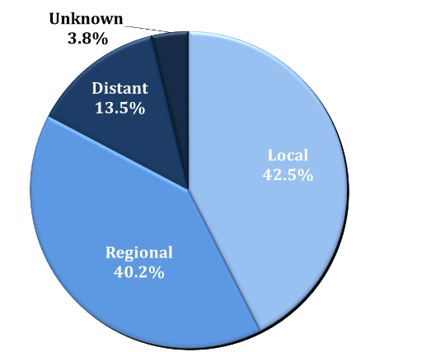

*Only includes invasive cases; in situ cases are not reportable  
 Source: Indiana State Cancer Registry.

During 2012-2016, of the 1,343 Indiana residents who received a diagnosis of invasive cervical cancer, 571 (42.5 percent) were diagnosed in the local stage, which has a five-year survival rate of 92 percent; 721 (53.7 percent) were diagnosed in the regional or distant stage; and 51 (3.8 percent) had unknown staging [Figure 1].2 The five-year survival rate drops to 57 percent for regional stage and 17 percent for cases diagnosed in the distant stage.2

**Figure 2. Cervical Cancer Incidence and Mortality Rates by Race* — Indiana, 2007-2016**

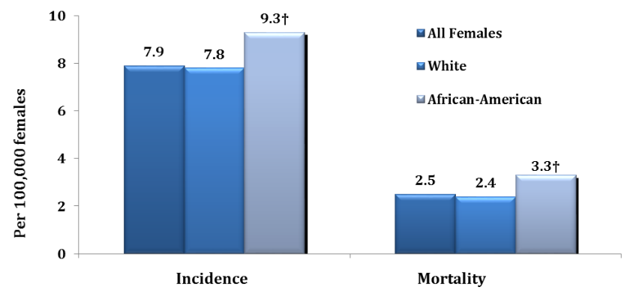

*Age-adjusted to the US 2000 Standard Population.

†Rate among African-American females is significantly higher (P<.05) than the rate among white females

Source: Indiana State Cancer Registry

**Can Cervical Cancer Be Detected Early?**

In the United States, the cervical cancer death rate declined by almost 50 percent in the last 30 years, mainly because of the effectiveness of Pap smear screening.5 There are two screening tests that can help prevent cervical cancer or find it early. The Pap test (or Pap smear) looks for *precancers,* which are cell changes on the cervix that might become cervical cancer if they are not treated appropriately. The HPV test looks for the virus that can cause these cell changes.

The United States Preventive Services Task Force recommends **screening for cervical cancer in women ages 21 to 29 with a Pap test every three years; or, for women ages 30 to 65, a Pap test every three years alone, a high-risk human papillomavirus (hrHPV) test every five years alone, or a combination of a Pap test and an hrHPV test every five years (cotesting).6**

According to the Indiana Behavioral Risk Factor Surveillance System, in 2016, 68.3 percent of Indiana women age 21-29 reported having had a Pap test during the past three years.7

The Indiana Breast and Cervical Cancer Program provides access to breast and cervical cancer screenings, diagnostic testing, and treatment for uninsured and underinsured women who meet eligibility requirements. To find out if you qualify for this program, call (317) 233-1325, or visit the website at [www.in.gov/isdh/19853.htm](http://www.in.gov/isdh/19853.htm).

**What Can You Do To Help Prevent Cervical Cancer?8**

* Get vaccinated! Protecting yourself from HPV decreases your risk for cervical and other cancers.
* Practice safe sex.
* Limit your number of sexual partners.
* Be smoke free. Visit [www.quitnowindiana.com](http://www.quitnowindiana.com) for free smoking cessation assistance.
* See your doctor regularly for a Pap test that can find cervical pre-cancers.
* Follow up with your doctor, if your Pap test results are not normal.
* Ask for an HPV test with your Pap test if you are 30 years-old or older.

**Get Involved: Join the Indiana Cancer Consortium (ICC)**

* The ICC is a statewide network of over 100 agencies including the Indiana State Department of Health.
* The ICC seeks to reduce the cancer burden in Indiana through the development, implementation and evaluation of a [comprehensive plan](http://indianacancer.org/wp-content/uploads/2018/06/2018-2020-Cancer-Control-Plan-MAY-29-FINAL.pdf) that addresses cancer across the continuum from prevention through end-of-life.
* Become a member at [www.indianacancer.org](http://www.indianacancer.org).

**Community resources**

* To view and learn more about the Indiana Cervical Cancer Strategic Plan 2019-2028, which is for everyone in Indiana who is invested in the goal of eliminating cervical cancer in the state, visit <https://www.in.gov/isdh/22689.htm>.
* To learn more about the [Indiana Breast and Cervical Cancer Program](http://www.in.gov/isdh/24967.htm), visit [www.in.gov/isdh/24967.htm](http://www.in.gov/isdh/24967.htm) or call (317) 233-1325.
* To learn more about Indiana’s cervical cancer burden, view the [*Indiana Cancer Facts and Figures 2015: Cervical Cancer*](http://indianacancer.org/wp-content/uploads/2015/06/Indiana-Cancer-Facts-and-Figures-2015_cervical-cancer.pdf) report.
* To view a toolkit of resources and information regarding Indiana’s cervical cancer burden, visit the [ICC](http://www.indianacancer.org/) website at [www.indianacancer.org/cervical_cancer_toolkit/](http://www.indianacancer.org/cervical_cancer_toolkit/).
* For tobacco cessation assistance, contact the Indiana Tobacco Quitline at 1-800-QUIT NOW (1-800-784-8669) or [www.quitnowindiana.com](http://www.quitnowindiana.com).

**References**

1. American Cancer Society. What is Cervical Cancer? Accessed at <https://www.cancer.org/cancer/cervical-cancer/about/what-is-cervical-cancer.html> on December 11, 2018.
2. American Cancer Society. Cancer Facts and Figures 2018. Accessed at <https://www.cancer.org/content/dam/cancer-org/research/cancer-facts-and-statistics/annual-cancer-facts-and-figures/2018/cancer-facts-and-figures-2018.pdf> on December 11, 2018.
3. American Cancer Society. Cervical Cancer: Prevention and Early Detection. Accessed at https://www.cancer.org/cancer/cervical-cancer/prevention-and-early-detection/cervical-cancer-risk-factors.html on December 11, 2018.
4. Centers for Disease Control and Prevention. Human Papillomavirus Vaccination: Recommendations of the Advisory Committee on Immunization Practices (ACIP). Accessed at <https://www.cdc.gov/mmwr/preview/mmwrhtml/rr6305a1.htm> on December 11, 2018.
5. American Cancer Society. Key Statistics for Cervical Cancer. Accessed at <https://www.cancer.org/cancer/cervical-cancer/about/key-statistics.html> on December 11, 2018.
6. United States Preventive Services Task Force. Final Recommendation Statement: Cervical Cancer Screening. Accessed at <https://www.uspreventiveservicestaskforce.org/Page/Document/RecommendationStatementFinal/cervical-cancer-screening2> on December 11, 2018.
7. Indiana Behavioral Risk Factor Surveillance System. Accessed at [www.in.gov/isdh/25194.htm](http://www.in.gov/isdh/25194.htm) on December 4, 2018.
8. Centers for Disease Control and Prevention. What are the Risk Factors for Cervical Cancer? Accessed at <https://www.cdc.gov/cancer/cervical/basic_info/risk_factors.htm> on December 11, 2018.