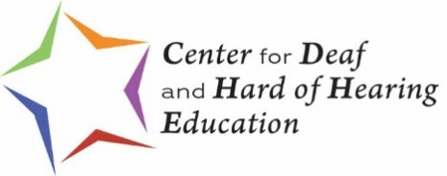
Consideration of Special Factors When an Indiana Student is Deaf or Hard of Hearing

\

NOTE: | The intent of this form is to guide discussion among all members of the IEP team who review a student’s needs based on language and communication skills and access. The result of this thoughtful discussion about the student’s communication access, social, and instructional needs will be documented and utilized in determining the current performance levels as well as other components of the IEP, including: appropriate, specially designed instruction and IEP goals, and will, as appropriate, result in any necessary action plan to address the student’s needs.

 | Indiana State Board of Education Special Education Rules Title 511 Article 7
 | 511 IAC 7-42-6 developing an individualized education program
 |  | (c) |  | The Case Conference Committee (IEP team) must also consider the following special factors when applicable
 |  |  | (4) |  | In the case of a student who is deaf or hard of hearing or a student who is deaf-blind, the student’s:
 |  |  |  | (A) |  | Language and communication needs;
 |  |  |  | (B) |  | Opportunities for direct communications with peers and professional personnel in the student’s language and communication mode;
 |  |  |  | (C) |  | Academic level; and
 |  |  |  | (D) |  | Full range of needs; including opportunities for direct instruction in the student’s language and communication mode.

Date of this Form: |  |  |  | Date Form Filled Out
Completed By: | List all names of who completed form on this date
Child’s Name: | Child’s Full Name | Grade: | Grade of Child.
Language(s) Used in the Home Environment (i.e., English, ASL, Spanish, etc.): |  |  |  |  | List Languages

NOTE: | Identify all necessary assistive devices and environmental accommodations necessary to ensure access to and participation in the general education curriculum or required by the student to benefit from necessary specialized instruction.
What assistive technology devices are used by the child? (HA(s), CI(s), DM system, captioning, VP, etc.)
List Assistive Technology
What age did child receive hearing aid(s)? |  | Age |  | Cochlear implant(s)? |  |  | Age
Include hours per day devices are used at home: |  |  | Time worn |  | At school: | Time worn
Additional factors impacting communication (e.g. vision, voice, AAC, trach, etc.):
List additional factors
What is needed to increase the proficiency of parents and family members in communicating with the child?
List needs to increase proficiency of family regarding communication with child

(A) The child’s language and communication needs;
Expressive/Receptive Communication Continuum
To fill out the table below, please consider the following definitions/illustrations:

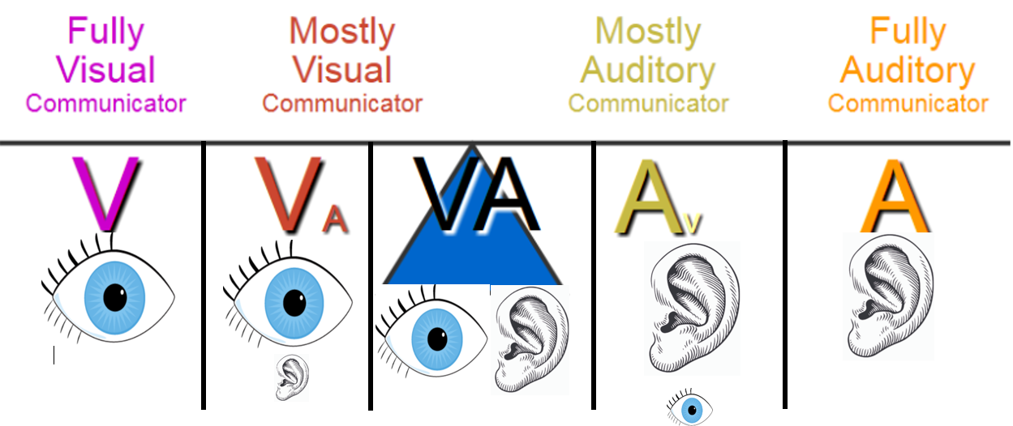
V: | Depends on visual information ASL/signs
V_{a:} | Depends on ASL/signs; obtains some benefit from auditory information
VA: | Equally depends on and able to use ASL/signs and auditory information via spoken language
A_{V}: | Depends on spoken language, sometimes needs sign to clarify spoken language
A: | Depends on auditory information via spoken language

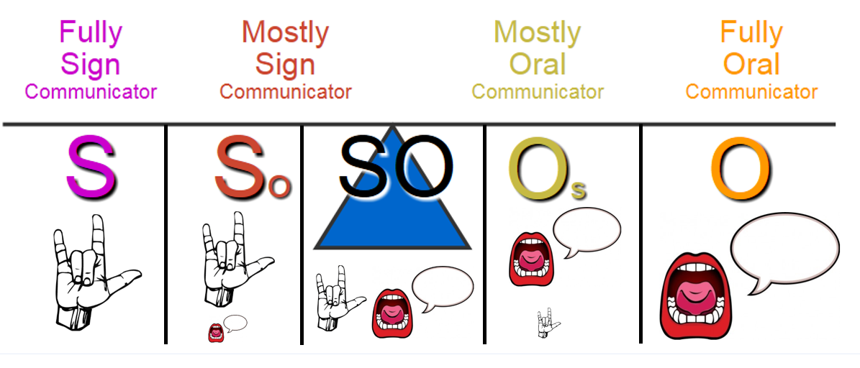
S: | Uses signs/ASL only
S_{o}: | Uses signs/ASL; some oral communication
SO: | Equally able to use sign and oral communication
O_{s}: | Uses oral communication; signs for clarification
O : | Uses oral communication only

 | How the student understands: | How the student expresses:
In the home with parent(s)/sibling(s): | Receptive language | Expressive language
In the classroom or childcare setting with teacher(s): | Receptive language | Expressive language
In the classroom or childcare setting with peer(s): | Receptive language | Expressive language
In social situations with hearing adult(s): | Receptive language | Expressive language
In social situations with Deaf adult(s): | Receptive language | Expressive language
In social situations with hearing peer(s): | Receptive language | Expressive language
In social situations with deaf peer(s): | Receptive language | Expressive language

Document any additional communication needs or supports (e.g. pictures, cues, etc.):
Additional communication needs or supports

(B) Opportunities for direct* communication with peers and professional personnel in the child’s language and communication mode;
*Direct language/communication/instruction occurs person to person, not through an additional source (e.g., educational interpreter, class note-taker, etc.)
Specify opportunities for direct* instruction. | List opportunities for direct instruction
Specify opportunities for direct* communication with peers. |  | List direct peer communication
Specify opportunities for direct* communication with professional staff and other school/childcare personnel.
List opportunities for direct communication with staff
List strategies for increasing opportunities for direct communication/instruction as needed
List strategies for increasing direct communication opportunities

(C) Academic level;
NOTE: | Considering the mode or modes of communication used by the student, identify all supports needed by this student to participate in the general curriculum and extracurricular activities and benefit from other school services available to all students; this information assists with the development of specialized instruction as well as appropriate accommodations and modifications.

1 a. | What supports have been provided to this child previously or currently to acquire the age/grade-level academic skills and concepts included in the general education curriculum?
 | List previous or current supports
 | 1 b. | What strategies are needed to increase the child’s proficiency in language and communication to acquire age/grade-level academic skills and concepts?
 |  | List needed strategies

2 a. | What supports have been provided to this child previously or currently to acquire daily living/functional living skills?
 | List previous or current supports
 | 2 b. | What strategies are needed to increase the child’s proficiency in communication and language development to acquire daily living/functional living skills?
 |  | List needed strategies

(D) Full range of needs

The IEP team has considered the full range of needs, which is defined as encompassing academic, language, and social needs involving opportunities for direct instruction in the student’s language and communication mode as well as incorporated this information in the student’s IEP and reviewed annually.
Comments: | Add comments here

Historical record of document review:
School/District | Participants | Review Date Log
Name | Names of all participants | Date
Name | Names of all participants | Date
Name | Names of all participants | Date
Name | Names of all participants | Date
Name | Names of all participants | Date
Name | Names of all participants | Date
Name | Names of all participants | Date
Name | Names of all participants | Date
Name | Names of all participants | Date
Name | Names of all participants | Date
Name | Names of all participants | Date
Name | Names of all participants | Date
Name | Names of all participants | Date
Name | Names of all participants | Date

Adapted from “Communication Considerations for Students who are Deaf or Hard of Hearing,” New Mexico, “IEP Communication Plan for Students Who are Deaf or Hard of Hearing,” Iowa, “Communication Plan for Child/Student Who is Deaf/Hard of Hearing,” Colorado, and “Student Language and Communication Profile Summary,” Laurent Clerc National Deaf Education Center, Gallaudet University
Revised 4/2020

