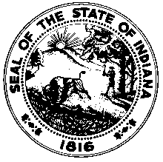

Governor’s Workforce Cabinet

Agenda
Thursday, April 18, 2019
10:00 a.m. – 12:00 p.m.
Indiana State Library, History Reference Room
315 W. Ohio St.
Indianapolis, IN

- Call to Order

- Roll Call of Members

- Approval of the Minutes

- Reports
  - Chairman’s Report

  - Agency Reports

  - Committee Updates

- New Business

  - Oren Cass - Presentation
  - Local Career Coaching Grant Parameters
  - Committee Approval
  - Legislative Update
  - National Association of Workforce Boards 2019 Forum Summary
  - American Workforce Policy Advisory Board Update

- Adjournment

