Appendix 5. Governance Structure

Overview
The State is implementing a rigorous, multi-layered Governance Structure that balances accountability, collaboration, mutual support, and regional flexibility. This structure is designed to ensure projects respond to local needs while maintaining strong oversight and alignment with State and CMS requirements.
As a condition for receipt of Regional Grants funding, each Regional Coalition must adhere to the Growing Rural Opportunities for Well-being (GROW) Regional Grants Governance Structure. Regional Coalitions are expected to collaborate within and across Governance Structure entities to support a streamlined planning and implementation process that is accountable to both the State of Indiana and CMS.
The GROW Regional Grants Governance Structure operates within Indiana’s broader Rural Health Transformation Program (“Program”) structure which provides oversight across all twelve (12) initiatives, including the State Steering Committee, the HFS Executive Oversight Committee, and the Governor’s Office. This ensures there is consistent awareness and comprehensive monitoring of progress across all Program initiatives. The GROW Regional Grants Governance Structure is also comprised of entities specifically established to support Regional Coalitions in developing and implementing projects that are responsive to local needs.
Each governance entity has defined responsibilities that collectively support strategic regional partnerships, promote quality improvement, strengthen the financial stability of rural facilities, and expand access to care.

Indiana RHTP Governance Structure
Figure 1. Indiana RHTP Governance Structure

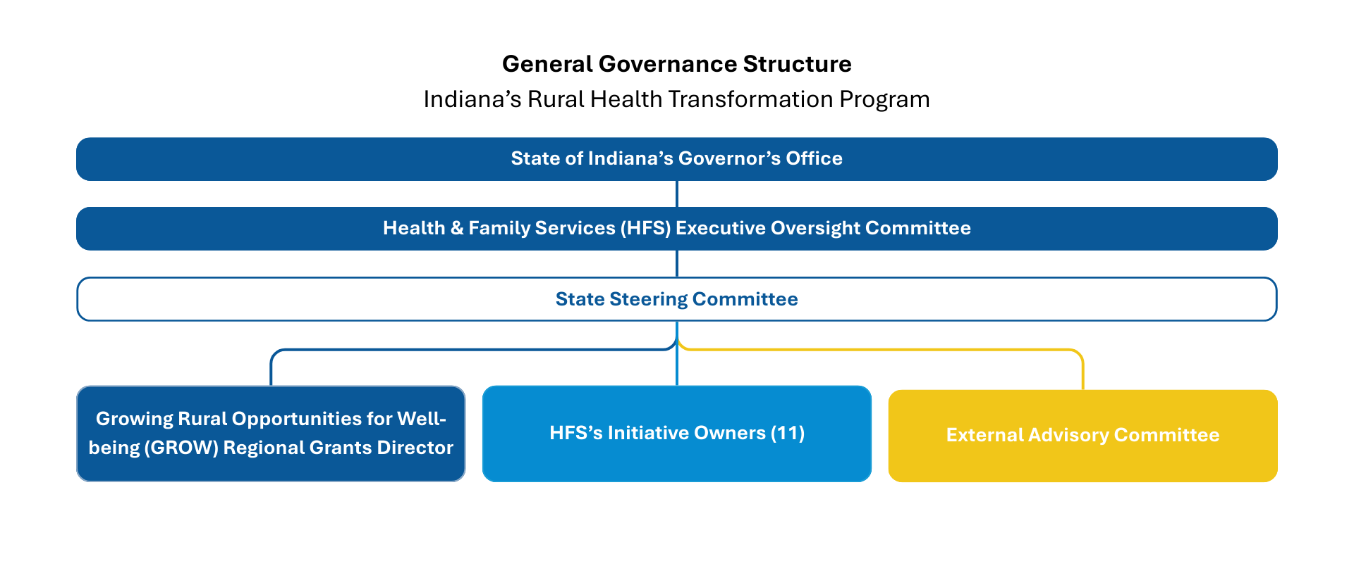

Executive Oversight Committee
The Executive Oversight Committee consists of leadership and subject matter experts from the Health and Family Services (HFS) vertical agencies and the Governor’s office.
The Executive Oversight Committee maintains oversight throughout the life of the grant and retains the ability to adjust funding amounts year after year based on compliance and outcomes. The Committee maintains the final decision-making capacity for:
- Application approval,
- Funding amounts, and
- Oversight into reporting, budget and key performance outcomes.

State Steering Committee
The State Steering Committee, jointly staffed by the Family and Social Services Agency (FSSA) and the Indiana Department of Health (IDOH), oversees all activities, progress, and risks across the full Program.

RHTP Advisory Committee
The RHTP Advisory Committee serves in a strictly advisory capacity, leveraging unique knowledge and skills to:
- Offer expertise;
- Offer recommendations and insight to inform the State Steering Committee;
- Facilitate connections both statewide and for Regional Grants, including community partners, and other relevant entities; and
- Propose support/solutions for specific initiatives when needed to navigate complexities of the initiatives.

GROW Regional Grants Governance Structure
Figure 2: GROW Regional Grants Governance Structure
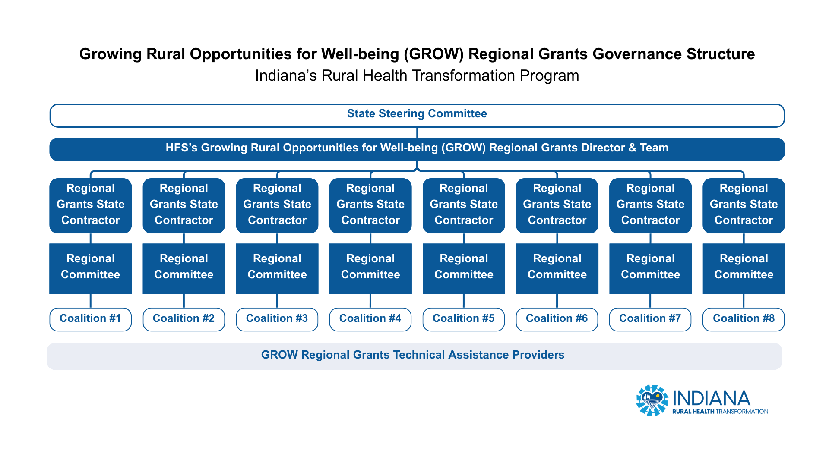

State GROW Regional Grants Team
The State GROW Regional Grants Team oversees operations of the Regional Grants implementation.
The eight (8) Regional Grants State Contractors report directly to this team. The State Team monitors Regional Coalition performance, implementation progress, risks, and sustainability through ongoing stakeholder engagement.

Regional Grants State Contractor
The State will assign one (1) Regional Grants Contractor to each of the eight (8) Regional Coalitions. The eight (8) Regional Grants State Contractors will be engaged within each region to facilitate the success of the Regional Grants implementation and report directly to the State GROW Regional Grants Team for oversight of Regional Grants. These contractors will be responsible for contract and budget management, reporting compliance and collection, and will be the main State point of contact for Primary Subrecipients within the Regional Coalition and Regional Committees.

Regional Coalitions
Regional Coalitions will consist of healthcare providers, public health entities, and other regional stakeholders collaborating to identify priorities, develop proposed initiatives, and oversee implementation of funded activities. The Coalition is responsible for ensuring that projects reflect the collective needs of the region and promote coordinated, region-wide impact.
Each Regional Coalition must establish its own collaborative structure and decision-making process that defines roles, authority, and processes for collaboration and accountability throughout the grant period. The Coalition is responsible for maintaining active engagement among members, monitoring implementation progress, and ensuring alignment with State requirements. The Regional Coalition must collaborate with the Regional Committee in alignment with the Regional Coalition’s proposed collaborative structure and the State’s direction.
Each Regional Coalition will work with the Technical Assistance Providers to submit one unified application that reflects the unique needs of the region.

Regional Committee
The Regional Committee consists of fourteen (14) stakeholders within the individual region, appointed by the State Executive Oversight body, and exists only in an advisory capacity.
They will represent key rural health stakeholders, utilizing subject matter expertise to assess potential beneficiaries of the Regional Grants, thus ensuring an equitable distribution of funds and accountability.
The Regional Committee must meet at least quarterly to provide strategic guidance, foster regional collaboration, drive accountability, and review regional progress and impact. The expectation is that the Regional Committees will review regional applications before they are submitted to the State.

Technical Assistance Providers
Figure 3: Rural Health Transformation Technical Assistance Provider Network (RHT-TAN) Structure
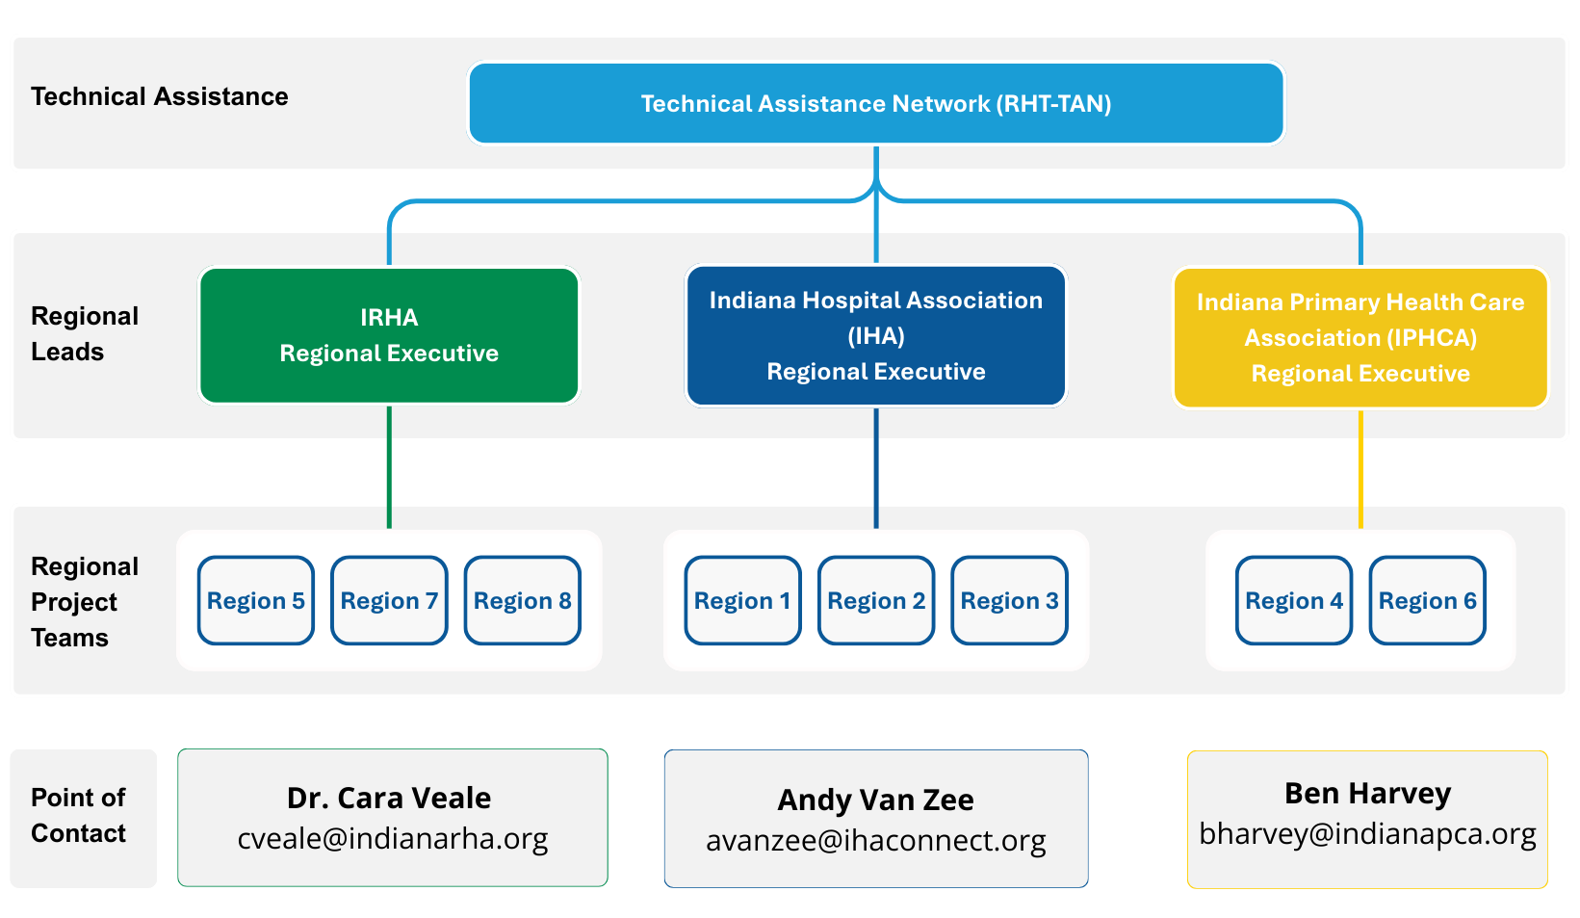
To ensure statewide consistency, equitable support, and rural health expertise, the Indiana Hospital Association (IHA), the Indiana Primary Health Care Association (IPHCA) and the Indiana Rural Health Association (IRHA)—hence force referred to as the Rural Health Transformation Technical Assistance Network (RHT-TAN)—will function as a statewide technical assistance and administrative support model for the GROW Regional Grants across the eight Regional Coalitions. Throughout application development, the RHT-TAN will support Regional Coalitions by convening stakeholders and potential Subrecipients within each region, supporting regional Needs Assessments, helping the Regional Coalitions set priorities and design proposed activities in response to identified needs, supporting Regional Coalitions to develop logic models, budgets, and staffing models necessary to administer proposed grant activities, and helping regions assemble complete applications as defined by the requirements in the Growing Rural Opportunities for Well-being (GROW) Regional Grants Program Request for Funding (RFF) application. RHT-TAN will support the identification and convening of regional stakeholders and facilitate Regional Committee meetings. Regional Coalitions will work with their Technical Assistance Provider to submit their Application Package to the State.
Following award, the RHT-TAN will support Regional Coalitions during project implementation by tracking progress against milestones and deliverables, proactively identifying risks and implementation challenges, and providing troubleshooting and problem-solving support. In addition, they will deliver subject matter expertise through one-on-one technical assistance and the facilitation of training, peer learning, and best-practice dissemination across regions.

