Indiana Department of Veterans Affairs
Veteran Service Organizations
FY25 Grant Solicitation



Solicitation Release Date: April 01, 2024

Application Deadline: May 15, 2024 – 5:00 PM EST

Grant Period of Performance: July 1, 2024 – June 30, 2025

The Indiana Department of Veterans Affairs (IDVA) is seeking applications from eligible Veteran Service Organizations (VSO).

The grant amounts will vary depending on each applicant’s need for funds, past performance assisting veterans in securing available benefits, and the volume of eligible VSO applicants.

All applications, procedures, and documentation should follow Indiana Code, Indiana Administrative Code, and Indiana Department of Veterans Affairs’ policies.

Grant applications and required documentation shall be submitted online.

Contact Information

Gabrielle J. Owens
General Counsel
GOwens1@dva.in.gov / (317) 232-3165

Brookelynn Deaton
Grant and Compliance Administrator
BDeaton1@dva.in.gov / (317) 234-86

Contents
Important Dates 4
Eligibility and Purpose 4
Application Process 4
Grant Award 5
Allowable & Unallowable Costs 5
Reporting 6
Noncompliance 7
Unobligated Funds 7
Goals 7
Appendix A 8

Important Dates

Steps in Process | Date
Grant Solicitation Release | 04/01/2024
Grant Press Release | 04/05/2024
Grant Q&A Session | 04/10/2024
Grant Applications Due | 05/15/2024
Grant Scoring Complete | 05/22/2024
Award Notices Sent | 05/24/2024
Revised Budgets and Project Narratives Due | 05/31/2024
Grant Period of Performance Starts | 07/01/2024

Dates may be subject to change at Indiana Department of Veterans Affairs discretion.

Eligibility and Purpose
An eligible applicant is an organization that meets the criteria set forth in the Indiana Budget for Fiscal Year 2025 (Appendix A).
- The Indiana Department of Veterans Affairs shall provide grants to organizations in accordance with Section 5902 (formerly Section 3402) of Title 38, United States Code (U.S.C.) and subsections 14.628(a) and (c) of 38 C.F.R.
- Eligible organizations shall have an accredited Veteran Service Officer with a presence in Indiana.
The organization must be financially able to provide the services proposed in its application and must be able to utilize or obligate the grant funds during the grant year. Additionally, the organization must be in compliance with all state and federal laws and be free of tax liabilities.

VSO Grant awards may only be used to assist veterans in securing available benefits.

Application Process
Applicants must submit the following:

- A completed Application for Grants for Veteran Service Organizations.
- A detailed explanation of the organization's mission, activities, and membership.
- A detailed description of all the services provided to veterans by the organization and a detailed explanation of how those services align with the services described in IC 10-17-13.5-4(a).
- A detailed description regarding the effective use of the organization's funding. This shall include 3-5 goals or objectives, as well as a set of performance indicators to measure the success toward meeting those goals, a detailed description of what data will be collected for those indicators, and anticipated benchmarks for success.
- Programmatic data evidencing past performance assisting veterans with securing their benefits for at least three years prior to this application.
- Copies of the organization’s articles of incorporation and bylaws.
- A letter from the Internal Revenue Service affirming the organization's tax-exempt status under Section 501 of the Internal Revenue Code.
- Audited financial statements of the organization from an independent auditor for the last three (3) years or the life of the organization, whichever is shorter.
- Organization’s federal and state tax returns for the last three (3) years or the life of the organization, whichever is shorter.
- A detailed statement describing the organization's need for a grant, a description of services to assist veterans securing their benefits, and evidence that the organization can address the need. This shall service as your Project Narrative which will be attached to the grant agreement as Exhibit A and should not exceed ten (10) pages.
- A detailed line-item budget proposal describing how any grant funds will be used.

Goals

As stated above in the “Application Process,” applicants are to submit three to five goals or objectives they plan to meet if they receive funding. VSOs offer a wide range of services to the veteran population, including, but not limited to, hosting job fairs, assisting with housing for homeless veterans, and providing access to accredited veteran service representatives who help apply for VA benefits. There will be a tab labeled “Goals” in the organization’s workbook for reporting and reimbursements to outline successes, obstacles, and progress of the organization’s defined and detailed goals. The collection of this information allows IDVA to share successes and highlights of the organization.

Grant Award

An organization that is awarded a grant shall not receive any funding until a grant agreement is fully executed by all requisite state agencies.

Allowable & Unallowable Costs

Allowable costs are costs necessary and reasonable to perform the program. All costs associated with the proposed program shall be included in the organization’s proposed budget as Exhibit B. Allowable costs include, not are not limited to:

- Travel Expenses
- Salaries and Benefits
- Supplies
- Postage
- Training/Conferences for education or certification
- Promotional Materials setting forth the Grantee’s contact information
- Direct service to Veterans
- Transportation of Veterans
- Equipment
Unallowable costs are costs that do not further the program purpose or contribute to the successful operation of the program. Any unallowable costs will be denied. Unallowable costs include, but are not limited to:

- Gifts, subgrants, donations to other organizations
- Fines and penalties
- Uniforms, logo merchandise, or organizational branded merchandise
- Speaker costs
- Annual conference costs
- Entertainment costs
- Capital improvements/Repairs to buildings or structures
- Food for consumption at an event or meeting
- Alcohol
- Lobbying
- Fundraising
- Purchase or acquisition of real estate
- Any cost that is unreasonable

If a grantee needs a budget modification during the grant period, the grantee must submit that request in writing. The budget modification must be approved by Indiana Department of Veterans Affairs prior to the grantee implementing the modification.

Any grantees who receive an award for direct assistance to veterans, must coordinate with the Indiana Department of Veterans Affairs, Military Family Relief Fund prior to providing the direct assistance. This partnership will ensure non-duplication of efforts and allow a greater scope of resources.

Reporting

All grantees are required to do the following:

- Account for all grant funds received under this program using generally accepted accounting principles. A grantee shall track all assets, expenses, cost of goods, and use of funds.
- Any purchases of supplies or equipment for $1,000 or more, purchased with monies from the grant, must be given an asset tag. Indiana Department of Veterans Affairs must be notified if the grantee, at any time wishes to sell, dispose, or donate said asset. Approval of Indiana Department of Veterans Affairs is required prior to disposition of any asset. Asset tags will be provided by Indiana Department of Veterans Affairs and are subject to audit verification.
- Submit monthly or quarterly financial reports to the Indiana Department of Veterans Affairs detailing all grant-related expenditures on a form prescribed by the Indiana Department of Veterans Affairs. A grantee shall also submit a comprehensive financial report of the grant at the end of the grant period.
- Submit monthly or quarterly an invoice seeking reimbursement to the Indiana Department of Veterans Affairs.
- Submit monthly or quarterly programmatic reports to the Indiana Department of Veterans Affairs detailing all grant-related programmatic successes. Submit a detailed performance report at the end of the grant period of performance detailing the outcomes achieved by the organization awarded the grant. The report must include the performance data and metrics identified in the original grant application. The report must also include a detailed analysis comparing the outcomes achieved to the benchmarks for success identified in the grant application.
- Submit a detailed performance report at the end of the grant period of performance detailing the outcomes achieved by the organization awarded the grant. The report must include the performance data and metrics identified in the original grant application. The report must also include a detailed analysis comparing the outcomes achieved to the benchmarks for success identified in the grant application.
- All reports and supporting documentation shall be submitted by email.

Indiana Department of Veterans Affairs hosts quarterly meetings for all its grantees. At least one representative of the organization must attend, either virtually or in person. The grantee quarterly training will be conducted by the grant administrator and/or general counsel.

As it deems necessary, the Indiana Department of Veterans Affairs may audit or inspect any and all books, accounting records, or other documents related to the grant at any time. The Indiana Department of Veterans Affairs may require a grantee, at grantee's expense, to obtain an independent audit from an auditor approved by the Indiana Department of Veterans’ Affairs.

Noncompliance

If the Indiana Department of Veterans Affairs determines that a grantee is not in compliance with the terms of the grant agreement or has failed to maintain compliance with the eligibility requirements, the Indiana Department of Veterans Affairs shall terminate the grant agreement and notify the grantee in writing.

If it is determined that any funds paid to the grantee were inappropriate and/or due to the grantee’s non-compliance, those funds shall be returned to the Indiana Department of Veterans Affairs.

Unobligated Funds

Any funds not obligated within the performance period will be unavailable to the grantee.

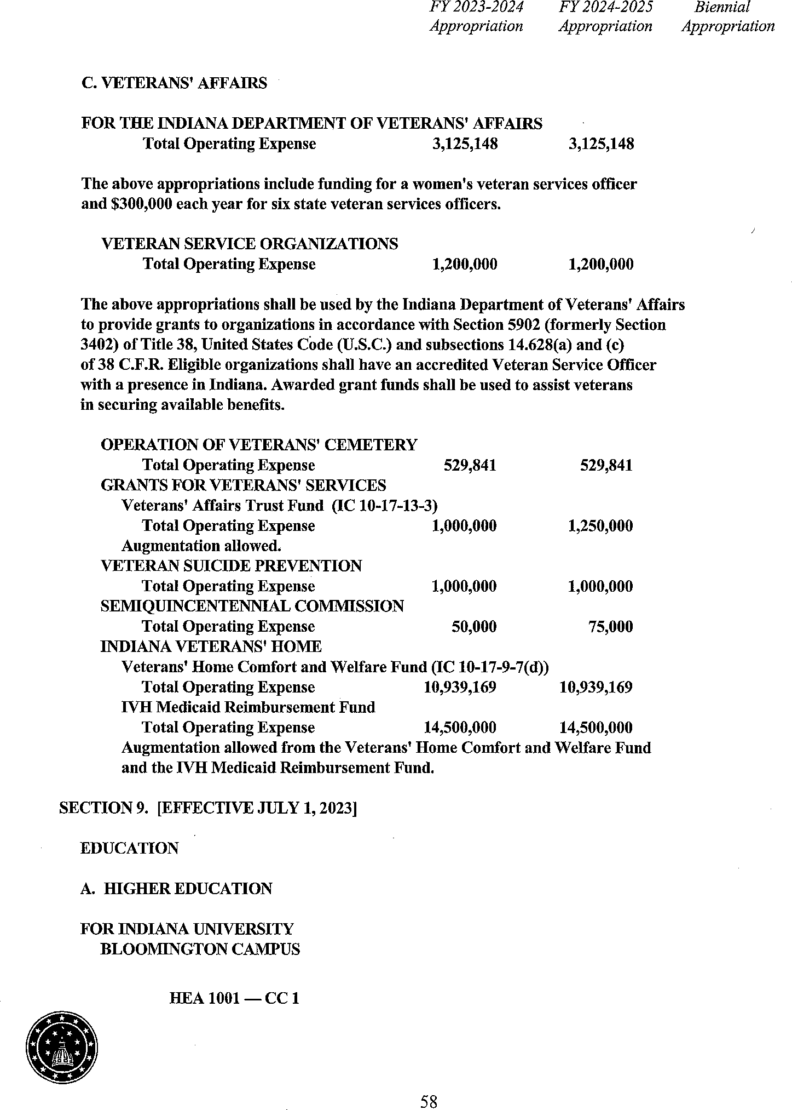
Appendix A

