Indiana Department of Veterans Affairs
2023 Non-Profit Partner
Solicitation

November 16, 2022

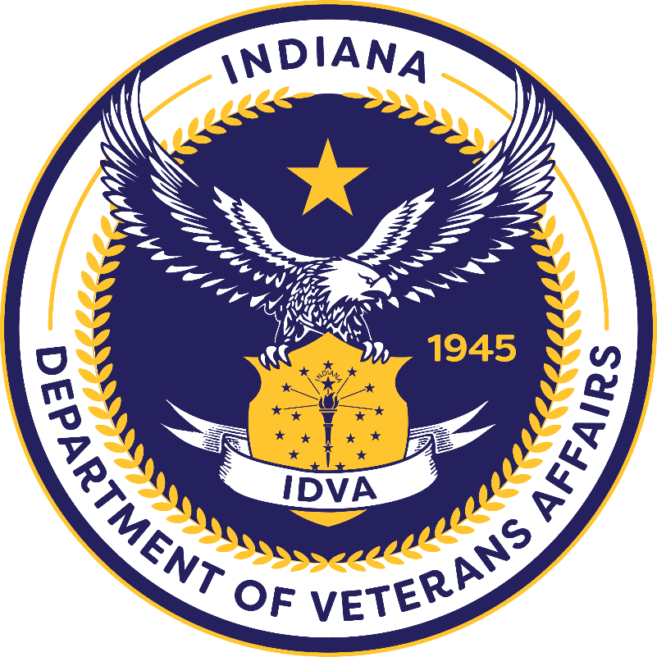

Indiana Department of Veterans Affairs
Non-Profit Partner for 2023 Solicitation

Solicitation Release – November 16, 2022

Application Deadline: - December 16, 2022

Period of Performance: 12 Calendar Months

The Indiana Department of Veterans Affairs (“IDVA”) is seeking applications for a non-profit organization to serve as the Non-Profit Partner of the Year (“NPP23”). The NPP23 will actively partner with IDVA for annual fundraising events. These events are intended to raise funds to be utilized by the NPP23 to enhance its service to Indiana Veterans.

All applications, procedures, and documentation should comply with the Indiana Code, the Indiana Administrative Code, and any applicable Indiana Department of Veterans Affairs’ policies.

Contact Information

Gabrielle J. Owens, General Counsel GOwens1@dva.in.gov (317) 232-3165

Anthony Weber, Deputy Director AWeber@dva.IN.gov (317) 234-8662

All questions should be sent via the email above.

Definitions 4
Eligibility 4
Important Dates 5
Application Process 5
Letters of Support 6
Application Review 6
Award 7
Unallowable Costs of Non-Profit Partner 2023 Funds 7
Appendix A 8
Non-Profit Partner 2023 Application

Definitions

- “Veteran” means an individual residing in Indiana who:
- Has served in any branch of the Armed Forces of the United
States or their reserves, in the National Guard; and
(2) Must not have received a dishonorable discharge.

- “Non-Profit” means an organization that has a 501(c)(3) tax-exempt status
as proven by documentation from the Internal Revenue Service.

Eligibility

An eligible applicant is an organization that serves Veterans and has a 501(c)(3) tax-exempt status and provides services to Veterans residing in Indiana or to entice Veterans to relocate to Indiana. The NPP23 must be financially able to provide the services proposed in its application. The organization must be in compliance with all state and federal laws and shall not have any liabilities to the State of Indiana including, but not limited to, the Indiana Department of Revenue or the Indiana Department of Workforce Development.

Additionally, the NPP23 must have the resources to serve as an active partner with IDVA including, but not limited to:

  - Assisting with the planning of multiple annual events;
  - Having personnel and/or volunteers to perform duties at each event;
  - Leveraging other partnerships to enhance the participation of and help ensure the success of each event; and
  - Utilizing all promotional avenues to promote and publicize each event.

Important Dates

Steps in Process | Date
Grant Solicitation Announcement | 11/16/2022
Q&A Session | 12/02/2022
Applications Due | 12/16/2022
Application Reviews Complete | 12/22/2022
Award Notice | 12/30/2022

Application Process

Please submit a letter of intent to apply for NPP23 by 4:00 pm on the due date listed above. This should be on official letterhead of the organization and should provide a brief description of your anticipated programs that will use the NPP funds, as well as the service area in which you plan serve. NPP funds must be used to enhance an organization’s programs or services to Veterans.

To apply for NPP23, an organization must submit a written application on the form prescribed by the Indiana Department of Veterans Affairs (Appendix A). The entire application should be no longer than 10 pages. The organization’s application must be accompanied by the following documentation:

  - The name, address, and contact information, including email address, of the organization.
  - The name, address, and contact information of the chief executive officer or the chief financial officer of the organization.
  - Evidence that the organization is registered with the Indiana Secretary of State.
  - A detailed explanation of the organization's mission, activities, and membership.
  - A detailed description of all services provided to Veterans by the organization.
  - A letter from the Internal Revenue Service affirming the organization's tax-exempt status under Section 501 of the Internal Revenue Code.
  - A detailed explanation of the organization’s achievements during the past calendar year.

An application will not be considered eligible for approval until all required documents have been received by IDVA. IDVA may deny an incomplete application.

If there is a change to the organization’s application, or documentation contained therein, the organization shall notify the Indiana Department of Veterans Affairs within ten (10) days of the change. The Indiana Department of Veterans’ Affairs may revoke an organization’s eligibility for NPP23 if the changes affect the applicant's eligibility.

Letters of Support

Letters of support are strongly recommended. These letters of support should be from individuals, businesses, institutions of higher education, or other organizations that serve Veterans. These letters of support need to be on the official letterhead of the supporting organization. If the letters of support are from individuals, there is no need for official letterhead; however, the individual’s contact information must be contained within the letter.

Application Review

The Indiana Department of Veterans’ Affairs will review all applications for completeness. Complete applications will be scored by a team of individuals. Scoring factors will include, but are not limited to:

- The organization’s geographic location;
- The number of Veterans in the organization’s service area;
- The organization’s ability to be an active partner with IDVA;
- The organization’s ability to meaningfully serve Veterans; and
- Letters of support.

Award

After IDVA identifies the NPP23, the organization will be notified in writing. Organizations not selected will also be notified in writing. Organizations that are not selected cannot appeal IDVA’s selection.

Unallowable Uses of Non-Profit of the Year Funds

The NPP may not use funds from this partnership with IDVA to:

- Satisfy any federal, state, or local tax, fee, or fine;
- Purchase alcohol;
- Lobbying;
- Bonuses to employees or volunteers of the organization;
- Renovations or construction; or
- Purchase real property.

Appendix A

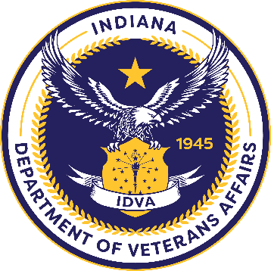
APPLICATION FOR NON-PROFIT PARNTNER 2023

Name of Organization:
Federal Tax ID Number:
Point of Contact: |  | Contact Number:
Address:
County: Service Area(s):
Email Address:
Are you registered with the Indiana Secretary of State? Yes No
Question One: What are your current fundraising activities?
Question Two: What are your overarching goals/objectives if you were chosen?

Continued on Following Page
Question Three: Describe your accounting practices and/or accounting software.
Question Four: Describe the resources and other partnerships that you would leverage as Non-Profit Partner 2023.
Question Five: Do you owe any monies to the State of Indiana including, but not limited to, the Indiana Department of Revenue or the Indiana Department of Workforce Development? YES NO

If yes, please explain:
Total funds received/raised for each of the past three fiscal years:  Calendar Year 2022 $_______________________  Calendar Year 2021 $_______________________  Calendar Year 2020 $_______________________ |  |  | Number of veterans served:  Calendar Year 2022 _____________________  Calendar Year 2021 _____________________  Calendar Year 2020 _____________________
CHECKLIST
___ Proposal

___ Letters of Support

___ Goals and Program Documentation

(Signature) | (Print Name) |  |  | (Date)

Please send this application with your supporting documentation to:
Indiana Department of Veterans Affairs
Attention: Anthony Weber
777 North Meridian Street, Suite 300
Indianapolis, IN 46204

