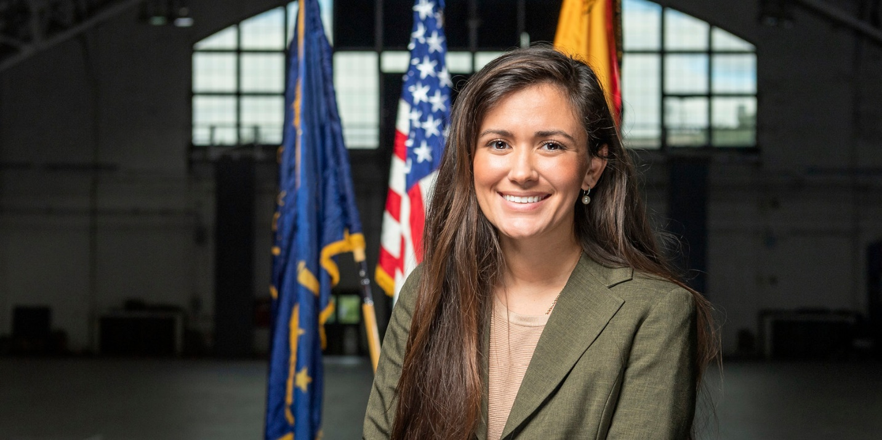Morgan Torres is the Director of the Veterans Success Center at Purdue University. The Veterans Success Center is responsible for managing a portfolio of over 1,500 military-connected students pursuing and using education benefits at Purdue University. She served in the U.S. Army Reserve as a motor transporter. Collectively, she earned three Army Achievement Awards and held several leadership positions within her platoon during her time in the service.

