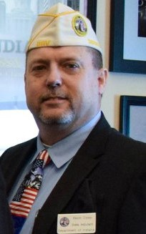
Kevin Coley has been with the DAV for 13 years. The last six years Kevin has been hired as the State Department Adjutant. I manage the day to running of 28 chapters within the State of Indiana. I served in the Army and Army Reserve for 21 years. I retired as a First Sergeant E-8 in April 2001. I have served on the IDVA Commission for the last four years. I served in the first Gulf War from November 1990 until July of 1991. I am a service connected combat veteran.

