INDIANA DEPARTMENT OF VETERANS AFFAIRS
ANNUAL REPORT
2019 (July 1, 2018 – June 30, 2019)
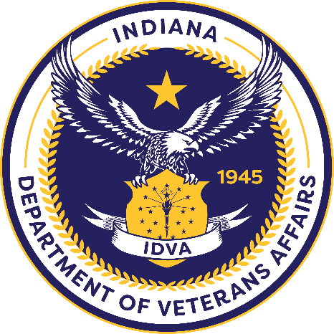

Contents
Section 1: Department Overview 1
Section 2: Executive Staff 2
Section 3: IDVA Staff 3
Section 4: Division Overview - Training and Services 4
Section 5: Division Overview - Military Family Relief Fund (MFRF) 7
Section 6: Division Overview - State Approving Agency (SAA) 8
Section 7: Division Overview - Legal 9
Section 8: Division Overview - Communications 9
Section 9: Division Overview - Women Veterans 11
Section 10: Indiana Veterans Memorial Cemetery 13
Section 11: Indiana Veterans Home 15
Section 12: Letter from the Director 18

Section 1: Department Overview
Since its establishment in 1945, the Indiana Department of Veterans Affairs (IDVA) has remained focused on improving the lives of Hoosier veterans. As veteran communities and benefits evolve, the IDVA is dedicated to customizing communication to reach every veterans and family category or group. The IDVA staff creates, coordinates and participates in direct outreach events for veterans and their families across the state daily.

Thanks in part to key partnerships with the Indiana National Guard and many other veteran organizations, IDVA continues to increase the number of veterans placed in jobs, receiving state and federal benefits, and attending tailored events to advance their ability to Live, Work and Thrive in Indiana.
IDVA has experienced considerable changes in leadership in the fiscal year. Over a brief period, there were multiple resignations including the director and deputy director. In January 2019, Dennis A. Wimer was appointed as IDVA director. Over the past year, Director Wimer has brought stable leadership, modern vision and full transparency to the division.

Notable improvements include the IDVA Military Family Relief Fund (MFRF), which experienced reconstruction in cooperation with the Indiana Veterans Affairs Commission. IDVA has fostered and expanded State of Indiana partnerships as well as private sector relationships.

Director Wimer is overseeing a re-structuring of IDVA executive leadership to further advance the department. Executive positions created and filled include Operations Director, General Council, and Outreach Director. IDVA is currently redefining additional policies to empower the dedicated division leaders and staff throughout the department.

Aligning the mission and vision of the entire IDVA, including the Indiana Veterans Memorial Cemetery and the Indiana Veterans Home, is well on its way. The future of IDVA is positive, transparent and dedicated to make Indiana a premier state where veterans Live, Work and Thrive.

Section 2: Executive Staff
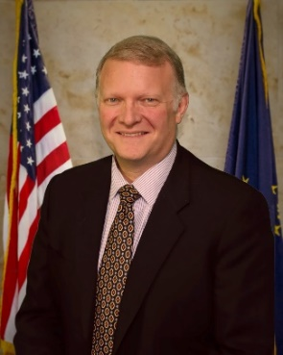
Dennis A. Wimer, Director
Dennis has been serving as director for one year. He is an Air Force veteran who brings a wealth of experience from the business, nonprofit and educational industries. He brings a servant’s mindset to the agency and is excited to continue serving Indiana’s veterans and their families.

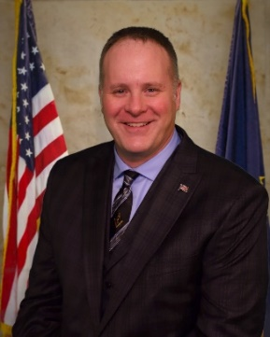
Mike Thompson, Operations Director
Mike most recently served in the Indiana Department of Workforce Development. He is currently a member of the 38th Sustainment Brigade as distribution and integration staff sergeant, Indiana National Guard. He is attending college at Trine University where he is two classes away from completing his MS degree in Leadership.

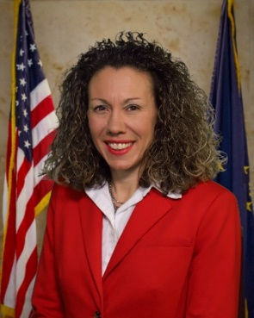
Gabrielle Owens, General Counsel
As General Counsel, Gabrielle is providing legal advice as well as leadership in departmental policy, audit and legislative functions. Most recently, she served in the Indiana Criminal Justice Institute and has over 20 years’ experience in practicing law. Gabrielle is the daughter of a retired Air Force colonel.

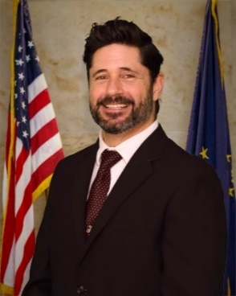
Joseph DeVito, Outreach Coordinator
Joe joins us from Madison where he formerly served as the District State Veteran Service Officer for the Southeast District. He is a Coast Guard veteran and graduate of Indiana University Southeast. Joe has experience in business, outreach and volunteer work. As Outreach Coordinator, he brings a passion for reaching veterans and increasing the number of veterans served and benefits awarded across the state.

Section 3: IDVA Staff
Top row (left to right): Gabrielle Owens, Ray Baker, James Morrison, Phil Krumm, Mike Thompson, Joe DeVito, Matt McDermitt. Middle row (left to right): Nicole VanDyke, Dennis Wimer, Kirsten Clark, Mike Aichele, Tim Dyke, Mike Hamm, Laura McKee. Bottom row (left to right): Summer Tacy, Tara Eggen, Kay Ross, Amber Mertens, Kelly Cherry and Lynn Dickey.
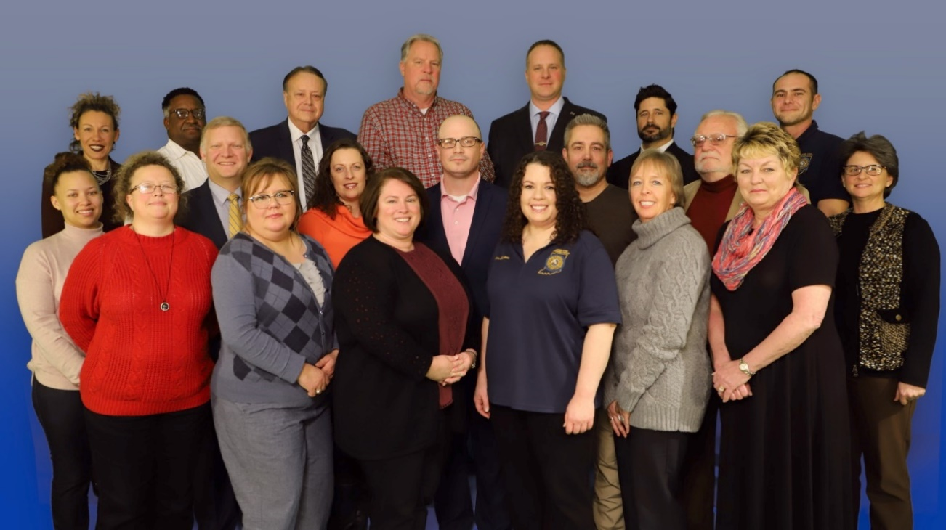

Section 4: Division Overview - Training and Services

Indiana State Benefit applications processed YTD for 2019:
Veteran License Plates (DHV, PH, POW/MIA): 710
Disabled Veteran Property Tax Deductions: 855

Tuition and Fee Exemption Scholar Track Applications:
(2019-2020 Academic Year): 543
(2018-2019 Academic Year): 1,866 Online applications only at scholartrack.in.gov.
Total: 2,409

TOTAL Applications Processed: 4,517

Training and Services (continued)

District Service Officers
The (6) DSOs each cover 15+ County Veteran Service Offices (CVSOs). The DSOs provide on-site training, community outreach and special projects assistance to the offices. A new District Service Officer (DSO) was offered the job in the Central West District in November.

County Veteran Service Officers
Accredited CVSOs: 87
Accredited Assistant CVSOs: 12
Fayette and Shelby Counties share same CVSO (Cambria Sparks)

Summary:
This year the annual CVSO training was held June 10-12, 2019 at the R. Martin Umbarger Conference Center in Edinburgh, Indiana. Over 120 service officers and their staff attended. Presenters from the Louisville VA Medical Center briefed on the new Mission Act. We also had presentations about the Appeals Modernization Act, Suicide Prevention, and an update from the VA regional office Director, Mike Stephens and his staff. Other presentation topics included: updates of state benefits due to legislative changes, pension eligibility, claim development for asbestos exposure and a briefing from our partners at the Indiana Department of Workforce Development. An annual exam was administered to identify training needs and checks on learning.

The service department has continued to work closely with the Commission for Higher Education with updates and features within the Scholar Track website. Tuition and Fee Exemption applications for Purple Heart Recipients and Children of Veterans are completed online through this website. This has put the program in line with all other state aid programs and has streamlined the application and approval process exponentially.

Training and Services (continued)

Veteran and Support our Troops license plate sales for 2019 were over $1.6 million. These dollars go into the Military Family Relief Fund which assists eligible veterans in financial distress. The 2019 legislation increased a disabled property tax deduction from $12,480 to $14,000 beginning in the 2020 property assessment year and increased the maximum property value from $175K to $220K. A disabled Hoosier veteran parking placard was created and was available to eligible veterans the first week of July. This placard allows the veteran more flexibility for free handicapped metered parking in Indiana as it can be moved to various vehicles the veteran uses for transportation. A new disabled Hoosier veteran license plate will also be designed to include the veteran’s branch of service insignia on the plate.

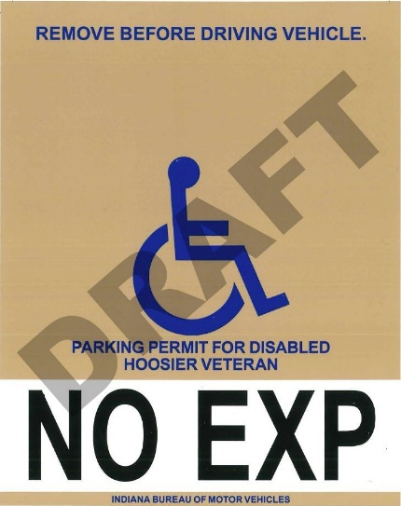

Section 5: Division Overview - Military Family Relief Fund (MFRF)
Beginning Jan. 2, 2007, the IDVA began accepting grant applications from the families of deployed or recently deployed Indiana National Guard members and members of the Selected Reserves. Effective July 1, 2017, the MFRF became available to all veterans that served on active duty during a national conflict or war time period. Funding comes from the BMV military license plate sales and private donations.

The MFRF is designed to assist veterans and their dependents who are experiencing financial hardship. Qualified veterans may use the grant for essential living needs such as food, housing, utilities, medical services, basic transportation and childcare. The MFRF processed 1,716 applications in the fiscal year 2019. Grants totaling $1,394,481.93 were given to aid our veterans.

Housing and utilities are the most frequently requested needs for assistance. The emergency grants awarded have kept many veteran families in their homes by avoiding evictions and utility disconnections. In the past year multiple phases of the MFRF processes have been streamlined, to include full transparency and a fair appeals process. The MFRF leadership is dedicated to keeping the application and process steps modern and accessible to all applicants.

The MFRF also helps veterans by connecting them with other assistance programs such as: free financial counseling, employment counseling through the Indiana Department of Workforce Development and legal assistance through the Indiana Legal Services Military Assistance Project.

Section 6: Division Overview - State Approving Agency (SAA)
There were 48 compliance survey visits assigned for 2019. Targeted Risk Based Reviews complaints completed two for the year. Completed the work with the Commission of Higher Education on Compliance with 38 U.S.C. 3679(c) for Chapter 31 in state tuition. All seven schools have been confirmed as in compliance.

SAA has reviewed 197 institutions’ catalogs and bulletins, to approve their programs, process addendum to their catalog to delete programs and add new programs in their catalog for veterans/dependents to be certified for GIBILL® benefits. To date, we participated in 17 outreach events and 10 liaison events. The SAA has worked and approved 49 new locations for veterans/dependents to use GIBILL® benefits.

During the SAA’s National Association of State Approving Agencies (NASAA) Summer Business and Training Conference, Amber Mertens was elected as NASAA Secretary and Ray Baker was elected as Alternate Vice President for the Central Region. Baker also sits on two other committees, Conference Planning and Automation and Technology.

The SAA managed and completed all requirements of the 2019 Cooperative Agreement to include 40 additional supervisory visits to Apprenticeship and On-the-Job Training establishments.

Section 7: Division Overview - Legal
During fiscal year 2019, the Indiana Department of Veterans Affairs determined that it needed to include in its compliment a General Counsel and thereby establish an IDVA Legal Division. The IDVA Legal Division was tasked with numerous duties and responsibilities, including but not limited to:
- Providing counsel to the IDVA executive team and IDVA employees
- Representing IDVA in all tuition and fee exemption appeals
- Representing IDVA in Military Family Relief Fund appeals
- Coordinating the IDVA legislative activities
- Administering the solicitation and award of state and federal grants
- Executing grant agreements with IDVA grantees
- Executing contracts for necessary services provided to IDVA
- Creating and administering an internal and external compliance monitoring function
- Developing policies and procedures for IDVA

Section 8: Division Overview - Communications

Communications (continued)

Social Media
Facebook – More than 500 posts, 6,895 followers
Instagram – 174 posts, 247 followers
Twitter – 192 Tweets, 794 followers
LinkedIn – 97 connections

Agency is currently contracting with a local PR firm and developing new inter-state agency partner programs.

Website
The format of the live Website has been completely re-formatted to make benefits, services and information easier to find and more accessible. Launched an interactive benefits portal that will assist veterans in identifying benefits they are eligible for. Also created a calendar section where calendar events can be viewed on the homepage. The design is fluid and subject to adjustment in 2020.

Newsletter
Reformatted and redesigned the GovDelivery newsletter in a more readable format. Increased internal story production to at least one internal story or feature per month.
20,280 total subscribers, 8.85% growth
52% click rate
1,109.20% increase in new subscribers

Phones
Reorganized the DVA mainline phone system to ring fewer times and offer a voicemail box that picks up if phone is unanswered during the day. Also have voicemail messages set up for after hours, weekends and holidays. Access to voicemail inbox and calendar granted.

Section 9: Division Overview - Women Veterans
The Women Veteran’s Program (WINVet-Women of Indiana Who are Veterans) is dedicated to empowering women veterans to attain the utmost quality of life by providing reliable resources, delivering quality community outreach, cultivating vast networking, and identifying distinguished allegiance to community and service. IDVA fully recognizes our women veterans throughout the state and provides state benefits equal to all veterans. Indiana has approximately 32,000 women veterans putting Indiana 20th in the nation for population.

The WINVet Program participates in a multitude of outreach events throughout the state incorporating partnerships with many services recognizing and educating women veterans about benefits, filing claims, and the services which are available to them. Outreach includes partnering with Federal VA health care and benefits, Big 4 service organizations, and community organizations such as the Indiana Fever WNBA team.

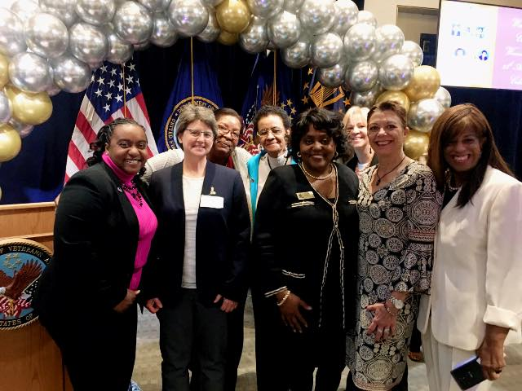
The IDVA Women’s Program Director continues to preside as the President of the National Association of State Women Coordinators (NASWVC). The association is a valuable complement to the responsibilities of the Women Veterans Coordinator.

It is a leading advocate for women veterans by closely working with a variety of veteran service organizations, partnering with the Federal VA Women Veteran Center and helping enhance service to our women veterans in every state. The NASWVC capitalized on opportunities to support legislative matters to progress the services for those throughout our nation. In 2019, the association submitted written support to the House Committee on Veterans Affairs and a Statement of Record to the Subcommittee on Veterans Health.

Women Veterans (continued)

The 2019 IDVA Women Veterans Conference supplied ample established vendors providing a plethora of information for women veterans. The keynote speaker was a graduate of the Veterans Court. There was a Veterans Judiciary panel providing specific answers from a variety of departments. Post-Traumatic Stress Disorder was also discussed during a presentation regarding how massage, acupuncture, and exercise helps reduce symptoms and anxiety.

The Women Veterans Coordinator attended 30 outreach events in eleven months of 2019. The program distributed sixty-six DD-214 Informational Welcome packets for women veterans and received 172 new Indiana Women Veteran Registrations.

Section 10: Indiana Veterans Memorial Cemetery
Burial Applications (Pre-Needs):
105 applications were accomplished by veterans and approved for burial at the Indiana Veterans Memorial Cemetery.

Interments:
130 Veterans
60 Spouses

Headstones Set:
170 permanent headstones were ordered and set

Governor Memorial Certificates:
2,432 certificates were issued to families of veterans who passed away this year in Indiana

April 18, 2019 - Independent Funeral Directors of Indiana attended a briefing and tour of the cemetery. Nineteen funeral directors were in attendance.
April 27, 2019 - Funeral Service and Interment of Fireman 3rd Class Willard Irvin Lawson, KIA on USS Oklahoma during the attack on Pearl Harbor Dec. 7, 1941. At the time of his enlistment, he resided in Milton, KY. In attendance was his great nieces and other family members and approximately 300 veterans and citizens of the surrounding communities. WDRB 41 Louisville TV Station completed a nice segment on this event.
July 19, 2019 - Funeral Services and Interment were held for a veteran who did not have family or financial means for a funeral or interment. Over 600 veterans and their families attended this service. This story was covered by the four TV Stations in Louisville, WHAS 11, WDRB 41, WAVE 3 and WLKY 32.
August 2019 - The Navy Seabee Chapter NSVA Island X-4 New Castle, Indiana dedicated a monument at the Indiana Veterans Memorial Cemetery in honor of the NAVY Seabees service.

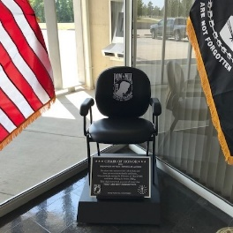
Indiana Veterans Memorial Cemetery (continued)

September 2019 - Rolling Thunder Chapter 1 Indianapolis dedicated a CHAIR OF HONOR.

September 29, 2019 - Funeral service for Mayor Damon Welch, Mayor of Madison, who passed away unexpectedly. Family and friends were in attendance as well as over 500 veterans, city employees and citizens.

FOR PRISONERS OF WAR—MISSING IN ACTION
For those who answered the call to duty or
have yet to return to family and home,
Who are listed among the Prisoners of War (POW)
and those Missing in Action (MIA),
This chair is reserved as a seat of honor that
THEY ARE NOT FORGOTTEN

Section 11: Indiana Veterans Home
Administration
The Indiana Veterans Home (IVH) has continued to honor our veterans and spouses with compassionate, comprehensive care in a community-tailored setting to meet the unique goals of these heroes and their families.

IVH provides comprehensive nursing care to 162 residents with high acuity levels, major disabilities, and multiple chronic conditions associated with the aging process. IVH has a Domiciliary Care Unit that houses 21 residents. IVH completed both the ISDH and VA surveys and did well. All findings were immediately corrected and monitored to ensure that staff corrected any deficient behavior.

IVH continues to partner with Purdue University’s Communication Department on our Music Therapy Program. We also have Julia Berry come to the facility to do 1:1 art therapy with three residents each week. Our pet therapy program includes Libby, a Labrador retriever; CSM, our therapy cat; and two cats in the Crafts and Hobby’s room for our residents to enjoy. These pets make the facility a home as most residents had pets prior to admission. IVH also partners with IVY Tech and IUPUI for nursing students and social service students for the clinical portion of their course. IVH will also be working with TSC and their Certified Nursing Aide program to complete the clinical hours required for certification.

Business Office
No General Fund Appropriation, we are now a Business Unit with full revenue responsibility to cover its expenses.

Finalized clean-up of prior years’ open purchase orders and requisitions, dating back to 2010 and released over $600K back to state reserves. All bank accounts are now fully reconciled each month and all variances from prior years have been cleared. Business office had a successful annual VA survey with one minor finding related to the facility evacuation plan.

Indiana Veterans Home (continued)

Over 20 skids of records being retained within IVH were catalogued and delivered for archiving to the state retention center. All outstanding funds due from the VA for the MacArthur renovation were collected from the VA in the amount of $1.6 million.

The Business Office has now assumed all duties for accounting activities and no longer utilizes the state’s prior MOU with IVH to provide services. IVH’s annual revenues over the past year have exceeded the prior historic highest level obtained, and the amount of surplus monies placed into IVH’s reserves was the largest historic annual amount collected.

Recreation
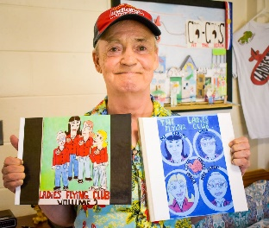
Recreation entertained the residents with several large events including Mother’s Day, Father’s Day, Autumn Celebration and a Thanksgiving Event. Each event had great attendance with some of the events holding the record for the largest attendance all year. The residents enjoyed music, food, fun and socialization.

Nursing
The nursing department is now proud to have five certified wound nurses on staff to care for our residents. Recently we sent our two-unit managers for additional dementia training and we now have two dementia certified unit managers. We have partnered with Tippecanoe School Corporation to be the clinical site for their CNA career classes. We have added several new staff members to our team and continue to recruit. Nursing has contracted with an after-hours x-ray service to enable us to provide more services to our residents without having to transport to an outpatient facility.

Indiana Veterans Home (continued)

Maintenance
Both Mitchell Chiller Renewals
Pyle Patio Furniture and Awnings
MacArthur 1 Fencing
MacArthur 1 Bathrooms ADA Compliant
New Grounds/Garage Equipment bought after 15-30 years
John Deere Tractor
Two John Deere mowers
Dump Truck purchasing in-progress (this will also be used as snow removal in the winter)
Salty Dog for ice/snow removal
Tire Changer
Tractor Turbine Blower
Tiller for Tractor
Mitchell Shelter add-on
Gazebo in inner circle new roof
Many sidewalk repairs (Safety issues)
Three employees certified for Pest Control

Section 12: Letter from the Director
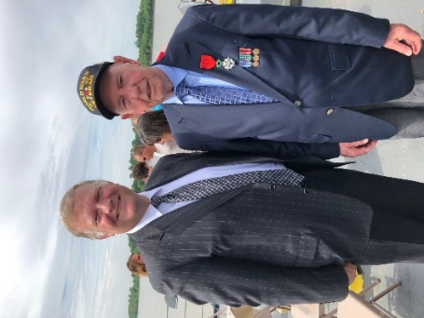
Team,
What a year we have had forging new partnerships and making way for veterans and their families to Live, Work and Thrive in the great state of Indiana. We have exceeded expectations reorganizing our staff for maximum effectiveness and of also increasing benefits for Hoosier veterans. Of particular note, House Bill 1010 was signed by Gov. Holcomb in August 2019 making military retirement state income tax free and we now have a Disabled Hoosier Veteran parking placard.

Spring 2020 we will relocate our services to 777 North Meridian Street. The entirely refurbished former American Legion building will become our new home, complete with the beauty and design features of its original 1925 grandeur. We will have increased capabilities in assisting veterans, larger space for training and staff meetings, as well as improved technology access.

This next year, we look forward to our Grants for Veterans Services program, which will allow for up to $1 million in funds to assist organizations across the state in ending veteran homelessness.

Going forward, we will have a fully staffed executive leadership team, along with leadership at the Indiana Veterans Home and the Indiana Memorial Cemetery. Additionally, our staff will be fully equipped to handle veteran needs in any program from employment to military family relief to women veterans.

Thank you for your continued work. I look forward to this year being a great one for IDVA and for Indiana veterans.

Dennis A. Wimer

