Date: Click or tap here to enter text.
Submittal Choose an item.:
Des. No.
Is route on the National Truck Network? ☐ Yes ☐ No
Route: Click or tap here to enter text.
Design Year AADT: Click or tap here to enter text.
Functional Classification: Click or tap here to enter text. Terrain: Click or tap here to enter text.
Project Scope of Work: Click or tap here to enter text. | Design Criteria Reference | Existing  Condition | Does the proposed design satisfy the criteria?  (Enter the value provided in the appropriate column.)
Enter the minimum criteria below. |  |  | Yes | No ⁽¹⁾ ⁽²⁾ | N/A
1. Design Speed: mph
2. Lane Width, Mainline: ft
Auxiliary Lanes: ft
3. Usable Shoulder Width (uncurbed sections) adjacent to: Mainline: ft
Auxiliary Lanes: ft

Paved Shoulder Width (uncurbed sections) adjacent to: Mainline: ft
Auxiliary Lanes: ft
4. Bridge Clear Roadway Width ft ⁽³⁾
5. Design Loading Structural Capacity
6. Horizontal Curve, Minimum Radius =
ft
7. Superelevation Transition Length ft ⁽³⁾ Distribution % (on tangent/on curve)
8a. Stopping Sight Distance, Horizontal Curve ft
8b. Stopping Sight Distance, Vertical Curve
(Crest Only) ft
9. Maximum Grades %
10. Travel Lane Cross Slope: %
11. Superelevation Rate e_{max} = %
12. Minimum Vertical Clearance ft
13. Americans with Disabilities Act (ADA)
14. Bridge Railing Test Level ⁽³⁾
(circle one of the following) TL-2 TL-3 TL-5
⁽¹⁾ For high speed facilities and Freeways, items 1-3, 5-6 & 8-12 require a Level One design exception when minimum criteria are not satisfied.
⁽²⁾ For low speed facilities, items 1, 2(NTN only), 5 & 12 require a Level One design exception when minimum criteria are not satisfied.
⁽³⁾ A Level Two design exception is required for items not referenced in note 1 or 2 when minimum criteria are not satisfied. Include a brief explanation with the design computations.
Are there plan revisions from the previous submittal that affect Level One criteria? ☐ Yes ☐ No Date Click or tap to enter a date.
Submitted By Click or tap here to enter text. Date Click or tap to enter a date. INDOT location or Consultant: Click or tap here to enter text.
Checked By Click or tap here to enter text. Date Click or tap to enter a date.
INDOT reviewer Click or tap here to enter text. Date Click or tap to enter a date.
Level One Controlling Criteria Checklist Instructions
The Level One Design Criteria checklist should be completed regardless of the high-speed/low-speed or Level One/Level Two designation and included with each submittal. A separate checklist should be completed for the mainline and each S-line, ramp, and phase of maintenance of traffic. All 10 high-speed controlling criteria apply to freeways and interstates, including exit and entrance ramps, regardless of design speed. See Design Memo 20-13

See Indiana Design Manual Section 40-8.0 for information on design exception documentation.

Submittal. Typically the submittal is either Stage 1, Stage 2, Stage 3, or Final Tracings. Preliminary or Final Plans should be used for Bridge Rehabilitation, Partial 3R, and Traffic projects as appropriate. See IDM 14-2.0.

Des. No. Enter the 7-digit designation number.

Route. Enter the road name. For bridge projects enter the road name and the feature crossed, e.g. US231 over White River.

National Truck Network. Indiana’s NTN is comprised of all federal aid primary routes as of 1991. The NTN is available as a separate layer on INDOT’s Road Inventory and Functional Class Viewer (to best view the NTN, other layers should be turned off).

Functional Classification. IDM 40-1.01 describes the various functional classifications – arterial, collector, local road. Enter the functional classification as shown in IDM Figure 14-3C. Include the rural or urban designation. For urban designations, include the sub-designation of suburban, intermediate, or built up. Where the checklist is being used for a ramp, trail, or other unique feature, enter the description.

Design Year and AADT. Typically the design year is 10 to 20 years from the letting date. Enter the year and the corresponding AADT. See IDM 40-2.02

Terrain. Enter either rolling or level as appropriate. Indiana does not have mountainous terrain.

Project Work Type. IDM 40-6.0 describes the project scope of work categories. The scope of work determines which criteria apply to the geometric design of the project. See IDM Figure 14-3C, Project Design Criteria for acceptable entries.

Design Criteria Reference. Enter the Indiana Design Manual figure or AASHTO reference used to establish the minimum design criteria. When using an AASHTO reference, include both the title of the reference and the section, e.g. GB Table 5-3. Use the following abbreviations
IDM – Indiana Design Manual
GB – AASHTO’s A Policy on Geometric Design of Highways and Streets (the Green Book)
LV – AASHTO’s Geometric Guidelines for Design of Very Low Volume Roads ADT ≤ 400
IS – AASHTO’s A Policy on Design Standards, Interstate System

Existing Condition. Enter the value of the existing condition. This field is mandatory for 3R projects or where an existing substandard condition is being retained.

Proposed Design. Enter the value provided (not an X) in the appropriate column. Where more than one value is needed, e.g. multiple horizontal curves, “see calculations” is acceptable.
Design Criteria Supplemental Information
Calculations. The documentation for each item should be included in the design computations with the checklist. Calculations must be initialed and dated. Where an existing condition on a 3R project is retained or replaced in kind, the evaluation of crash history and no expansion planned must be included.

Shoulder Width on a Bridge. The minimum shoulder width on a bridge is the minimum paved shoulder width from the geometric tables or the existing approach roadway paved shoulder width without guardrail, whichever is greater. The guardrail offset on the approach roadway should be carried over the bridge. The approximate 4-in loss due to connection of the concrete bridge railing transition/guardrail transition may reduce the offset but may not reduce the minimum paved shoulder width. See Bridge Clear Roadway Width for additional information.

Examples
- (Desirable) A 2-ft guardrail offset is provided on the approach roadway. The approximate 4-in. reduction at the transition connection will result in a 1’-8” offset on the bridge. The minimum paved shoulder width is not reduced, and a design exception is not required (for shoulder width). Check bridge clear roadway width against minimum required.
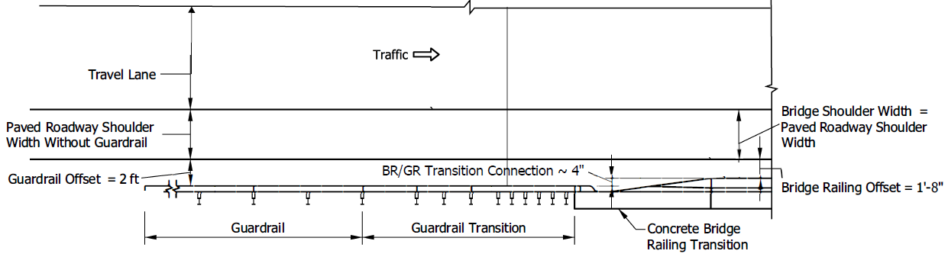
- Zero guardrail offset is provided on the approach roadway. The approximate 4-in. reduction at the transition connection will result in a 4-in reduction to the paved shoulder width on the bridge, and a design exception is required (for shoulder width). Check bridge clear roadway width against minimum required.
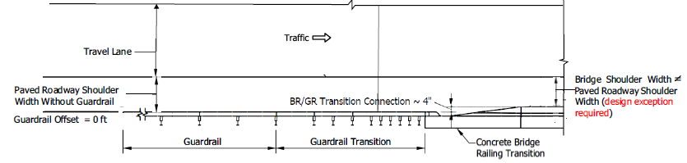

Design Criteria Supplemental Information (con’d)
Bridge Clear Roadway Width. Bridge clear roadway width is a Level Two criteria. Where the sum of the lane and shoulder widths is less than 30 ft (arterials and collectors) or 28 ft (local roads), the greater width is the minimum criteria.
Aug. 2022 [Note: “Local roads” is referring to the roadway functional classification, not local ownership of a roadway. The bridge clear roadway width provided should be that which is appropriate based on the site conditions, speed, traffic, needs of the bridge as part of the transportation network, as well as the needs of the community. Where the appropriate width is less than the minimums listed above, a brief explanation should be documented with the design computations.]

Superelevation Transition Length and Distribution. Superelevation transition length and distribution are Level Two criteria. Both the transition length and distribution are important aspects of providing appropriate superelevation.

ADA Criteria. Exceptions to ADA criteria are approved through the ADA Technical Advisory Committee. Exceptions are either a technical inquiry or determination of technical infeasibility.

Bridge Railing Test Level. Bridge railing test level is a Level Two criteria. The project-specific test level needs and site constraints should be included with the design computations. See Design Memo 19-08. Non-standard railing and modifications must be coordinated with the Bridge Design Division prior to use.

