
School Admin
User Guide
Access, rosters, staff accounts, and reports
August 2026
For staff with School Admin access at participating Indiana schools

Contents
1. Before you begin 2
2. The Administrator Dashboard 2
3. Share or replace the registration token 3
4. Load your student roster 4
5. Add a graduation requirement 5
6. Add admins and counselors 6
7. Run reports 7
8. Report field reference 8
9. Troubleshooting 9
10. Help and accessibility 10

1. Before you begin
This guide is for School Admin users who manage school access, load student rosters, maintain staff accounts, and run reports in Indiana Career Explorer.
Have this ready
- An account with School Admin access for your school.
- Confirmation that you are working in the correct school — these tools change live data.
- For each staff member you plan to add: first name, last name, email address, phone number, and role.
- A school-approved secure channel for sharing tokens and exported reports.

Protecting student data. Many screens and every emailed report contain student or staff information. Follow your district’s privacy, records-retention, and secure-sharing rules whenever you download, email, or store a report.

2. The Administrator Dashboard
Every task in this guide starts from the Administrator Dashboard. It is organized into three areas.
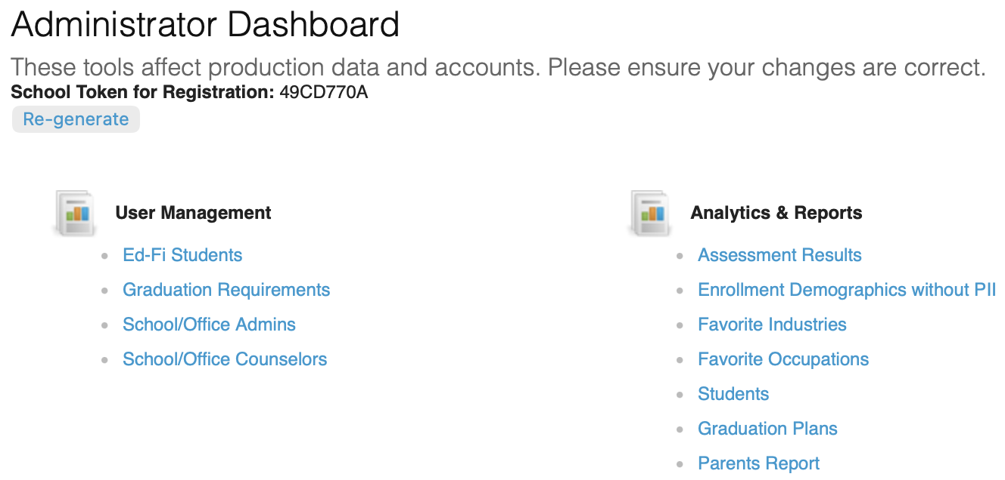
Figure 1. The Administrator Dashboard
- School Token for Registration — the code students enter when they register with an STN. See section 3.
- User Management — Ed-Fi Students, Graduation Requirements, School/Office Admins, and School/Office Counselors. See sections 4 to 6.
- Analytics & Reports — seven reports covering assessments, favorites, students, graduation plans, and parents. See section 7.

These tools affect production data. Changes you save here apply immediately to live student and staff accounts. Review each change before saving.

3. Share or replace the registration token
The School Token for Registration appears at the top of the dashboard. Students enter it when they register with an STN, and counselors can see the same token on their own dashboards.

Share the current token
- Copy the token exactly as it appears — it is case-sensitive.
- Send it through a school-approved secure channel to whoever is guiding registration.

Replace the token
- Select Re-generate.
- At the message “Are you sure you want to create a new school token?”, select OK to replace it, or Cancel to keep the current one.
- Copy the new token, then update any registration instructions that still contain the old one.
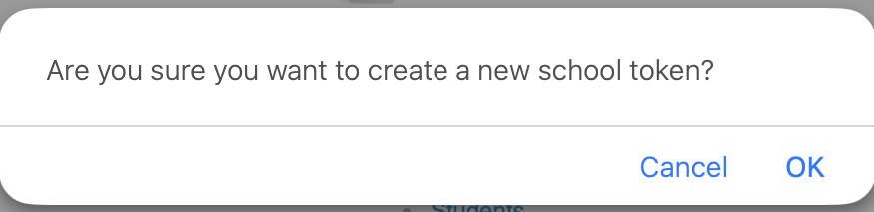
Figure 2. Confirmation shown before a new token is created
Regenerate only when authorized. Replacing the token immediately invalidates any instructions that contain the previous value. Never post a token on a public webpage or send it in an unsecured message.

4. Load your student roster
Roster your students through either Ed-Fi or Clever — not both. Confirm which method your school has approved before you import anything.

Review or download the current roster
- On the dashboard, under User Management, select Ed-Fi Students.
- Review the Name, Email, Student ID, and Grade columns.
- Select Download CSV if you need an authorized copy of the roster.
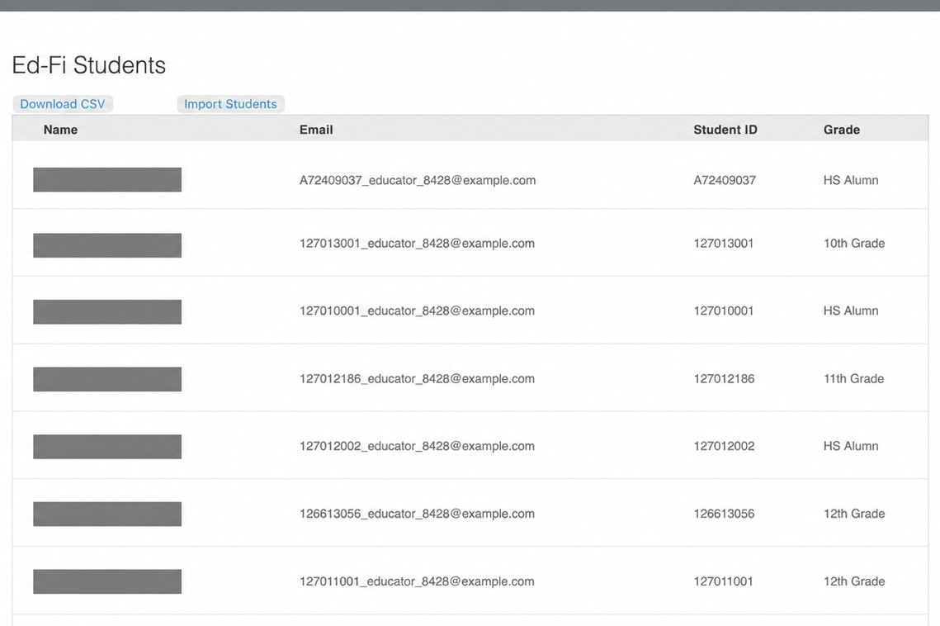
Figure 3. Ed-Fi roster page, with student names masked

Import students through Ed-Fi
- On the Ed-Fi Students page, select Import Students.
- Read the warning. If your school uses Clever, select Cancel and stop here.
- If Ed-Fi is your approved method, select OK to run the import.
- When the import finishes, compare the student count against what you expected and review any errors the system reports.
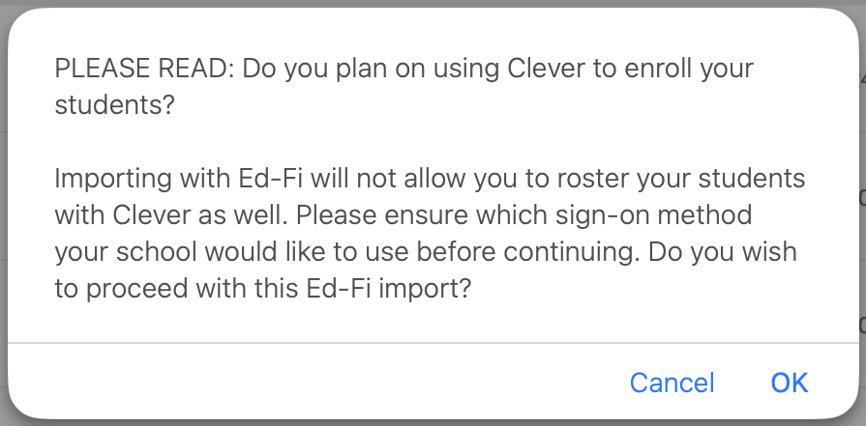
Figure 4. Choosing Ed-Fi rules out Clever for the same students
If your school uses Clever. Teachers sign in through the Indiana Career Explorer icon on their Clever dashboard and can see their students without setting up an account manually.

5. Add a graduation requirement
A graduation requirement is a resource that appears on the dashboards of students in the grade bands you select.
- On the dashboard, under User Management, select Graduation Requirements.
- Open the option to add a new requirement.
- Enter the Title of Resource. This field is required.
- Under “Select which user(s) can see this resource,” choose 9-12, K-8, or both.
- Under Event location, choose URL or Attachment, then provide it. A selection is required.
- Enter the Resource Description. This field is required.
- Select Save, or Cancel to leave without saving.
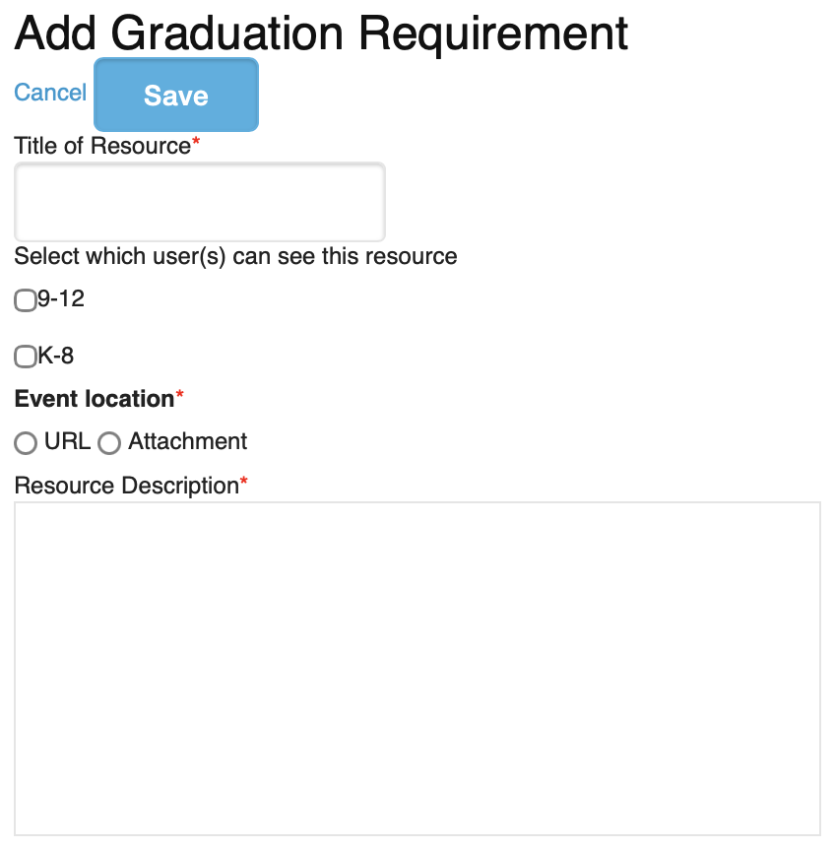
Figure 5. Add Graduation Requirement form
Check your work. After saving, open a student view for the grade band you selected and confirm the resource appears where you expect it.

6. Add admins and counselors
Indiana Career Explorer has two school staff roles: School/Office Admin and School/Office Counselor. Assign advisors to the counselor role. The list pages and the add forms work identically for both, so the steps below apply to either one.

Open the staff list
On the dashboard, under User Management, select School/Office Admins or School/Office Counselors.
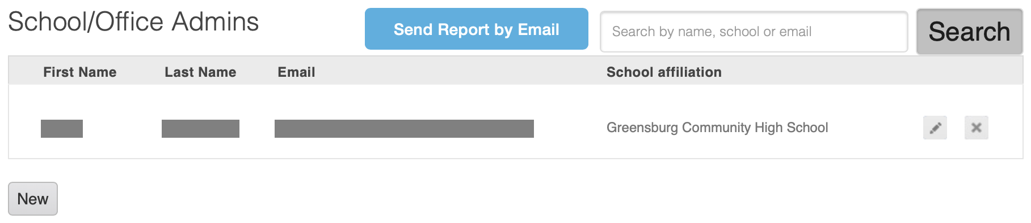
Figure 6. Staff list page — the counselor list looks the same
From the list you can
- Search by name, school, or email using the search field and Search button.
- Edit a record using the pencil icon in that person’s row.
- Remove a record using the X icon in that person’s row.
- Email yourself the full list using Send Report by Email.

Add a person
- Select New.
- Enter First name, Last name, and Email. All three are required, marked with a red asterisk.
- Enter Phone Number and Role if applicable.
- Review the entry, then select Save — or Cancel to leave without saving.
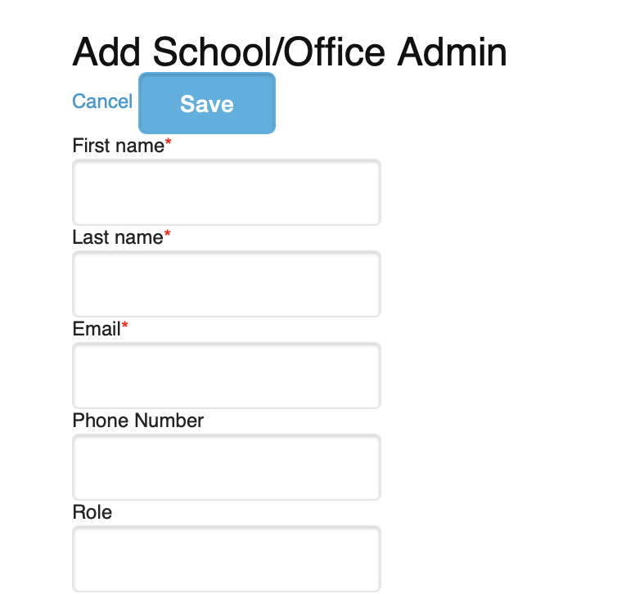
Figure 7. Add staff form — identical for admins and counselors
What happens next. Indiana Career Explorer emails the new staff member a request to set a password. Once they set it, they can sign in and access the student list.

7. Run reports
Open any report by selecting its name under Analytics & Reports on the dashboard.
Report | What it shows you
Assessment Results | Assessment completion dates, plus each student’s leading industry and career matches.
Enrollment Demographics without PII | Aggregate enrollment demographics, designed to exclude personally identifiable information.
Favorite Industries | How many students have favorited each industry.
Favorite Occupations | The occupations students at your school have favorited.
Students | Student identity, account activity, school, favorites, advising, parent invites, and assessment status.
Graduation Plans | Diploma and postsecondary plans, guardian signatures, assessment milestones, and coursework.
Parents Report | Parent account details and the parent-student graduation-plan invitation and signature history.

Example: the Favorite Industries report
Most reports follow the same pattern — a snapshot on screen, and the complete version delivered by email.
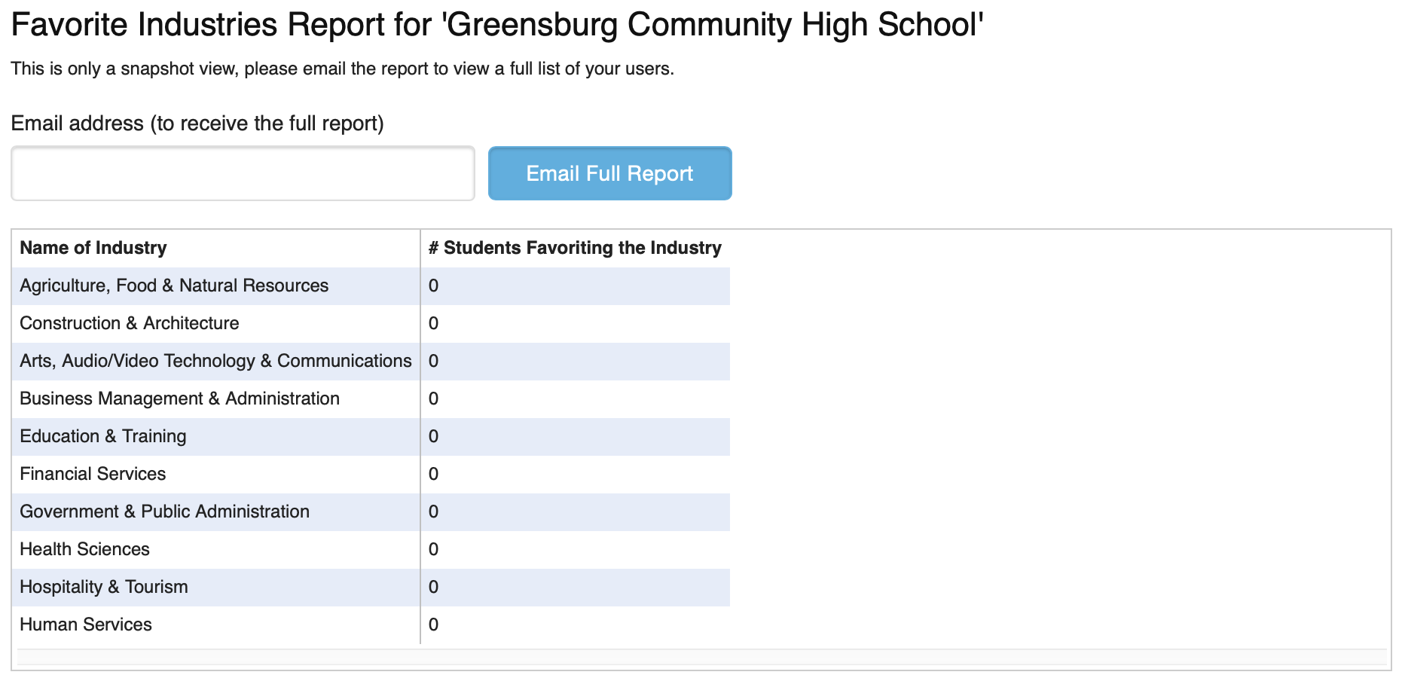
Figure 8. Favorite Industries snapshot and full-report email control
- From Analytics & Reports, select Favorite Industries.
- Review the on-screen snapshot, which lists Name of Industry and # Students Favoriting the Industry.
- To get the complete list, type the destination address into “Email address (to receive the full report).”
- Select Email Full Report.
- Retrieve the report from that mailbox and store or share it according to school policy.

Read favorite counts carefully. A count reflects students who marked interest in an industry. It is not enrollment, assessment performance, or a settled career decision.

Three reports carry direct identifiers. Students, Graduation Plans, and Parents Report all include names, email addresses, and account activity. Request, store, and share them only through approved secure methods.

8. Report field reference
The fields included in each of the four detailed reports.

Assessment Results
Student and school Student First Name; Student Last Name; Email; School; Grade Level
Completion Taken On; Assessment Completions
Matches Industry Match 1–3; Career Match 1–5

Students
Identifiers User ID; Portfolio ID; First Name; Last Name; Email; STN
Sites and referral Entry Site; Referring Pages; Member Sites; Source
Dates and activity # of Skills; Registration Date; Last Login Date; School and Grade Update Date
Location and school City; State; Postal Code; Region; School; Grade; JAG
Plans and favorites Graduation Goals; Favorite Industries; Favorite Careers; # Industries Favorited; # Careers Favorited
Support and completion Has Career Advisor; Parent Invites Sent; Assessment Taken?; AWP Complete?; Has Alternate Graduation Plan

Graduation Plans
Student First Name; Last Name; Email; School; Grade; Address; City; State; Zip; Year of Graduation
Guardian and signature Parent or Guardian; Signature; Signatory Type; Invited On; Date of Signature; Graduation Promise; Acknowledgement
Plans Diploma Plan; After High School Plan; Study after HS; Learn More About
Indiana assessment milestones IAM date and results for 6th, 7th, 8th grade and High School
Readiness assessments Date and results for ACT Inspire; PreACT; PSAT 8/9; PSAT NMSQT; ACT; SAT; ASVAB; WorkKeys; Accuplacer; AP
Courses and checklist 9th–12th Grade Courses; Completed Checklist

Parents Report
Parent account Parent First Name; Parent Last Name; Parent Email; Parent Registration Date; Parent Site Affiliations; Parent Location; Parent # of Skills; Parent Last Login
Linked student Student First Name; Student Last Name; Student School
Plan and invitation Graduation Plan signed?; Date of Graduation Plan signature; Invite Status; Invite Sent At; Invite Accepted At

Confirm local definitions. Before acting on a blank value, a missing signature, or an incomplete checklist, check how your school records that item. A blank field does not always mean the step was skipped.

9. Troubleshooting
If this happens | Do this
I cannot see the dashboard tools | Confirm you signed in with your School Admin account and the correct school affiliation. If the tools are still missing, use Contact Support.
A staff record will not save | Check that First name, Last name, and Email are all filled in and that the email address is correct. Note any message the page displays.
I selected Re-generate by mistake | Do not distribute either token until you confirm which one is active. Contact authorized school support if the active token is unclear.
An emailed report did not arrive | Verify the recipient address, check spam and quarantine, and allow normal delivery time before requesting it again.
A report looks incomplete | Check whether the page describes what you see as a snapshot. Favorite Industries, for example, requires the emailed version for the full list.
A step does not match what I see | Stop before saving. Get current district or product instructions for that page before continuing.

Reporting a problem. Include the page name, your school, the date and time, the exact control label, any message shown, and a privacy-safe screenshot. Remove or obscure student and staff information unless support has given you a secure channel.

10. Help and accessibility

Getting help
Use the Contact Support link in the Indiana Career Explorer page footer for account or product assistance. Do not send student records, passwords, or registration tokens unless support provides an approved secure method.

Accessibility
- Every screenshot in this guide has descriptive alternative text, and every procedure is complete in words alone — you do not need to see an image or distinguish a color to follow it.
- Required fields are identified in the text as well as by the red asterisk shown in the interface.
- Use the navigation pane in Word, or bookmarks in a PDF reader, to move between sections by heading.

If a control cannot be reached or understood with a keyboard or assistive technology, report it through Contact Support. Include the page name, the control label, your browser, the assistive technology you use, and the result you expected.

