Instructions for Entering a New Claim for CEP Sponsors

This form provides SFAs with detailed instructions on how to file a site claim for participating Community Eligibility Provision (CEP) schools.
Step by Step Instructions
- Log into the CNPweb and select the current program year: 2020

- The Sponsor Summary screen appears. Click on the Claims tab under the Sponsor Summary title.

- For desired month, click Add at the right side of the screen. This will bring up a blank Sponsor Claim. No claims data can be entered on this page, but you must click on Submit tab at the bottom of this page. Next an Error message is displayed - which only means that the claim process is not finished yet.

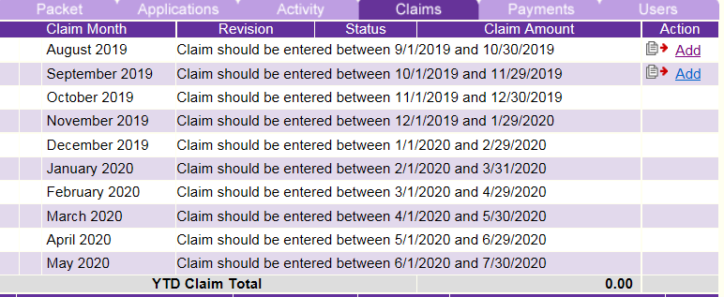
- At the bottom of this page, click here to see the Sponsor Summary page again where you will see a yellow folder with a “+” sign to the left of the month you are preparing to claim. Click on this folder to display all the sites that operated during that month.

- All sites will now be listed with Add at the right side of the screen. Click Add, on one of your approved CEP schools, and an actual Site Claim will be displayed with the site name and number.

- Enter the total number of meals served for each applicable program (i.e. C.E.P. Lunch, C.E.P. Breakfast, etc.). Do not try to calculate the CEP percentages of free or paid meals, as the system will complete this calculation for you based on your approved free claiming percentage. Also, enter the total number of adult meals, days of operations, average daily attendance, and number of meals served for any other approved child nutrition programs (i.e. Snack).
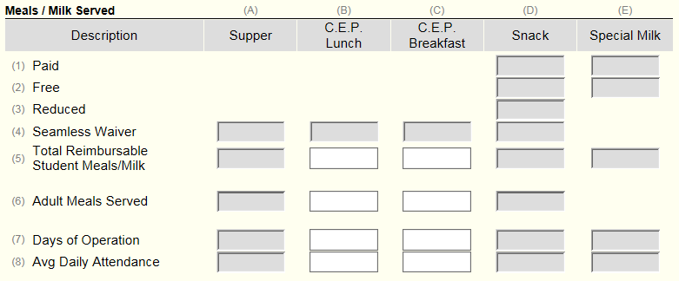
Reminders:
- Numbers entered on the CEP site claim should NOT include meals vended to outside programs such as head start, etc.
- All CEP site claims should only have editable fields for total reimbursable meals for breakfast and lunch. If the other fields for breakfast and lunch appear (i.e. free/reduced/paid), contact the state agency for review.

- Enter the total number of students currently enrolled in line 12 (Eligible Children).
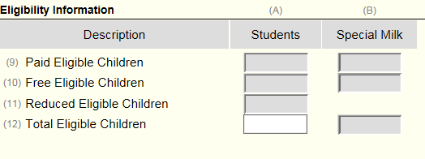
- At the bottom, click Submit and a Post Confirmation will appear informing you of the status of the Site Claim (Error or Approved). Any errors should be corrected and the site claim resubmitted.

- Click here to select another site, if applicable. You should now be back at the Sponsor Summary Claims page. If other sites need to be entered, repeat the steps listed above.

- If the summary totals are correct, proceed to item number 19 and check the box. By checking box 19 you indicate that the claim is ready for payment and that you have evidence to support this claim – this is like certifying it with your signature on a paper document.

- Next click submit. The Sponsor Claim Summary will appear with the amount to be reimbursed by the meal and category. Click here at the bottom of the page and you will return to the Sponsor Summary Claims page. Under status it will say Approved and the total claim amount to be paid will be displayed.

  - If the status is Errors, review the sponsor claim to see the error message and make any corrections if possible.
  - If the status is Pending Submission, the box at the bottom of the sponsor claim was not checked. Please edit the sponsor claim, check the box and resubmit.

Reimbursement Claims can be filed:
- Beginning on the first day of the month following the claim month (August claim can be entered on/after September 1, September claim on October 1, etc.)
- Sponsor has 60 days from the last day of the claim month to file a claim on the CNP web system.

Claims should be consolidated as follows:
- 10 days or less in the initial month of operations combined with the claim for the subsequent month.
- 10 days or less in the final month of operations combined with the claim for the preceding month.
- While combining the claims remember to check the box on the claim form in the CNP web which states: Combine the claim month of “….”with this claim.

Please keep in mind:
- Meal counts must be kept separately for each calendar month.
- Never add the totals served in one month to the totals served in another month; the meal totals have to be submitted under the full month.
- An average processing time for a claim is about 3-4 weeks.

For assistance with filing your CEP site claims, please contact SCNFinance@doe.in.gov.

