Anti-Bullying Recess Worksheet for K-1

1. Circle the wrong behaviors.

Description: C:\Documents and Settings\plawrenc\Local Settings\Temporary Internet Files\Content.IE5\PZN3SG17\MC900232446[1].wmf Description: C:\Documents and Settings\plawrenc\Local Settings\Temporary Internet Files\Content.IE5\NG42EDBS\MC900436043[1].wmf Description: C:\Documents and Settings\plawrenc\Local Settings\Temporary Internet Files\Content.IE5\YZJTLRUA\MC900232130[1].wmf 

1. Draw the face of what someone would look like who has been picked on or hurt.
2. Circle what you should do when you are angry with someone.

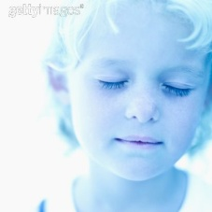  Description: C:\Documents and Settings\plawrenc\Local Settings\Temporary Internet Files\Content.IE5\YZJTLRUA\MC900232130[1].wmf 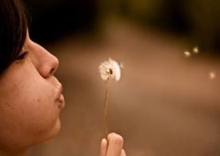 Description: C:\Documents and Settings\plawrenc\Local Settings\Temporary Internet Files\Content.IE5\NG42EDBS\MC900232446[1].wmf

1. Draw a picture of what you will do the next time you are angry.
2. On a separate piece of paper, write an apology note.