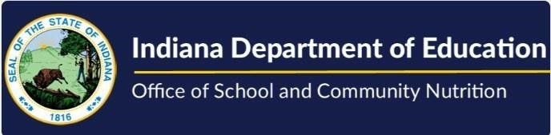
USDA Foods Training Program

Live Training
2025 Annual Pre-order Survey Training (Length: 53 mins, 50 sec)– a recorded, live presentation explaining what it is, when it’s done and how the survey is completed.
USDA Foods: Forecasting for the Future (Length: 48 min, 6 sec)- A panel discussion on forecasting USDA Foods. Topics range from entitlement, utilizing USDA Foods tools, and calculators to determining processor pounds.
Virtual/On Demand Training
FSMCs & SFAs Utilizing USDA Foods (Length: 10 mins, 28 sec)- Information on the roles of the FSMC and SFA and their collaboration utilizing their UDSA Foods efficiently.
State Assigned Warehouses and Your School Webinar (Length: 8 mins, 39 sec) – Provides information regarding state assigned Direct Delivery warehouses.
FDP Online Trainings (Length: 30 mins) – Eight short videos that address the CNPweb and Food Distribution Program functions.
What Happens After the Pre Order Forecast Survey? (Length: 9 mins, 20 sec) – A focus on what happens on the months after the annual pre-order (forecast) survey closes.
USDA Foods Year at A Glance Webinar (Length: 14 mins, 26 sec) – Outlines the timeline for USDA Foods for the school year.
Where's the Entitlement? (Length: 8 mins, 36 sec) – Provides insight on entitlement and where to find it.
Different Vendors Different Dates Webinar (Length: 7 mins, 44 sec) – Designed to clear up confusion regarding USDA Foods date labeling.
USDA Foods Available List Webinar ( Length: 4 mins, 05 sec)– Provides information about USDA’s Foods Available List
Recalls, Holds and Disasters (Length: 12 mins, 52 sec) – Provides information on RA’s responsibility and roles in a recall, hold, or disaster situation.
USDA Foods Invoices, Invoice Credits and Program Fees (Length: 11 mins, 5 sec) – Provides an explanation of invoices and fees related to the USDA Foods Distribution Program
USDA Foods Diverting Bulk Pounds to Processors (Length: 14 mins, 29 sec) – Helpful information designed to assist you in your bulk Direct Diverted pounds that are sent to processors.
Moodle Training (an e-Learning Platform) – use Enrollment Key
“SCN”
Excess Inventory of USDA Foods (Length: 9 mins, 26 sec) – What is it and how can it be managed?
Processing USDA Foods (Length: 20 mins, 59 sec) – Schools can elect to send bulk raw USDA Foods to processors to be processed into ready to eat end products using a procurement process.
Detailed Information About the USDA DoD Fresh Program (Length: 31 mins, 25 sec) – A 3-part series on participating in the USDA Department of Defense Fresh Fruits and Vegetables Program from getting started to ordering.
USDA Foods Annual Pre-order (Forecast) Survey (Length: 23 mins, 55 sec) – Provides a detailed explanation of what, when and how the survey is completed.

