PROTOCOL FOR
MACROINVERTEBRATE SAMPLE COLLECTIONS AND
INDEX CALCULATION

LAKE AND RIVER ENHANCEMENT (LARE) PROGRAM
INDIANA DEPARTMENT OF NATURAL RESOURES
DIVISION OF FISH AND WILDLIFE

PURPOSE
The Lake and River Enhancement Program (LARE) uses biomonitoring to:

- Prioritize subwatersheds within an initial Diagnostic Study for future Watershed Land Treatment Projects (WTLP);
- Indicate whether conservation practices have improved stream conditions at the scale of a small subwatershed after 5-10 years of implementation with landowners compared to biomonitoring at the same sites prior to project implementation; and
- Determine whether individual best management practices have improved stream conditions compared to an upstream reference site (post-construction monitoring).

This protocol follows the US EPA Rapid Bioassessment Protocol (RBP) which must be used for all biomonitoring efforts in LARE-funded projects, unless otherwise specified in the project scope. In general, biomonitoring conducted for LARE diagnostic studies and watershed management plans identify macroinvertebrates to the family level and use associated metrics, while pre- and post-treatment monitoring of LARE watershed land treatment projects identify macroinvertebrates to the lowest taxonomic level (genus or species) to allow for finer resolution detection of changes in water quality. Any deviations from the protocol must receive prior approval of the LARE Biologist.

TIME FRAME
The IDNR LARE index period is from July 15 – November 30 with a preferred sampling window of mid-September through October to maximize macroinvertebrate diversity and increased size of most organisms for more accurate identification.

LICENSE REQUIREMENTS
A Scientific Purposes License is not needed to sample aquatic insects. A fishing license or Scientific Purposes License is needed to collect crayfish, depending on the number and manner in which the crayfish will be taken. The only mussels that can be taken or possessed without a Scientific Purposes License are Asiatic clams, quagga mussels and zebra mussels. Individuals should not touch a mussel, or even just a dead shell, unless they know for sure that it is one of these three species listed above. Otherwise, a Scientific Purposes License is required to collect or possess a native mussel or dead shell. For threatened and endangered species, adhere to the restrictions imposed by the Scientific Purposes License.

US EPA RAPID BIOASSESSMENT PROTOCOL
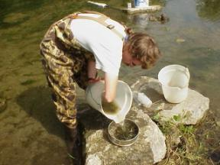
The USEPA’s Benthic Macroinvertebrate Protocol II (family-level) or RBP III (genus or species) single habitat approach provides a systematic field collection and analysis method to determine how benthic macroinvertebrate assemblages reflect habitat and water quality conditions. High overall biodiversity (or number of families living in a particular place) indicates that there is a wide range of stable habitat and food resources in the area with very little pollution. Different families have particular needs for feeding, reproduction, and pollution tolerance. The families are scored for each of these characteristics, according to what they indicate about the quality of the physical habitat or water chemistry.
Photo credits: IDEM

The survey consists of a 100-organism subsample for the riffle/run sample at each survey location. A voucher collection will be submitted to IDNR Division of Fish and Wildlife to be forwarded to the Department of Entomology, Purdue University. See below for additional details.

Field Collection

Riffle – Run Sample
Make collections at riffles within the designated reach (15 times the stream width or 100m in length). Site locations should be well documented on maps, with photos and GPS coordinates. All waypoints recorded should be done so using datum NAD83. Waypoints should be displayed using Latitude and Longitude expressed in decimal degrees. The selected riffle will be kicked twice to capture varying flow velocities, substrate types, canopy cover, or other entities that may enhance diversity in the riffle area. Collect macroinvertebrate samples with a one-meter square kick screen.

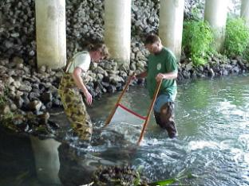
One crewmember holds the screen within or immediately below the riffle while another crewmember steps upstream of the screen and places large stones on the screen bottom. Kicker disturbs an area approximately one meter square of substrate immediately upstream of the screen. Kicker wipes organisms off larger stones in the kick area and those holding down the screen.

To prevent the loss of organisms in the kick screen, the kicker holds and raises the bottom of the net while the holder prevents flow of water over the top of the net.

Kicker and holder rinse the screen into a bucket using a number 35-mesh sieve to capture runoff. Repeat the above steps at a second location in the riffle with a different flow velocity. Pick off any organisms lingering on the screen with forceps and place in the sieve or sample jar (1 quart, wide mouth jar).

Rinse the debris in the bucket by repeatedly swirling the debris and then pouring the water through the sieve. Repeat this process of rinsing and pouring through the sieve at least five times. Place all vegetative debris from the sieve into the sample jar using forceps, and rinse remaining material from the sieve into the jar using a squirt bottle. The remaining rock and sand remaining in the bucket are scanned for snails, caddisfly cases, etc. which are removed and placed in the sample jar. The only mussels that can be taken or possessed without a Scientific Purposes License are Asiatic clams, quagga mussels and zebra mussels. Individuals should not touch a mussel, or even just a dead shell, unless they know for sure that it is one of these three species listed above. If a native mussel is collected in the sample it should be returned to a suitable area of the stream as soon as possible.

Place a waterproof label into the jar identifying the state and county where collected, exact location, date, collector, for example:

IN: Greene Co.
Indian Creek at C.R.500N
Date: 05-10-2006 Collected by: S. Beach

Preserve the macroinvertebrate sample by adding a sufficient volume of 70% ethyl alcohol to inundate all sample material in the jar.

Leaf Pack Sample
In addition to the riffle-run sample a leaf pack sample should also be collected at the sample site to collect data on shredders. The sample should consist of collecting various plant parts such as leaves, twigs, bark, or their fragments. Potential sources include leaf packs, near-shore zones, and depositional areas. Only the upper surface of litter in the depositional areas should be sampled to ensure that they are from the aerobic zone. A variety of sources should be collected if available; several handfuls of material should be adequate. Care must be taken to avoid collecting recent or fully decomposed leaf litter to optimize collection of the shredder community. Seasonality may influence the rate of decomposition and may have an important impact on shredder abundance.

This supplemental sample is processed separately from the riffle-run sample and used only for characterizing the functional feeding groups. Taxonomic identification is not necessary for this sample and the organisms should be simply classified as shredder or non-shredder. The sample may be field sorted in a small pan or in a sieve. If a large number of macroinvertebrates are collected a representative subsample of 20 to 40 organisms may be removed for classification. Numbers of individuals representing the shredder functional feeding group, as well as total number of organisms collected should be recorded and later used for calculating the ratio of shredders to total metric.

LABORATORY METHODOLOGY

Sample Sorting and Identification
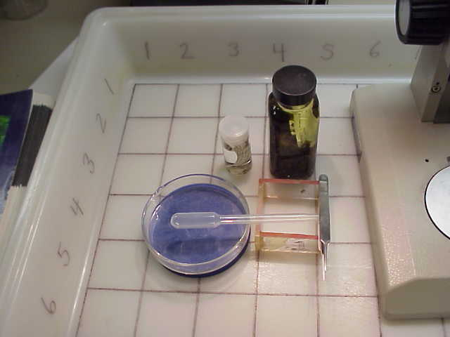A 100-organism subsample is recommended by USEPA (1990) as a time saving sorting procedure for use with the riffle/run sample. The described method is based on that of Hilsenhoff (1987). The procedure consists of evenly and randomly distributing the composite riffle/run sample in a gridded pan that has a light colored bottom. As numbered grids are randomly selected all organisms are removed until at least 100 organisms have been selected from the composite sample. This method of subsampling provides a representative estimate of the benthic fauna as well as a consistent unit of effort. Evaluations have shown that 100-organism subsamples provide an adequate estimate of community structure as compared to 200 and 300-organism subsamples (USEPA 1990, Shackleford 1988). Greater sensitivity demonstrated with a 300-organism subsample is subtle and may not warrant the additional time expenditure required. Laboratory sorting of each 100 organism subsample is estimated to require between 1 and 1.5 hours for an experienced biologist as opposed to 3 to 4.5 hours for a 300-organism subsample The following procedure is performed for all samples.

Sorting Procedure
The sample is first thoroughly rinsed in a 500 micron screen or a sampling net to remove fine sediments. Any large organic material (whole leaves, twigs, algal and macrophyte mats) should be rinsed thoroughly, visually inspected, and discarded from the sample. The sample contents are placed in a large, flat pan (approximately 30x45 cm or so) with a light colored bottom. The bottom of the pan will be marked with a numbered grid pattern (77 squares). Each grid will measure 5x5 cm. Organisms should be evenly distributed in the pan. Samples too large to be effectively sorted in a single pan may be thoroughly mixed in a container with some water, half of the homogenized sample placed in each of two gridded pans. Each half of the sample must be composed of the same kinds and quantity of debris. Also since the samples will be preserved in alcohol it will be necessary to soak the sample contents in water for about 15 minutes to hydrate the benthic organisms, preventing them from floating on the water surface during sorting. Use only enough water to allow complete dispersion of the sample within the pan. An excessive amount of water will allow sample material to shift within the grid during sorting.

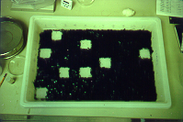
A random numbers table is used to select a number corresponding to a square within the gridded pan. Grid selection from pans is random in order to ensure a representative subsample. Remove all debris and organisms from within the selected square to a separate Petri dish and sort using low power under a microscope. If you do not get at least 100 organisms from the random square, proceed with the process of selecting squares and removing organisms until the total number sorted from the finished square is within 10% of 100. If more than two pans are required to subsample, randomly select which pan to subsample from first. Then select the random square from the first pan. If you do not sort at least 100 organisms from the randomly selected square in the first pan, select a random square in the second pan. Continue alternating between pans until 100 organisms have been sorted. Any organism which is lying over a line separating two squares is considered to be in the square containing its head. In those cases where it is not possible to determine the location of the head (e.g. worms), the organism is considered to be in the square containing the largest portion of its body. Any square sorted must be sorted in its entirety, even after the 100-organism count has been reached

Organism Identification
All benthic macroinvertebrates in the subsample should be identified to the appropriate taxonomic level (either family level or lowest positively identified taxonomic level – generally genus or species), enumerated, and recorded on the laboratory bench sheet (Appendix A).

A voucher collection will be submitted to IDNR Division of Fish and Wildlife at the same time as the draft report is submitted, allowing two months for review by IDNR or outside specialists. The collection will be forwarded to the Department of Entomology, Purdue University. A voucher for each taxon identified at each site will be curated according to Purdue’s protocols for specimen handling, as follows:

  - Use a 2 dram vial with a neoprene stopper and 70 to 80% ethyl alcohol;
  - Label format must include state, county, stream, location, date, collecting firm, contract or project number, voucher specimen;
  - Identification to lowest taxonomic level indicated for the protocol;
  - Vials tagged with two identification labels in the following format:
    - taxonomic name, the individual who identified the specimen, and the date, for example:

Baetis flavistriga

Identified by: J. Doe October 2005

    - state and county where collected, exact location, date, collector, for example:
IN: Greene Co.
Indian Creek at C.R.500N
Date: 05-10-2006 Collected by: S. Beach

  - Data sheet that indicates the number of individuals, taxon, location of collection, and vial number of voucher specimen.

Calculations FOR RBP II (family level) or RBP III (GENUS OR SPECIES)

Standard metrics for LARE reports are:

- Number of Taxa
- EPT Index
- Percent Dominant Taxa
- Ratio of EPT/Chironomidae
- Modified Hilsenhoff Biotic Index (HBI)
- Ratio of Scraper/Filtering Collectors
- Ratio of Shredder/Nonshredder
- Community Loss Index

Calculation of the standard metrics and interpretation of their meaning is described briefly below. Additional details are on pages 7-14 to 7-18 of Barbour et al (1999) and pages 109 to 123 of the methods publication EPA/600/4-90/030.

A description of genus-level functional feeding groups can be found on pages 644-652 in Merritt and Cummins (1984), and also in Appendix B of Barbour et al (1999). Family-level functional feeding groups can be found on pages 187-191 in Bouchard (2004).

Hilsenhoff pollution tolerance values, ranging from 0 to 10, for families is on page 245-246 of the methods publication EPA/600/4-90/030, and can also be found in Hilsenhoff (1988). Hilsenhoff tolerance values can be supplemented with values from Bode (1988). Families not assigned a tolerance value by either Hilsenhoff or Bode should be excluded from the HBI. Hilsenhoff tolerance values for genus and species level calculation are available from Hilsenhoff (1987).

- Number of Taxa: The number of families or genus/species identified in the subsample.

Taxa are groups of organisms and can refer to any level of phylogenetic classification (kingdom, phylum, class, order, family, genus, and species). The number of different types of any given taxa, or taxa richness, in the collection is a measure of biodiversity. Taxa richness generally increases with increasing water quality, habitat diversity, and habitat suitability.

- EPT Index: Total number of distinct taxa in the Orders Ephemeroptera, Plecoptera, and Trichoptera.

The EPT Index summarizes the richness in groups that are generally considered pollution sensitive (Ephemeroptera / mayflies; Plecoptera / stoneflies; Trichoptera / caddisflies). The EPT Index generally increases with increasing water quality. This metric may be particularly useful for indicating nutrient enrichment in small streams.

- Percent Dominant Taxa: The highest number of individuals in a given taxa divided by the total number of individuals in the subsample.

The Percent Dominant Taxa can reveal an overabundance of one group and little diversity in the community. Characteristics of the dominant group can indicate the problem (e.g., only one habitat type present, little dissolved oxygen, high nutrients or presence of a particular toxin which does not affect the dominant group). A high number indicates environmental stress.

- Ratio of EPT to Chironomidae: Total number of individuals in Orders Ephemeroptera, Plecoptera, and Trichoptera divided by the total number of Chironomidae individuals.

The Ratio of EPT to Chironomidae abundance shows the number of individuals from sensitive orders (Ephemeroptera / mayflies; Plecoptera / stoneflies; Trichoptera / caddisflies) compared to pollution tolerant midges or gnats (Chironomidae). A high ratio indicates low levels of heavy metals (e.g., copper, mercury, aluminum), higher dissolved oxygen, and lower nutrients.

- Modified Hilsenhoff Biotic Index (HBI): Summation of the tolerance value times the number of individuals for a specific taxon divided by the total count of individuals for all taxa with a tolerance value. The equation is HBI = sum of [(x_{i} x t_{i}) / n] where x_{i} = number of individuals within a taxon; t_{i} = tolerance value of that taxon and n = total number of organisms in the sample with a tolerance value. HBI is the average of tolerance value of the sample.

Example: Belostomatidae 21 individuals (t_{i} = no value)
Baetidae 10 individuals (t_{i} = 4)
Chironomidae (blood red) 40 individuals (t_{i} = 8)
(10x4) + (40x8) / (10 + 40) = (40+320) / 50= 7.2 Family Level HBI score

The HBI is a rating for tolerance to organic pollutants (nutrients / fertilizers), but may also indicate toxic pollutants (e.g., heavy metals, pesticides). Pollution tolerant organisms have higher scores.

- Ratio of Scrapers to Filtering Collectors: Total number of individuals classified as a scraper functional feeding group divided by the total number of individuals feeding as a filtering collector.

The proportion of these two feeding groups is important because predominance of a particular feeding type may reflect a stressed condition. Specialized feeders such as scrapers are more sensitive organisms and are thought to be well represented in healthy streams. Whereas filtering collectors are considered to be generalists and are more tolerant to pollution that might alter availability of certain food. Scrapers feed primarily on diatoms, and are not able to utilize filamentous algae, which often increases with organic enrichment. Filtering collectors use filamentous algae as attachment sites and often increase with organic enrichment. However filter feeders are thought to be sensitive to toxicants bound to fine particles and may decrease in abundance when toxicants are present. The Ratio of Scrapers to Filtering Collectors may not be a good indication of organic enrichment if adsorbing toxicants are present.

- Ratio of Shredders to Total: The total number of individuals classified as a shredder functional feeding group divided by the total number of individuals.

The Ratio of Shredders to Total shows the number of individuals that feed by shredding leaf litter and organic debris that falls into the stream from riparian vegetation. They are also susceptible to toxic pollutants that may be attached to riparian vegetation (e.g., herbicides, heavy metals). A high ratio indicates a healthy streamside zone with well-established vegetation.

- Community Loss Index (CLI): The CLI ranges from zero to infinity. The formula for CLI is: I = (a-c)/b where I = Coefficient of Community Loss, a = the number of taxa at the reference site, b = the number of taxa at the study site and c = the taxa common to both sites. The result is a ratio of the number of taxa assumed lost due to the pollution source (a-c) to the number of taxa remaining including any new taxa.

The Community Loss Index was developed by Courtemanch and Davies (1987) and compares the diversity of the collection site with the expected or measured diversity in a reference site that has excellent water quality and habitat. A higher number shows that more species are missing from the collection site than would have been expected under high quality conditions.

Comparison to Reference Site
The biological condition scoring criteria for each benthic macroinvertebrate parameter assigns numeric values of 6 for nonimpaired, 4 for slightly impaired, 2 for moderately impaired, and 0 for severely impaired (Appendix B). The numeric values for each site are then totaled and divided into the score for the reference site so that the reference location is equal to 100%. Site scores are then compared to the reference site and assigned biological condition categories based on percent comparison to the reference site score. It should be noted that the biological condition categories are slightly different depending on which protocol is used. An example of a completed metric scoring report is included in Appendix C.

IDNR Contact for LARE Biomonitoring:

Rod Edgell, redgell@dnr.in.gov, 260-244-6805

References

Barbour, M.T., J. Gerritsen, B.D. Snyder, and J.B. Stribling. 1999. Rapid Bioassessment Protocols for Use in Streams and Wadeable Rivers: Periphyton, Benthic Macroinvertebrates and Fish, Second Edition. EPA 841-B-99-002. U.S. Environmental Protection Agency, Office of Water, Washington, D.C. http://water.epa.gov/scitech/monitoring/rsl/bioassessment/index.cfm

Bode, R.W. 1988. Quality Assurance Workplan for Biological Stream Monitoring in New York State. New York State Department of Environmental conservation. Albany, NY. http://www.nysl.nysed.gov/scandoclinks/ocm43110991.htm

Bouchard, R. W., Jr. 2004. Guide to Aquatic Invertebrates of the Upper Midwest. Regents of the University of Minnesota, Minneapolis, Minnesota. http://wrc.umn.edu/pubs/watersqq/guidetoaquaticinverts/index.htm

Courtemanch, D.L. and S.P. Davies. 1987. A coefficient of community loss to assess detrimental change in aquatic communities. Water Resources 21(2):217-222.

Hilsenhoff, W.L. 1987. An improved biotic index of organic stream pollution. Great Lakes Entomologist. 20:31-39.

Hilsenhoff, W.L. 1988. Rapid Field Assessment of Organic Pollution with a Family-level Biotic Index. Journal of American Benthological Society. 7(1):65-68

Merritt, R.W. and K.W. Cummins. 1984. An Introduction to the Aquatic Insects of North America, 2nd Ed., Kendall/Hunt Publishing Company. ISBN 0-8402-3180-0.

Shackleford, B. 1988. Rapid Bioassessments of Lotic Macroinvertebrate Communities: Biocriteria Development. Arkansas Department of Pollution Control and Ecology, Little Rock, Arkansas.

U.S. EPA. 1989. Rapid Bioassessment Protocols for Use in Streams and Rivers: Benthic Macroinvertebrates and Fish. EPA 440/4-89/001. U.S. Environmental Protection Agency; Office of Water; Washington, D.C.

U.S. EPA. 1990. Macroinvertebrate Field and Laboratory Methods for Evaluating the Biological Integrity of Surface Waters, EPA/600/4-90/030. U.S. Environmental Protection Agency; Office of Research and Development; Cincinnati, OH. http://www.epa.gov/bioiweb1/pdf/EPA-600-4-90-030MacroinvertebrateFieldandLaboratoryMethodsforEvalutingtheBiologicalIntegrityofSurfaceWaters.pdf

Appendix A: Macroinvertebrate Laboratory Bench Sheet
Appendix B: Biological Scoring Criteria and Impairment Categories

RBP II – family level approach, from EPA/440/4-89/001
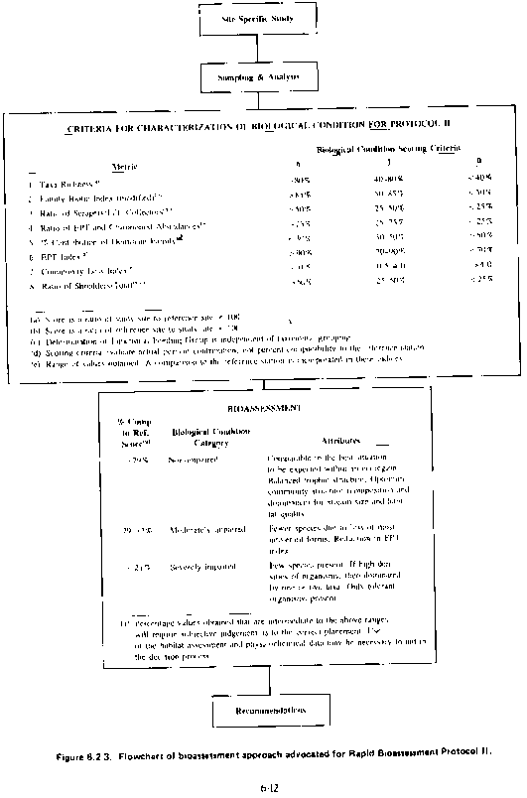
RBP III– genus/species level approach, from EPA/440/4-89/001

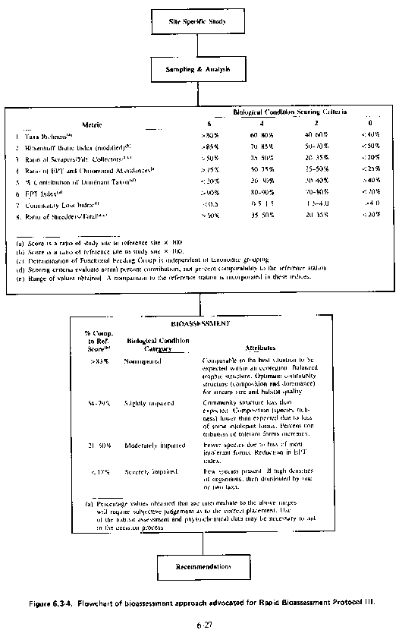
Appendix C: Example of a completed LARE metric scoring report

 |  | Sites
Metrics |  | 1* | 2 | 3 | 4 | 5
Number of Taxa |  | 20 | 11 | 13 | 12 | 12
EPT Index |  | 10 | 4 | 5 | 8 | 8
% Dominant Taxa |  | 31 | 35 | 43 | 28 | 60
Ratio of EPT to Chironomidae |  | 18 | 3.8 | 8.2 | 33 | 11
Modified HBI |  | 4.3 | 4.2 | 5 | 5.3 | 5.5
Ratio of Scrapers to Filtering Collectors |  | 0.2 | 0.2 | 0.3 | 0 | 0
Ratio of Shredders to Nonshredders |  | 1 | 1 | 12 | 14 | 0
Community Loss Index |  | 0 | 1.1 | 0.9 | 0.9 | 1.2
 |  | Scoring per Sites
 |  | 1* | 2 | 3 | 4 | 5
Number of Taxa |  | 6 | 2 | 4 | 4 | 4
EPT Index |  | 6 | 0 | 0 | 4 | 4
% Dominant Taxa |  | 2 | 2 | 0 | 4 | 0
Ratio of EPT to Chironomidae |  | 6 | 0 | 2 | 6 | 4
Modified HBI |  | 6 | 6 | 4 | 4 | 4
Ratio of Scrapers to Filtering Collectors |  | 6 | 6 | 6 | 0 | 0
Ratio of Shredders to Nonshredders |  | 6 | 6 | 6 | 6 | 0
Community Loss Index |  | 6 | 4 | 4 | 4 | 4
Total |  | 44 | 26 | 26 | 32 | 20
% of Reference |  | 100 | 59 | 59 | 73 | 45
Biological Condition Category (RBP III) |  | N | S | S | S | M
*Note: Site 1 was used as reference site

