PRE-BID MEETING

Oil & Gas Well Plugging
Multiple Projects Bid Dates of September 15 to 29, 2022
DEPARTMENT OF NATURAL RESOURCES
STATE OF INDIANA

Project No: ENG2312302077 – ENG2312302089

Team Live Meeting

Date: September 1, 2022 @ 9:30 AM ET
Location: DNR Engineering Conference Room

- Attendee Sign-in Roll Call Brian list to check

B. Welcome, Introductions, Project Contacts:
1. Access to site:
  - Orphan Well Manager: Brian Royer: broyer@dnr.in.gov
  - Office Phone: 317-417-6556
2. Document Questions are to be submitted and answers will be shared with all bidders by email only
- Oil & Gas Brian Royer: broyer@dnr.in.gov
- Oil & Gas Jim AmRhein: jamrhein@dnr.in.gov
- DNR Engineering Dean Illingworth, dillingworth@dnr.in.gov
- Inspector :
  - Listed in the bid document for each region
- Orphan Well manager: comments

C. Bidding and Contract Requirements:
1. Project is estimated at $150,000 or above.
2. Notice to Bidders
- Electronic Bid Submission
- Teams Live Event Bid Opening
3. Bids shall be taken from Prime Contractors pre-qualified by the Public Works Certification Board in the following classification/s: 1799.06 Oil Well Services, Prequalification by the Certification Board is required for this project prior to bid opening.
4. Per the Instructions to Bidders, Work by Contractor, “The Contractor shall perform a minimum of 15% of the value of the work…” (DAPW 30)
5. Review of Participation Goals Notice to Bidders
6. Reference Bidding and Contract Requirements for detailed instructions.
7. A Davis-Beacon wage rate is applicable. Addendum for wage determinations is on sam.gov – Brian will send out the latest wage determination seven to ten days before the bid

D. Document Overview
- Specifications
  - Existing Conditions – Utility Locates
  - Alternates - as noted in the bid document
- Drawings
  - Site plans

E. Scope of Work:
1. The scope of work consists of the Base Bid and one or two Alternates. For description of work reference each project.
2. Items of special attention:
- Existing Conditions
- Access

F. Allowances:
1. There are no Allowance included in these projects.

G. Project Schedule:
1. Bids received until 1:31 or 2:31 PM (Indianapolis Time) September 15 to 29, 2022 depending on the project
2. Normal work hours 7:00 AM to 5:30 PM
3. Project duration is 710 calendar days
4. Daily site cleaning
5. Tree removal window is from October 1 – March 31
6. Special sequencing and timing requirements:
7. Invoices will be submitted once a month, specific date will be coordinated when contract is executed.

H. Site Restrictions:
1. Contractor Staging Areas as needed
2. Deliveries to contractor office / site
3. Dumpsters as needed
4. Site Security as needed for equipment
5. Excess Fill Dirt or Rock

I. Temporary Utilities
1. None on these projects

J. Project Approvals:
1. Contractor to Obtain the Plugging plan approval from Oil & Gas
2. Local Building Permits not required
3. Septic Permit not required
4. Notification to Oil & Gas 48 hours prior to plugging per division rules

K. Bidding Documents:
- DNR Engineering Website – Division of Engineering Home Page: https://www.in.gov/dnr/engineer/
- DNR Engineering Website – DNR Project Bidding Information Page: https://www.in.gov/dnr/engineer/2908.htm
- Subscribe to receive email updates when the Engineering Bid Page is updated: https://public.govdelivery.com/accounts/INDNR/subscriber/new?topic_id=INDNR_16

L. Reference Information:
1. IDOA Certification board: https://www.in.gov/idoa/state-property-and-facilities/public-works/certification-board/
2. Bidder ID #: https://www.in.gov/idoa/procurement/supplier-resource-center/requirements-to-do-business-with-the-state/bidder-profile-registration/
3. W-9 & Direct Deposit: The successful bidder will be required to complete the Automated Direct Deposit Authorization Agreement & W-9 Form. Please reference the Auditor of State website for additional information: https://www.in.gov/auditor/.
It is recommended that you go online and complete this process. It will save time in getting a contract signed.

M. Site Tour will be conducted after the contract is executed and a final list of
Wells is developed:
DNR

N. Q & A:

- The base bid is on page 62
- The alternate’s bid is on page 63
- The unit price sheet is page 65
- Information about actual project is on page 121
- The quantity of wells in the base and alternate bids is on page 122
- The inspector is listed on page 123
- Special documentation requirements are listed on page 126
- A final list of wells will be established after methane detection by DNR inspectors, but an initial list of about 20-25 wells will be sent to contractors upon completion of contracting.
- Specifications require for class A cement, it may not be available, Brian will confirm if class L is ok to use. We have confirmed that Class L meets the standards of part 2 of section 5 shown below. 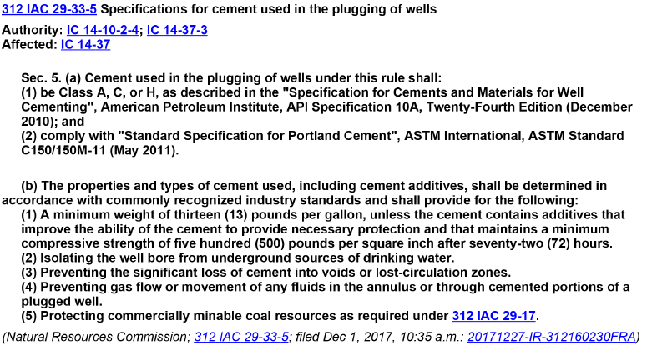
- Question: When DNR identify the wells in each package will all of them have adequate records for the contractor to develop the plugging plan? Answer: The contractor will have access to all the records DNR has and Brian will assist on areas where there are not good records. DNR staff will be available to assist in USDW calls if needed.
- Question: If a bid comes in and are awarded, what occurs if someone cannot fulfill them, execute a contract. Answer: Low bidder may submit a written request to withdraw the bid. Upon that the next low bid will be awarded the contract.
- Question: Rig mat / mud boat, on the item unit price sheet, and why it is listed together as one? Answer: Give price per day on mud boat or per rig mat per day and cross out the one you do not plan to use, so you will just be giving a price for one or the other.
- Question Jennifer – Davis Bacon wage if there is an update after the bid do they need to update the wage that is paid? Answer: All contractors will pay the wage rate in the last wage determination sent within 10 days of bid due date. Those will be the wage rates locked in for the entire contract period.
- Question: Nicki - Are the bid results available online or in another manner other than the live online opening? Answer: They will be posted online by IDOA public works.
- Question: Brandy - Site restriction how do they pay for land damages to a farmer? Answer:
There are unit prices for a per acre price and an allowance of two acres /well allowed on these bids. Contractor should produce a suitable number / acre and that is what will be paid to farmer after it is determined the impacted acreage. Contractor can even put this number in the landowner notification letters so they are aware ahead of time what the damage rate per acre is that will be paid. DNR will be sending out templates for landowner notifications to winning bidders. But contractors can add this to it.
- Question: Jennifer – if you are not aware of a landowner requesting damages (cost outside of your bid) do you submit a change order request. Answer: Crop damages and damages to improvements are the only damages that DNR is liable for payment in these projects per statute. If there are other unexpected issues that arise with costs outside of the unit price sheet (such as rental of fishing tools) those will have to be billed as “Extra items not on bid” and include details on what it was and it should be billed at a maximum of your cost plus 10%.

