[INSERT NAME OF COUNTY] LOGISTICs STAGING AREA (LSA) operation ANNEX [template]

[INSERT Month and year]

TABLE OF CONTENTS
TABLE OF CONTENTS 2
DISCLAIMER 5
EXECUTIVE SUMMARY 6
RECORD OF CHANGES 7
RECORD OF DISTRIBUTION 7
PLANNING AGENCIES 8
Primary Agency 8
Supporting County Agencies 8
Supporting State Agencies 8
Non-Governmental Organizations 8
Local Organizations 8
PURPOSE, SCOPE, SITUATION AND ASSUMPTIONS 9
Purpose 9
Scope 9
Situation 9
Hazards 9
Core Capabilities and Mission Areas 10
Capability Assessment - Core Capabilities 11
Core Capability 11
Logistics 11
Planning Assumptions 12
Planning Considerations 14
Safety Concerns 14
CONCEPTS AND OPERATIONS 15
Activation Process 15
Reception of Resources Process 15
Distribution of Resources 16
Resource Request Process 17
ORGANIZATION AND ASSIGNMENT OF RESPONSIBILITIES 18
Organization 18
Indiana National Guard (INNG) 20
Indiana Department of Correction (IDOC) 20
Commercial Contractors 20
Assignment of Responsibilities 20
County Emergency Management Agency Director (EMA) 20
County Staging Area Organizational Chart (Examples) 21
Staging Area Organizational Chart Example 1. 21
Staging Area Organizational Chart Example 2. 22
Logistics Staging Area Manager (STAM) Responsibilities 22
Prepare and Mobilize 22
Build the Team 23
Lead, Supervise, Direct 23
Perform Staging Area Manager-Specific Duties 23
Communicate and Coordinate 25
Manage Risk 25
Document 26
Demobilize 26
Ground Support Unit Leader 27
Ordering Unit 27
County Accountable Property Officer 28
Transportation Unit Leader 28
Planning Unit Leader 28
Resource Tracking Unit Leader 29
Reporting Unit Leader 29
Twice Each Day 29
Essential County LSA Equipment 30
APPENDIX A – SITE LAYOUT 31
Layout Planning Factors 31
Staging Area Layout Examples 33
APPENDIX B – LSA ON-SITE STORAGE AREA REQUIREMENTS 35
APPENDIX C – INITIAL LSA RESOURCE REQUIREMENTS 37
APPENDIX D – LSA DISTRIBUTION CHECKLIST 47
Pre-Incident 47
Post-Incident 48
Demobilization 49
APPENDIX E – DEMOBILIZATION CHECKLISTS 50
Demobilization Initiated 50
Notification 50
End of Receiving 50
Demobilization Planning 50
Demobilization Preparation 50
Redistribute Supplies 50
Supplies 50
Materials 50
Dismantle the Point of Distribution 51
End Operations 51
Pack Equipment 51
Decontaminate Equipment 51
Inventory Equipment 51
Transport Ready 51
Load Equipment 51
Clean Site 51
Site Inspection 51
Return Site 51
Close Out Operations/Records 52
Release Staff 52
Notify Division of Emergency Management 52
Return Records 52
End Deployment 52
APPENDIX F – POINTS OF DISTRIBUTION (POD) TYPES 53
POD Layout – Type I 53
POD Layout – Type II 54
POD Layout – Type III 55
APPENDIX G – COUNTY LSA CAPABILITIES FORMS 56
APPENDIX H – ACRONYMS 57
APPENDIX I – REFERENCES 59

DISCLAIMER

This template was created by the Indiana Department of Homeland Security (IDHS) to assist Indiana county Emergency Management Agencies (EMAs) and their stakeholders in the development of their County Logistics Staging Area (LSA) annex, which supports their county logistics plan.
This template provides example language and sample charts and layout diagrams to assist counties with identifying and documenting their specific needs for the establishment of a successful LSA. This template should be modified to follow each county’s organizational structure, capability, and capacity. This template follows NIMS/ICS, FEMA and other organizations and accredited state guidance. Please see the references on in Appendix I for links.
IDHS welcomes feedback on this template. Our goal is to provide our county stakeholders with the most comprehensive product for our county EMAs and stakeholders.

EXECUTIVE SUMMARY
[Insert county name] County provides this document to implement its County Logistics Staging Area (LSA); a designated location to receive, stage and deploy critical shipments of commodities, supplies and resources in critical local and/or state incidents. A LSA consists of three main functions to assist with a surge of critical shipments:
- Resources: Employing staff and/or stock supplies and equipment at the facility
- Shipments: Receiving, staging, and deploying commodities, supplies or equipment
- Deployments: Shipments at site assigned to an incident or being utilized
Staffing will be essential to a successful process in the event of an incident. Each incident will vary in size and number of personnel needed to support an LSA and the ability to be able to increase or reduce the size is an important consideration when exercising this capability. For a large incident, a general guideline is to assign and schedule between 40 and 172 personnel at any given moment during a county emergency. An LSA site consists of many functional areas which identify the need for such calculated staffing:
- Check-in and check-out gates: Points for entering and exiting the LSA compound.
- Holding area: Area for shipments diverted upon arrival requiring additional action.
- Shipment storage areas: Areas for preparing shipments to deploy out of LSA.
- Equipment yard: Area for special handled items and maintenance utilities
- Driver support center and staff rest area: Facilities with amenities for staff/drivers
- Ground support area: Area for support equipment with tool, spill, and repair kits
- Fuel point: Station where emergency service vehicles can refuel (petrol & diesel)
- LSA command post: Field office for command lead and staff needing workstations.
- Advanced operations areas: Areas of activations for special operational abilities such as ground or intermodal operations
It is essential that a flexible command system is utilized, as situations may be subject to drastic changes in the state of an incident. This document provides the fundamental procedures, strategies and assumptions for the activation, operations, and demobilization phases of the LSA. Doing so will prove further successful operations with the introduction of an LSA in [Insert county name] county.

RECORD OF CHANGES
[Insert detailed information regarding any changes]
Change # | Change Description | Date Posted | Person(s) Responsible

RECORD OF DISTRIBUTION
[Insert who received a copy of this annex]
Date | Agency/Department | Agency Representative | Method of Delivery

PLANNING AGENCIES
The primary agency identifies the appropriate support agencies that fall under this plan and collaborates with each entity to determine whether it has the necessary resources, information, and capabilities to perform the required tasks and activities within each phase of emergency management, including activations in the [Insert county name] County Emergency Operations Center (EOC) and impacted areas. Though an agency may be listed as a primary agency, it does not control or manage those agencies identified as supporting agencies. The agencies listed below are part of the Whole Community Planning Committee for this plan.

PRIMARY AGENCY
[Insert name of county EMA agency]

SUPPORTING COUNTY AGENCIES
[Insert supporting county agencies]

SUPPORTING STATE AGENCIES
Indiana Department of Homeland Security | [Insert other supporting state agencies]

NON-GOVERNMENTAL ORGANIZATIONS
[Insert supporting non-governmental agencies]

LOCAL ORGANIZATIONS
[Insert supporting local organizations]

PURPOSE, SCOPE, SITUATION AND ASSUMPTIONS

PURPOSE
The [Insert county name] County logistics staging area (LSA) is a temporary assembly point (location) for the reception and onward integration of commodities, goods and other resources needed to support the response and recovery operations of a disaster or emergency. This annex establishes the guidelines and tasks for the initiation and operation of an LSA. To help aid multiple commodities points of distribution (C-PODS), an LSA serves as a focal point to receive resources such as emergency power, material handling equipment, food, and water, as well as any other necessary resources from outside the county. The LSA is responsible for the operations of the emergency response site that receives and deploys resources to C-PODS.

SCOPE
This has been developed as an annex to the [insert name of county CEMP or EOP] and is supported by the [insert county name] County Logistics Plan. The [insert county name] County Logistics Plan addresses how the county will support local municipalities, unincorporated portions of the county, public shelters (general and special needs), critical facilities, points of distribution (PODs) and disaster recovery centers (DRCs). This annex lists planning assumptions and considerations that establish fundamental procedures and strategies. The annex establishes a concept-of-operations spanning establishment, reception of resources, site operations, resources distribution and demobilization.

SITUATION

HAZARDS
Various risk assessments have identified the most probable natural, human-caused, and technological hazards that face our county. This includes the Threat and Hazard Identification and Risk Assessment (THIRA), which assesses risk and sets capability targets that reflect preparedness goals based on the National Preparedness System’s five mission areas and 32 core capabilities. THIRA data is used as the baseline data for the Stakeholder Preparedness Report (SPR). The SPR is an assessment that compares current capabilities with targets, identifies gaps and prioritized investments and includes other preparedness activities to address gaps. The gap is quantified between current capabilities and targets, and then indicates whether the gap is related to any of the five following areas: planning, organization, equipment, training, and exercise (POETE). This produces actionable information, providing clear direction on where to focus efforts and resources to have the biggest impact. The following chart highlights those mission areas and core capabilities associated with this annex.

CORE CAPABILITIES AND MISSION AREAS
PREVENTION | PROTECTION | MITIGATION | RESPONSE | RECOVERY
Planning
Public Information and Warning
Operational Coordination
Intelligence and Information Sharing |  | Community Resilience | Infrastructure Systems
Interdiction and Disruption |  | Long-Term Vulnerability Reduction | Critical Transportation | Economic Recovery
Screening, Search and Detection |  | Risk & Disaster Resilience Assessment | Environmental Response/Health and Safety | Health and Social Services
Forensics and Attribution | Access Control and Identify Verification | Threats and Hazards Identification | Fatality Management Services | Housing
 | Cybersecurity |  | Fire Management and Suppression | Natural and Cultural Resources
 | Risk Management for Protection Programs and Activities |  | Logistics and Supply Chain Management
 | Supply Chain Integrity & Security |  | Mass Care Services
 | Physical Protective |  | Mass Search and Rescue Operations
 |  |  | On-Scene Security, Protection, & Law Enforcement
 |  |  | Operational Communications
 |  |  | Public Health, Healthcare, and Emergency Services
 |  |  | Situational Assessment

CAPABILITY ASSESSMENT - CORE CAPABILITIES
The following table lists the response core capabilities that this plan most directly supports along with specific actions related to each of these core capabilities.

CORE CAPABILITY | LOGISTICS
Critical Transportation | - Manage transportation that includes equipment and procedures for moving material from storage facilities and vendors to incident victims, particularly with emphasis on the surge and sustainment portions of response.  - Provide transportation management services, including fulfilling requests from other state organizations.
Logistics and Supply Chain Management | - Coordinate resource support for survivors.  - Provide resource management that includes determining requirements, sourcing, ordering and replenishment, storage and issuing of supplies and equipment.  - Provide facilities management that includes location, selection and acquisition of incident facilities, such as joint field offices (JFO), as well as storage and distribution facilities.  - Establish and operate logistics support facilities to include the management of services related to lodging and feeding incident support personnel.  - Provide personal property management to include policy and procedures guidance for maintaining accountability of material, as well as identification and reutilization of property acquired to support a federal response operation.  - Manage electronic data interchanges to provide end-to-end visibility of response resources.  - Plan for transitional support to recovery operations concurrent with response operations.
Supply Chain Integrity & Security | - Secure and strengthen the resilience of 100 percent of the key nodes, transportation methods between nodes and materials in transit between supplier and customer.
Access Control and Identity Verification
  - Ensure 100 percent identity verification of individuals to authorize, grant or deny access to specific physical locations and systems, to protect critical facilities and assets.
  - Ensure 100 percent identity verification of individuals to authorize, grant or deny access to specific cyber locations and systems to protect critical facilities and assets.
Planning | - Conduct a systematic process engaging the whole community, as appropriate, in the development of executable strategic, operational and/or community-based approaches to meet defined objectives.
Operational Coordination | - Establish and maintain a unified and coordinated operational structure and process that appropriately integrates all critical stakeholders and supports the execution of core capabilities.
Public Information and Warning | - Deliver coordinated, prompt, reliable and actionable information to the whole community using clear, consistent, accessible, and culturally and linguistically appropriate methods to effectively relay information regarding any threat or hazard and, as appropriate, the actions being taken, and the assistance being made available.

PLANNING ASSUMPTIONS
- The [Insert county name] County Logistics Plan will be activated when there is a need for an LSA.
- The [Insert county name] County has pre-identified primary and secondary LSA sites within the county.
- [Insert county name] County has identified multiple commodities points of distribution sites (C-PODs).
- The general assumption that re-supply will occur at any time during the day or night, requiring 24-hour security.
- The increase of research, support and logistics will be instigated upon the increase of the complexity of the incident, its mass of scope, intensity, and duration.
- The [Insert county name] County Logistics Plan will be activated based on the size and severity of the impact of an incident occurring within the county.
- Multiple LSAs may need to be established for an event depending upon the span of control the site can support.
- Cascading effects to commercial and governmental supply chains may not be immediately obvious but could further hinder logistics support efforts for 14 days or more.
- [Insert county name] County has limited resources to support a major disaster that results in a full activation of its logistics organization and/or extended logistics operation and will require mutual aid and/or commercial assistance to meet the resource demands of its citizens.
- [Insert county name] County resources (public and commercial) will receive the highest priority for use, as available, before out-of-county or out-of-state resources are utilized.
- A catastrophic event or a series of concurrent smaller events will require a vast amount of emergency resources to respond to the emergency needs of affected communities as well as recover from the effects.
- Resource requirements may be for an extended period and local resources will be exhausted quickly in a major or catastrophic event.
- Local resources and supplies shall be exhausted including all mutual aid that can be provided, before formally requesting the state of Indiana’s assistance.
- In-state or out-of-state mutual aid, and commercial resources and personnel, will be required for an extended period.
- Expedient field logistic staging areas, temporary operations centers, as well as emergency worker living, and support accommodations will be required to support relief efforts.
- Military resources may not be available to support operations due to other national security mission requirements.
- Concurrent events in other counties or states may exhaust available state, federal and commercial resources in a short period of time.
- Impacts or restrictions on transportation assets may delay the response time of some resources.
- Multiple response agencies operating on different communications frequencies may not be able to communicate with each other without specialized interoperable communications systems or mutual aid radio networks.

PLANNING CONSIDERATIONS
Having a 24-hour operation will be important to maintain to provide requests for re-supplies and urgent needs to several C-PODS during an event, if needed. This will also allow for more efficient truck transport, allowing travel to occur when the surrounding road networks are less congested. It is essential to consider:
- Extra staff will be required to cover 24-hour operations with each working on-site for 12-hour shifts with a decrease in staff workloads for longer mobilizations
- Security threats will be more prominent during the overnight hours
- Additional lighting and high-visibility PPE will be required
- Lighting on roads may not be restored due to the proximity of the incident
- Reduced visibility may cause safety risks
- Decreased alertness of night staff (LSA staff and drivers)

SAFETY CONCERNS
A safety officer will be required to prevent any safety issues or breaches within the LSA. A safety officer will be assigned at all LSA and C-POD locations. This individual will be responsible for overall security, fire, medical and life safety concerns, which includes compliance with OSHA regulations such as forklift operations and certification of operators.

CONCEPTS AND OPERATIONS
The [Insert County Name] County LSA will be staffed, equipped and capable of providing support services to conduct staging operations on behalf of the County. The LSA will receive bulk resources of commodities, supplies, materials, and equipment from federal, state and/or vendor resources to support local operations. The LSA will be established and be operational as soon as possible after determining the need and activating the process.
The [Insert County Name] County Emergency Management Agency (EMA) will pre-select (and negotiate, if necessary) at least two primary logistics sites. The two types of logistics sites are the [Insert County Name] County logistics staging area and the [Insert County Name] County commodities points of distribution (C-POD) site. These sites will be used for the purpose of receiving and distributing bulk emergency relief supplies such as water, ice, food, and tarps within the first 24-96 hours after an event.
[Insert County Name] County may survey and identify the LSA site(s) as it deems necessary and in accordance with the provisions defined within this document.

ACTIVATION PROCESS
Upon notification of an occurring incident, the LSA may be activated by the [Insert County Name] County Emergency Operations Center (EOC) director or designee or at the direction of the designated county official. This need is based on the influx of resources and a need to temporarily store them before onward movement to their destination.
The [Insert County Name] County EMA or designee shall appoint a logistics staging area manager (STAM). The County STAM will oversee all daily operations at the LSA.

RECEPTION OF RESOURCES PROCESS
The County LSA receives disaster-related commodities from a state logistical staging area, federal staging area, federal mobilization sites or vendors. The STAM will account for, store as required, ship to C-PODs or other designated sites, as well as redirect and recover unused supplies.
- Record any delivery of goods, materials and supplies by the resource, amount, date received and location within the LSA to the site inventory and staged for distribution.
- The STAM will not sign any bills of lading, delivery tickets, invoices, or other documentation, until the resource has been inventoried. After inventory, the STAM will delegate a member of the management team to sign delivery documents and maintain copies for the record and future reimbursement.
- For equipment: Record date received, equipment serial numbers, name of vendor and record engine hours if equipment has engine clock. Keep all parts and accessories with a major piece of equipment (e.g., hoses and connectors with pumps). Note any preexisting damage and fuel tank levels. If the situation permits, take pictures to document condition of resources upon arrival.

DISTRIBUTION OF RESOURCES
All resource requests will be made through WebEOC/Mission Task Board and tasked to the State EOC Logistics Section.
Resources will be assigned to fill a resource request. When a resource is assigned, a record will be kept of where the resource will be used and updated with the SEOC and when the resource has been provided.
Issue equipment by serial number using a signature receipt form to the personnel who will use it. The STAM will maintain an accurate status of who has signed for it and where the equipment will be used. Record the engine hours and keep all parts and accessories with a major piece of equipment.
Record any issue of goods, materials and supplies by resource type and amount, whom it was issued to, the date of issue and issuer’s name. Update site resource totals in the resource tracking inventory and inform the SEOC Logistics Section.
Resources from the state LSA will be distributed to a local LSA or to a C-POD. The delivery location will be agreed upon by the state and county based on the most efficient delivery method and transportation cost.
Temporary transfer of property from the state to a county:

- This requires state coordination and concurrence within state financial procedures.
- Assets leased by the state on behalf of a county are financially transferred from the state to the county upon delivery and issuance of a county purchase order to the vendor to cover the lease period.
- The county will be held accountable for all physical property assigned during the operation.
- The county will be billed the purchase/replacement price of tangible property for any leased property not returned to the vendor of record or back to the state.
- Leased equipment IS reimbursable.
- Purchased equipment is NOT reimbursable.

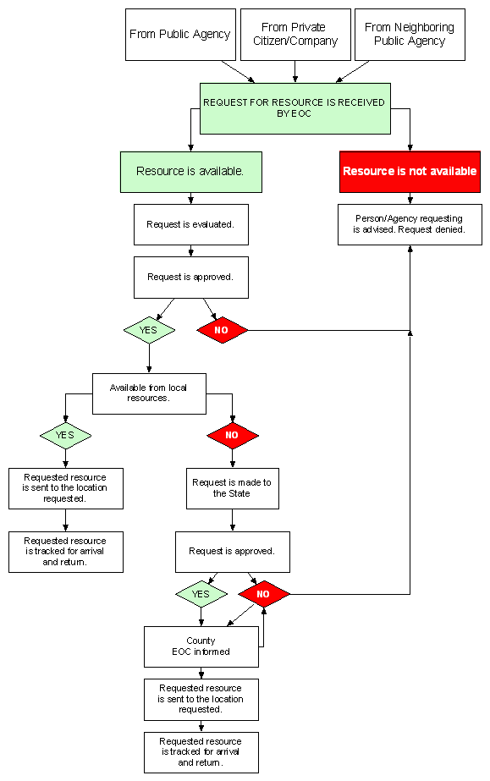
RESOURCE REQUEST PROCESS

ORGANIZATION AND ASSIGNMENT OF RESPONSIBILITIES

ORGANIZATION
Recognized as a critical element of the Incident Command System (ICS), logistical staging areas (also known within ICS as “staging areas”) are established to maintain a ready reserve of tactical resources and operational overhead to support evolving or emergent operational resource requirements. LSAs with adequate resource reserves are a critical component of maintaining a proactive posture on the incident and readiness to respond to contingencies.
The Operations Section Chief (OSC), in coordination with the Logistics Section Chief (LSC), directs the establishment of staging areas to enable the positioning of, accounting for, and onward movement of requested and available resources. Per NIMS/ICS, the final destination for resource orders is under the purview of the OSC.
The LSC is responsible for execution and movement of the resource order and for ensuring the staging team is capable of meeting current, emerging, or anticipated operational resource requirements.
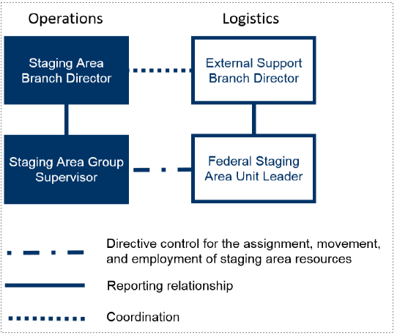
There is requirement to have clear lines of communication and coordination between the OSC and LSC for staging area operations. The chart below demonstrates how FEMA organizes the Federal Staging Area using hard lines of reporting relationships and dot-hard line of directive control and dot lines for coordination.

Staging areas are managed by a staging area manager (STAM) who reports to the operations section chief or deputy. Staging areas are usually organized by geographic location and are named as such (10th Street Staging, Hamilton School Staging, etc.). The designated staging area manager is responsible for all activities within that area, to include establishing, maintaining, check-in, storage, and distribution of all resources at staging. There may be more than one staging area on an incident and separate staging area may be designated for land-based and maritime resources. Typically, aviation resources are staged at the air operations base instead of a multi-resource staging area.
The operations section chief may identify the need for a staging area at any time, but this typically occurs in the initial response or as part of the incident action plan (IAP) planning process during the tactics meeting or preparation for the tactics meeting. As part of the IAP planning process, the LSA is planned for in a similar fashion as a division or group; the staging area is noted on the operations section organization chart, is documented on the ICS-215 with required resources and logistical support requirements and receives an ICS-204 in the IAP.
Like an incident command post, joint information center or incident base, a staging area is considered an incident facility and the required logistical support requirements can be lengthy. While the direction to establish a staging area comes from the operations section chief, the logistics section has a requirement to support the staging area as a facility.
If the pre-determined staging area site is unavailable, a general location identified by the operations section chief, the staging area manager, along with the logistics section chief will locate the best possible site. This includes coordination with the finance section chief to negotiate a lease and/or land-use agreement. Finally, the safety officer will need to inspect the site for potential safety hazards.
Once the site is acquired, the STAM, along with support from the logistics section, will determine the layout to support the operational aspects of the LSA along with all the associated support elements that will be co-located with the LSA.
Depending on the activities within the staging area, the logistics section would provide shelter, security, signage, supplies and other support items. The STAM will work with all the unit leaders within the logistics section, but the most interaction usually occurs with the facilities unit leader and supply unit leader. The STAM will continually manage the LSA until it is no longer needed and then will work with the logistics section to return the site to its original condition as outlined in the lease/usage agreement.
As resources are assigned to an LSA, they are considered available to the operations section chief for immediate reassignment to a division or group. They are considered “on the clock” or in “paid” status, as they must be available for immediate deployment in the operations section. This is different from resources that are “out of service” in a base or camp. Resources in an LSA must be available to deploy immediately (typically defined as five minutes or less) meaning they must be fully fueled, equipped, staffed and ready for operations.
The STAM plays a critical role in the resource management process. At the direction of the operations section chief, STAMs may work with the resources unit leader to assemble single resources into strike teams and task forces. Additionally, the STAM may disassemble strike teams and task forces for assignment as single resources. With all resources assigned to the LSA available for reassignment in the operations section, the STAM must keep the resources unit leader and operations section chief apprised of any changes to the status of any resource in the LSA including reassignment, out of service or changes to strike teams and task forces.
Indiana National Guard (INNG)
The INNG may agree upon availability to assist with facilitating the LSA site during emergency operations by establishing manning for efficient and effective LSA operations and provide cost estimates to the SEOC Logistics Section.
Indiana Department of Correction
Upon availability, will provide manpower to assist with any setup.
Commercial contractors
County EOCs may enter into non-binding or retainer agreements that refer to establishing, managing, and operating LSAs.

ASSIGNMENT OF RESPONSIBILITIES

COUNTY EMERGENCY MANAGEMENT AGENCY DIRECTOR (EMA)
- Designate a STAM and give it a copy of the map, which has the planned layout for the LSA.
  - The staging area manager (STAM) could be a county employee, an emergency manager from another county under mutual aid or a contracted individual designated by the county to act on behalf of the county.
- Deploy to LSA site or send designee to begin necessary site preparations and improvements, if needed.
- Coordinate transfer of commodities from storage sites and/or vendor locations.
- The county EMA will develop a target date/time for the LSA establishment and report date to county operations section chief.
- Evaluate commodities distributed and determine burn rate.
- Coordinate demobilization plan with STAM.
- Upon demobilization of LSA, submit all necessary paperwork to the county EOC documentation unit leader or the county planning section chief.

COUNTY STAGING AREA ORGANIZATIONAL CHART (EXAMPLES)

STAGING AREA ORGANIZATIONAL CHART EXAMPLE 1.

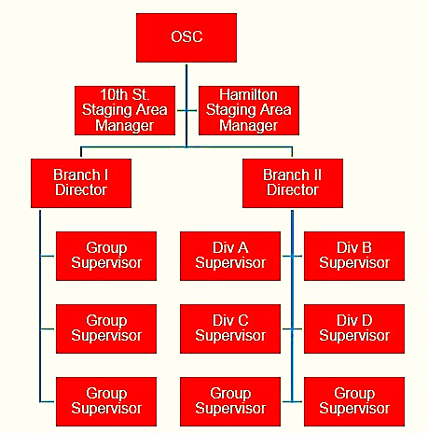
STAGING AREA ORGANIZATIONAL CHART EXAMPLE 2.

LOGISTICS STAGING AREA MANAGER (STAM) RESPONSIBILITIES
The STAM is responsible for managing all activities within the staging area and ensuring organization and space for all assigned resources while they wait for tactical assignments. The STAM reports to an operations section chief or other assigned supervisor and works in the operations functional area.

Prepare and Mobilize
- Obtain and assemble information and materials needed for kit.
- Ensure individual readiness.
- Gather critical information pertinent to the assignment.
- Travel to and check in at assignment.
- Review the incident action plan (IAP) and obtain briefing, objectives, radio frequencies and intent from supervisor.

Build the Team
- Assemble and validate readiness of assigned personnel and equipment assigned to the staging area.
- Establish and communicate chain of command, reporting procedures, risk management processes and radio frequency management.
- Establish a common operating picture with module supervisors.
- Brief current and newly arriving modules using IAP and/or briefing checklist.

Lead, Supervise, Direct
- Model leadership values and principles. Provide positive influence. Emphasize teamwork.
- Establish and communicate objectives, priorities, potential work assignments and performance expectations.
- Identify, analyze, and use relevant situational information to make more informed decisions and take appropriate actions.
- Adjust actions based on changing information and evolving situational awareness.
- Develop and implement contingency plans. Communicate changing conditions to assigned resources and supervisor.
- Ensure incident objectives and performance standards are understood.
- Communicate problems immediately and take corrective actions.

Perform Staging Area Manager-Specific Duties
- Obtain initial briefing from supervisor and attend subsequent operational period briefings. Determine the types and numbers of resources to be maintained in the staging area.
- Complete Activity Log (ICS 214) for each operational period for the duration of the assignment.
- Establish the staging area to ensure quick response for apparatus/vehicles.
- Establish vehicle traffic patterns and assign parking.
- Check in and track STAM resources.
- Establish and communicate the following:
  - Staging area rules
  - Restricted areas (e.g., helibase, private property)
  - Procedures for staging, dispatching, check-out, refueling, status reporting
  - Rotation of assigned resources for feeding, personal needs, etc.
  - Established crew standby areas
  - Safety concerns
- Establish, communicate, and implement staging area dispatch procedures. Organize task force or strike teams, as necessary.
- Coordinate with the planning section.
  - Provide a copy of the staging area layout to the planning section and ensure staging areas are located on the IAP maps.
  - Obtain transportation and IAP maps.
  - Obtain the incident contingency plan containing emergency procedures outlined for the staging area.
- Coordinate with the logistics section.
  - Determine the needs of personnel in the staging area.
- Coordinate with the finance/administration section.
  - Determine procurement procedures and identify what resources are available locally.
  - Establish appropriate timekeeping procedures for the staging area.
- Coordinate with the safety officer.
  - Develop measures for ensuring safety of personnel while monitoring and assessing hazards.
- Relocate the staging area as directed.
- Close out the staging area.
- Rehabilitate the staging area.

Communicate and Coordinate
- Follow established processes and chain of command for collecting, producing, and distributing information.
- Communicate with supervisors regarding resource control issues that may arise. Correct deficiencies immediately.
- Establish a bulletin board, and post procedures for the staging area and a copy of the IAP for each operational period.
- Report any changes or hazardous conditions to supervisor.
- Communicate effectively using multichannel radios. Understand how to clone and program radios for staging area resources.
- Conduct and/or participate in after action reviews (AAR).

Manage Risk
- Apply the risk management process:
  - Identify hazards
  - Assess hazards
  - Develop controls and make risk decisions
  - Implement controls
  - Supervise and evaluate
- Ensure compliance with all safety practices and procedures for assigned personnel.
- Plan for medical emergencies. Ensure that assigned resources are prepared to execute the medical plan (ICS 206). Ensure familiarity with medical responders, communication procedures and transportation plan.
- Monitor for signs and symptoms of fatigue, illness, or injury. Mitigate appropriately.
- Account for location, health, safety, and welfare of assigned personnel.
- Take precautions for any hazardous materials in the staging area:
  - Ensure the safe handling of hazardous materials.
  - Dispense fuel and hazardous materials carefully.
  - Use absorbent materials as required by local protocol. See operations section chief, logistics section chief or resource advisor.
  - Coordinate with ground support unit leader concerning the handling of hazardous materials.
  - Rope or flag off areas where hazardous materials or safety hazards are present.

Document
- Complete, ensure timeliness of, and route as required:
  - Emergency equipment shift tickets
  - Fuel receipts
  - Incident personnel performance rating (ICS 225)
  - General message (ICS 213)
  - Activity log (ICS 214)
  - Agency-specific forms

Demobilize
- Confirm and obtain instructions from the operations section chief to demobilize fire resources.
- Operations section chief is responsible for notifying the other sections (e.g., Logistics, Planning).
- Use the demobilization check-out form (ICS 221) to assist in proper demobilization procedures.
- Brief assigned resources on demobilization procedures and responsibilities.
- Rehabilitate staging area to pre-incident condition.

Ground Support UniT LEADER
- Responsible for safe and orderly storage of assets and commodities.
- Provide space/storage for specialized items (perishables, controlled materials).
- Establish centralized receiving process at facilities.
- Conduct cross loading operations.
- ID transportation requirements.
- Manages physical environment (e.g., receiving, temp storage, distribution, provides controls and procedures).
- Prepare, coordinate, and monitor retrograde transport of commodities and teams.
- Operates and maintains equipment.
- Ensures operators are trained and certified.
- Responsible for driver support area.

Ordering Unit
- Provides general financial guidance to the STAM and staff.
- Plans for and assures the proper acquisition process is in place.
- Prepares and provides financial tracking reports.
- Identifies potential financial management concerns.
- Tracks all credit card and purchase order purchases.
- Secures funding for equipment and other essentials for operation.
- Determines funding needs for feeding/billeting.
- Establishes local vendor contract for services.
- Purchases supplies.
- Plans and initiates fiscal closeout procedures for staging area.
- In-processes personnel.
- Establishes building maintenance and custodial arrangements.
- Identifies and manages billeting/lodging requirements in coordination with County Emergency Operations Center.

COUNTY ACCOUNTABLE PROPERTY OFFICER
- Ensures all accountable property received is properly marked and inventoried.
- Prepares accountable property reports.
- Establishes internal controls.
- Issues equipment (e.g., cell phones, computers).
- Establishes tracking mechanisms for recoverable accountable property.
- Conducts “wall to wall” inventory at closeout of staging area.
- Recovers and properly disposes of property during demobilization phase.

Transportation UniT LEADER
- Plans for and executes all support activities of both ground and air transportation.
- Conducts fueling operations.
- Coordinates traffic flow at site.
- Manages fleet vehicles.
- Provides layout and traffic control of staging area.
- Coordinates with state LSA on shuttle drivers.

PLANNING UNIT LEADER
- Provides receiving and distribution services for the county LSA.
- Processes mission taskings from the Emergency Operations Center to field sites.
- Develops an operational checklist for pre- and post-activities.
- Provides distribution assistance in some cases.
- Develops and publishes shipping schedule (movement coordination).
- Publishes safety, security, and operational plans to keep staff informed.
- Prepares demobilization plan/transition plan.
- Conducts planning meetings for staff.

Resource TrackinG UNIT LEADER
- Ensures all assets are tracked moving through the system and staging area.
- Utilizes appropriate programs to prepare asset visibility reports to management.
- Maintains current inventory of assets.
- Maintains receiving and distribution reports.

REPORTING UNIT LEADER
- Coordinates and implements standard reporting procedures to include formats, timeframes, and methods.
- Ensures that common units of measurement are consistent with the state LSA and reporting requirements.
- Prepares management reports and central point of collection for reports.

TWICE EACH DAY
- Receiving - check-in gate log
- Shipping - check-out logs
- Inventory

ESSENTIAL COUNTY LSA EQUIPMENT
The list below indicates basic essential equipment to run an LSA. More is in Appendix C.
ITEM  Forklifts conventional 6,000 lb. | QUANTITY  2 | PROVIDER  Vendor Contract
Pallet Grabbers and Chain sets | 1 | Locally Provided
Pallet Jacks, hand operated | 2 | Vendor Contract
Cellular Phones | 1 | Locally Provided
Extension Cords, 12/3 GA. | 500' | Locally Provided
Eye Protection, safety glasses | 25 | Locally Provided
Flashlights, “D” Cell (2), Industrial | 12 | Locally Provided
Motorola Talk-Abouts or equivalent (optional) | 6 | Locally Provided
Hard Hats, conventional | 30 | Locally Provided
HazMat spill kit | 1 | Locally Provided
Hearing Protection, plugs, disposable | 100 | Locally Provided
Megaphone, 25-watt, w/remote mic | 1 | Locally Provided
Traffic cones | 40 | Locally Provided
Work gloves (Pair) | 10 | Locally Provided
Barricade tape (rolls) 1000 ft. | 4 | Locally Provided
Barricades | 12 | Locally Provided
10'x10' Shade Tent | 4 | Vendor Contract
Electrical Boxes | 2 | Vendor Contract
Fans, warehouse, 36 in. | 1 | Vendor Contract
Lights, portable, 4,000-watt Light Tower | 2 | Vendor Contract
Portable Toilets, self-contained, with daily service contract | 6 | Locally Provided
Vests, safety | 50 | Locally Provided

APPENDIX A – SITE LAYOUT

LAYOUT PLANNING FACTORS
Logistics staging area site planning is dependent on terrain, infrastructure, access, and facilities. The staging area manager either determines the site layout pre-incident or on-site during the incident.
The concept of “first in, first out” is used for commodity and resource storage and parking. “First in, first out” saves drayage fees by allowing vehicles that arrive first to be unloaded and released first. The following figure illustrates a logistics staging area site layout. It is intended for planning purposes and is not to scale.
Staging areas and PODs demand strategic consideration and tactical pre-disaster decision-making. To ensure preparedness, these elements must become solid fixtures in emergency management planning. Each of the steps mentioned for site selection is integral to the overall preparedness design. Note: 1 acre = 42,000 square feet
- One tractor and trailer requires a 12’ x 100’ space allocation (1,200 square feet)
- One trailer only requires a 12’ x 60’ space allocation (720 square feet)
- One tractor only requires a 12’ x 40’ space allocation (480 square feet)
- One generator trailer pack (200 – 750 kW) requires a 10’ x 20’ space allocation (200 square feet)
- Check-in area should accommodate at least 8 trucks at a time (9,600 square feet)
- Check-out area should accommodate at least 8 trucks at a time (9,600 square feet)
- One emptied semi trailer, single pallet layer, requires a 12’ x 60’ floor space allocation (720 square feet)
- 80 square feet per office worker
  - Typical staff of 30 office staff = 2,400 square feet
  - Office equipment space = 500 square feet
The following considerations should be considered when determining a suitable location for a county staging area. These items correlate to the diagram appearing on the next pages.

- Command area
- Check-in and check-out
- Parking areas segregated by resource type
- Heavy equipment staging areas
- Enclosed warehouse
- Loading docks and/or ramps
- Refueling depot
- Heliport
- Driver support area(s)
  - Information center
  - Catering
  - Showers
  - Restrooms

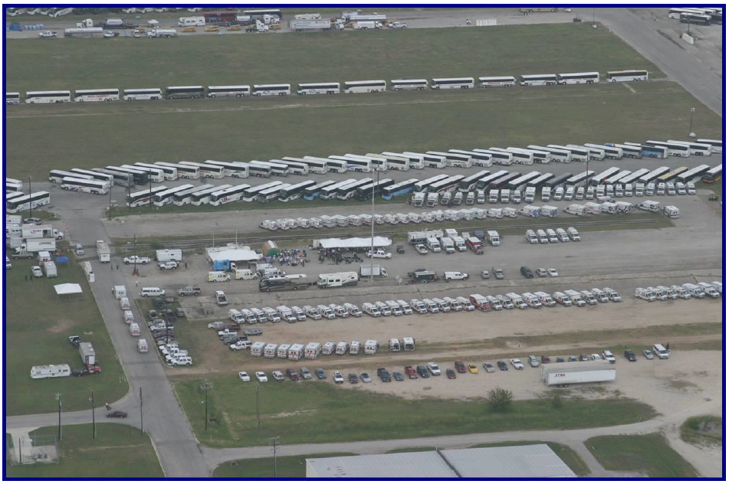
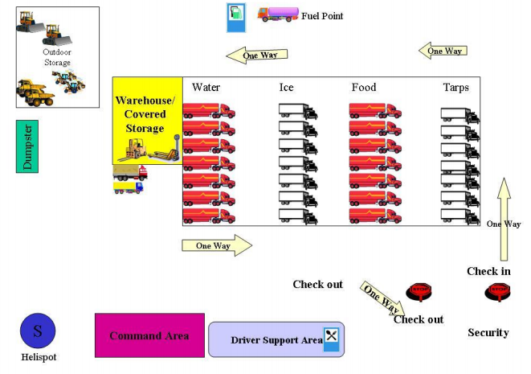
STAGING AREA LAYOUT EXAMPLES
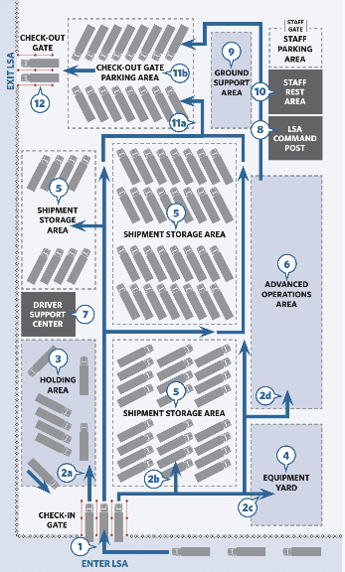
1

2

3

4

5

6

7

8

9

10

11

12

Check-In Gate: Shipments enter and are checked by the gate crew.

The traffic crew uses color-coded markings to direct shipments:
- Holding Area: Shipments needing further review are directed here.
- Shipment Storage Areas: Accepted shipments are directed here.
- Equipment Yard: Shipments with equipment may be directed here.
- Advanced Operations Area: At LSAs with advanced operations certain shipments may be directed here.

Shipments with problems are resolved at the Holding Area.

Shipment of equipment requiring special handling are maintained at an Equipment Yard.

Shipments ready for deployment are parked and staged at Shipment Storage Areas.

Shipments may be directed to an Advanced Operations Area when an LSA is coordinating advanced operations, such as cross-docking, shuttle fleets, leased trailers and intermodal connections.

Driver Support Center: Drivers may use restrooms and showers. Water and information are provided to drivers awaiting deployment.

LSA Command Post: A field office for LSA activities, which includes workstations and space to hold LSA action planning meetings.

Ground Support Area: Fuel, tool kits, spill kits, repair parts, vehicles and material handling equipment used at the LSA are available to help resolve issues that may obstruct operations at the LSA.

Staff Rest Area: Staff find basic amenities including food (if required), restrooms, showers, phones, computers and power outlets. Staff may also enter and exit the LSA at Staff Parking Area, served by a gate.

Check-Out Parking Area:
- Trailers are released and parked here when needed for deployments.
- Deployments are organized and documentation finalized prior to departure.

Check-Out Gate: All deployments are checked prior to departure by the gate crew and leave the LSA through the Check-Out Gate.

APPENDIX B – LSA ON-SITE STORAGE AREA REQUIREMENTS
Ideally the location requirements for an LSA would include some or all the following characteristics:
- Near a major interstate or state highway
- Fenced or secure area
- Separate enter/exit access routes for disaster shipments
- Entrance/exit for staff and operation equipment apart from the trucking entrance/exits
- On-site commercial or military airport/field
- On-site rail spur/head
The minimum requirements for the LSA would be as follows:
- Covered area
- 20,000 sq. ft. (can also be open areas with portable cover)
- Administrative area
- Loading docks located inside permanent structures
- Hard stand area (paved, chipped asphalt or compressed rock)
- 250,000 sq. ft. (6 acres) to accommodate 208 trucks with trailers
- Helicopter landing zone
The main attribute for maximum capacity for the LSA is the surrounding road network. If local or emergency response traffic interferes on a continuing basis, consider opening a second site.

ON-SITE STORAGE AREA REQUIREMENTS
MAXIMUM TRAILERS PER DAY | TRACTOR + TRAILER |  | TRAILER ONLY
AMOUNT | SQUARE FEET | ACRES | SQUARE FEET | ACRES
200 | 240,000 | 6 | 144,000 | 4
400 | 480,000 | 12 | 288,000 | 7
600 | 720,000 | 17 | 432,000 | 10
800 | 960,000 | 23 | 576,000 | 14
1,000 | 1,200,000 | 28 | 720,000 | 17
1,200 | 1,440,000 | 34 | 864,000 | 20
1,400 | 1,680,000 | 39 | 1,008,000 | 24
1,600 | 1,920,000 | 45 | 1,152,000 | 27
1,800 | 2,160,000 | 50 | 1,296,000 | 30
2,000 | 2,400,000 | 56 | 1,440,000 | 34

APPENDIX C – INITIAL LSA RESOURCE REQUIREMENTS
[MODIFY FOR COUNTY LSA REQUIREMENTS]
INITIAL LSA RESOURCE REQUIREMENTS |  |  |  |  | DAYTIME ONLY |  | 24-HOUR
LSA Estimated Throughput |  |  |  |  | 100 | 200 | 200 | 400 | 600 | 800
ITEM |  |  |  | UNIT | QUANTITY
AM/FM radio |  |  |  | Each | 1 | 1 | 1 | 1 | 1 | 1
Axe or hatchet, with sheath |  |  |  | Each | 2 | 1 | 1 | 1 | 1 | 1
Bacteriostatic replacement for eye-wash station (8 oz.) |  |  |  | Bottle | 4 | 4 | 4 | 4 | 4 | 4
Baseball caps, high-visibility, orange (one-size-fits-all) |  |  |  | Each | 23 | 38 | 46 | 72 | 99 | 127
Black laser toner cartridge |  |  |  | Each | 7 | 11 | 11 | 18 | 25 | 32
Blade or hacksaw |  |  |  | Each | 10 | 10 | 10 | 10 | 10 | 10
Bolts (5/16-inch diameter x 2 1/8-inch height) |  |  |  | Each | 30 | 30 | 30 | 30 | 30 | 30
Box cutters |  |  |  | Each | 29 | 29 | 29 | 29 | 29 | 29
Broom |  |  |  | Each | 1 | 1 | 1 | 1 | 1 | 1
Buckets (5 gallon) |  |  |  | Each | 12 | 12 | 12 | 12 | 12 | 12
Calculators (solar, pocket-type) |  |  |  | Each | 4 | 4 | 4 | 4 | 4 | 4
Camp saw |  |  |  | Each | 1 | 1 | 1 | 1 | 1 | 1
Carpenter square (6 inch) |  |  |  | Each | 1 | 1 | 1 | 1 | 1 | 1
Caution tape (3-inch x 1,000 ft.) |  |  |  | Roll | 16 | 16 | 16 | 16 | 16 | 16
CD-ROMs (blank, with cases) |  |  |  | Each | 10 | 10 | 10 | 10 | 10 | 10
Clipboards |  |  |  | Each | 19 | 30 | 36 | 52 | 69 | 87
Coffee urn (electric, no plumbing required, 60 cup capacity) |  |  |  | Each | 1 | 1 | 1 | 1 | 1 | 1
Coffee (ground) |  |  |  | Pound | 2 | 2 | 3 | 4 | 5 | 6
INITIAL LSA RESOURCE REQUIREMENTS |  |  |  |  | DAYTIME ONLY |  | 24-HOUR
LSA Estimated Throughput |  |  |  |  | 100 | 200 | 200 | 400 | 600 | 800
ITEM |  |  |  | UNIT | QUANTITY
Color laser toner cartridges (cyan, magenta, and yellow) |  |  |  | Each | 7 | 9 | 9 | 13 | 19 | 24
Cord, cotton braided (1/8-inch diameter x 100 ft.) |  |  |  | Roll | 1 | 1 | 1 | 1 | 1 | 1
Cord, nylon shroud (2,100 ft., 550-LB breaking strength) |  |  |  | Spool | 2 | 2 | 2 | 2 | 2 | 2
Correction tape (1/5 x 315 inches, 10/pack) |  |  |  | Pack | 1 | 1 | 1 | 1 | 1 | 1
Creamer, non-dairy (500 packets/box) |  |  |  | Box | 3 | 3 | 3 | 2 | 4 | 4
Cups, disposable paper (12 oz., white, 1,000/pack) |  |  |  | Pack | 1 | 1 | 1 | 1 | 2 | 2
D-cell batteries (24/pack) |  |  |  | Pack | 3 | 3 | 5 | 6 | 7 | 8
Digital camera (1GB external memory, with charger) |  |  |  | Each | 1 | 1 | 1 | 1 | 1 | 1
Disposable forks (heavyweight, 1,000/box) |  |  |  | Box | 1 | 1 | 1 | 1 | 1 | 1
Disposable knives (heavyweight, 1,000/box) |  |  |  | Box | 1 | 1 | 1 | 1 | 1 | 1
Disposable spoons (heavyweight, 1,000/box) |  |  |  | Box | 1 | 1 | 1 | 1 | 1 | 1
Document bags, file folders (waterproof) |  |  |  | Each | 10 | 20 | 20 | 40 | 60 | 80
Duct tape, dark green (60 yards x 1 inch) |  |  |  | Roll | 5 | 8 | 8 | 15 | 21 | 28
Duct tape, electric blue (60 yards x 1 inch) |  |  |  | Roll | 6 | 10 | 10 | 19 | 28 | 37
Duct tape, fluorescent green, (60 yards x 1 inch) |  |  |  | Roll | 3 | 3 | 3 | 4 | 5 | 6
Duct tape, orange (60 yards x 1 inch) |  |  |  | Roll | 7 | 12 | 12 | 23 | 34 | 45
Duct tape, purple (60 yards x 1 inch) |  |  |  | Roll | 5 | 8 | 8 | 15 | 21 | 28
Duct tape, red (60 yards x 1 inch) |  |  |  | Roll | 6 | 10 | 10 | 19 | 28 | 37
Duct tape, silver (60 yards x 1 inch) |  |  |  | Roll | 17 | 17 | 17 | 18 | 19 | 20
Duct tape, teal (60 yards x 1 inch) |  |  |  | Roll | 5 | 8 | 8 | 15 | 21 | 28
Electrical tape, plastic (3/4-inch x 36 yd.) |  |  |  | Roll | 3 | 3 | 3 | 3 | 3 | 3
Envelopes (9.25 inches x 12 inches) |  |  |  | Each | 50 | 50 | 50 | 100 | 100 | 100
Fence post driver |  |  |  | Each | 1 | 1 | 1 | 1 | 1 | 1
File folders (12 inches x 9.5 inches) |  |  |  | Each | 250 | 250 | 450 | 450 | 650 | 650
File folders (hanging with 1/5-inch cut index tabs, 25/box) |  |  |  | Box | 4 | 4 | 4 | 8 | 12 | 12
File handle (8- to 14-inch files) |  |  |  | Each | 1 | 1 | 1 | 1 | 1 | 1
File mills (10 inches) |  |  |  | Each | 12 | 12 | 12 | 12 | 12 | 12
Fire extinguishers, purple K (for fuel fires), 21 lbs. |  |  |  | Each | 4 | 4 | 4 | 4 | 4 | 4
Fire extinguishers, class ABC, 5 lbs. |  |  |  | Each | 4 | 4 | 4 | 4 | 4 | 4
Floodlights w/tripod stand (halogen, 2-head, 1,000-watt w/bulb) |  |  |  | Each | 0 | 0 | 12 | 12 | 13 | 14
Foam boards (30 inches x 20 inches, white) |  |  |  | Each | 73 | 76 | 75 | 88 | 103 | 116
Folders/portfolios, double pocket (25/box) |  |  |  | Box | 1 | 1 | 1 | 2 | 2 | 2
Folding chairs |  |  |  | Each | 60 | 60 | 60 | 80 | 80 | 80
Folding table (6 ft. x 3 ft.) |  |  |  | Each | 27 | 27 | 27 | 29 | 30 | 31
Forms package (copies of all forms needed at the LSA) |  |  |  | Each | 1 | 1 | 1 | 1 | 1 | 1
Fuel storage type I safety cans for flammables (5 gallons) |  |  |  | Each | 5 | 5 | 12 | 14 | 16 | 18
Funnels for type I steel safety can |  |  |  | Each | 2 | 2 | 2 | 3 | 3 | 3
Garbage bags, heavy-duty (32 gallons, 250/box) |  |  |  | Box | 2 | 2 | 2 | 2 | 3 | 3
Garden hoses (standard 75 ft. x 5/8-inch diameter) |  |  |  | Each | 2 | 2 | 2 | 2 | 2 | 2
Gator or golf cart (diesel/electric with charging accessories) |  |  |  | Each | 2 | 2 | 2 | 2 | 2 | 2
Generator (minimum 1,400 watts, gasoline, or diesel) |  |  |  | Each | 0 | 0 | 1 | 1 | 1 | 1
Generator (minimum 2,500 watts, gasoline, or diesel) |  |  |  | Each | 0 | 0 | 1 | 1 | 1 | 1
Generator (minimum 8,000 watts, gasoline, or diesel) |  |  |  | Each | 0 | 0 | 2 | 2 | 2 | 2
Hacksaw frame |  |  |  | Each | 1 | 1 | 1 | 1 | 1 | 1
Hammer, claw-type |  |  |  | Each | 3 | 3 | 3 | 3 | 3 | 3
Hand cleaning wipes (72/pack) |  |  |  | Pack | 1 | 1 | 1 | 2 | 2 | 2
Hand soap (3 oz., 72/box) |  |  |  | Box | 1 | 1 | 1 | 1 | 1 | 1
Hand trucks (300 lbs. capacity) |  |  |  | Each | 4 | 4 | 4 | 4 | 4 | 4
Handheld 3/4-inch invisible tape dispensers |  |  |  | Each | 6 | 6 | 6 | 6 | 6 | 6
Hanging file boxes, 21.5 inches (l) x 15 inches (h) x 12.5 inches (w) |  |  |  | Each | 8 | 8 | 8 | 12 | 16 | 16
Highlighters (4-color set) |  |  |  | Each | 2 | 2 | 2 | 4 | 4 | 4
Hose adapter for water hydrant, with wrench |  |  |  | Each | 1 | 1 | 1 | 1 | 1 | 1
Hose couplings (5/8-inch diameter) |  |  |  | Each | 1 | 1 | 1 | 1 | 1 | 1
Ice chests (48 quarts) |  |  |  | Each | 10 | 10 | 10 | 10 | 10 | 10
ICS-219-1, resource status card, label, grey |  |  |  | Page | 25 | 25 | 25 | 25 | 25 | 25
ICS-219-2, resource status card, crew, green |  |  |  | Page | 50 | 50 | 50 | 50 | 50 | 50
ICS-219-5, resource status card, personnel, white |  |  |  | Page | 75 | 100 | 125 | 150 | 175 | 200
ICS-219-8, resource status card, equip/task forces, tan |  |  |  | Page | 75 | 100 | 125 | 150 | 175 | 200
Incident sign installation guide |  |  |  | Each | 1 | 1 | 1 | 1 | 1 | 1
Invisible tape refill rolls (3/4-inch x 36 yd., 6/pack) |  |  |  | Pack | 3 | 3 | 3 | 3 | 3 | 3
Jugs, insulated (5 gallons) |  |  |  | Each | 2 | 2 | 2 | 2 | 2 | 2
Knives, razor, retractable blade |  |  |  | Each | 6 | 6 | 6 | 6 | 6 | 6
Label, DOT, flammable gas class 2 (4 inches x 4 inches, 50/pack) |  |  |  | Pack | 1 | 1 | 1 | 1 | 1 | 1
Label, DOT, flammable liquid class 3 (4 inches x 4 inches, 50/pack) |  |  |  | Pack | 1 | 1 | 1 | 1 | 1 | 1
Label, DOT, flammable solid class 4 (4 inches x 4 inches, 50/pack) |  |  |  | Pack | 1 | 1 | 1 | 1 | 1 | 1
Label, DOT, non-flammable gas class 2 (4 inches x 4 inches) |  |  |  | Pack | 1 | 1 | 1 | 1 | 1 | 1
Label, DOT, oxidizer class 5.1 (4 inches x 4 inches, 50/pack) |  |  |  | Pack | 1 | 1 | 1 | 1 | 1 | 1
Labels, white adhesive (1.75 inches x .5 inch, 252/box) |  |  |  | Box | 4 | 4 | 4 | 4 | 4 | 4
Lanterns, LED (with 3 AA-cell batteries) |  |  |  | Each | 12 | 12 | 12 | 12 | 12 | 12
Laptop or mobile workstation (with network connectivity) |  |  |  | Each | 24 | 24 | 26 | 31 | 34 | 38
Legal pads (11.75 inches x 8.5 inches, ruled) |  |  |  | Dozen | 2 | 2 | 2 | 3 | 3 | 3
Lid removers |  |  |  | Each | 2 | 2 | 2 | 2 | 2 | 2
Light bulbs, 150-watt |  |  |  | Each | 46 | 46 | 46 | 46 | 46 | 46
Masking tape (1 inch x 60 yd., 4/pack) |  |  |  | Pack | 1 | 1 | 1 | 1 | 1 | 1
Measuring tape (100 ft.) |  |  |  | Each | 1 | 1 | 1 | 1 | 1 | 1
Measuring tape (25 ft.) |  |  |  | Each | 1 | 1 | 1 | 1 | 1 | 1
Metal stakes (for flood light assembly) |  |  |  | Each | 0 | 0 | 39 | 39 | 42 | 45
Multifunction copier/printer |  |  |  | Each | 6 | 6 | 6 | 6 | 7 | 7
Nails (10D, 3 inches) |  |  |  | Pound | 1 | 1 | 1 | 1 | 1 | 1
Nails (16D) |  |  |  | Pound | 1 | 1 | 1 | 1 | 1 | 1
Night-time reflective coating spray paint |  |  |  | Each | 16 | 16 | 16 | 16 | 16 | 16
Paper towel rolls (12/case) |  |  |  | Case | 1 | 1 | 1 | 2 | 3 | 4
Paper towels, multifold (4,000/box) |  |  |  | Box | 1 | 1 | 1 | 1 | 1 | 1
Paper (500 sheets/reams) |  |  |  | Ream | 12 | 20 | 20 | 33 | 51 | 64
Paper punch (3-hole punch) |  |  |  | Each | 1 | 1 | 1 | 1 | 1 | 1
Paper punch (single-hole punch) |  |  |  | Each | 1 | 1 | 1 | 1 | 1 | 1
Patch road sign overlay: Arrow Symbol / Blank / Emergency |  |  |  | Each | 6 | 6 | 6 | 6 | 6 | 6
Pavement striping machine (for spray marking paint) |  |  |  | Each | 4 | 4 | 4 | 4 | 4 | 4
Pens |  |  |  | Dozen | 20 | 26 | 36 | 47 | 57 | 72
Permanent marker, waterproof (black & 4-color set) |  |  |  | Each | 12 | 14 | 22 | 26 | 28 | 34
Placard, DOT, combustible class 3 (10.75 inches x 10.75 inches) |  |  |  | Each | 4 | 4 | 4 | 4 | 4 | 4
Placard, DOT, corrosive class 8 (10.75 inches x 10.75 inches) |  |  |  | Each | 4 | 4 | 4 | 4 | 4 | 4
Placard, DOT, dangerous class 4 (10.75 inches x 10.75 inches) |  |  |  | Each | 4 | 4 | 4 | 4 | 4 | 4
Placard, DOT, flammable class 3 (10.75 inches x 10.75 inches) |  |  |  | Each | 4 | 4 | 4 | 4 | 4 | 4
Placard, DOT, flammable gas class 2 (10.75 inches x 10.75 inches) |  |  |  | Each | 4 | 4 | 4 | 4 | 4 | 4
Placard, DOT, flammable solid class 4 (10.75 inches x 10.75 inches) |  |  |  | Each | 4 | 4 | 4 | 4 | 4 | 4
Placard, DOT, oxidizer class 5.1 (10.75 inches x 10.75 inches) |  |  |  | Each | 4 | 4 | 4 | 4 | 4 | 4
Platform truck, folding, heavy duty (600 lbs. capacity) |  |  |  | Each | 4 | 4 | 4 | 4 | 4 | 4
Pliers, slip joint- type (8 inches) |  |  |  | Each | 1 | 1 | 1 | 1 | 1 | 1
Pliers, with cutter (7 inches) |  |  |  | Each | 1 | 1 | 1 | 1 | 1 | 1
Pocket notebook (5.5 inches x 3.5 inches) |  |  |  | Dozen | 1 | 2 | 2 | 3 | 4 | 5
Portable eye-wash station (16 gallons) |  |  |  | Each | 1 | 1 | 1 | 1 | 1 | 1
Portable hand wash stations with service contract |  |  |  | Each | 3 | 3 | 3 | 4 | 5 | 6
Post-It note pads (3 inches x 3 inches) |  |  |  | Each | 12 | 12 | 12 | 24 | 24 | 24
Posts, round (60 inches high x .5-inch diameter) |  |  |  | Each | 43 | 44 | 43 | 44 | 45 | 46
Project display board, corrugated white trifold (48 inches x 36 inches) |  |  |  | Each | 2 | 2 | 2 | 2 | 2 | 2
Push pins (assorted color, 100/box) |  |  |  | Box | 1 | 1 | 1 | 2 | 2 | 2
Reflective pavement marking tape (150 ft. long x 4 inches wide) |  |  |  | Roll | 12 | 13 | 14 | 15 | 16 | 17
Replacement bulbs (halogen, 500-watt) |  |  |  | Each | 0 | 0 | 24 | 24 | 26 | 28
Respirators (N95, disposable, 20/pack) |  |  |  | Pack | 20 | 20 | 20 | 20 | 20 | 20
Retractable cone bar, orange, telescoping (60-108 inches) |  |  |  | Each | 30 | 30 | 30 | 30 | 30 | 30
Ribbon (flagging) red (1 inch x 300 ft.) |  |  |  | Roll | 7 | 7 | 7 | 7 | 7 | 7
Ribbon (flagging) yellow (1 inch x 300 ft.) |  |  |  | Roll | 6 | 6 | 6 | 6 | 6 | 6
Road sign adaptor clamps |  |  |  | Each | 12 | 12 | 12 | 12 | 12 | 12
Road sign kit instructions |  |  |  | Each | 1 | 1 | 1 | 1 | 1 | 1
Rope, solid braided nylon (600 ft. x 1/4-inch diameter) |  |  |  | Spool | 0 | 0 | 21 | 21 | 21 | 21
Rubber bands (assorted sizes, 1/4 lbs.) |  |  |  | Bag | 1 | 1 | 1 | 1 | 1 | 1
Ruler (12 inches) |  |  |  | Each | 1 | 1 | 1 | 1 | 1 | 1
Safety lights, vehicle strobe/beacon (LED, red, with 2 D-cell batteries) |  |  |  | Each | 2 | 2 | 2 | 2 | 2 | 1
Safety power strips (8-outlet, GFCI, outdoor-type) |  |  |  | Each | 14 | 17 | 17 | 23 | 29 | 36
Scissors |  |  |  | Each | 1 | 1 | 1 | 1 | 1 | 1
Scrapers (razor blade) |  |  |  | Each | 7 | 9 | 10 | 12 | 14 | 17
Screwdriver (combo flat/cross tip) |  |  |  | Each | 3 | 3 | 3 | 3 | 3 | 3
Screws (dry wall, 1 5/8 inches) |  |  |  | Pound | 1 | 1 | 1 | 1 | 1 | 1
Screws (dry wall, 2 1/2 inches) |  |  |  | Pound | 1 | 1 | 1 | 1 | 1 | 1
Security seal, plastic/polypropylene, numbered (250/pack) |  |  |  | Pack | 1 | 1 | 1 | 1 | 1 | 1
Shears (7-9 inches) |  |  |  | Each | 1 | 1 | 1 | 1 | 1 | 1
Shipping tag, blank |  |  |  | Each | 100 | 100 | 100 | 100 | 100 | 100
Shovels |  |  |  | Each | 4 | 4 | 4 | 4 | 4 | 4
Sign, “Be Prepared to Stop,” diamond roll up |  |  |  | Each | 2 | 2 | 2 | 2 | 2 | 2
Sign, flagger symbol, diamond roll up |  |  |  | Each | 2 | 2 | 2 | 2 | 2 | 2
Sledgehammer (8 lbs.) |  |  |  | Each | 1 | 1 | 1 | 1 | 1 | 1
Spray marking paint, highway yellow |  |  |  | Each | 42 | 42 | 42 | 42 | 42 | 42
Spray paint, black |  |  |  | Each | 13 | 13 | 13 | 15 | 17 | 19
Staple remover |  |  |  | Each | 3 | 3 | 3 | 5 | 5 | 5
Stapler, standard desk-type |  |  |  | Each | 5 | 5 | 5 | 6 | 6 | 6
Stapler (heavy duty, 1/2 inch) |  |  |  | Each | 3 | 3 | 3 | 3 | 3 | 3
Staples (heavy duty, 1/2 inch, 2,500/box) |  |  |  | Box | 3 | 3 | 3 | 3 | 3 | 3
Staples (standard, 25,000/box) |  |  |  | Box | 2 | 2 | 2 | 2 | 2 | 2
Stencil kit, letters, and numbers (4-inch height) |  |  |  | Kit | 4 | 4 | 4 | 5 | 5 | 5
Step ladder, 8 ft. |  |  |  | Each | 1 | 1 | 1 | 1 | 1 | 1
Stop / Slow EGR reflective paddle, wood handle (18 inches) |  |  |  | Each | 1 | 1 | 2 | 4 | 6 | 7
Stretch wrap, hand, 18 inches (w) x 1,500 ft. (l) |  |  |  | Each | 4 | 4 | 4 | 4 | 4 | 4
Sugar and sugar substitute for coffee (1,000 packet boxes) |  |  |  | Box | 2 | 2 | 2 | 2 | 4 | 2
T card sorter |  |  |  | Each | 2 | 2 | 2 | 2 | 2 | 2
Tarps (10 ft. x 12 ft.) |  |  |  | Each | 12 | 12 | 12 | 12 | 12 | 12
Telephones (analog) |  |  |  | Each | 5 | 5 | 5 | 5 | 5 | 5
Telephone extension cords (50 ft.) |  |  |  | Each | 5 | 5 | 5 | 5 | 5 | 5
Thumb tacks (200/pack) |  |  |  | Pack | 1 | 1 | 1 | 1 | 1 | 1
Plastic ties, one-way self-locking (15-17 inches) |  |  |  | Each | 20 | 20 | 20 | 20 | 20 | 20
Plastic ties, one-way self-locking (7 inches) |  |  |  | Each | 200 | 200 | 200 | 200 | 200 | 200
Toilet paper rolls (24/case) |  |  |  | Case | 1 | 1 | 1 | 2 | 3 | 4
Tool sets (general mechanic) |  |  |  | Kit | 2 | 2 | 2 | 2 | 2 | 2
Traffic safety vests (high-visibility orange, ANSI Class 1) |  |  |  | Each | 16 | 25 | 32 | 46 | 61 | 77
Traffic warning flags, wood handle (orange, 24 inches x 24 inches) |  |  |  | Each | 2 | 4 | 2 | 4 | 6 | 7
Trash cans (32 gallons) |  |  |  | Each | 16 | 16 | 17 | 22 | 27 | 32
Truck tire repair kit (heavy duty) |  |  |  | Each | 1 | 1 | 1 | 1 | 1 | 1
Two-way radio with charger |  |  |  | Each | 35 | 46 | 40 | 54 | 67 | 84
U channel signpost |  |  |  | Each | 12 | 12 | 12 | 12 | 12 | 12
Universal maintenance absorbent pads (30 inches x 30 inches, 50/case) |  |  |  | Case | 1 | 1 | 1 | 1 | 1 | 1
Universal spill control drum kit (55 gallons) |  |  |  | Each | 1 | 1 | 1 | 1 | 1 | 1
Universal spill control kit (5 gallons) |  |  |  | Each | 1 | 1 | 1 | 1 | 1 | 1
USB key drive (8 GB) |  |  |  | Each | 8 | 8 | 8 | 8 | 8 | 8
Washer (5/16-inch diameter) |  |  |  | Each | 60 | 60 | 60 | 60 | 60 | 60
Water (10 oz. bottles, 24/case) |  |  |  | Case | 248 | 378 | 498 | 753 | 950 | 1170
Whistle (standard, plastic) |  |  |  | Each | 4 | 4 | 4 | 4 | 4 | 4
Wi-Fi-enabled mobile computing device (iPhone, Android, Blackberry or similar) |  |  |  | Each | 3 | 5 | 4 | 8 | 12 | 16
Wing nut (5/16-inch diameter) |  |  |  | Each | 30 | 30 | 30 | 30 | 30 | 30
Wiping rags (cotton, 13 inches x 10 inches, 200/box) |  |  |  | Box | 2 | 2 | 2 | 2 | 2 | 2
Wireless access point for network connectivity |  |  |  | Each | 3 | 3 | 4 | 5 | 6 | 6
Work organizer file folder (accordion-style) |  |  |  | Each | 5 | 5 | 5 | 5 | 5 | 5
Wrecking bar (18 inches long, 5/8-inch diameter) |  |  |  | Each | 1 | 1 | 1 | 1 | 1 | 1
Wrench (adjustable, 12 inches) |  |  |  | Each | 2 | 2 | 2 | 2 | 2 | 2
Wrench (adjustable, 6 inches) |  |  |  | Each | 2 | 2 | 2 | 2 | 2 | 2
Wrench, bung-type |  |  |  | Each | 1 | 1 | 1 | 1 | 1 | 1

APPENDIX D – LSA DISTRIBUTION CHECKLIST
[MODIFY FOR COUNTY LSA REQUIREMENTS]

PRE-INCIDENT
PHASE I | - Prepare to activate county staging area and points of distribution  - Ensure logistics plans are reviewed  - Contact site owner and activate MOU or execute lease  - Arrange for staffing of locations and are prepared for deployment  - Prepare personnel and equipment for deployment  - Identify county staging area equipment to be deployed  - Pack county staging area jump boxes  - Fuel vehicles
PHASE II | - Review county staging area and point of distribution procedures  - Assess the situation  - Notify vendors of support requirements  - Standby one county staging area support package from locally contracted vendors  - Determine assets to deploy  - County staging area team  - County staging area manager  - Operations  - Plans  - Logistics  - Finance

POST-INCIDENT
PHASE III  (0-24 hours) | - Prepare to deploy personnel and assets post-landfall  - Evaluate resource needs next operational period  - Verify suitability of county staging area site  - Decision to open county staging area  - Determine county staging area site repairs to be accomplished  - Determine points of distribution for local points of distribution sites  - Deploy points of distribution equipment resources and staff  - Material handling equipment (MHE), traffic control, support equipment manager, MHE operators, labor, security  - Monitor the situation
PHASE IV  (24-48 hours) | - Evaluate resource needs next operational period  - Establish the logistics staging area  - Move resources to the logistics staging area  - Deploy personnel and equipment to the logistics staging area  - Activate the logistics staging area  - Begin logistical staging area operations  - Transfer resource request activity to the logistical staging area  - Mission assignments begin  - Resource tracking  - Situation reporting
PHASE V  (48-72 hours) | - Fulfill resource requirements  - Evaluate resource needs next operational period  - Monitor the situation
PHASE VI  (72+ hours) | - Fulfill resource requirements and evaluate resource needs next operational period  - Re-supply the logistics staging area  - Assess resource requirements  - Begin demobilization planning and prepare for demobilization  - Monitor the situation

demobilization
PHASE VII | - Contact vendors to return leased/contracted resources  - Areas of operations  - C-PODs  - Logistical staging area  - State Emergency Operations Center

APPENDIX E – DEMOBILIZATION CHECKLISTS

Demobilization Initiated
Notification | - Counties in conjunction with the State Emergency Operations Center evaluate the requirements to suspend or relocate points of distribution and/or county staging areas.  - Notify all agencies supporting the points of distribution of need to demobilize operations.
End of Receiving | - Notify State Emergency Operations Center and vendors of demobilization and to stop shipment at least 24 hours prior to the final delivery request.  - Notify incoming shipments of any need to change ship point prior to demobilization.
Demobilization Planning | - Develop transfer plans for all goods, inventory, and support systems.  - Develop plans for re-packing any borrowed equipment and/or goods for transfer back to point of origin.  - Notify vendors of demobilization date and time for pickup of vendor-supplied nonexpendable equipment.
Demobilization Preparation | - Stage supplies for shipping to distribution sites, volunteer agencies and other active agencies.  - Stage materials and provided resources and support systems for pickup. Stage vendor and/or mutual aid-provided resources and support systems for pickup.

Redistribute Supplies
Supplies | - In coordination with the county and State EOC Logistics Section Chief, redistribute remaining supplies to identified distribution sites.
Materials | - In coordination with the county and State EOC Logistics Section Chief, redistribute remaining supplies to identified distribution sites.  - Recycle pallets.

Dismantle the Point of Distribution
End Operations | - Notify County and State Emergency Operations Centers that shipping to distribution sites will be ending as of a certain date and time.  - Identify locations of logistics support trailer equipment.  - Recover all equipment belonging to the logistics support trailer.
Pack Equipment | - Dismantle all equipment, especially office systems and support equipment.  - Prepare forklifts and pallet jacks for pickup and loading.  - Recover unused equipment and store it in the logistics support trailer.
Decontaminate Equipment | - Decontaminate any equipment that has been used in flooded areas such as pumps and pipes used to pump out flooded areas.
Inventory Equipment | - Inventory all office equipment and systems versus initial receipts.  - Inventory all forklifts, pallet jacks and other floor operation equipment for pickup.  - Inventory logistic support trailer equipment.
Transport Ready | - Contact vendors to provide pickup date and time for remaining equipment and systems.  - Contact state resources to pick up all equipment and support systems.  - Ensure transport available for any remaining resources.
Load Equipment | - Work with County and State Emergency Operations Centers and vendors to load last equipment and support systems.
Clean Site | - Perform final site cleaning for transfer back to local or vendor control.
Site Inspection | - Perform site inspection to determine readiness for return.
Return Site | - Return site to local control.  - Arrange to disconnect hard lines.  - Notify County and State Emergency Operations Centers that control has been returned.

Close Out Operations/Records
Release Staff | - Ensure staff is properly rested prior to departing for home station.  - Have staff turn in all issued safety equipment, signage, and other point of distribution equipment.  - Notify agencies and County and State Emergency Operations Centers.  - Release point of distribution management from duties.
Notify Division of Emergency Management | - Notify County and State Emergency Operation Centers that all point of distribution operations are discontinued and demobilization is complete.
Return Records | - Send all shipping, receiving and truck logs plus copies of all electronic media and records back to the Logistics Section at the State Emergency Operations Center.  - Send copies of all bills, receipt of equipment, shipping reports, etc., to the Logistics Section at the State Emergency Operations Center.
End Deployment | - Everyone goes home for much-needed rest.

APPENDIX F – POINTS OF DISTRIBUTION (POD) TYPES
Points of distribution (PODs) are locations where food, water and other supplies received from the resource staging centers will be given directly to residents. Distribution points may be in parking lots or open fields in the disaster area, located as close to victims as possible. PODs may be in neighborhoods for residents who are unable to drive and can walk from their homes and obtain supplies.
Like staging areas, PODs can be classified into three different categories – Type I, Type II and Type III – determined by population base. The following set of diagrams maps the design utilized by each POD type.

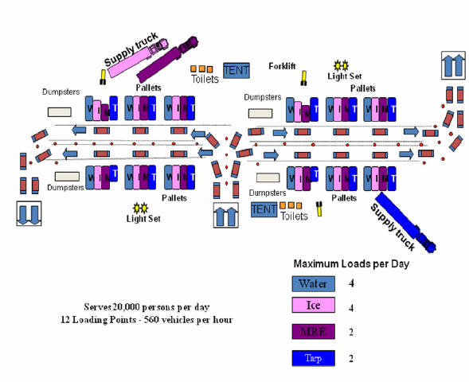
POD LAYOUT – TYPE I
POD TYPE I – Serves 20,000 persons per day; 12 loading points – 560 vehicles per hour; individual vehicles drive through and ice and water are loaded into their trunks. Recommend one case of water, 2 or 3 bags of ice and 6 MREs per vehicle. Supply trucks for ice, water, MREs and tarps are to be off-loaded promptly and returned for re-supply.

POD LAYOUT – TYPE II
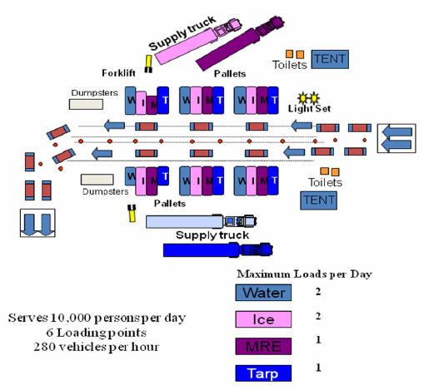

POD TYPE II – Serves 10,000 persons per day; 6 loading points – 280 Vehicles per hour; individual vehicles drive through and ice and water are loaded into their trunks. Recommend one case of water, 2 or 3 bags of ice and 6 MREs per vehicle. Supply trucks for ice, water, MREs and tarps are to be off-loaded promptly and returned for re-supply.

POD LAYOUT – TYPE III
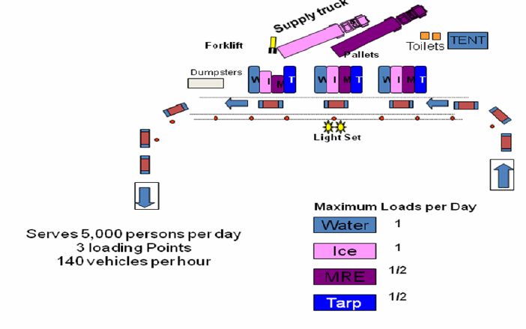

POD TYPE III – Serves 5,000 persons per day; 3 loading points – 140 vehicles per hour; individual vehicles drive through and ice and water are loaded into their trunks. Recommend one case of water, 2 or 3 bags of ice and 6 MREs per vehicle. Supply trucks for ice, water, MREs and tarps are to be off-loaded promptly and returned for re-supply.

APPENDIX G – COUNTY LSA CAPABILITIES FORMS
The IDHS SEOC Logistics Section Chief created a County Logistics Staging Area Capabilities Form in an Excel spreadsheet as pictured below. There are 3 workbooks in the spreadsheet that allows for county EMAs to input primary, secondary, and tertiary site locations and share with the SEOC Logistics Section Chief who compiles county information into one product. The Excel spreadsheet is a separate product from this plan.

Department of Homeland Security


Indiana Logistics Staging Area Capabilities Form

APPENDIX H – ACRONYMS

ACRONYMS | FULL DESCRIPTION
BOL | Bill of Lading
CONOPS | Concept of Operations
C-POD | Commodities Points of Distribution
CLSA | County Logistics Staging Area
CPG | Comprehensive Preparedness Guide
EMA | Emergency Management Agency
EMAC | Emergency Management Assistance Compact
EMS | Emergency Medical Services
EOC | Emergency Operations Center
EOP | Emergency Operations Plan
ETA | Estimated Time of Arrival
FEMA | Federal Emergency Management Agency
FOG | Field Operations Guide
FSA | Federal Staging Area
GPS | Global Positioning System
IAP | Incident Action Plan
ICS | Incident Command System
IMT | Incident Management Team
INNG | Indiana National Guard
JFO | Joint Field Office
LSA | Logistics Staging Area
MHE | Material Handling Equipment
MOA | Memorandum of Agreement
MOU | Memorandum of Understanding
MRE | Meal, Ready-to-Eat
NIMS | National Incident Management System
POD | Point of Distribution
PPE | Personal Protective Equipment
SEOC | State Emergency Operations Center
SLSA | State Logistics Staging Area
SOP | Standard Operating Procedure
USACE | United States Army Corps of Engineers
VOAD | Voluntary Organization(s) Active in Disasters

Appendix i – REFERENCES

Emergency Management Services International, Inc. (EMSI). Effective Use and Management of Staging Areas. http://www.emsics.com/effective-use-management-staging-areas/
FEMA ICS Resource page https://training.fema.gov/emiweb/is/icsresource/icsforms/
National Wildfire Coordination Group. Staging Area Manager Job Aid J-236. https://www.nwcg.gov/sites/default/files/products/training-products/J-236_0.pdf
NIMS ICS Forms booklet of all fillable ICS forms with instructions link https://training.fema.gov/emiweb/is/icsresource/assets/ics%20forms/nims%20ics%20forms%20booklet%20(v3).pdf
Texas Department of Public Safety and Emergency Management Staging Area Manager Job Aid. https://ticc.tamu.edu/Documents/IncidentResponse/AHIMT/JobAid/STAM_JA-07012014.pdf

