Standard Operating Procedure (SOP) | Communications PACE Planning  [Agency]
Version 1 | Date:
Purpose
This SOP describes the process for Primary, Alternate, Contingency, and Emergency (PACE) Communications Plans for agencies to develop their own.

What is PACE?
PACE, originally developed by the U.S. military, is a methodology designed to enhance resilient communication strategies in challenging situations. In emergency communications, a PACE plan ensures effective response across all operating conditions by maintaining operability, interoperability, and continuity. PACE frameworks help organizations prepare for backup communication options during extraordinary events, providing redundancies to ensure continuity even if primary channels fail.
Process
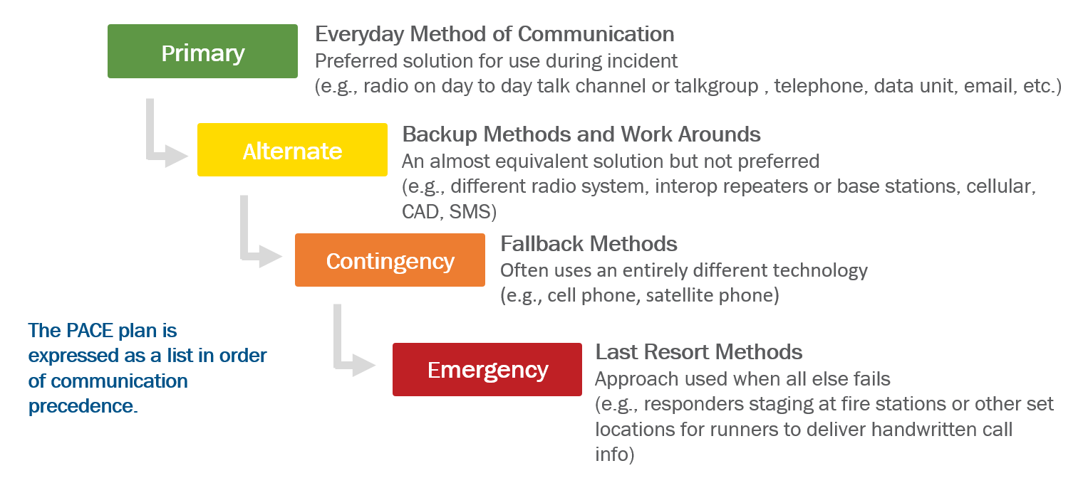

Primary
Channel, device, or system used in normal operations

Alternate
Channel, device, or system that are not as frequently used and may not have the same capability

Contingency
Requires entirely different devices than original radio or system

Emergency
A last resort approach that requires high reliability

Implementation Guide
In coordination with leaders from public safety agencies, [enter your agency] has developed the following PACE plan to address common threats to communication pathways, possible system failures, how personnel respond, and resources to aid in the implementation of PACE. Prior to implementation, staff from [enter your agency] should train, exercise, practice and regularly review the PACE to build a more resilient plan. Below is a Communications PACE Plan for [enter your agency].

Technology | Primary (Provider/Vendor)  Contact/Phone # | Alternate (Provider/Vendor)  Contac/Phone # | Contingency (Provider/Vendor)  Contact/Phone # | Emergency (Provider/Vendor)  Contact/Phone #
CAD System | [Vendor / Provider ]
 | [Contact / phone ]
Radio System
Fire Paging/Alerting
911 Phonelines
Cellular/Voice Data
Admin Phone
GIS/Mapping
EMD
Messaging
Recording

Activation
A failure of the Primary technology may trigger utilization of your Alternate technology. Further failures result in triggering Contingent and Emergency technologies. Process for alerting public safety agencies that the PACE Plan has been initiated.

Dispatch notifies the following persons/agencies of PACE activation by [phone/page/email/mass notification system] for [all technology/only _____ technology].
- [agency/person/contact info]
- [agency/person/contact info]
- [agency/person/contact info]
- [agency/person/contact info]
- [agency/person/contact info]
Return to normal operations
As technologies recover and/or are repaired and restored should trigger a return to the previous form of technology used. If the agency is at an Alternate technology level and the Primary is restored, this triggers a return to Primary technology.
Process for alerting public safety agencies of return to normal operations.
Dispatch notifies the following persons/agencies of return to normal operations by [phone/page/email/mass notification system] for [all technology/only _____ technology].
- [agency/person/contact info]
- [agency/person/contact info]
- [agency/person/contact info]
- [agency/person/contact info]

Resources

This section identifies resources necessary for [enter your agency] to perform PACE functions:
 | Contact Information | Other

Distribution

This PACE plan has been distributed to the following:
Name | Agency | Date

Revisions

This PACE plan has been revised:
Section Revised | Revision | Date

