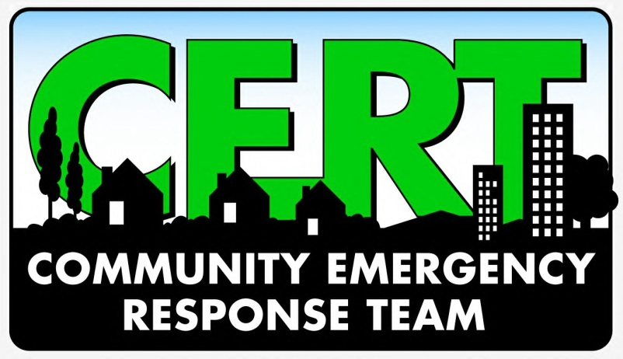
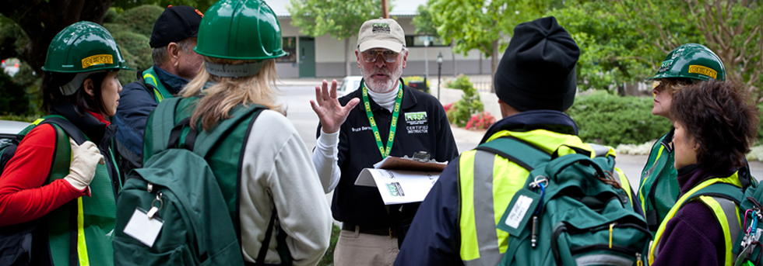

It’s Our Community
Help Protect It
CERT is made up of volunteers from the community, working together for the benefit and safety of the community.

What: CERT Informational Meeting
Where: [LOCATION, ADDRESS]
When: [DATE AND TIME]

