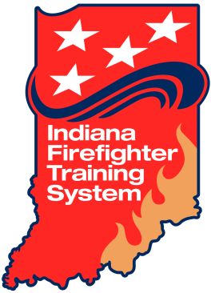
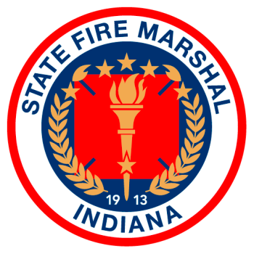
Fire/Public Safety Academy Training System
302 W. Washington Street
Indianapolis, IN 46204

Lead Instructor
May 2015

This paper is developed for those Fire Departments who desire to test for certification purposes those members who are under the age of 18.
This questionnaire has been developed for those fire departments who desire to conduct classroom training and hands-on training for skill development and testing to determine compliance with the Board of Firefighting Personnel Standards and Education rules for Mandatory, Firefighter I and Firefighter II certifications.

Training Center Capability
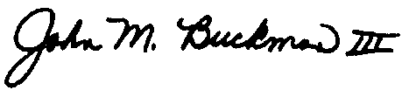
The skills required to be certified at either the Mandatory, Firefighter I or Firefighter II level are not simulated skills. The candidate must actually conduct the skills that are required. These questions relate to the availability of props to conduct some of the specific skills associated with these certifications. Please indicate by marking the Yes box indicating you have the listed training assets or will acquire them through a district fire training council or you will be using a training center/facility that has the listed assets.

Skills Training and Testing
All skills associated with certification for Mandatory, Firefighter I and Firefighter II are required to be physically performed by the candidate. Simulations are not allowed unless specifically stated in the specific skill sheet. Please complete the questionnaire below so that your ability to conduct the skills associated with the specific certification you will be testing for are in compliance with the Board rules.

The Board of Firefighting requests this document be completed within 7 days of receipt and returned to the State Fire Academy Training Office for review and processing.

State Fire Training Director
Indiana State Fire Marshal Office
302 W. Washington Street
Room E-241
Indianapolis, IN 46204
317-417-3695
jbuckman@dhs.in.gov
Prop Name | Have or Build | Acquire District Asset | Use a Training Center | Use Acquired Structure
Indicate in the "Use A Training Center" if you are using one of the district firefighter training centers to conduct the skills portion of a Mandatory/Firefighter I/II or Modular course. If you are using a district firefighter training center you DON'T need to to answer any other question.
Please indicate in the columns to the right by marking with an X your response to the question.
Forcible Entry Prop - each student must force an inward and outward swinging door.
Vertical Ventilation Prop - each student must cut a hole in a roof top situation with a power saw (K12 type/Chain Saw type) and an axe.
Wall Breach - each student must breach a drywall covered wall prop.
Entanglement Prop - each student must escape from an entanglement prop that creates a situation where the student is entangled in wires.
Ladder - each student must remove from apparatus, carry, raise, climb a ladder to a roof and return ladder to apparatus.
Roof Ladder - each student must remove from apparatus, carry, raise, place a roof ladder on a roof with hooks extended and return ladder to apparatus.
Advance a hose line up a stairway - each student is required to advance a charged hoseline up a stairway.
Advance a hose line down a stairway - each student is required to advance a charged hoseline down a stairway.
Search and Rescue drill - is there a room(s) available to conduct search drills while advancing a hose line and carrying a axe or similar tool to expand search area?
Fire Extinguisher - is there a live fire prop available?
Ropes and Knots - is there a facility available that has the capability for the student to stand aboveground and hoist various tools and equipment?
Windows - will there be a prop available for breaking glass?

 | Yes | No
In the conduct of the structural live burn portion for firefighter I certification - will you be obtaining a burn permit from IDEM?
In the conduct of the car fire live burn portion for firefighter I certification - will you be obtaining a burn permit from IDEM?
When you conduct live fire training events will you comply with NFPA 1403?
Suggested Operational Procedures
Do you understand the OSHA requirements for an employer who is employing persons under the age of 18?
Have you conducted a medical assessment of the students prior to the start of training?
Has the student signed a liability waiver?
Have you notified your workers compensation, accident and health insurance carrier that you will be training persons under the age of 18 in the skills associated with Mandatory/Firefighter I?

Lead Instructor Name | Instructor Certification Level / Length of Time Certified | How many times has the individual previously served as a lead instructor?
Lead Evaluator Name | Evaluator Certification Level Length of Time Certified | How many times has the individual previously served as a lead evaluator?
Safety Officer | Safety Officer Certification Level / Length of Time Certified | How many times has the individual served as a safety officer?

 | Agree | Disagree
Instructor to Student Ratio while conducting practical skill exercises will be a maximum of 2 students to 1 Instructor.

