Indiana Family Preservation Services
Agenda and Questions
June 3, 2022

- Concrete supports reminder—Please complete this form for any concrete spend, and send to Bridget McIntyre (Bridget.McIntyre@dcs.in.gov) or the Child Welfare Plan (ChildWelfarePlan@dcs.in.gov):
https://www.in.gov/dcs/files/Expense-Tracking-Agencies.xlsx

- Current case information: (as of 6/2/22)
Regions | Family Pres Case Count
1 | 146
2 | 45
3 | 90
4 | 82
5 | 47
6 | 61
7 | 119
8 | 112
9 | 65
10 | 189
11 | 78
12 | 65
13 | 69
14 | 44
15 | 77
16 | 112
17 | 56
18 | 91
Grand Total | 1548

Down 4 from last meeting.

- Usage and documentation of EBPs
  - Must be using at least one EBP as a foundation of your service
  - You can chose, as long as you are able to utilize the model to fidelity
  - Must be at least promising practice on California Evidence Based Clearinghouse for Child Welfare (http://cebc4cw.org/ )
  - Will become more critical once DCS Prevention Plan is approved
    - Optimistic this will be done very soon
    - Will be claiming Title IV-E dollars per the models you are using and reporting monthly

- “Family Pres Fridays” for DCS staff update
  - Attendance was low due to holiday weekend.
  - Reviewed information below

- Updated data on INFPS and its impacts on families of color (chi square)
  - Blue is Over-represented
  - Red is Under-represented

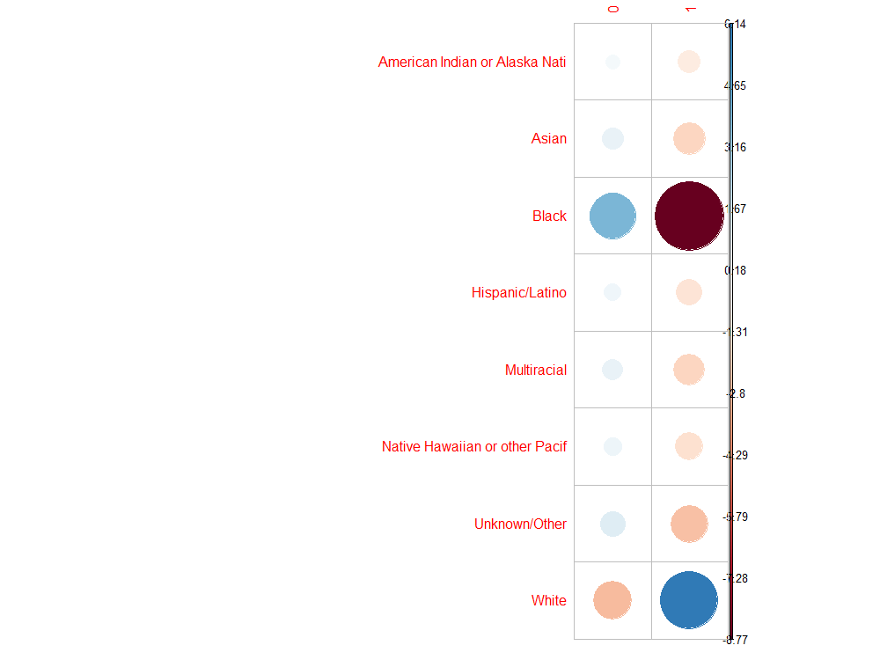

- Out-of-home cases down to 10,111, which is down 13.8% in just the last year (May 2021 to May 2022).
Out-of-home cases are down 22.0% since INFPS launched 2 years ago.

At the end of May, we were at 10,111 children in out-of-home care. This is our lowest number since February 2014.

Also, at the end of May, our absence of repeat maltreatment held steady at 95.23% (down slightly from 95.44% in April, which was our highest percentage since April 2011--132 months—11 YEARS!

- Questions received:

- I wanted to make you aware of an issue that continues to arise in our cases. When a married couple signs an IA, the father (husband) is not signing the documents, and ultimately refusing to participate in services. This has come up twice in just the last month. Feedback from an FCM supervisor explained that the father is within rights to refuse services, and directed the provider to continue with mother and children.
  - IA’s are not court ordered. If one parent does not agree to the IA and refuses to participate, continue engaging the rest of the family.
  - Work with the child and family team regarding these cases
  - Continue to support non-participating parent where you can, and emphasize that your role is to support the family
  - If you encounter a safety concern, you must call DCS so that we can respond accordingly.

Anything else?

- Perhaps I am not thinking about the data correctly, but could the INFPS data on removal based on race, also indicate that we are more likely to remove children of color at the very beginning of an assessment, while we give white families the benefit of the doubt at first, open an IA or in home CHINS, and end up removing later?
  - Yes, looking at removals outside of Family Pres, you see that black children are overrepresented
  - Having the conversation makes a difference. The hope is that the unconscious bias is becoming more conscious

- If you have concerns about the families you’re working with, you must talk to the DCS team about it!
  - Document interventions
  - Document visits
  - Continue to CALL and talk to the team – communicate well
  - Some of these are high risk cases and require a lot of attention
  - Be in the home as often as needed
  - Involve the family in safety planning

- Is there a way that if a agency close a case as a successful closure and the family comes back into care resulting in a removing, coding as unsuccessful. Is there a way the agency get that data include the name of the family. This can be used a learning and coaching tool for the agency.
  - Families have a right to confidentiality. We are unable to give that specific information
  - As an agency, you can remain involved with a family after case closure, as long as they are willing and you can bill Medicaid or another payor source
- Court has ordered the family and FCM have one meeting a week without anyone else there – no Family Pres or family support are allowed. Is there a policy that requires DCS to visit the family without any other parties?
  - The Services Team is not aware of this policy, however there are many, many policies and we are not well-versed on all of them.
  - You can review policy on the DCS website, as it is updated regularly and remains current

Next meeting 6/17/2022 @ 1:00 EST

THANK YOU!

