Indiana Family Preservation Services
Agenda and Questions
May 19, 2023

- Concrete supports reminder and discussion—Please complete this form for any concrete spend, and send to Bridget McIntyre (Bridget.McIntyre@dcs.in.gov) or the Child Welfare Plan (ChildWelfarePlan@dcs.in.gov):
https://www.in.gov/dcs/files/Expense-Tracking-Agencies.xlsx

As a reminder, the anticipated costs of concrete supports were built into the per diem.

The decision to use concrete supports should also be a team one with good planning to ensure families achieve maximum benefit from these supports.

- Initial INFPS evaluation has been published, and can be found in the Child Abuse and Neglect journal here: https://www.sciencedirect.com/science/article/pii/S0145213423001175

- Please be sure to prioritize completion of surveys when asked. Reach out to Brian Goodwin (Brian.Goodwin@dcs.in.gov) if you have any questions on this.

  - If you have not received a notice to complete a survey, it is highly likely that the families you serve have not been selected for evaluation

- DCS was asked to present on Family Pres in Washington DC this-past Wednesday. It was a great opportunity to talk about the impressive work you all have been doing!

  - Indiana and Connecticut were the only two states asked to present
  - Regarding FFPSA
  - Because of the progress we’ve made in reducing kids in care and increasing safety
  - Exciting time to talk about the work being done here in Indiana
  - Author of Families First was in attendance and very interested in the work we’re all doing!

- Current case information: (as of 5/18/23)

Region | Family Pres Case Count
1 | 104
2 | 61
3 | 96
4 | 134
5 | 44
6 | 51
7 | 142
8 | 122
9 | 77
10 | 180
11 | 87
12 | 56
13 | 71
14 | 42
15 | 76
16 | 127
17 | 61
18 | 108
Grand Total | 1639 (+70)
Region | DCS Case
1 | 91
2 | 54
3 | 76
4 | 126
5 | 40
6 | 45
7 | 137
8 | 111
9 | 56
10 | 168
11 | 79
12 | 52
13 | 62
14 | 37
15 | 71
16 | 110
17 | 61
18 | 95
Grand Total | 1471 (+36)
Region | JD/JS
1 | 13
2 | 7
3 | 20
4 | 8
5 | 4
6 | 6
7 | 5
8 | 11
9 | 21
10 | 12
11 | 8
12 | 4
13 | 9
14 | 5
15 | 5
16 | 17
18 | 13
Grand Total | 168 (+34)

- Updated stats:
- April saw our first increase in out-of-home kids since February 2021 (26 months ago). We were up 4 kids, and at 8,701 overall.
- We did have a 15th month in a row exceeding the federal safety target of 94.6% (we were 95.09% in April 2023).

- Outcomes by race in INFPS. Let’s discuss!

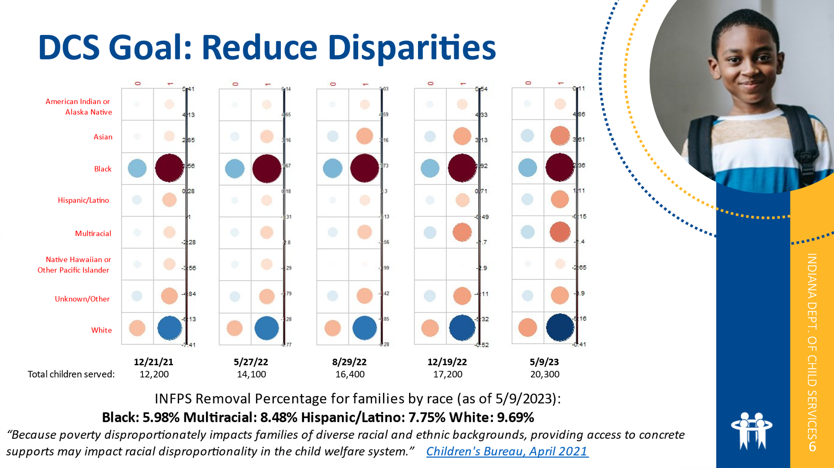

- Questions received (only one question was received, and it is a carryover from last meeting):

- Is there an update on family reunification?
  - Nothing concrete at this point.
  - The concept is still alive and in conversation at DCS
  - Nothing pending to get services rolled out

- On the updated rates sheet for FY24 starting July 1st, it shows a separate component code for the additional children on the FP referrals. Are we going to receive more information on how that is going to work and how it needs to be billed?
  - Family Preservation rates are not changing and there will not be any invoice changes.
  - The actual recommendation was to reduce the rate
  - Concrete supports are factored into the rate, which is why it was not reduced
  - Additional children are not paid under a different component, and there are no new components for INFPS

- As of July 1st, 2023, a stipend will be available for non-licensed kinship homes.
  - This will be $300 per child, per month
  - Details are being discussed. There will be communication forthcoming.
  - There will be no change to current allowances (personal allowance, birthday gift allowance, clothing allowance, etc.) the child may receive

Anything else?

If we’re being asked to involve the whole family, why is the whole family not included on the referral? We’ve seen where stepparents aren’t included on IAs, so not included on referral. Is this something that can be looked into?
All caregivers should be on the referral.

Next meeting: 6/16 @ 1:00 Eastern
THANK YOU!

