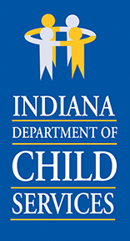
Mike Braun, Governor | Jennifer Dorfmeyer, Director
INDIANA DEPARTMENT
OF CHILD SERVICES
Call 800-800-5556 to report suspected Child Abuse or Neglect.

NOTICE OF PUBLIC COMMENT PERIOD AND PUBLIC HEARING

The Indiana Department of Child Services (department) will set residential provider, child placing agency and DCS managed foster care rates pursuant to administrative rules. The department will have a public comment period and a public hearing to address rate setting for the following year as provided in 465 IAC 2-16-16, 465 IAC 2-17-18, and 465 IAC 2-18-13.

Annual Public Comment Period
The public comment time period will allow providers, foster parents and other interested persons or organizations to communicate ideas, suggestions, or other comments regarding the rate setting process. The annual public comment period for 2027 rates will be August 24, 2026-September 23, 2026.
Please send comments to the department at RateRulePublicComments@dcs.in.gov or:

Indiana Department of Child Services Attention: Rate Rule Public Comments
302 W. Washington Street, E306-MS47
Indianapolis, IN 46204

Annual Public Hearing
The annual public hearing for 2027 rates will be open to the public, and the department will accept comments, suggestions, and feedback related to annual review of rates. This public hearing will be Thursday, September 24, 2026 from 10am – 12pm and will be held virtually. The link for the hearing is: https://teams.microsoft.com/meet/28870546783838?p=LayuCiMlSwL71Sf2nd

