Posting Date: Click here to enter a Posting Date

Request for Proposals Notification

Title: Enter LPA Name County Board of Commissioners Countywide Bridge Inspection and Inventory Program in accordance with National Bridge Inspection Standards for Cycle Years Enter the cycle years this RFP covers. (Des # Enter Des. No.) in the Choose an item. District.

Response Due Date & Time: Click to enter a Due Date at Click here to enter a Time

This Request for Proposals (RFP) is official notification of needed professional services. This RFP is being issued to solicit a letter of Interest (LOI) and other documents from firms qualified to perform engineering work on federal aid projects. A submittal does not guarantee the firm will be contracted to perform any services but only serves notice the firm desires to be considered.

Contact for Questions: Click here to enter Name/Title
Click here to enter Street Address
Click here to enter City/State/Zip Code
Click here to enter Phone #
Click here to enter Email Address

Submittal Requirements:

1. |  | ☐ | Letter of Interest – Click here to enter # of Copies. Copies (required content and instructions follow) sent through the U.S. Mail;

OR
 |  | ☐ | Letter of Interest – submitted electronically (pdf) to at email address .

AND

2. |  | ☐ | One (1) signed Affirmative Action Certification and associated required documents for all items if the DBE goal is greater than 0% sent through the U.S. Mail;

OR
 |  | ☐ | One (1) signed Affirmative Action Certification and associated required documents for all items if the DBE goal is greater than 0% sent electronically (pdf) to at email address .

Submit To: Click here to enter Name/Title
Click here to enter Street Address
Click here to enter City/State/Zip Code
Click here to enter Phone #
Click here to enter Email Address

Selection Procedures:

Consultants will be selected for work further described herein, based on the evaluation of the Letter of Interest (LOI) and other required documents. The Consultant Selection Rating Form used to evaluate and score the submittals is included for your reference. Final selection ranking will be determined by:

☒ The weighted score totals with the highest score being the top ranked firm.

Requirements for Letters of Interest (LOI)

- General instructions for preparing and submitting a Letter of Interest (LOI).

  - Provide the information, as stated in Item B below, in the same order listed and signed by an officer of the firm. Signed and scanned documents, or electronically applied signatures are acceptable. Do not send additional forms, resumes, brochures, or other material unless otherwise noted in the item description.

  - LOI’s shall be limited to twelve (12) 8 ½” x 11” pages that include Identification, Qualifications, Key Staff, and Project Approach.

  - LOI’s must be received no later than the “Response Due Date and Time”; as shown in the RFP header above. Responses received after this deadline will not be considered. Submittals must include all required attachments to be considered for selection.

- Letter of Interest Content

  - Identification, Qualifications and Key Staff

    - Provide the firm name, address of the responsible office from which the work will be performed, and the name and email address of the contact person authorized to negotiate for the associated work.

    - List all proposed sub consultants, their DBE status, and the percentage of work to be performed by the prime consultant and each sub consultant. (See Affirmative Action Certification requirements below.) A listing of certified DBE’s eligible to be considered for selection as prime consultants or sub-consultants for this RFP can be found at the “Prequalified Consultants” link on the Indiana Department of Transportation (INDOT) Consultants Webpage. (https://www.in.gov/indot/doing-business-with-indot/consultants/consultants-prequalification/).

    - List the Project Manager and other key staff members, including key sub consultant staff, and the percent of time the project manager will be committed for the contract, if selected. Include project engineers for important disciplines and staff members responsible for the work. Address the experience of the key staff members on similar projects and the staff qualifications relative to the required item qualifications.

    - Describe the capacity of consultant staff and their ability to perform the work in a timely manner relative to present workload.

2. Project Approach

a. Provide a description of your project approach relative to the advertised services. For project specific items confirm the firm has visited the project site. For all items address your firm’s technical understanding of the project or services, cost containment practices, innovative ideas and any other relevant information concerning your firm’s qualifications for the project.

Requirements for Affirmative Action Certification

A completed Affirmative Action Certification form is required for all items that identify a DBE goal greater than "0", in order to be considered for selection. The consultant must identify the DBE firms with which it intends to subcontract.

On the Affirmative Action Certification, include the contract participation percentage of each DBE and list what the DBE will be subcontracted to perform.

If the consultant does not meet the DBE goal, the consultant must provide documentation in additional pages after the form that evidences that it made good faith efforts to achieve the DBE goal.

All DBE subcontracting goals apply to all prime submitting consultants regardless of the prime's status of DBE.

INDOT DBE Reciprocity Agreement with KYTC

An Agreement between INDOT and the Kentucky Transportation Cabinet (KYTC) established reciprocal acceptance of certification of DBE firms in their respective states under the Unified Certification Program (UCP) pursuant to 49 CFR ?26.81(e) and (f).

Copies of the DBE certifications, as issued by INDOT or the Kentucky Transportation Cabinet (KYTC), are to be included as additional pages after the AAC form for each firm listed on the AAC form. The following are DBE Locator Directories for each State Transportation Agency:

INDOT: https://entapps.indot.in.gov/DBELocator/

KYTC: https://transportation.ky.gov/Civil-Rights-and-Small-Business-Development/Pages/Certified-DBE-Directory.aspx

Information about the Indiana DBE Program is available at:
INDOT: Doing Business with INDOT: Business Opportunity Initiative Division.

Information about the KYTC DBE Program is available at:
Kentucky Transportation Cabinet.

Work item details:

Local Public Agency: Enter LPA Name County Board of Commissioners

Project Location: Each Individual Bridge Site within Enter LPA Name County

Project Description: Countywide Bridge Inspection and Inventory Program in accordance with National Bridge Inspection Standards for Cycle Years Enter the cycle years this RFP covers.

INDOT Des #: Enter Des. No.

Services: Inspection of all highway bridges in the County including highway bridges within the cities and towns except State highway bridges, Federal Land bridges and privately owned bridges. Inspection Types and Frequencies are defined in below table:

Inspection Type/Months | 48 | 24 | 12 | Other*
Routine
Number of Bridges
Bridge Numbers
Fracture Critical
Number of Bridges
Bridge Numbers
Underwater
Number of Bridges
Bridge Numbers
Complex
Number of Bridges
Bridge Numbers
Element
Number of Bridges
Bridge Numbers
Special
Number of Bridges
Bridge Numbers

Other* - Provide frequency and justification (includes all bridges inspected outside of compliance months).
Special – Define type of Special Inspection required with justification

Phases Included:

Phase Year

☐ I 20

☐ IA 20

☐ II 20

☐ IIA 20

Month(s) Compliance Date: Click here to enter text.

Funding: 80% Federal Funding, 20% Local Funds

Term of Contract: Enter contract duration (e.g. 2 years) or “Until Project Completion”

DBE goal: %

Required Prequalification Categories:

☐ 14.1 Regular Bridge Inspection
☐ 14.2 Complex Bridge Inspection
☐ 14.3 Underwater/In-Water Bridge Inspection
☐ 14.5 Bridge Load Capacity Rating and Other Bridge Analysis/Training

LPA Consultant Selection Rating Sheet for Bridge Inspection
Sample:
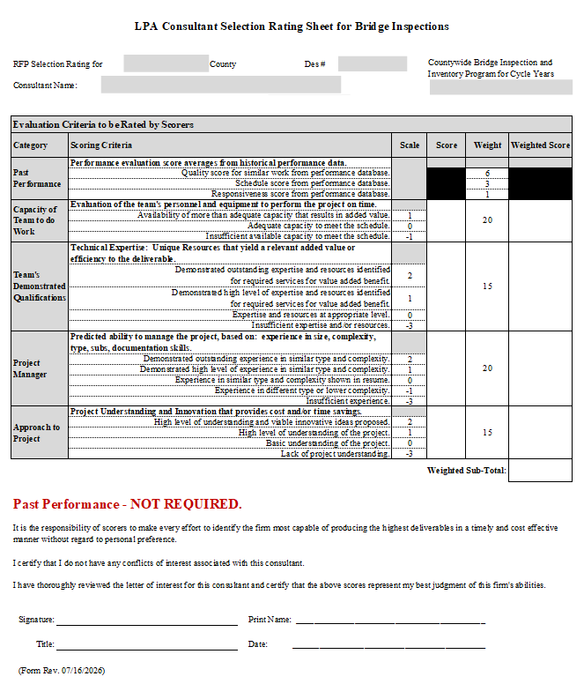

Des. #: Enter Des. No.

Affirmative Action Certification (AAC) for Disadvantaged Business Enterprises (DBE)

I hereby certify that my company intends to affirmatively seek out and consider Disadvantaged Business Enterprises (DBEs) certified by the State of Indiana’s DBE Program and the Kentucky Transportation Cabinet (KYTC) DBE Program to participate as part of this proposal. An Agreement between INDOT and KYTC established reciprocal acceptance of certification of DBE firms in their respective states under the Unified Certification Program (UCP) pursuant to 49 CFR §26.81(e) and (f).

I acknowledge that this certification is to be made an integral part of this proposal. I understand and agree that the submission of a blank certification may cause the proposal to be rejected. I certify that I have consulted the following DBE websites to confirm that the firms listed below are currently certified DBEs:

INDOT: https://entapps.indot.in.gov/DBELocator/
KYTC: https://transportation.ky.gov/Civil-Rights-and-Small-Business-Development/Pages/Certified-DBE-Directory.aspx

I certify that I have contacted the certified DBE’s listed below, and if my company becomes the CONSULTANT, these DBEs have tentatively agreed to perform the services as indicated. I understand that neither my company nor I will be penalized for DBE utilization that exceeds the goal. After contract award, any change to the firms listed in this Affirmative Action Certification to be applied toward the DBE goal must have prior approval by INDOT’s Economic Opportunity Division.

I. | DBE Subconsultants to be applied toward DBE goal for the RFP item:
 |  | Certified DBE Name | Service Planned | Estimated Percentage to be Paid*
 |  |  |  | %
 |  |  |  | %
 |  |  |  | %
 |  |  |  | %

II. | DBE Subconsultants to be utilized beyond the advertised DBE goal for the RFP item:
 |  | Certified DBE Name | Service Planned | Estimated Percentage to be Paid*
 |  |  |  | %
 |  |  |  | %
 |  |  |  | %
 |  |  |  | %

Estimated Total Percentage Credited toward DBE Goal: %

Estimated Percentage of Voluntary DBE Work Anticipated over DBE Goal: %

Company Name:

Signature: ___________________________________________________ Date: Click or tap to enter a date.

- It is understood that these individual firm percentages are estimates only and that percentages paid may be greater or less as a result of negotiation of contract scope of work. My firm will use good faith efforts to meet the overall DBE goal through the use of these or other certified and approved DBE firms.

