Engage Families With the
Protective Factors Conversation Guides
Build parental capacities and protective factors with the families you work with!
Use the Conversation Guides to support families by engaging caregivers in personalized conversations about the protective factors.
Each set includes worksheets for caregivers and key points to cover to help families develop skills to prevent child abuse before it begins and recognize that asking for help is a sign of strength—not a weakness.
Use these guides one-on-one, as part of a structured activity for a larger group, or in-person or virtual settings. Each conversation guide is available in English and Spanish on the National Child Abuse Prevention Month website.
Get the Conversation Guides!

Be sure to download the new Conversation Guide GIFs and pair them with a message about strengthening family protective capacities. Share them year-round as part of your community outreach to highlight each of the six protective factors in an interactive and engaging way.

  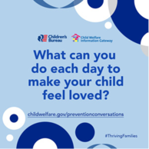
  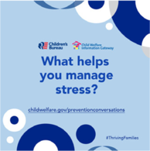

Prevention For All Communities
(Prevención para todas las comunidades)
By providing all families with equal opportunity and access to the supports they need and showing that asking for help is a sign of strength, not weakness—we can help improve the safety and well-being of children and youth across the country.
Share this collection of Spanish-language child abuse prevention resources with the families and community members in your area.

Protective Factors for a Strong Family (Factores de protección para una familia fuerte)
This factsheet helps families understand what protective factors are and gives examples of how they can be identified in real life situations. It also offers tips and resources to help parents and caregivers strengthen and apply each factor in their own lives to help their family thrive.

Conversation Guides (Guía de conversación)

Work with families to put protective factors into practice in their everyday lives. Each guide focuses on one of the six protective factors and includes a worksheet for the family and a guide that outlines key points for professionals.

Preventing Child Abuse and Neglect (Cómo prevenir el abuso y la negligencia de menores)
Learn how communities and individuals can strengthen families, protect children, and prevent child abuse and neglect. This factsheet for families addresses prevention strategies and protective factors and includes a list of resources for more information.

Additional Resources in Spanish (Recursos adicionales en español)
Selected publications on child abuse and neglect, prevention, responding to abuse and neglect, and supporting and preserving families are available in Spanish. Browse the resources here.

Like the website? Have new ideas? We’d love to hear about it! Take the survey.
Follow us on Facebook and Twitter and join the conversation by using the following hashtags: #ChildAbusePreventionMonth and #ThrivingFamilies.


