Registering your state-issued device with Ivanti - MobileIron Go

- Swipe up to get started.
Select English Select United States
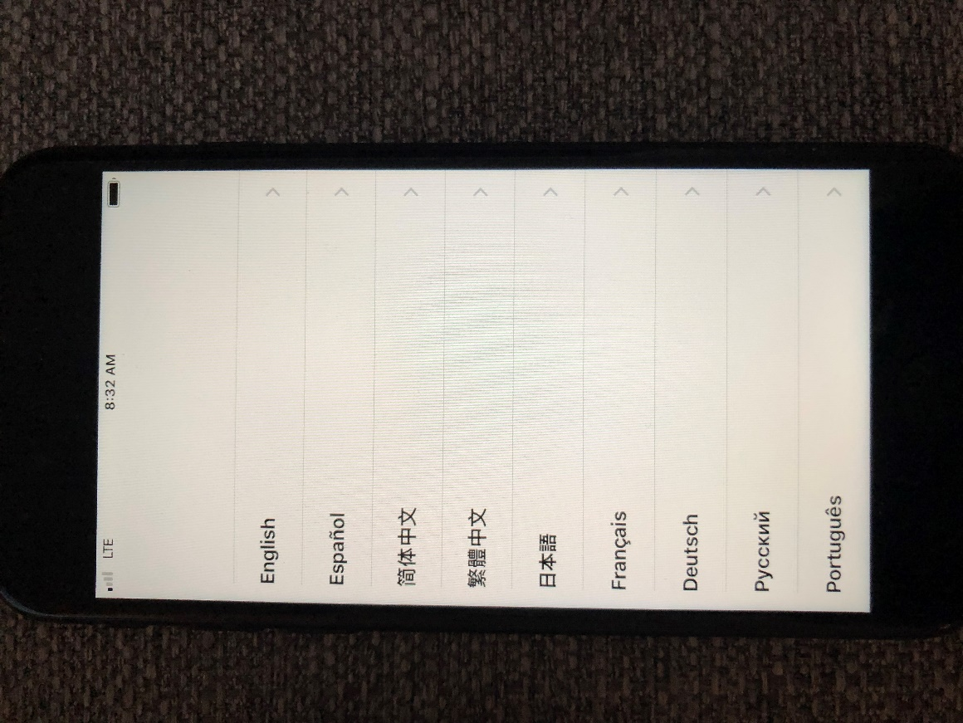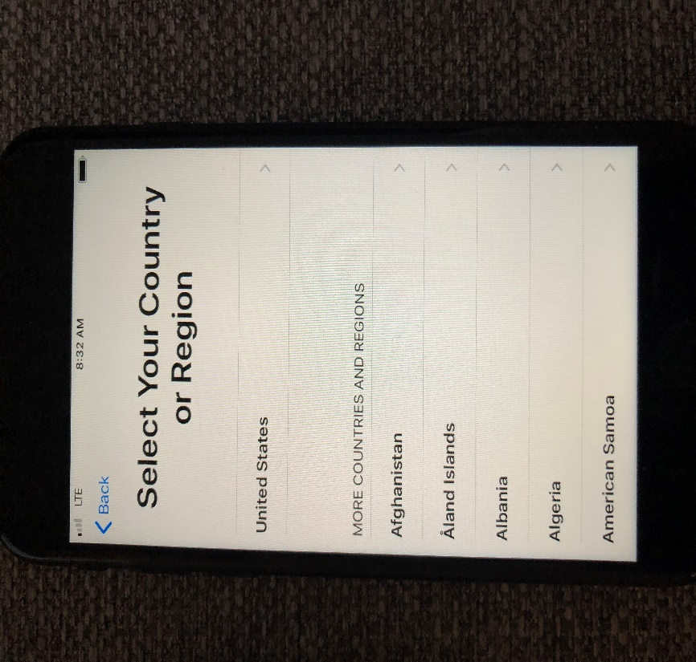

- Click on Set Up Manually
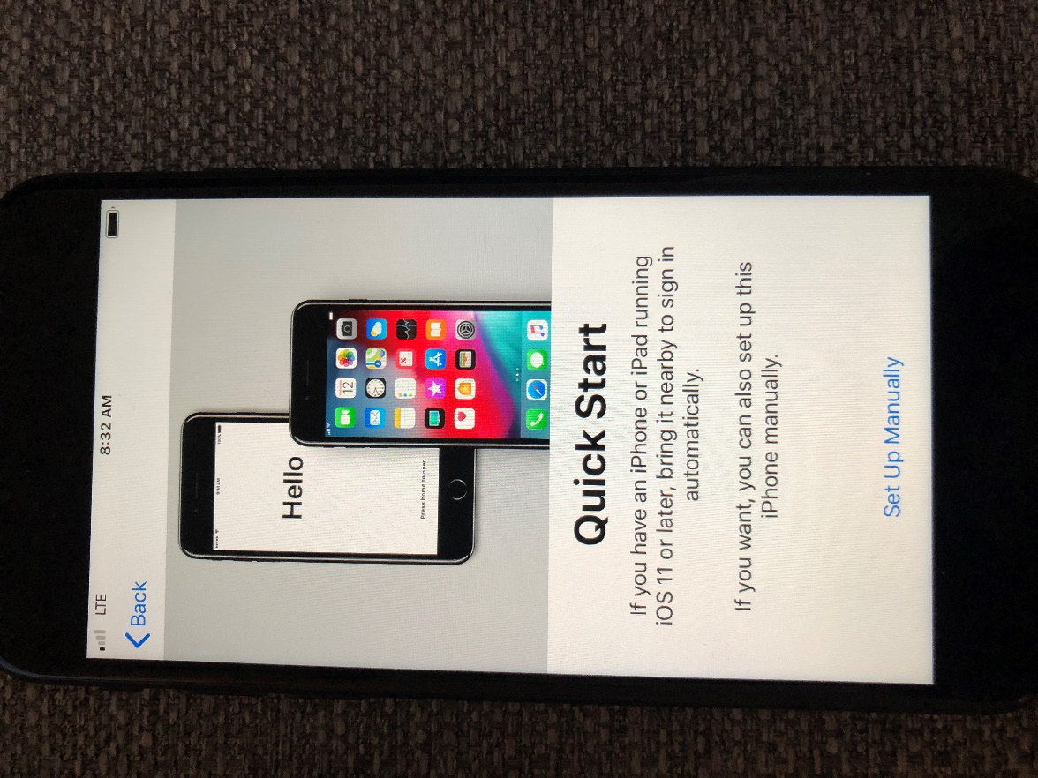
- Select Use Cellular Connection
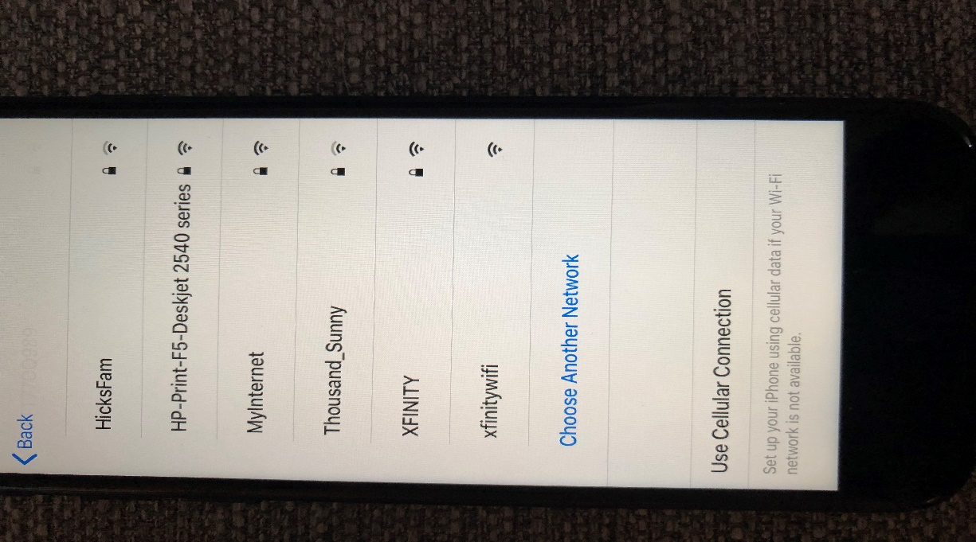

- If "Use Cellular Connection" is not available, click on Indiana Public Wifi (you will be directed to the User Agreement screen. Click on Accept and Done
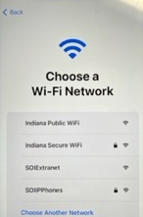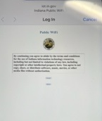

- Click on Continue on the Data & Privacy screen.
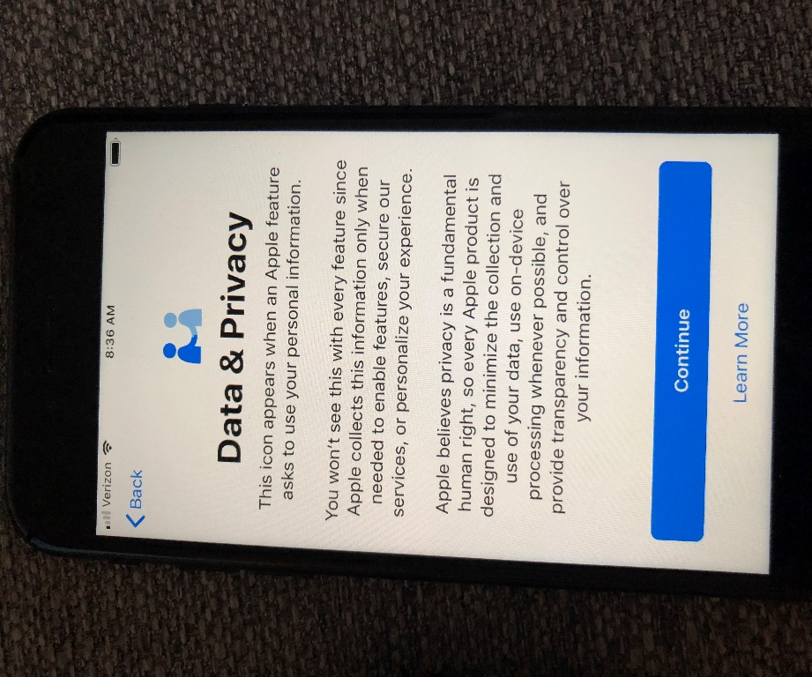

- Click on Next on the Remote Management Screen.
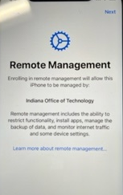

- Enter your Email address and click on Continue. Select Company owns this device.
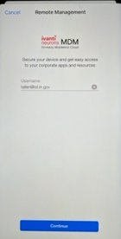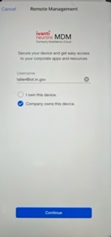

- You will be prompted to sign in with your Email and Network password to authenticate.
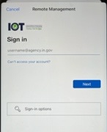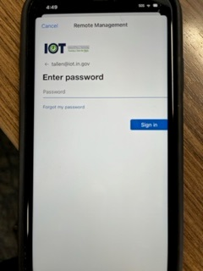

- Create a passcode for the device. (It cannot be the same number - ascending or descending).
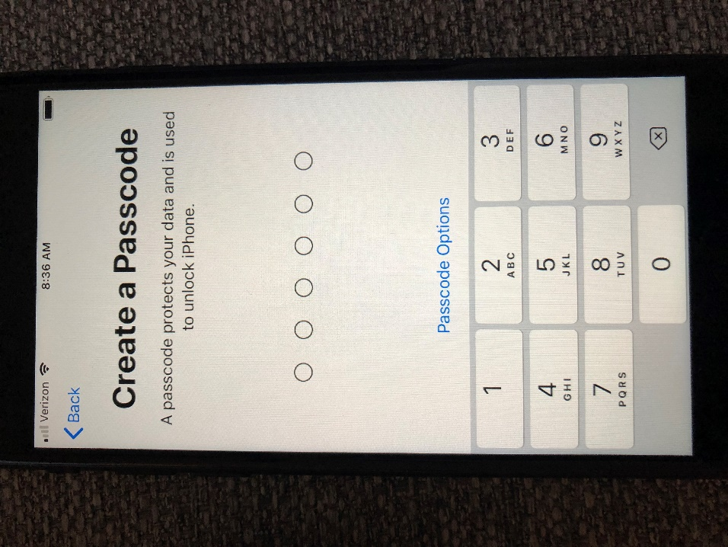

- Click on Continue to keep the iPhone up to date.
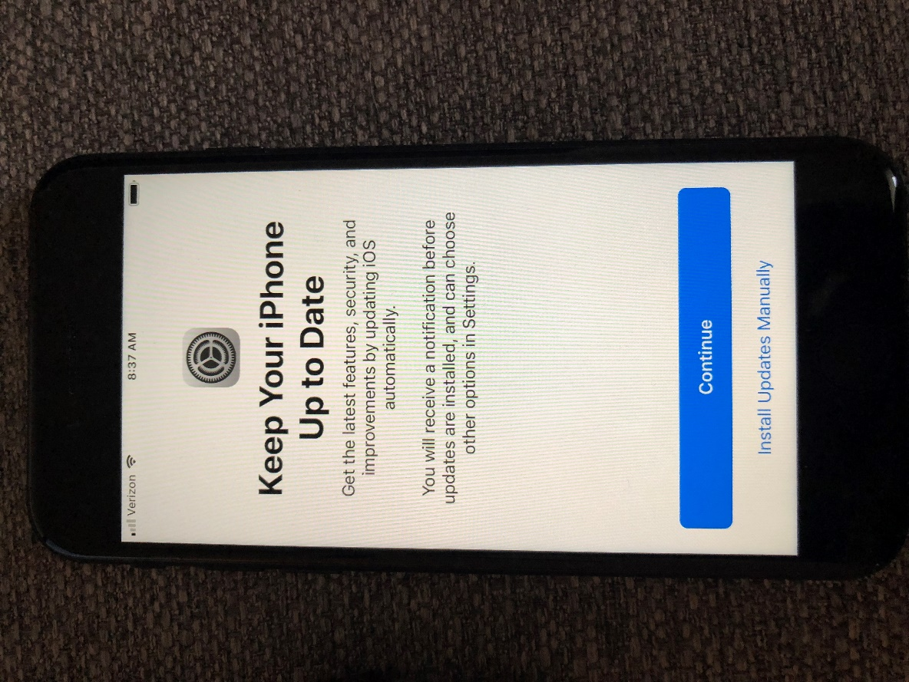

- Enable Location Services and click on Get Started.
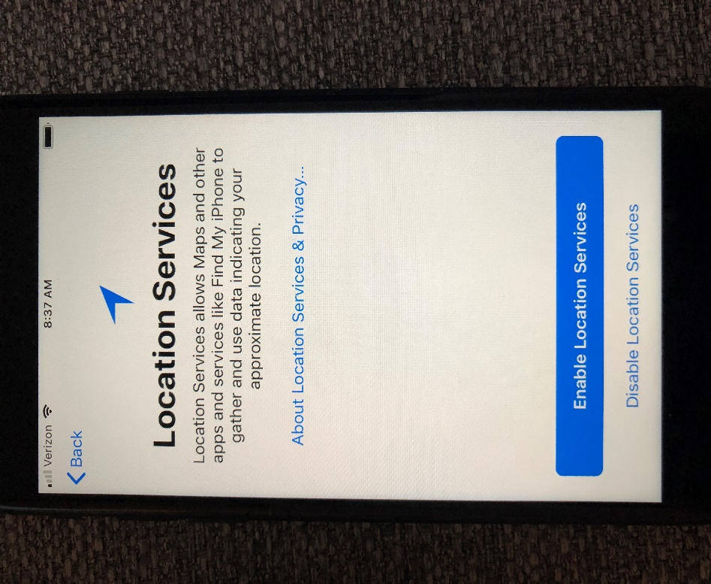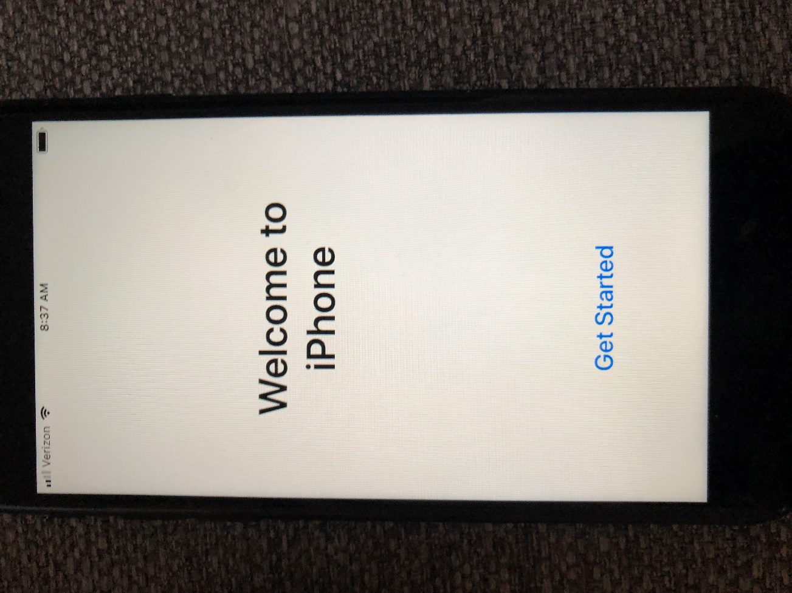

- The MobileIron Go app, Apps@Work, Microsoft Teams and the Authenticator app will automatically load to the device.

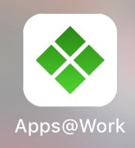

- Click on the MobileIron Go app and click Allow.
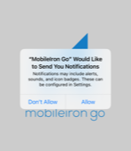

- You will then be prompted to update your Exchange account. Click on Edit Settings.
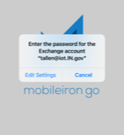

- You will be prompted to Authenticate, then click on Work or School Account. 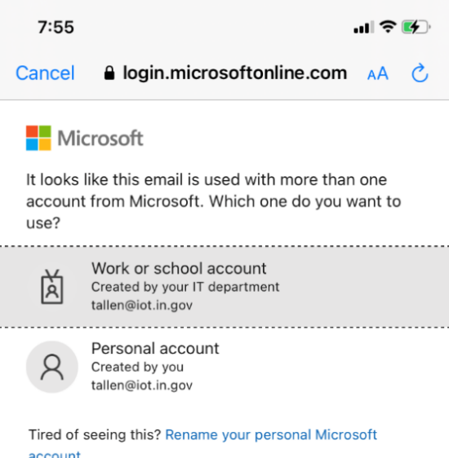

- The Exchange account will show what it will sync. Click on MobileIron Go on the top left.
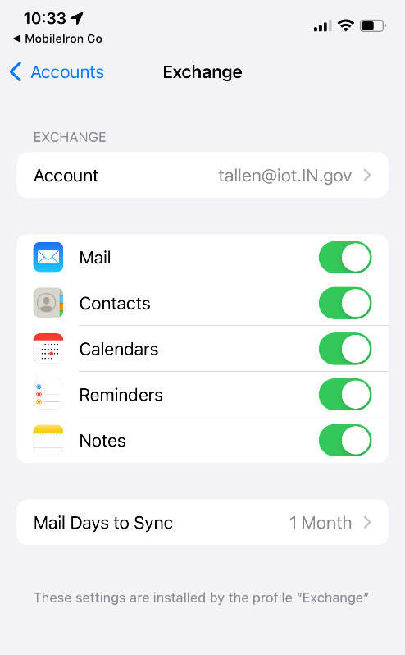

- In Setup, register your device on the Microsoft Office 365 compliance screen. Click Continue.
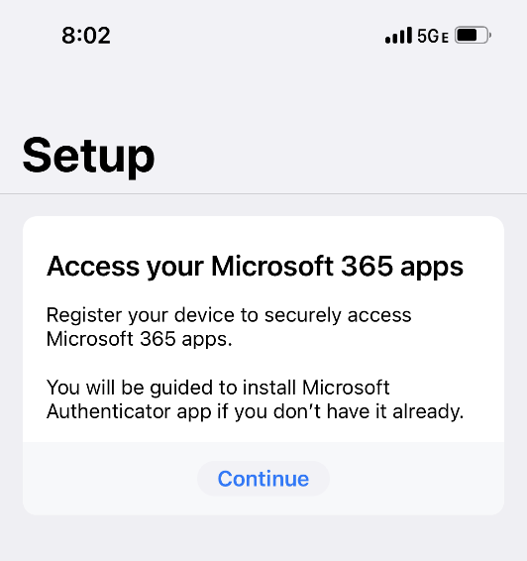

- Click Open and choose your account.
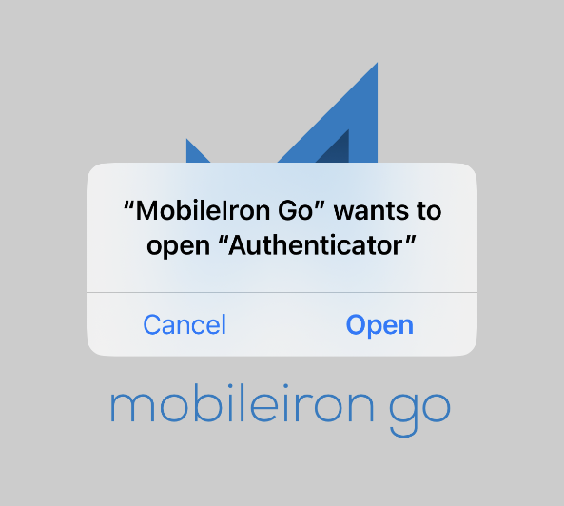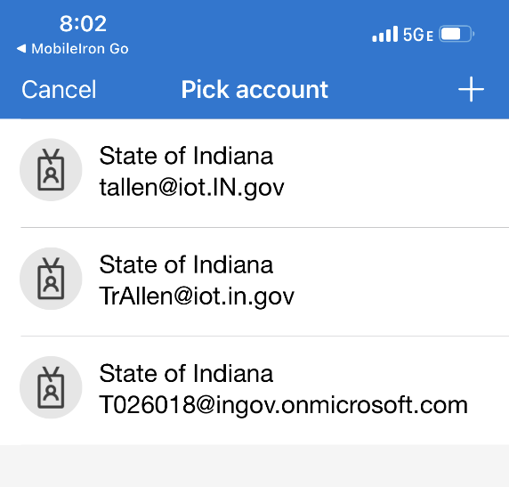

- Enter your password and sign in.
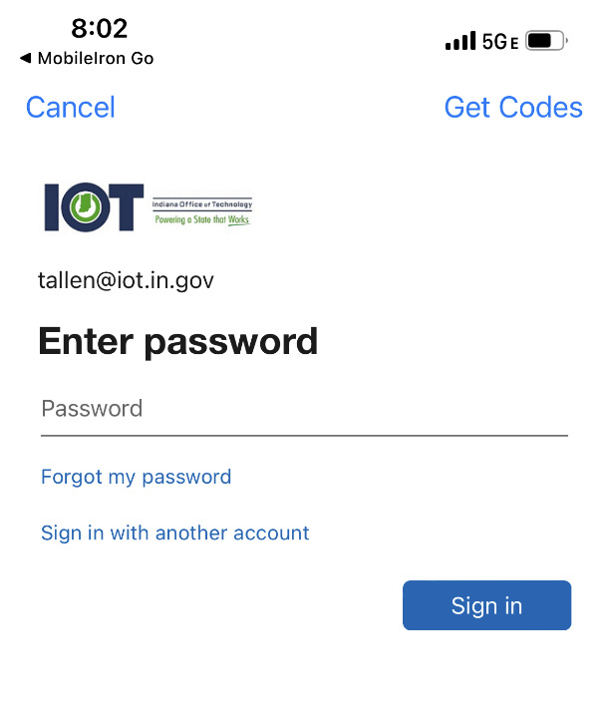

- Your device will finish authenticating and your Device Status will be shown in Compliance.
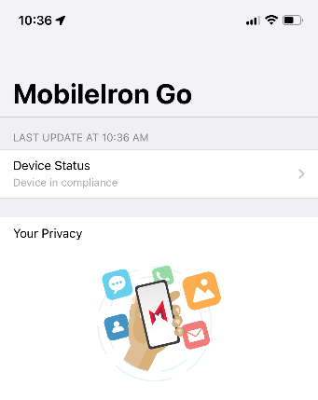
Your device is now registered. You will need to complete the setup for Teams by signing in and authenticating as well.

