Schedule your preventive care visits & earn Wellness Rewards
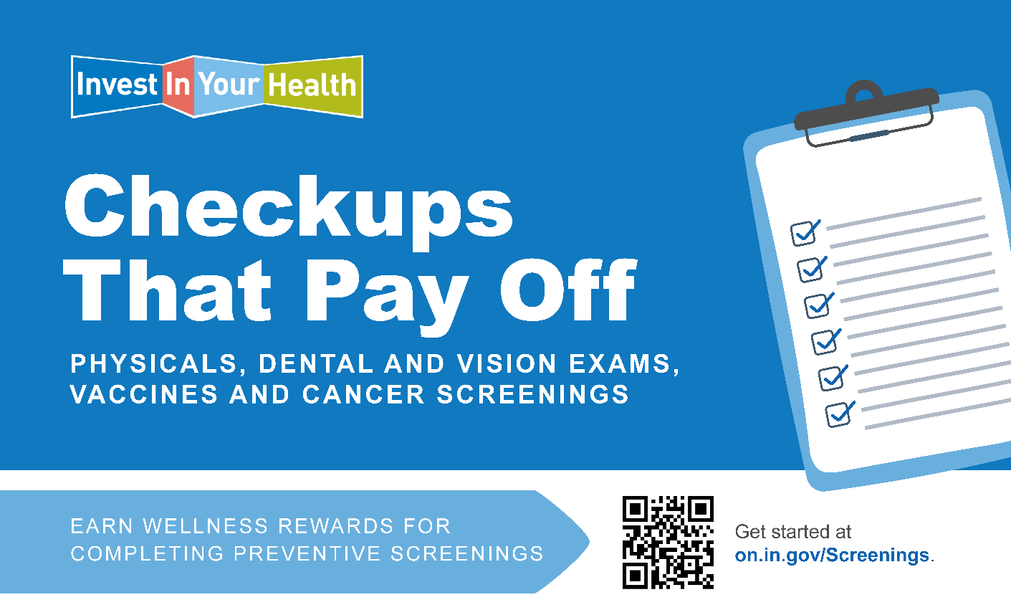
Now is the time to schedule your preventive care screenings for 2026.
Not only can eligible employees and spouses earn Wellness Rewards for completing these appointments, but they can also help you make informed decisions about your health and offer opportunities for early diagnosis of medical conditions.
These preventive care screenings are a great place to start:
- Annual Physical: Earn $200
- Cancer Screenings: Earn $50/screening
- Eye Exam: Earn $50
- Dental Exam & Cleaning: Earn $50
- Vaccines: Earn $25/vaccine, up to $100
Log in to the Mobile Health Consumer portal to learn about the rewards you can earn for completing preventive screenings.
For full details about how to earn the reward and information about preventive care, please visit www.in.gov/investinyourhealth/preventive-care/preventive-screenings.

