

Tools provided by the IN.gov Program for agency webmasters and communication staff

Web Content Management System (CMS)

IN.gov is currently making the switch to a new content management system- Matrix from Squiz. This change brings a more modern, efficient and intuitive system. All migrations will be completed by the end of 2021.
Features:
- Modern and easy-to-use interface
- SEO friendly URLs, no more numbers (e.g. https://www.in.gov/iot/2752.htm)!
- More controls for easier updates
- Granular user permissions
- Management workflows with comments
- Multi-device preview tools
- Shared resources for all agencies
- Google Analytics integration
- Robust content creation tools
- Flexible development and customization options
- Integrated with Access Indiana for easy login with your network account
- 508 compliance auditor built in

Website with training materials and tips: https//cms.in.gov/cmsreference
Webinar overview: https://www.in.gov/core/files/cms/ingov-squiz-webinar-062320.mp4
Request access: INWP: WebMasters.IN.gov: Content Management System
Login: The login will first take you to www.access.in.gov and then to https://cms.in.gov/ after you are signed in there.
Request Training: www.in.gov/inwp/webmasters/training

Localist – State of Indiana Calendar



IN.gov deploys a calendar (https://events.in.gov/)- a single place for citizens to learn about events, press releases and public meetings happening in state government. The news and events calendar provides a consistent and rapid way to inform citizens that live, visit or conduct business with the State of Indiana about time-sensitive information.

Features:
- Keyword search
- Embed YouTube or Vimeo video directly into the event
- WYSIWIG Editor for entering news releases and events
- Upload images to calendar news and events entries
- Users can subscribe to the calendar content
- Workflow submission of events
- Mobile accessible view of calendar entries

Calendar basics - .This document outlines the basics of Localist and provide links to other online resources to continue learning.

How to post events - This is a step-by-step guide on how to post press releases in the calendar.

Request access: https://www.in.gov/inwp/webmasters/statewide-solutions/ingov-calendar-and-press-release-system/
Login: https://cms.in.gov – click Log in with Access Indiana
Request Training: www.in.gov/inwp/webmasters/training

Funnelback – Search

IN.gov offers advanced search services for websites, intranets, directories, databases, and other digital assets. Currently, all IN.gov managed sites are utilizing this search for their default site search. If you have additional needs or a separate project that requires more in-depth or customized search parameters, IN.gov can provide a custom interface with analytics and controls.
Features:
- Custom Design – IN.gov can design your search and results page to either seamlessly integrate into your existing page/site, or develop a custom interface that has its own experience separate from your site.
- Faceting – Organize your search results into categories for quick filtering
- Type-ahead – Add suggestions that users can click while typing in the search bar
- Keyword Highlighting – Show the keyword highlighted in documents and pages

Dashboard Intro Video - A quick introduction on how to access Funnelback and the controls of the dashboard.
Search Analytics Video - An overview of the different analytics dashboards and views.
Accessibility, Content, and SEO Auditors Video - Funnelback provides additional services to analyze your content.
Search Optimization Tools Video - Different ways to provide better search results to your users and how to control your site search.
Request access: https://www.in.gov/inwp/webmasters/web-content/search-services/
Login: https://admin.search.in.gov/d/auth/login
Request Training: www.in.gov/inwp/webmasters/training

GovDelivery
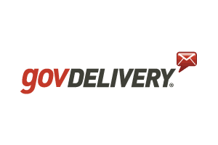
GovDelivery, a digital communications platform created exclusively for governmental entities, is the State of Indiana’s primary means of sending mass emails to citizens, employees, vendors and others. The platform engages subscribers through email, texts (SMS), social media and websites. Nationwide, it is a top referrer of traffic to government websites. Sign up for training to learn more about GovDelivery and how to use it.

To receive help with any issues encountered while using GovDelivery, enter a HelpDesk ticket. If there is an emergency, first enter a ticket and then escalate with a follow-up email to Graig Lubsen.

Request access: http://www.in.gov/inwp/2469.htm
Login: https://admin.govdelivery.com/session/new
Request training: http://www.in.gov/inwp/2584.htm

GovLinks – link shortener



GovLinks is used to create short URLs that are able to be tracked to gauge their effectiveness.

In order to be able to create a request for a new, short URL, a user must first be granted access to the GovLinks App. Please contact Graig Lubsen at Glubsen@iot.in.gov to request access.

From the Homepage, you can view all of your submitted and pending requests and view all existing groups that have been created, or create a new group. When selecting a new group, click on the link button to enter the URL creation page. After the link is created, the next page will display the short URL information just entered. Copy the specific URL and paste it into the media platform you’re using. A specific URL should be generated for each platform; one for Twitter, one for Facebook, etc.
Quick start guide: https://www.in.gov/inwp/files/GovLinks-Documentation.pdf

Request access: http://www.in.gov/inwp/2469.htm
Login: https://on.IN.gov
Request training: http://www.in.gov/inwp/2584.htm

Siteimprove Quality Assurance
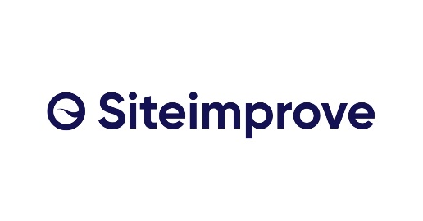
Siteimprove is a multifaceted service used by the State of Indiana for website governance. It provides automated processes of identifying website problems such as broken links and misspellings. Sign up for training to learn more about Siteimprove and how to use it.

For help with any issues encountered while using Siteimprove, enter a HelpDesk ticket. If there is an emergency, first enter a ticket and then escalate with a follow-up email to Graig Lubsen.

Request access: This process is different than all others. Visit https://my2.siteimprove.com/Auth/Saml2/10656 and sign in with your computer login credentials. This creates your account. Then, email Graig to ask for proper permissions to be assigned.
Login: www.siteimprove.com
Request training: http://www.in.gov/inwp/2584.htm

About IN.gov: As a division of the Indiana Office of Technology (IOT), the IN.gov Program supports all state web design and development and establishes and enforces polices to ensure that IN.gov is safe, secure and easy to-use.

