PowerPoint Template

As of August 2020
The current INDOT PowerPoint template contains a watermark of the INDOT logo and four transportation elements down the right edge of the slide. The template utilizes a widescreen (9x16) format.
The INDOT PowerPoint template can be downloaded from the ERIN Templates, Logos & Guidelines webpage:

https://ingov.sharepoint.com/sites/INDOTIntranet/SitePages/Templates,-Logos-%26-Guidelines.aspx
To transfer an existing presentation to the INDOT template, follow these steps:
Note: The current version of the PowerPoint application does not enable users to use the “Reuse Slide” feature to bulk transfer slides from an existing/old presentation to the INDOT template. Use the steps below to transfer slides to the INDOT template.

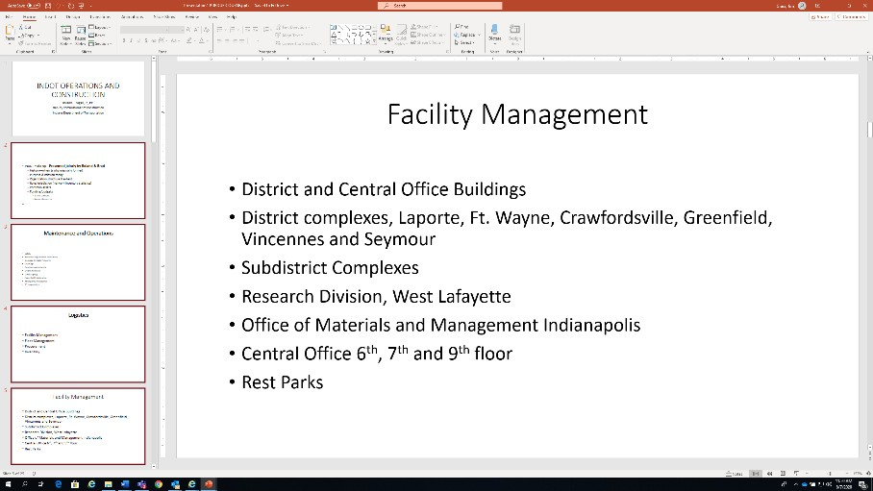
- Open the existing/old presentation you wish to transfer to the INDOT template.

- Open the INDOT PowerPoint template.

- In the thumbnail view panel on the existing/old presentation,
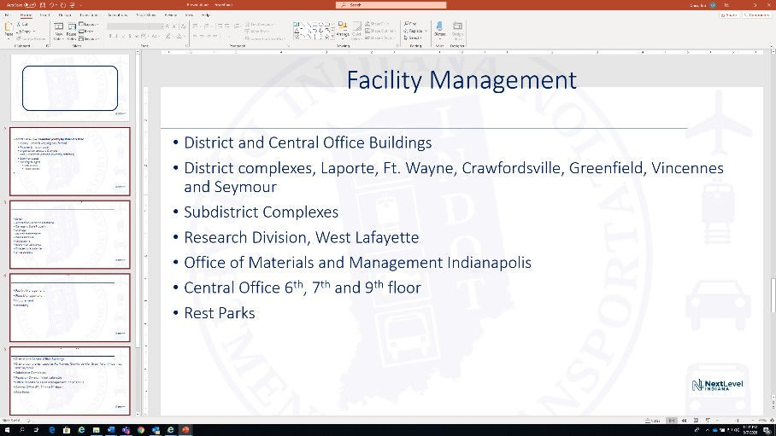
left-click on the slides you wish to transfer (hold down the shift key and left-click to select multiple slides); Right-click and select “Copy.”

- In the thumbnail view panel on the INDOT template, right-click and select “Use Destination Theme” Paste Option. The copied slides will be pasted into the INDOT template with the correct formatting.

- To transfer the title slide to the INDOT template, select the title slide thumbnail from the existing/old presentation, and use it to replace the title slide thumbnail in the INDOT template using the “Use Destination Theme” Paste Option.
Please Note
Existing/old presentations converted to the INDOT template may need some manual adjustments.
- Slide titles that were white will need to be changed to the approved font, style, and color
  - Calibri Light 44
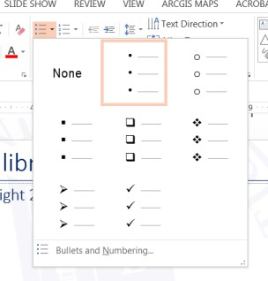
  - Dark Blue (R: 0 G: 32 B: 96)
- Text box for titles should be 13 inches wide, centered in the slide
  - Top edge of title text box is aligned with top of slide
  - Bottom edge of title text box is aligned with the thin title bar
- Text boxes for the body of the slide should be 13 inches wide, centered in the slide
- Text boxes for the body of the slide should end ¾” from the bottom of
the slide
- Slide titles may need to be reformatted or moved
- Bulleted content may need to be reformatted or moved
  - Standard bullet location is just under 3/8” from the left of the slide
  - Standard bullet style is small, round, and dark blue at 100% of text size
INDOT PowerPoint Template Style Guide
Title Slide
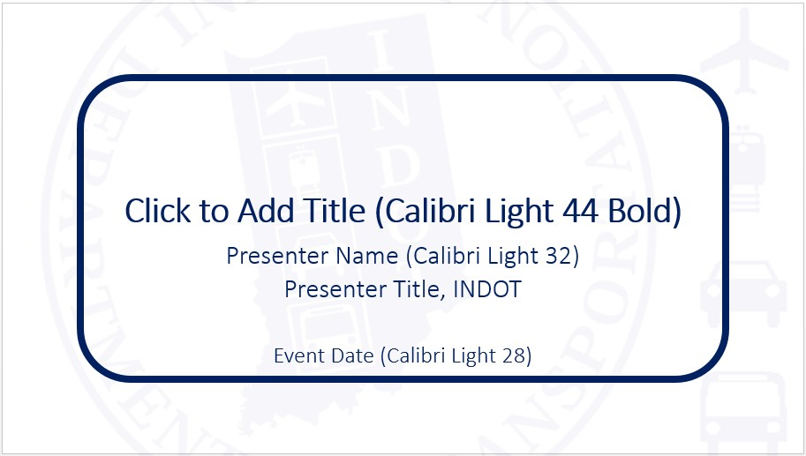
Title, text, and bullet color:
Dark Blue
R: 0
G: 32
B: 96

Regular Slides
Paragraph Settings:
Indentation
Before text: .25 Hanging by .25
*Spacing Before: 10 pt
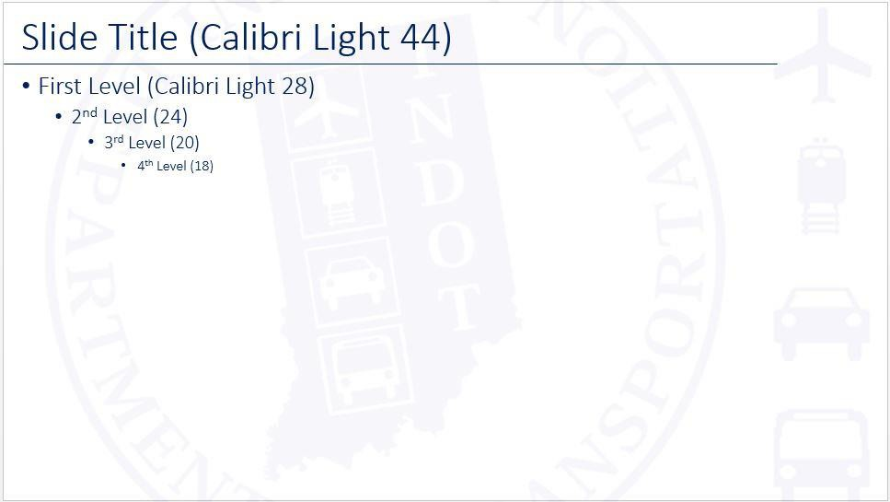

Indentation
Before text: .75 Hanging by .25
*Spacing Before: 5 pt

Indentation
Before text: 1.25 Hanging by .25
*Spacing Before: 5 pt

Indentation
Before text: 1.75 Hanging by .25
*Spacing Before: 5 pt

Updating bullet points:
Go to Bullets and Numbering and choose the small round bullet from the list of default choices.
- Color: Dark Blue
- Size: 100% of text
Photos:
- Standalone photos or graphics should be centered in the slide
- The left edge of standalone photos or graphics should be 3/8” from the left of the slide
- The bottom edge of photos or graphics should be no closer than ¾” from the bottom of the slide
For specific questions about converting existing/old PowerPoint presentations to the INDOT PowerPoint template or questions about INDOT PowerPoint style, contact Jim Grass at jgrass@indot.in.gov.

