

2018 DRAFT

Statewide Analysis of Future Resource Requirements for Electricity

Indiana Utility Regulatory Commission Staff
Table of Contents
I. Executive Summary 1
II. Background 2
A. Overview of Statutory Requirements 2
B. Integrated Resource Plans 3
1. What is an Integrated Resource Plan? 3
2. IRP History and Evolution 3
3. IRP Contents (2015 – 2017) 6
4. IRP Importance in Analysis 7
C. State Utility Forecasting Group 7
1. SUFG History 7
2. SUFG Modeling Update 8
III. Statutorily Required Information 8
A. Probable Future Growth of the Use of Electricity 8
1. Indiana Utilities’ Forecasts 9
a) Duke Energy Indiana – 2015 IRP 10
b) Hoosier Energy – 2017 IRP 10
c) Indiana Michigan Power – 2015 IRP 11
d) Indiana Municipal Power Agency – 2017 IRP 12
e) Indianapolis Power & Light Company – 2016 IRP 12
f) Northern Indiana Public Service Company – 2016 IRP 14
g) Southern Indiana Gas & Electric Company – 2016 IRP 15
h) Wabash Valley Power Association – 2017 IRP 16
2. State Utility Forecasting Group Forecast 17
3. Indiana Forecast Summary 18
4. Regional Forecast 19
5. National Forecast 20
B. Future Resource Needs 21
1. State Utility Forecasting Group 21
2. Indiana Utilities’ Resource Needs 22
a) Duke Energy Indiana – 2015 IRP 22
b) Hoosier Energy – 2017 IRP 23
c) Indiana Michigan Power – 2015 IRP 24
d) Indiana Municipal Power Agency – 2017 IRP 24
e) Indianapolis Power & Light Company – 2016 IRP 25
f) Northern Indiana Public Service Company – 2016 IRP 27
g) Southern Indiana Gas & Electric Company – 2016 IRP 28
h) Wabash Valley Power Association – 2017 IRP 28
3. Indiana Future Resource Needs Summary 28
C. Resource Mix and Location 29
1. Indiana Utilities’ Resource Mix 33
a) Duke Energy Indiana – 2015 IRP 33
b) Hoosier Energy – 2017 IRP 34
c) Indiana Michigan Power – 2015 IRP 35
d) Indiana Municipal Power Agency – 2017 IRP 37
e) Indianapolis Power & Light Company – 2016 IRP 38
f) Northern Indiana Public Service Company – 2016 IRP 40
g) Southern Indiana Gas & Electric Company – 2016 IRP 42
h) Wabash Valley Power Association – 2017 IRP 43
2. Indiana Resource Mix Analysis 46
3. Renewable Resources in Resource Mix 46
4. Energy Efficiency and Demand Response 49
D. Resource and Operational Efficiencies Gained Through RTOs 50
1. MISO Region 51
2. PJM Region 53
3. The National Perspective 55
E. Comparative Costs of Other Means of Meeting Future Needs 55
1. Fuel Price Projections Influence Comparative Costs 57
2. The Changing Fuel used in Generation Resources in the United States 59
F. Conclusion 61
IV. Appendices 63

Executive Summary

The 2018 Statewide Analysis of Future Resource Requirements for Electricity (“Statewide Analysis”) was prepared by Indiana Utility Regulatory Commission (“IURC” or “Commission”) staff for the Governor and Indiana General Assembly. The main portion of this analysis centers on the statutory requirements of Indiana Code § 8-1-8.5-3. To develop this analysis, Commission staff reviewed the information provided in Indiana electric utilities’ Integrated Resource Plans from 2015 to 2017and the State Utility Forecasting Group’s 2017 forecast, as well as other information sources. Information provided from the State Utility Forecasting Group (“SUFG”) included results from its recent modeling update funded by the Commission.

Indiana’s electric utilities are required to supply power at the lowest reasonable cost while providing safe and reliable service. An Integrated Resource Plan (“IRP”) is a plan submitted by an electric utility to the Commission, and it assists the utility in making sure it has the necessary resources to fulfill this obligation to serve. The plan looks forward over the next 20 years, forecasts the types and quantity of generation that the utility will need to reliably provide electricity to its customers, and evaluates resource alternatives on both a short-term and long-term basis to meet those future electricity requirements.

Indiana’s electricity needs will increase between 0.1 percent and 1.12 percent each year over the next 20 years. Electricity demand has shown very low projected growth rates. In the last decade, growth in electricity demand has typically been less than two percent per year. More recently, growth rates of around one percent (or even negative for some utilities) have been common. While much of the low-growth rates and projected growth are attributed to increasing efficiency of electrical appliances (including LED lighting and improved appliance technologies) and industrial and commercial efficiencies for larger electricity users, low growth is also affected by economic swings and demographic changes.

Taking into account plant retirements, the generation and/or other resources required to meet Indiana’s future needs are: 3,600 megawatts (MW) by 2025, 6,300 MW by 2030, and 9,300 MW by 2035. The utilities project adding combinations of natural gas, wind, solar, biomass, and hydro, as well as maintaining and improving customer energy efficiency and demand response programs. The utilities make their resource decisions based generally on the comparative costs of these resources. In addition, Indiana electric utilities have gained efficiencies through membership and participation in regional transmission organizations, which provide economic dispatch of generation resources at the wholesale market level and access to resources over a broad region, thereby lowering overall costs to Indiana ratepayers.

Indiana’s resource mix is continuing to change. This change is being largely driven by market changes that resulted from lower and stable prices of natural gas. Costs driven by federal environmental regulations, and lower costs of renewable energy resources, energy efficiency, and demand response have also contributed to the change in resource mix. The paradigm change in the natural gas markets caused by hydraulic fracturing (“fracking”) has resulted in lower prices and reduced price volatility, and future projections show continued significant natural gas reserves. The cumulative effects of federal environmental regulations over decades have imposed significant costs on coal-fired generation. In the IRPs and in discussions with Indiana utilities, it is clear that the ongoing and future environmental costs pale in significance to the projections of low natural gas costs as a driver of future resource decisions. The result is the retirement of some older, smaller, less-efficient coal-fired power plants. Additionally, the lower costs of renewable resources, such as solar and wind, further change Indiana’s generation portfolio. Finally, distributed energy resources and new technologies will continue to have an effect on the resource mix composition.

Background

Overview of Statutory Requirements

This analysis of future electric resource requirements is being provided to the Governor and the Indiana General Assembly pursuant to Indiana Code § 8-1-8.5-3. In 2014, the Commission provided its recommendations that concerned, in part, the need for generation resources in the near and long term and how energy efficiency and demand side management can help reduce that need. The Commission’s recommendations focused on the importance of Integrated Resource Plans in which public electric utilities assess their energy needs and the generation and other resources to meet those needs, under a variety of circumstances, in both the short (3-5 years) and long term (20 years or more). In 2015, Senate Enrolled Act (“SEA”) 412 was enacted, which codified the requirement that utilities submit IRPs, as well as energy efficiency plans, and amended Ind. Code § 8-1-8.5-3 to clarify the analysis to be performed by the Commission regarding future resource requirements for electricity.

In 2015, the Commission opened a new round of stakeholder meetings to modernize and update its IRP rule, and the Commission provide additional funding to the State Utility Forecasting Group (“SUFG”) for updated modeling software to provide more robust forecasting tools. From 2014 through the fall of 2017, the electric utilities have submitted IRPs in accordance with the additional requirements in the Commission’s draft IRP proposed rules. In December 2017, SUFG issued its “Indiana Electricity Projections: The 2017 Forecast,” using its new state-of-the-art modeling software. The Commission’s updated IRP and energy efficiency rules are expected to be fully promulgated and in effect before the end of the 2018 calendar year.

On April 11, 2018, the Commission issued a General Administrative Order (“GAO”), GAO 2018-2, delegating the authority to perform this annual analysis to Commission staff. GAO 2018-2 also set forth the approximate timelines and procedures for an open, transparent process to receive comments and hold a public hearing on a draft analysis, prior to the completion and submission of the final analysis each year.

Indiana Code § 8-1-8.5-3(a) states that this analysis must include an estimate of the following:
- The probable future growth of the use of electricity;
- The probable needed generating reserves;
- The optimal extent, size, mix, and general location of generating plants:
- The optimal arrangements for statewide or regional pooling of power and arrangements with other utilities and energy suppliers to achieve maximum efficiencies for the benefit of the people of Indiana; and
- The comparative costs of meeting future growth by other means of providing reliable, efficient, and economic electric service, including purchase of power, joint ownership of facilities, refurbishment of existing facilities, conservation (including energy efficiency), load management, distributed generation, and cogeneration.

In preparing this analysis, and through the Commission’s regular involvement in regional and federal energy issues, Commission staff utilized information from Indiana utilities’ IRPs, the Midcontinent Independent System Operator (“MISO”), the PJM Interconnection, LLC (“PJM”), the Federal Energy Regulatory Commission (“FERC”), and the U.S Energy Information Administration (“EIA”).

Integrated Resource Plans

What is an Integrated Resource Plan?

Indiana’s electric utilities are required to supply power at the lowest reasonable cost while providing safe and reliable service. The integrated resource planning process results in a range of resource portfolios and a preferred plan submitted by each electric utility on a staggered three year cycle to the Commission. The IRP assists the utility in its resource planning, making sure it has the necessary resources to fulfill future obligations. The IRP looks forward over at least the next 20 years to estimate the amount of resources the utility will need to reliably provide electricity to its customers, and evaluates resource alternatives on both a short-term and long-term basis to meet those future electricity requirements on a reliable and economic basis.

IRP History and Evolution

During the 1970s and the early 1980s, following the shocks from two oil embargoes and expectations for burgeoning demand for more electricity, Indiana’s utilities, like utilities throughout the United States, built enormous amounts of generating capacity. Unfortunately, the utility’s forecasts were overly optimistic, which resulted in construction of excessive generating capacity. The excess capacity, in turn, led to rapidly escalating electric rates for customers. Prudence investigations became common-place, which resulted in financial stress on electric utilities. Several electric utilities across the country went into default and, in extreme cases, bankruptcy. This era, and the ramifications of rapidly escalating costs, was transformational for the electric utility industry and for utility regulation – including the widespread adoption of IRP processes and added emphasis on energy efficiency and demand response (collectively referred to as “Demand-Side Management”). “Demand Response” is the reduction in electricity usage for limited periods of time, such as during peak electricity usage or emergency conditions

In 1983, the Indiana General Assembly responded by enacting Indiana Code chapter 8-1-8.5, “Utility Powerplant Construction,” which established the need for planning, as well as requiring utilities to petition the Commission for approval of new electric generation facilities prior to their construction, lease or purchase. A “certificate of public convenience and necessity” (“CPCN”) was now required and could only be issued by the Commission upon specific findings, including that the proposed additional capacity was necessary and was consistent with planning. In 1985, this chapter was amended to establish the State Utility Forecasting Group (“SUFG”) to provide an independent forecast and analysis of future electricity requirements.

In 1995, the Commission promulgated the Integrated Resource Plan Rule (“IRP Rule”), located in the Indiana Administrative Code at 170 IAC 4-7, which established the requirement that certain electric utilities in Indiana submit an IRP to the Commission every two years. The IRP Rule also set out in great detail what should be included in a utility’s IRP. The following utilities were (and are) required to submit IRPs:
- Duke Energy Indiana (“Duke”)
- Hoosier Energy
- Indianapolis Power & Light Company (“IPL”)
- Indiana Michigan Power Company (“I&M”)
- Indiana Municipal Power Agency (“IMPA”)
- Northern Indiana Power Service Company (“NIPSCO”)
- Southern Indiana Gas & Electric Company (“SIGECO”)
- Wabash Valley Power Association (“Wabash Valley”)

Much has changed since 1995 in the electric industry in general and resource planning specifically. Integrated resource planning has become increasingly sophisticated over the years with new computer modeling and other technologies. In 2001, FERC approved MISO and PJM as regional transmission operators (“RTOs”). Together, those two RTOs cover the entire State of Indiana. The RTOs control the transmission of electricity at the bulk transmission or wholesale level, in contrast to the Indiana utilities who control the distribution or retail level of electricity delivery. Because of the existence of RTOs, some aspects of Indiana utilities’ IRPs are no longer performed by the utilities. For instance, although the transmission grid is now operated by the RTO’s, the 1995 IRP rule (still in effect) assumed the utilities maintained operational control of their own transmission system.

As a result of these changes at the regional and federal level, the Commission started an investigation in 2009 (IURC Cause No. 43643) to assess the need to reformulate the IRP Rule, taking the modern day grid context into account. In an order issued October 14, 2010, the Commission determined the need existed to update the 1995 IRP rule. Commission staff performed extensive research and facilitated an inclusive stakeholder process. That process resulted in a draft proposed IRP rule in 2012. The 2012 draft proposed rule was not officially promulgated due in part to the rulemaking moratorium, Indiana Executive Order 13-03. Nevertheless, starting with the IRPs that were due in 2013, utilities voluntarily agreed to follow the 2012 draft proposed rule requirements, including:
- A public advisory process to educate and seek input from customers and other interested stakeholders;
- Contemporary Issues Technical Conference, sponsored annually by Commission staff, to provide information on new technologies, computer models, and planning methods;
- Using information reported to and from the relevant RTOs;
- Upgrades to modeling risk and uncertainty; and
- A report on each utility’s IRP by the director designated by the Commission (currently the Director of the Research, Policy, and Planning Division).

Following the passage of SEA 412 in 2015, Commission staff again facilitated an inclusive stakeholder process to further update the 2012 draft proposed rule. After numerous public meetings and rounds of comments in which the stakeholders participated, the Commission developed another draft proposed rule. The utilities began voluntarily complying with this updated proposed rule in their 2016 IRPs, including:
- Remodeling the procedural schedule for the submission of IRPs and energy efficiency plans so the filings are now made every three years;
- Removing obsolete requirements;
- Adding a checklist specifying all the required content in the integrated resource plans and energy efficiency plans;
- Updating the transparent stakeholder processes utilities must use to allow stakeholder and public input into the development of the plans; and
- Reframing the resource selection criteria to better reflect modern forecasting models and the modern electricity market.

The most-recent draft proposed IRP rule (IURC RM #15-06; LSA #18-127) was granted an exception to the rulemaking moratorium by the Office of Management and Budget on February 12, 2018. The Notice of Intent to Adopt a Rule was published in the Indiana Register on March 14, 2018, and on May 25, 2018, the State Budget Agency approved the fiscal impact of this rulemaking. The rulemaking is expected to be completed and the updated IRP Rule fully promulgated before the end of 2018. Information regarding this rulemaking can be found on the Commission’s website at: https://www.in.gov/iurc/2842.htm.

IRP Contents (2015 – 2017)

The fundamental building blocks of an IRP include researching customer electricity needs (i.e., “load research”), forecasting future electricity needs (i.e., “load forecasting”) over a number of circumstances or scenarios, assessing existing generation resources, and systematically considering all forms of resources needed to satisfy short-term and long-term (at least 20 years) requirements under the various scenarios. Increasingly, IRPs include planning for generation, transmission, and the distribution system. IRPs assess various risks and their ramifications.

Long-term resource planning starts with a forecast of customers’ electricity needs well into the future. Planning the lowest cost resources to provide reliable service over that time horizon is the objective of IRPs. Most states, including Indiana, that review utilities’ IRPs require a 20-year load forecast and resource planning horizon. The length of the planning horizon is to better ensure that the planning analysis objectively considers all resources.

All Indiana utilities have embraced the need to retain maximum flexibility in their resource decisions to minimize the risks of uncertainty, so the IRPs should be regarded as illustrative and not a commitment for the utilities to undertake. Rather, the IRPs should always be updated based on new information to minimize risks in adjusting to an uncertain future. Essentially, IRPs are a snapshot in time based on the best available information.

Perhaps the greatest benefit of an IRP is that it provides utilities with an objective and comprehensive assessment of the potential risks and attendant costs associated with forecasting customer needs and the requisite resources to meet those needs. The risk and uncertainties facing Indiana utilities – like other utilities throughout the nation – may be more significant than at any other time in the industry’s history with the possible exception of the Great Depression and the energy crisis of the 1970s-1980s. The most obvious risk confronting Indiana utilities (like other utilities across the nation) involves the economics of retiring existing facilities and the economic choice of alternative resources to replace retired generating resources. Since perfect prescience is not possible, utilities have a variety of risk factors to consider, such as:
- Short and long-term projections for the comparative costs of fuels;
- Short and long-term projections for market purchases;
- The range of potential costs for renewable resources;
- The potential for future technologies (e.g., increased efficiencies of renewable resource, energy efficiency, battery storage, distributed energy, continued improvements to combined cycle capabilities, microgrids, fuel cells, future nuclear, coal) to be transformational (such as electrification of transportation); and
- Whether load forecasts are unduly optimistic or pessimistic, among other factors.

IRPs encourage utilities to consider probable scenarios or futures, as well as risks that have a low probability but, if realized, would be highly consequential.

Integrated resource planning considers all resources. In addition to traditional resources such as coal, natural gas, and nuclear, an effective IRP also objectively considers energy efficiency, demand response, wind, solar, customer-owned combined heat and power, hydro-electric and battery storage, as well as the abilities of the transmission system. These many and varying resources are studied on a comparable basis to give greater assurance that the portfolios of resources considered and selected by the utilities are sufficiently robust and flexible to be altered as conditions warrant.

IRP Importance in Analysis

This analysis utilizes the most recent utility IRPs to determine the possible future load growth and generation needs for Indiana. The IRPs describe the process used to determine the best mix of generation and energy efficiency resources to meet their customers’ needs for reliable, low-cost, environmentally acceptable power over the next 20 years. Taken together, the IRPs allow the Commission to see the general direction for future load growth needs and generation options. However, as a caution, because each year only about one-third of the utilities submit an IRP due to the new three year cycle, it is difficult to compare on utilities experiences in 2015 with another utility’s resource consideration in 2017. Four years ago, for example, utilities were planning for the Clean Power Plan. Natural gas price projections due to fracking seemed to solidify more than expected by experts. Some utilities lost significant loads. Therefore, this analysis includes not only the utilities’ IRPs, but also analysis by the SUFG, the RTOs, and a national perspective.

State Utility Forecasting Group

The SUFG’s projection for Indiana’s resource requirements provides a useful perspective as a snap shot in time based on information from Indiana’s utilities and using state-of-the-art models. However, the SUFG’s analysis is not intended to suggest that it is an optimal long-term resource plan, as changing circumstances warrant continued review. Retirements of existing resources and other factors may accelerate or decelerate resource decisions. The SUFG is resource agnostic. Moreover, the SUFG does not assign the capacity requirement to specific utilities; rather, it is a statewide perspective.

SUFG History

The SUFG was created in 1985 when the Indiana legislature mandated, as a part of the CPCN statute, that a group be formed to develop and keep current a state-of-the-art methodology for forecasting the probable future growth of electricity usage within Indiana. The Commission works with Purdue and Indiana Universities to accomplish this goal. The SUFG, currently housed on Purdue University’s West Lafayette campus, produced its first set of projection in 1987 and has updated these projections periodically, usually biennially. The SUFG released its most recent forecast in December 2017.

SUFG Modeling Update

Under Ind. Code § 8-1-8.5-3.5(b), SUFG must keep its modeling system current. In the 2015-2017 contract with the Commission, SUFG acquired a new production costing and resource expansion program (AURORAxmp) and integrated the program in the modeling system. This was a major undertaking that resulted in increased efficiency in producing future forecasts and analyses. AURORAxmp has been populated with data specific to the Indiana utilities and the validation process is ongoing. New programs and modeling updates were part of the SUFG’s December 2017 report.

In addition, updates to different components of the modeling system are done regularly on an as-needed basis. Expected areas of focus in 2017-2019 include a re-estimation of the industrial sector models for the investor-owned utilities by supplementing information from the utilities with updated information about various Indiana industries (steel, manufacturing, foundries etc.). This includes production output, and local, state, and national economic information that can provide additional insights into the energy usage patterns of industrial customers, and a conversion of historical data from the Standard Industrial Classification (SIC) system to the North American Industry Classification System (NAICS).

Statutorily Required Information

Probable Future Growth of the Use of Electricity

Since the 1980s, forecasts for electricity demand by Indiana utilities and utilities across the nation have shown very low projected growth rates. In the last decade, growth in electricity demand has typically been less than two percent per year. More recently, growth rates of around one percent (or even negative for some utilities) have been common. While much of the low-growth rates and projected growth are attributed to increasing efficiency of electrical appliances (including LED lighting and improved appliance technologies) and industrial and commercial efficiencies for larger electricity users, low growth is also affected by economic swings and demographic changes. While recent history is instructive, it is not necessarily indicative of the future sales of electricity. Because of the significant costs and risks associated with either over or under-forecasting electricity requirements, increasingly sophisticated mathematical models and databases are employed to improve the accuracy and credibility of load forecasting. Regardless of the analytical rigor, long-term forecasts of future electric needs cannot always predict unanticipated events (e.g., recessions, inflation, and technological change). As a result, the goal is to have a credible forecast with plausible explanations for the factors that determine electric use, and provide decision makers with a reasonable understanding of factors (e.g., scenarios or sensitivities) that, if changed, would alter the forecast and resource decisions.

Because uncertainties in load forecasting are a significant driving force for the long-term resource planning decisions of utilities, it is imperative that utilities continue to improve the rigor of their analysis, utilize state-of-the-art planning tools, and develop enhanced databases that include more information on their customers’ current and future usage characteristics. The relatively rapid evolution of televisions, especially from cathode ray tubes to LEDs, provides an imperfect but reasonable corollary. Unexpected demographic trends, new industries (or closures of existing industries), other technological changes, recessions or more rapid economic growth are all factors that could significantly change the load forecast trajectories of Indiana utilities. It is for this reason that load forecasts and the entire IRP need to be redone on a three yearbasis to incorporate new information and developments.

Indiana Electricity Requirements in GWh (Historical, Current, and Previous Forecasts)
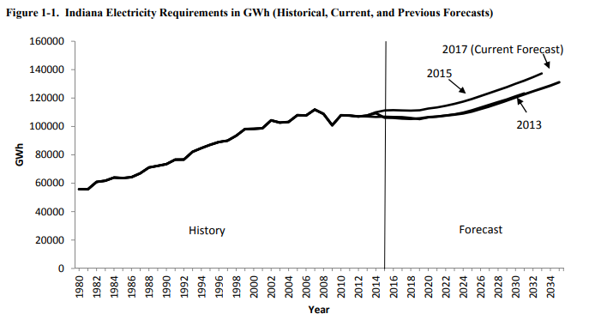
Source: State Utility Forecasting Group’s 2017 Electricity Projections. Pg. 1-4

Indiana Utilities’ Forecasts

Indiana utilities project relatively low load growth and adequate resources to satisfy reliability requirements.

Projected Growth Rate of Energy and Peak Demand over the Planning Period*
Utility Annual Energy Peak Demand
Duke Energy (2016-2035) | 0.7% | 0.8%
Hoosier Energy (2018-2037) | 0.7% | 0.7%
Indiana Michigan Power Co. (2016-2035) | 0.1% | 0.2%
IMPA (2018-2037) | 0.5% | 0.5%
IPL (2016-2037) | 0.5% | 0.4%
NIPSCO (2017-2037) | 0.3% | 0.4%
SIGECO South (SIGECO) (2016-2036) | 0.5% | 0.5%
Wabash Valley (2018-2036) | 0.8% | 0.8%
*The percentages are compound annual growth rates over the company-specific planning period.

Duke Energy Indiana – 2015 IRP

Duke Energy notes that 2015 energy usage has not returned to pre-2007 (pre-recession) levels. Summer peak demand is forecast to grow at just under one percent per year, which is a little faster than energy use.

Source: Duke Energy Indiana 2015 IRP. Pg. 44

Source: Duke Energy Indiana 2015 IRP. Pg. 44

Hoosier Energy – 2017 IRP

Hoosier Energy’s 20-year projection shows both energy and annual peak growing at an annual average of 0.7 percent. Hoosier Energy noted that load growth has slowed due to a combination of energy efficiency gains, economic slowdown, and a decline in the energy intensity of gross domestic product.

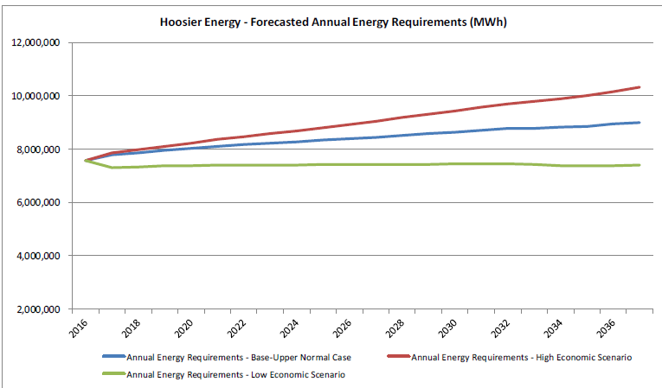
Source: Hoosier Energy 2017 IRP. Pg. 35

Indiana Michigan Power – 2015 IRP

According to its 2015 IRP, I&M is forecasting energy and peak demand requirements to increase at a compound average growth rate of 0.2 percent through 2035. I&M does not anticipate the need for additional capacity until 2035. Energy efficiency and demand response are projected to reduce I&M’s retail load by eight percent over the 2016-2035 planning horizon.

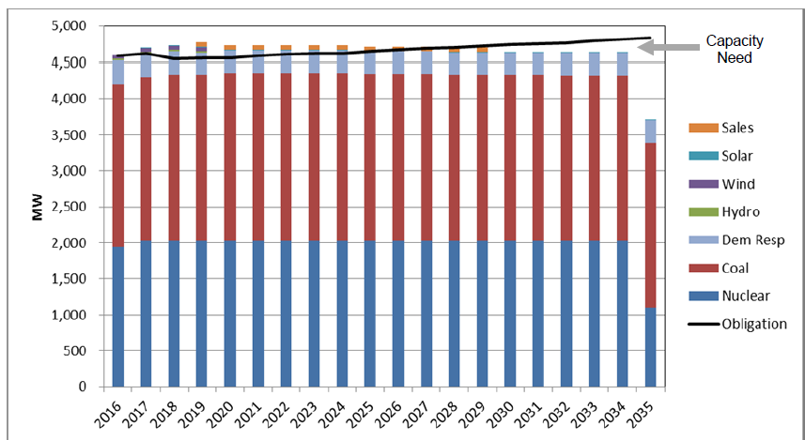
Source: Indiana Michigan Power 2015 IRP. Pg. ES-5

Indiana Municipal Power Agency – 2017 IRP

In 2017, IMPA's coincident peak demand for its 61 communities was 1,128 MW, and the annual member energy requirements during 2017 were 6,098,477 MWh. IMPA projects that its peak and energy will grow at approximately 0.5% per year. These projections do not include the addition of any new members or customers beyond those currently under contract. Since the last IRP was filed, IMPA has added one new member, the Town of Troy, Indiana. Additionally, in August of 2017, the Village of Blanchester, Ohio, which had been an IMPA customer since 2007, became an IMPA member. Combining all the IMPA’s loads (those in MISO and PJM) is expected to see load growth average a 0.6 percent compound annual growth rate (“CAGR”) over the next 20 years with those in the Duke, NIPSCO, and AEP areas expected to experience growth, while those in the SIGECO and Duke Ohio region are expected to contract somewhat.

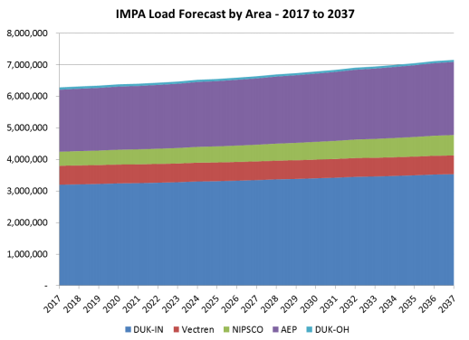
Source: Indiana Municipal Power Agency 2017 IRP. Pg. 5-40

Indianapolis Power & Light Company – 2016 IRP

Since 2005, IPL’s system energy requirements have been trending down. System energy requirements in 2015 were 14,471 GWh compared with 16,006 GWh in 2005. Energy use, on average, declined one percent annually over this period. IPL attributes the decline in customer usage to significant energy efficiency improvements in lighting, appliances, and end-use efficiency. In its IRP, IPL notes:

[P]art of the decline can be [attributed] to the 2008 recession and the slow economic recovery. Between 2007 and 2011 customer growth actually declined 0.1% per year. Since 2011, customer growth bounced back with residential customer growth averaging 0.8% per year and non-residential customer growth averaging 0.4% per year. But despite increase in customer growth and business activity, sales have still been falling 1.0% per year. Over the next twenty years, energy requirements are expected to increase 0.5% annually and system peak demand 0.4% annually, before adjusting for future DSM program savings (emphasis added) (pg. 40).

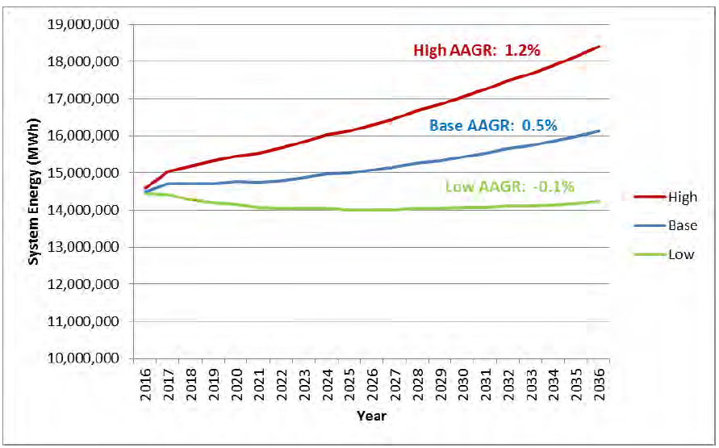
* “AAGR” means “average annual growth rate.”
Source: Indianapolis Power & Light 2016 IRP. Pg. 141
Source: Indianapolis Power & Light 2016 IRP. Pg. 142

Northern Indiana Public Service Company – 2016 IRP

NIPSCO’s forecast of its customers’ electric requirements “project an increase in overall customer energy usage of 0.33% compound annual growth rate (CAGR) for the period of the IRP (2017 to 2037), while the peak demand for the base case is 0.45%. The total number of NIPSCO electric customers is projected to increase from approximately 464,000 today to about 511,000 by 2037”.

Industrial load is particularly significant for NIPSCO. NIPSCO is projecting no growth for industrial load over the planning period. The potential addition or loss of a major customer and the ripple effects – or significant reductions in use due to technological change - could pose significant risks. Some of those risks could be beneficial, but others would not be. The following two graphs depict the low growth in energy sales and demand:

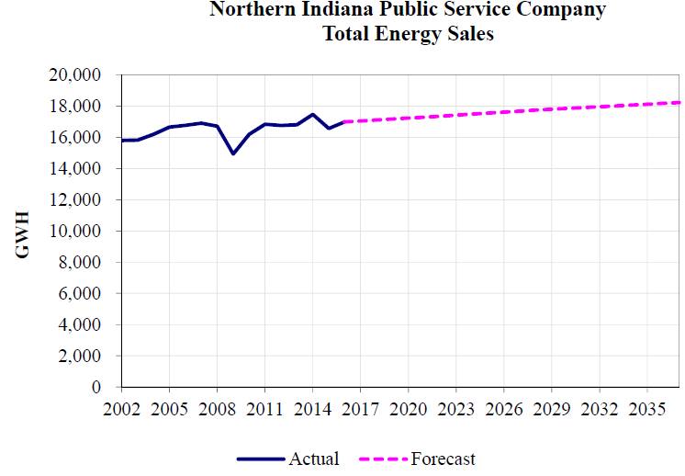
Source: Northern Indiana Public Service Company 2016 IRP. Pg. 28

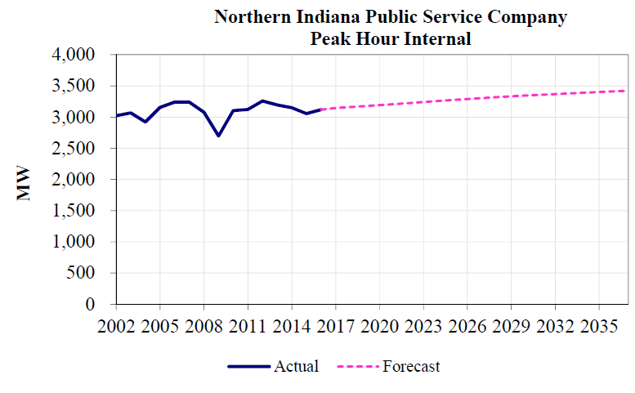
Source: Northern Indiana Public Service Company 2016 IRP. Pg. 30

Southern Indiana Gas & Electric Company – 2016 IRP

SIGECO has experienced very little load growth, and projections are showing this trend to continue through the planning horizon of 2036. Moreover, SIGECO has experienced significant loss of industrial load when a customer decided to meet much of its electricity needs by installing a customer-owned, large combined heat and power facility.

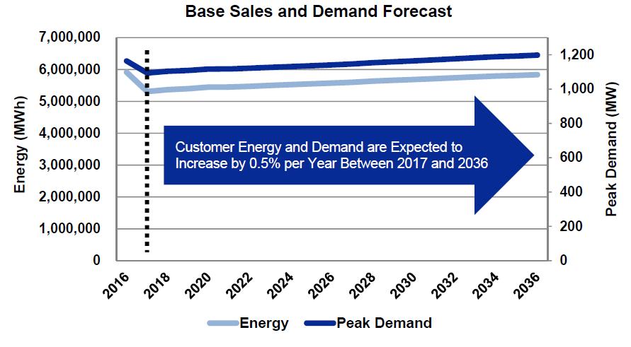
Source: Southern Indiana Gas & Electric Company 2016 IRP. Pg. 36

Wabash Valley Power Association – 2017 IRP

Wabash Valley is forecasting 0.9 percent growth in energy sales demand for the 2018-2036 planning horizon. Each Wabash Valley Member serves a variety of residential, commercial and industrial loads. The majority of the load is residential in nature. The Company’s winter peak usually occurs at 8:00 p.m. and the summer peak generally occurs in the evening around 7:00 p.m. These peak times reflect the highly residential nature of Wabash Valley’s load. Wabash Valley has two large customers whose demand may be interrupted.
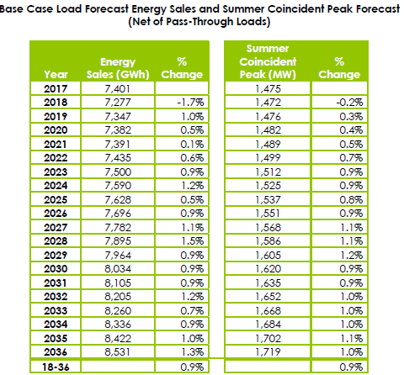
Source: Wabash Valley Power Association 2017 IRP. Pg. 39

State Utility Forecasting Group Forecast

The SUFG summarized its forecast of projected customer electric power needs in its Indiana Electricity Projections: The 2017 Forecast as follows:

The projections in this forecast are lower than those in the 2015 forecast, primarily due to increases in energy efficiency and less optimistic economic projections, compared to the earlier projections. This forecast projects electricity usage to grow at a rate of 1.12 percent per year over the 20 years of the forecast. Peak electricity demand is projected to grow at an average rate of 1.01 percent annually. This corresponds to about 230 megawatts (MW) of increased peak demand per year. The growth in the second half of the forecast period (2026- 2035) is stronger than the growth in the first ten years (pg. 1-1).

The 2017 forecast predicts Indiana electricity prices to continue to rise in real (inflation adjusted) terms through 2023 and then slowly decrease afterwards. A number of factors determine the price projections. These include costs associated with future resources required to meet future load, costs associated with continued operation of existing infrastructure, and fuel costs. Costs are included for the transmission and distribution of electricity, in addition to production.
Indiana Peak Demand Requirements in MW (Historical, Current, and Previous Forecasts
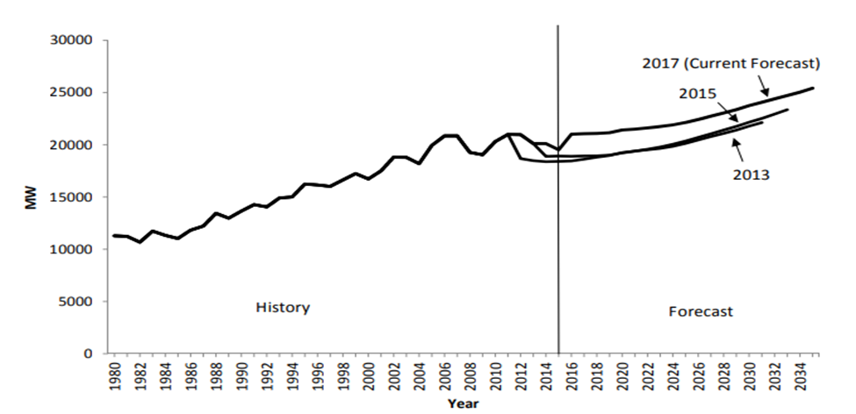
Source: State Utility Forecasting Group’s 2017 Electricity Projections. Pg. 1-4

Indiana Peak Demand Requirements Average Compound Growth Rates (Percent)
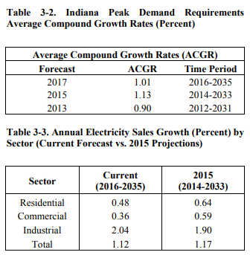
Source: State Utility Forecasting Group’s 2017 Electricity Projections. Pg. 3-1

Annual Electricity Sales Growth (Percent) by Sector (Current Forecast vs. 2015 Projections)
Source: State Utility Forecasting Group’s 2017 Electricity Projections. Pg. 3-3

Indiana Forecast Summary

In summary, based on the most recent submitted IRPs, Indiana utilities and the SUFG project relatively low load growth and adequate resources to satisfy reliability requirements. Indiana’s utilities in their IRPs project annual growth ranging from 0.1- 0.8 percent over the 20-year forecast horizon. The projected annual growth in peak demand ranges from 0.2- 0.8 percent.
The SUFG projects a slightly higher growth in electricity usage across Indiana than the individual utilities do in their IRPs, with 1.12% annual growth over the 20 year period and 1.01% annual growth in peak demand.

Regional Forecast

The SUFG also conducts a load forecast for MISO. Like the SUFG’s load forecast for Indiana, the MISO region is projecting very low growth rates in energy usage and demand. PJM and other regions are also expecting low load growth.

SUFG State Retail Sales (without EE Adjustments) for the MISO Region
Compound Annual Growth Rates
(2018-2037)
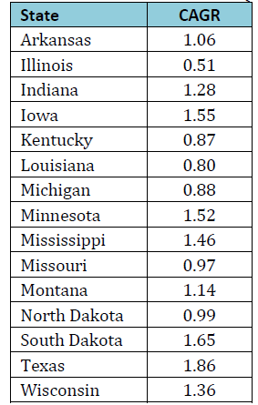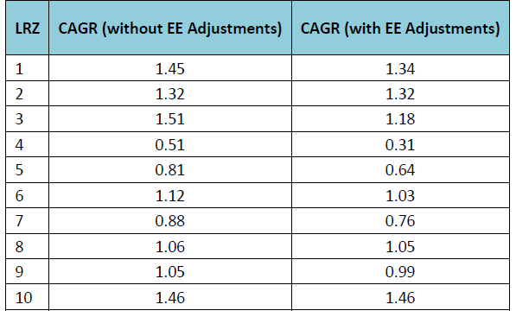
LRZ Metered Load Annual Growth Rates (2018-2037)
Source: State Utility Forecasting Group’s MISO Independent Load Forecast Update. Pg. ES-2
The maximum peak demand experienced by the MISO and PJM is more relevant to resource planning than the maximum demand incurred by their member systems. Specifically, the MISO and PJM coincident peak demand become the primary basis for determining the operating and planning reserve requirements (Resource Adequacy) for their regions. The MISO and PJM system wide reliability requirements are, in turn, allocated to their member utilities (in Load Resource Zones) based on their contributions to the MISO and PJM systems’ coincident peak demand (coincidence factor).

LRZ Non-Coincident Summer and Winter Peak Demand (with EE Adjustments) Compound Annual Growth Rates for MISO (2018-2037)
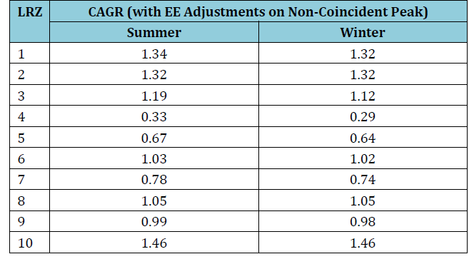
Source: State Utility Forecasting Group’s MISO Independent Load Forecast Update. Pg. ES-2

National Forecast

According to the Energy Information Administration (EIA) and, consistent with the experience of Indiana utilities and the region, electricity demand is largely driven by economic growth and increasing efficiency of the production and usage of electricity. Nationally, electricity demand growth was negative in 2017 but is projected to rise slowly through 2050. From 2017–2050, the average annual growth in electricity demand reaches about 0.9% in the Annual Energy Outlook 2018 Reference case. Through the projection period, the average electricity growth rates in the High and Low Economic Growth cases deviate from the Reference case the most—where the High Economic Growth case is about 0.3 percentage points higher than in the Reference case, and electricity growth in the Low Economic Growth case is about 0.3 percentage points lower than in the Reference case.

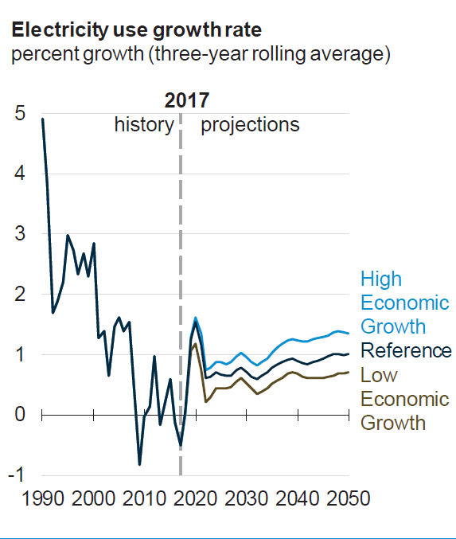

Future Resource Needs

With all the utilities, the predicted need for additional generation resources is based on the predicted annual energy requirements. The future generation needs will therefore vary in the predicted energy requirements. IRP’s typically will analyze multiple scenarios, or possible states of the world, to bracket differences between forecasts. The utilities may include low-growth and economic-growth scenarios. The needed annual energy changes with the economy, and so too will the need for additional generation. The below summaries of the needs for future generation are therefore only applicable under the specific scenario to which it applies.

State Utility Forecasting Group

In its Indiana Electricity Projections: The 2017 Forecast, the SUFG summarized its 2017 forecast regarding future generation needs as follows:

For this forecast, SUFG has incorporated significant revisions to its modeling system. As a result, unlike in previous forecasts, future resource needs are identified by a specific technology rather than by generic baseload, cycling and peaking types. The new utility simulation model can select the lowest cost mix of a number of different supply and demand options. Due to time and data limitations, demand-side resources were modeled as fixed quantities based on utility-provided information rather than allowing the model to select the amounts.

This forecast indicates that additional resources are not needed until 2021. This forecast identifies a need for about 3,600 MW of additional resources by 2025, 6,300 MW by 2030 and 9,300 MW at the end of the forecast period in 2035. In the long term, the projected additional resource requirements are higher than in previous forecasts. This is due to the retirements of additional existing generators that have been announced by Indiana utilities since the previous forecast report (pg. 1-1).

Indiana Utilities’ Resource Needs

Duke Energy Indiana – 2015 IRP

Duke Energy Indiana’s IRP for the 2015-2035 planning horizon is shown in the following table. The IRP includes the addition of two combined cycle facilities of 448 MW each – one in 2020 and the other in 2031. The IRP also determined a number of regular additions of wind and solar in relatively small increments, approximately 50 MW a year and 30 MW a year, respectively, from about 2020 through 2030. These additions come mostly after a number of anticipated retirements: five units at Wabash River (668 MW) in 2016; Connersville 1&2 combustion turbines (86 MW) in 2018, Gallagher units 2 & 4 (280 MW) in 2019, and Gibson 5 (310 MW) in 2031.

Duke Energy Indiana Integrated Resource Plan
Portfolio and Recommended Plan (2015-2035)
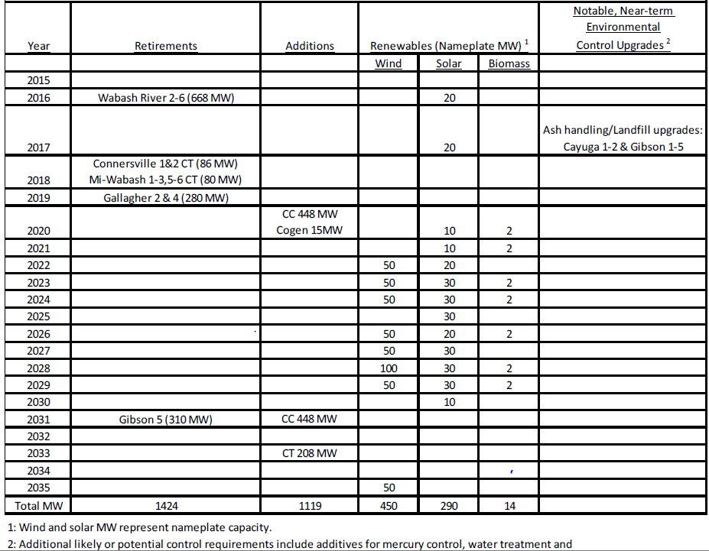
Source: Duke Energy Indiana 2015 IRP. Pg. 158

Hoosier Energy – 2017 IRP

Hoosier Energy’s IRP does not show a resource deficit until 2024. The Capacity Expansion Plan below shows Hoosier Energy’s intention of adding a significant amount of renewable resources beginning in 2020
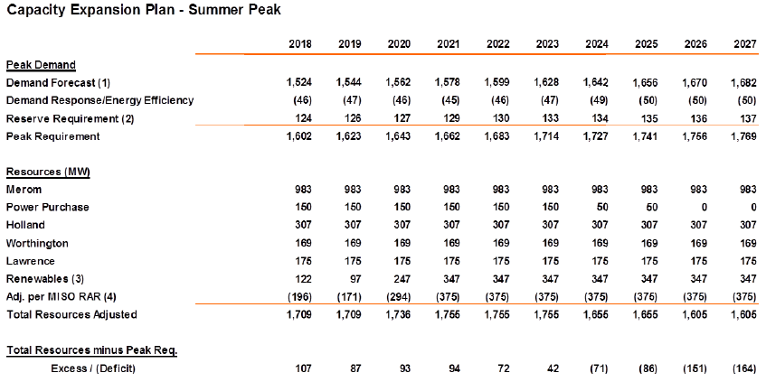
Source: Hoosier Energy 2017 IRP. Pg. 57

Indiana Michigan Power – 2015 IRP

I&M is a case study in how quick and significant market dynamics, combined with legal and regulatory circumstances, can change a utility’s resource decisions. Based on I&M’s 2018 IRP that is under development, I&M is assessing potentially significant changes beyond those contemplated in its 2015 IRP. According to the 2015 IRP, I&M did not anticipate the need for large scale additional capacity until 2035, when it forecast the need for 1253 MW of natural gas combined cycle generation coupled with a reduction in energy needs based on its energy efficiency programs. It also anticipated the addition of 600 MW of new solar generation throughout the 20 year period.

I&M’s 2018 IRP is being developed with a target completion date of November 1, 2018. I&M is planning to thoroughly review the potential for terminating the Rockport Unit 2 contract as early as 2023 and the closing of Rockport 1 by 2028. Economic, legal, and regulatory considerations are driving exploration of these options, among other considerations. It is important to keep in mind that the analysis is not complete and many factors will be considered prior to any decisions being made.

Indiana Municipal Power Agency – 2017 IRP

IMPA anticipates a need for market purchases through 2025 to provide a small amount of capacity and energy needed due to the expiration of a 100 MW power purchase agreement in 2021. From 2018 through 2027, IMPA anticipates much of its new resources will be solar and wind. After 2026, IMPA expects to be have adequate resources with the addition of one or more combined cycle units.

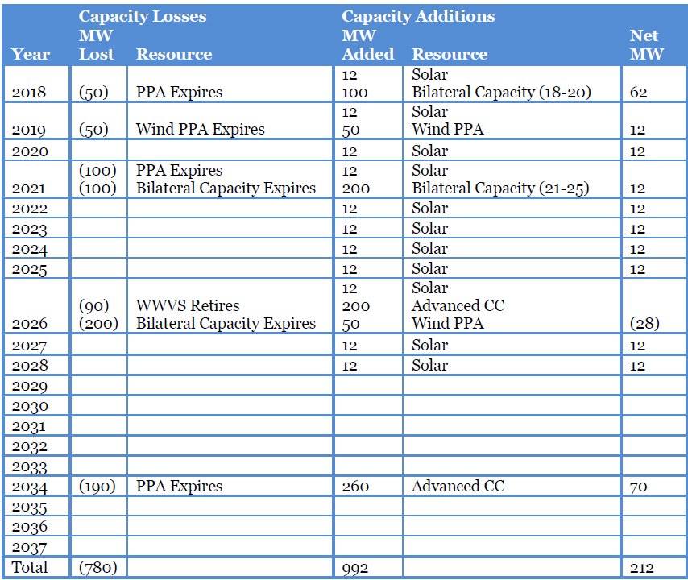
Source: Indiana Municipal Power Agency 2017 IRP. Pg. 1-13

Indianapolis Power & Light Company – 2016 IRP

IPL’s IRP includes a table showing all generation retirements and reductions under its six different scenarios.

Annual Supply-Side Capacity Additions and Retirements
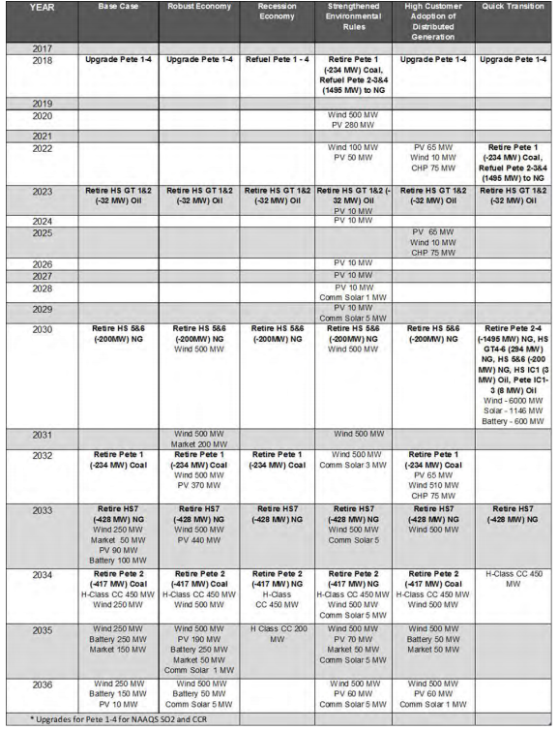
Source: Indianapolis Power & Light Company 2016 IRP. Pg. 157

Under the base case, one can see that the IRP calls for additional wind, power purchases, solar and a battery storage in 2033. In 2034, it calls for a new natural gas combined cycle plant as well as additional wind. In the final two years of the 20 year period, it anticipates more wind, solar, power purchases, and battery storage.

In its 2016 IRP and based on the information available in 2015 and 2016, IPL chose a hybrid portfolio made up of various scenario optimized candidate portfolios as its preferred portfolio. The IRP did not include needed generation resources for each scenario using the hybrid portfolio.

IPL notes, as any of the IRP’s could, that additional potential changes not easily modeled may affect future resource portfolios, such as the impacts of elections, technology changes, public policy changes, or stakeholder input.

Northern Indiana Public Service Company – 2016 IRP

NIPSCO’s 2016 IRP anticipated retiring its Bailly Generating Station (“Bailly”) Units 7 and 8 by May 2018. The replacement capacity necessary to meet the customer demand during the short-term action plan period would range from approximately 150-200 MW and would be addressed with either short-term purchase power agreements and/or market capacity purchases, whichever provides the best alignment of costs and mitigation of risks for customers.

The 2016 IRP also indicated that NIPSCO should continue to evaluate the value of developing an environmental compliance option at Schahfer Units 17 and 18. The Preferred plan was based on the likely retirement of Schahfer Units 17 and 18 in 2023. NIPSCO is currently in the process of updating its 2016 IRP and issued an all-source RFP also in May 2018 with the objective to fill a resource gap in 2023.

Resource Adequacy Assessment (MW)
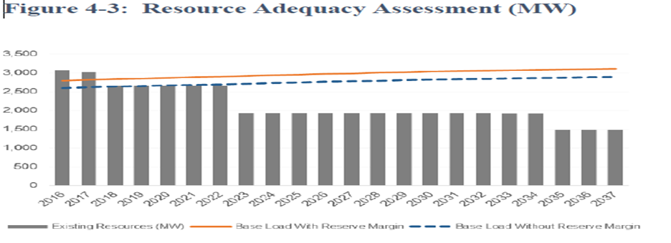Source: Northern Indiana Public Service Company 2016 IRP. Pg. 55

Southern Indiana Gas & Electric Company – 2016 IRP

In IURC Cause No. 45052, SIGECO is proposing to diversify its generation fleet based on its 2016 Integrated Resource Plan (“IRP”) by investing in a new combined cycle gas turbine, sized to replace certain coal-fired units that will be retired at the end of 2023. SIGECO is seeking a CPCN to construct the combined cycle gas turbine, with the capacity of 800-900 MW, adjacent to SIGECO’s Brown Generating Station.

Consistent with its 2016 IRP, SIGECO plans to retire Culley Unit 2 and the Brown Units 1 and 2 once the new plant is operational. According to SIGECO, Culley Unit 2’s age and efficiency will not justify further capital investment to allow it to continue to operate in the future. Brown Units 1 and 2 would require significant capital investment, including construction of a new scrubber, to allow them to continue to operate in the future. Although SIGECO has agreed to continue its joint operation of Warrick Unit 4 through December 31, 2023, the continued operation of that unit is not economic and is further complicated because ALCOA, following its recent organizational and operational changes, is not able to unconditionally commit to use of the jointly-owned unit as part of its future operations. Based on the 2016 IRP and updated IRP modeling completed in 2017, SIGECO plans to retire 73% of its current coal-fired generation fleet and diversify its generation portfolio by adding the combined cycle gas turbine at the end of 2023.

Wabash Valley Power Association – 2017 IRP

For the 2017-2036 IRP period, Wabash Valley’s IRP indicates capacity needs starting in 2018, and Wabash Valley anticipates meeting these needs in a diversified manner. Wabash Valley, unlike most utilities in Indiana and the MISO region, has winter peak demands that sometimes exceed its summer peak demand.

From 2018 to 2020, Wabash Valley expects to meet its incremental capacity needs primarily by purchasing capacity through the MISO’s capacity auctions or bilateral transactions. Wabash Valley will purchase output from three wind projects from 2018 to 2020. After 2020, Wabash Valley’s resource plan anticipates building 600 MW of baseload combined cycle resources and 350 MW of peaking combustion turbine resources along with 50 MW of energy efficiency. The expiration of existing purchase power agreements drives the need for these resources.

Indiana Future Resource Needs Summary

Based on the most recent submitted IRPs, Indiana utilities project relatively low load growth and adequate resources to satisfy reliability requirements. The utilities contemplate retirement of some generating units, particularly older and smaller coal-fired power plants, largely due to relatively low price forecasts for natural gas that may cause these coal-fired power plants to not be economical in the wholesale power market. Additionally, utilities find it difficult and costly to install or maintain environmental controls on smaller and older coal-fired power plants. The retirement of existing generation units will drive most of the large capacity additions within the forecast horizon. These capacity additions generally consist of gas-fired combined cycle facilities and significant additions of renewable resources.

For some utilities, the investment in more infrastructure and generation capacity is appropriate. For other utilities, their IRPs may suggest more reliance on regional power markets for purchases throughout the MISO and PJM regions. Some may opt for a combination of both. Even for the utilities that anticipate the need to build new generating facilities, they are eschewing capital-intensive facilities with significant lead times and, instead, are issuing requests for proposals for all cost-effective resources. It is clear that to the extent utilities elect to build more traditional generating facilities, the overwhelming preference is to build natural gas-fired combined cycle or natural gas peaking facilities.

Resource Mix and Location

In analyzing the possible future resources, it is important to note that the Commission does not have the capability to predict the location of potential future resources. The location of new resources is dependent on the specific utilities’ transmission topology, fuel sources, type and size of generation, and other factors. The location of current generation resources will change over time as generating units are retired and new generating units are built. The location of new generating units may also be influenced by energy efficiency, demand response, distributed energy resources and future transmission, distribution, and generation technologies. A map of the current location of generation resources is found in Appendix 7.

Considerations Affecting Resource Decisions

Within the last twenty years, environmental and safety regulations have imposed significant costs on the coal and nuclear-power generating fleets in particular. The capital costs associated with environmental retrofits and equipment necessary to comply with EPA requirements – including fixed Operations and Maintenance expenses (O&M) –were significant but paled in comparison to the cost of building new coal-fired or nuclear generating facilities. Since approximately 2010, hydraulic fractionation (fracking) has resulted in a paradigm change in the natural gas markets that resulted in lower prices and reduced price volatility that has far-reaching ramifications for the costs of gas-fired electric generation and, as a result, coal-fired power plants. These changes, taken as a whole, provide the primary impetus, in particular, for retirement of some coal-fired power plants and the resulting significant changes in the composition of the generating fleets for Indiana, the region, and the nation.

The following three graphics prepared by Northern Indiana Public Service Company in their current 2018 IRP stakeholder process illustrate the combined effects. While the graphics are based on NIPSCO’s experience, every Indiana utility, and utilities across the region and the nation, face the same fundamental factors that drive current and future resource decisions.

To illustrate the costs for coal-fired power plants and the dynamics with natural gas-fired units in particular, the following chart shows the key costs for coal-fired generation, broken down into fixed (that is, those costs that remain the same no matter the amount of electricity generated) and variable costs (that is, fuel and other costs that vary with the amount of electricity generated).
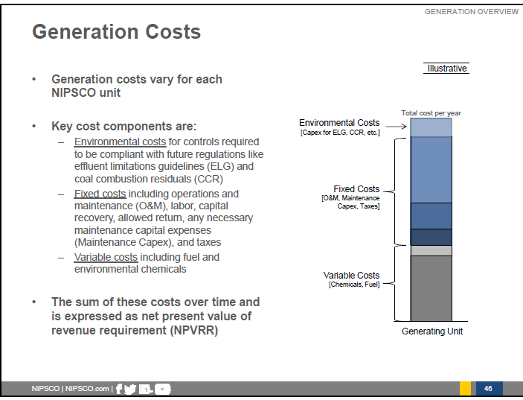

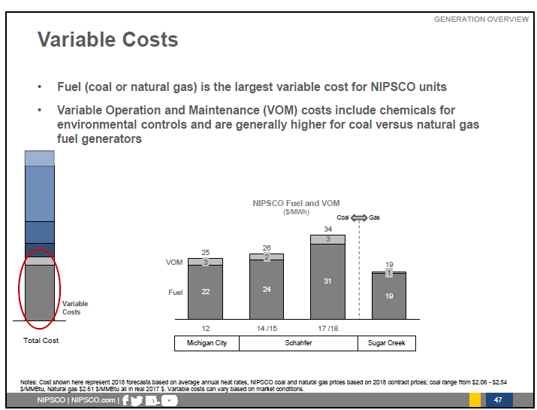
The following graph highlights the significant differences in the cost of maintaining coal-fired and gas-fired power plants. Maintenance costs are an important consideration in selecting new resources, as well as the decision to retain existing coal-fired generating units.

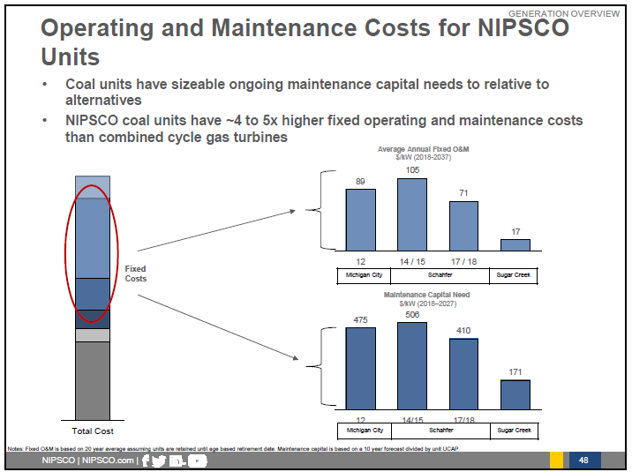

IPL, on page 69 of their 2015 IRP, constructed the following graph to describe the break-even point for their new Eagle Valley Combined Cycle facility and their most efficient coal-fired plant in Petersburg.
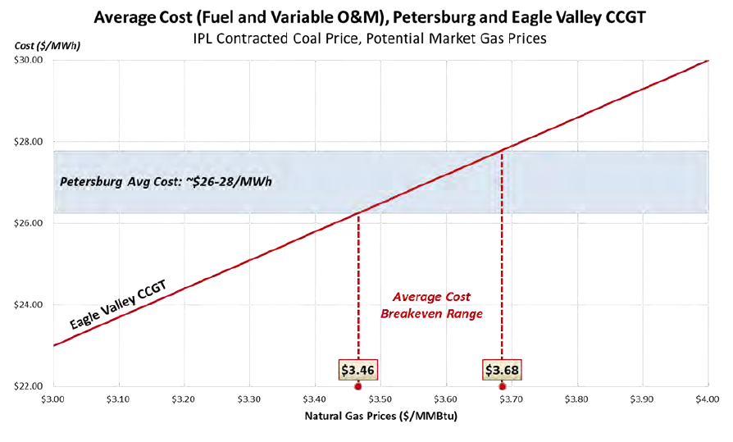
To be clear, while the cumulative effect of decades of environmental regulations have had a significant effect on coal-fired power plants, the most recent efforts by the Environmental Protection Agency to impose regulations on carbon dioxide (CO₂) were not significant drivers of resource decisions for Indiana’s utilities. That is, the potential cost and other ramifications of CO₂ regulations were dwarfed by the relatively low cost of natural gas as a generating fuel and the very high cost associated with the construction and maintenance of coal-fired generation.
The number of scheduled or completed coal capacity retirements are increasing through 2021. About 49.5 GW of coal capacity is or was scheduled for retirement between 2013-2-11, an increase from the 41.1 GWs scheduled as of March 27, [2017]. Forty-five coal units are slated to retire from 2017-2021 while 395 unites have been retired since 2012. Some power companies have said that low-priced natural gas continues to drive decisions to retire coal-fired units (SNL based on S&P’s Global Market Intelligence, October 11, 2017).

Similarly, as the recent cancelations of a nuclear power plant in South Carolina, significant cost over-runs at the Vogtle nuclear plant under construction in Georgia, as well as efforts by owners of nuclear and coal-fired generation to obtain subsidies, attest, the daunting on-going capital costs and operating cost pose significant hurdles. These were the primary factors in a large Ohio utility’s decision to file for bankruptcy in 2018. In the future, there may be technological changes that reduce the capital costs and, as a result, increase the economic viability of coal and nuclear generation units. Unexpected substantial increases in the price of natural gas may also make nuclear (and coal) more economically viable (i.e., more fully dispatched by the MISO and PJM. These market dynamics face every utility in the United States and are manifested in the growing number of retirements.

Unfortunately, other immediate casualties of these market pressures have resulted in bankruptcies of several coal companies.

A concern has been expressed that, as a nation, we may be placing too much reliance on natural gas and, thereby, not giving appropriate consideration to resiliency of the power system. As the U.S. Department of Energy’s Sandia Laboratory states:

“Grid resilience is a concept related to a power system’s ability to continue operating and delivering power even in the event that low probability, high-consequence disruptions such as hurricanes, earthquakes, and cyber-attacks occur. Grid resilience objectives focus on managing and, ideally, minimizing potential consequences that occur as a result of these disruptions.” Sandia, however, notes that “currently, no formal grid resilience definitions, metrics, or analysis methods have been universally accepted.”

The FERC currently has a process investigating the relationship between resiliency, reliability, and the performance of the bulk power system.

Indiana Utilities’ Resource Mix

When analyzing the generation resource mix in Indiana, retirements of existing coal resources are of primary focus. Every Indiana utility has exhibited a keen appreciation for the risks of retiring units compared to the risks of retaining units that may prove to be uneconomic at some point in the future.

Within the last 20 years, environmental regulations have imposed significant costs on coal -fired generation, in particular. The capital costs associated with environmental retrofits and equipment necessary to comply with U.S. EPA requirements, including fixed operations and maintenance expenses, were significant, but paled in comparison to the cost of building new coal-fired or nuclear generation facilities. Beginning about 2010, however, hydraulic fracturing (“fracking”) has resulted in a paradigm change in the natural gas markets that resulted in lower prices and reduced price volatility. As a result, the economics of operating coal-fired power plants changed drastically. These changes, taken as a whole, provide the primary impetus for retirement of some coal-fired power plants and the resulting significant changes in the composition of the generation fleets for Indiana, the region, and the nation.

Duke Energy Indiana – 2015 IRP

Duke Energy’s total installed net summer generation capability owned or purchased by Duke Energy is currently 7,507 MW. This capacity consists of 4,765 MW of coal-fired steam capacity, 595 MW of syngas/natural gas combined cycle capacity, 285 MW of natural gas-fired combined cycle capacity, 45 MW of hydroelectric capacity, and 1,804 MW of natural gas-fired or oil-fired peaking capacity. Also included is a power purchase agreement with Benton County Wind Farm (100 MW, with 13 MW contribution to peak modeled).

Duke Energy’s recommended plan for the 2015-2035 planning horizon is shown in the following table. The plan includes the retirement of five combustion turbines at Wabash River (668 MW) in 2016, Connersville 1&2 combustion turbines (86 MW) in 2018, Gallagher units 2 & 4 (280 MW) in 2019, and Gibson 5 (310 MW) in 2031. The plan also included the addition of two combined cycle facilities of 448 MW each – one in 2020 and the other in 2031. Resource additions also included regular additions of wind and solar in relatively small increments.

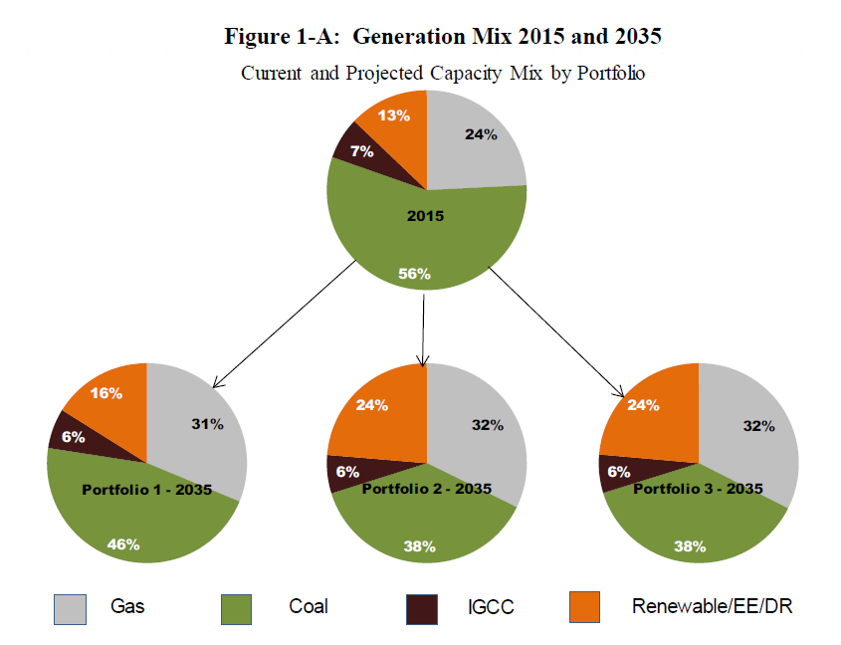
Duke Energy’s Generation Mix 2015 and 2035

Source: Duke Energy Indiana 2015 IRP. Pg. 16

Hoosier Energy – 2017 IRP

Hoosier Energy does not show a resource deficit until 2024-25. Hoosier Energy’s preferred capacity expansion plan suggests adding 891 MW of additional solar and wind over the planning period, as well as 205 MW of combustion turbines in 2024. The preferred plan also shows 208 MW of retirements of contracts through the 2018 – 2037 planning horizon.
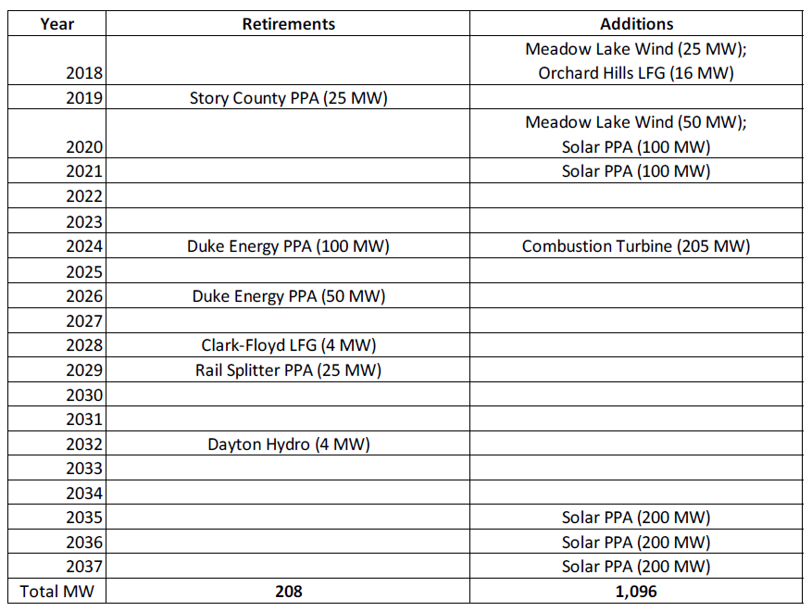
Source: Hoosier Energy 2017 IRP. Pg. 92

Indiana Michigan Power – 2015 IRP

I&M’s resource mix will be highly dependent on a decision on the Rockport generating units and its resource alternatives. I&M’s 2015 IRP is being updated in 2018 and the future resource mix is likely to be different than predicted in 2015. The 2015 IRP, however, remains the most recently submitted information. It describes the change in its generation mix during its 20 year IRP period based on its preferred resource portfolio. It notes the energy output attributable to coal-based assets decreases from 40 percent to 33 percent, while nuclear generation shows a decrease from 53 percent to 38 percent over the period. Likewise, in addition to energy from a new natural gas combined cycle plant, which would comprise 15 percent of its resource portfolio, renewable energy would be anticipated to increase from 6% to 13% over the planning period.

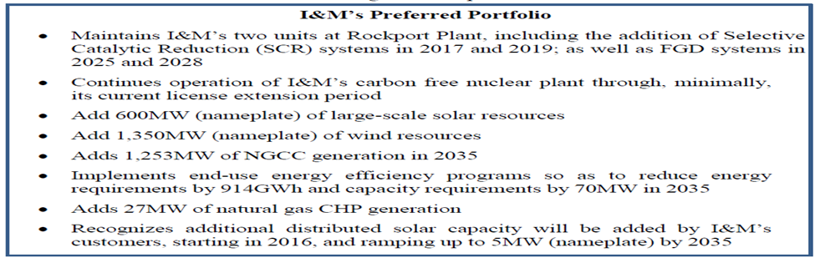
Source: Indiana Michigan Power 2015 IRP. Pg. ES-6

2016 I&M Energy Mix
Source: Indiana Michigan Power 2015 IRP. Pg. ES-10

2035 I&M Energy Mix
Source: Indiana Michigan Power 2015 IRP. Pg. ES-10

Energy efficiency and demand response is projected in the 2015 IRP to reduce I&M’s retail load by 8% over the 2016-2035 planning horizon. (Page 50). In addition, DSM programs implemented by I&M in 2015-2018 were expected to result in 37 MW of reduced demand.

I&M’s 2018 IRP is being developed with a target completion date of November 1, 2018. I&M is planning to thoroughly review the potential for terminating the Rockport Unit 2 contract as early as 2023 and the closing of Rockport 1 by 2028. Numerous factors are driving exploration of these options including economics, legal, and regulatory considerations. It is important to keep in mind that the analysis is not complete and many factors will be considered prior to any decisions being made.

Indiana Municipal Power Agency – 2017 IRP

IMPA anticipates a need for market purchases through 2025 to provide a small amount of capacity and energy needed due to the expiration of a 100 MW power purchase agreement in 2021. From 2018 through 2027, IMPA anticipates much of its new resources will be solar and wind. After 2026, IMPA expects to be have adequate resources with the addition of one or more combined cycle units. The following graphics show IMPA’s resource needs and the resources required to serve its member cities’ electrical requirements.

Source: Indiana Municipal Power Association 2017 IRP. Pg. 1-13

Indianapolis Power & Light Company – 2016 IRP

As confirmation of this strategy, IPL retired 260 MW of coal-fired generation, converted 630 MW of coal-fired generation to gas, and completed the 671 MW Eagle Valley Combined Cycle Gas Turbine (“CCGT”) on April 28, 2018. The following table shows how IPL’s resource mix changed over the period 2007-2017.

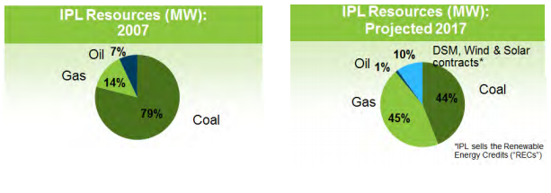
Source: Indianapolis Power & Light 2016 IRP. Pg. 3

In the IRP IPL embraced flexibility for future resources:

Optionality will take us many places, but at its core, an option is what makes you antifragile and allows you to benefit from the positive side of uncertainty, without a corresponding serious harm from the negative side (Page 2).

IPL has been a leader in Indiana in taking steps to change its portfolio, moving toward cleaner resource options through offering Demand Side Management (“DSM”) programs, replacing coal-fired generation with natural gas-fired generation, securing wind and solar long-term contracts known as Purchased Power Agreements (“PPAs”), and building the first battery energy storage system in the Midcontinent Independent System Operator’s (“MISO’s”) region. IPL plans to continue this transition proactively while simultaneously maintaining high reliability and affordable rates (Page 1).

The 2016 IRP, IPL contended, given the information available in 2015 and 2016, the hybrid preferred resource portfolio in the last column is a more appropriate solution. IPL cited technology costs that may decrease more quickly than currently projected which would likely drive changes in renewable and distributed generation penetration (Page 9). The below table details the four primary scenarios that were considered by IPL.

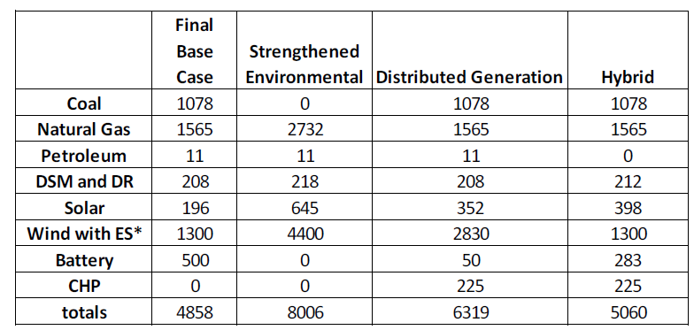

It should also be noted that IPL has been a leader in the deployment of Advanced Metering Infrastructure (AMI) that provides IPL with sub-hourly usage information. This very discrete data can be used to enhance the credibility of IPL’s load forecasting, opportunities to establish more precise rates that recognize the cost of providing electricity varies continuously, aid in the evaluation, measurement, and valuation (EM&V) of energy efficiency programs, demand response, distributed energy resources, and renewable resources, enables IPL to evaluate non-utility resources on a more comparable bases to utility resources, provides information needed to integrated new technologies such Energy Storage (e.g., batteries) and Electric Vehicles (EV), and improves the information need for distribution system planning which may result in improved distribution reliability.

Northern Indiana Public Service Company – 2016 IRP

NIPSCO’s 2015 coal-fired generation accounted for 66 percent of its resource mix, which was a 24 percent decrease from 2010. Natural gas generation constituted 19 percent in 2015. DSM, particularly the industrial interruptible program, accounted for about 15 percent of the resource mix in 2015.

NIPSCO retired Bailly Generating Station (“Bailly”) Units 7 and 8 by May 2018. The replacement capacity necessary to meet the customer demand during the short-term action plan period would range from approximately 150-200 MW and would be addressed with either short-term purchase power agreements and/or market capacity purchases, whichever provides the best alignment of costs and mitigation of risks for customers.

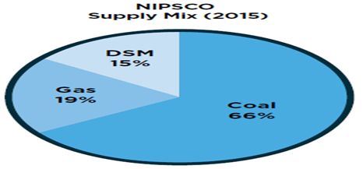
Source: Northern Indiana Public Service Company 2016 IRP. Pg. 4

NIPSCO, like other Indiana utilities, is using a combined cycle generating unit as a proxy for its next resource. However, NIPSCO, in the 2018 IRP under development is issuing an “all source Request for Proposals” as a means of securing future resources. According to NIPSCO, its supply strategy for the next 20 years is expected to:
- Lead to a lower cost, cleaner, diverse and compliant portfolio by retiring 50 percent of NIPSCO’s coal capacity by the end of 2023;
- Continue the company’s commitment to energy efficiency and demand response by including programs that are economically viable for all customers;
- Continue to comply with environmental regulations, specifically the Effluent Limitation Guidelines and Coal Combustion Residuals for the retained coal-fired generation;
- Maintain an appropriate level of interruptible service for NIPSCO’s major industrial customers;
- Reduce customer and company exposure to customer load, market, and technology risks by intentionally allocating a portion of the portfolio to shorter duration supply;
- Strongly consider cost to customers, while considering all technologies and fuels as viable to provide shorter duration supply;
- Add combined cycle gas turbine capacity to meet supply needs that are not covered by shorter duration supply options;
- Continue to evaluate additional supply retirements in light of changing market conditions and policy requirements;
- Continue to invest in infrastructure modernization to maintain safe and reliable delivery of energy services; and
- Continue to comply with North American Electric Reliability Corporation Critical Infrastructure Protection cyber security standards.

Southern Indiana Gas & Electric Company – 2016 IRP

SIGECO’s current generation mix consists of approximately 1,360 MW of installed capacity. This capacity consists of approximately 1,000 MW of coal fired generation (68 percent), 245 MW of gas fired generation, 3 MW of landfill gas generation, purchase power agreements totaling 80 MW from wind, and a 1.5 percent ownership share of Ohio Valley Electric Corporation (“OVEC”) which equates to 32 MW. SIGECO’s preferred resource plan would have the mix of natural gas and coal essentially swapping places in its generation resource mix. Natural gas would end the 20 year planning period at 63 percent of the resource portfolio, and coal would account for 16 percent. The small difference is made up for with small increases to energy efficiency and renewable.

SIGECO noted on page 9 of the Non-Technical Summary that the cost of renewable resources continue to decline but are still expected to be more expensive in the Midwest over the next several years. SIGECO also expressed the concern that they need to learn more about integrating solar resources in its territory:

Based on the IRP planning process, SIGECO has selected a preferred portfolio plan that balances the energy mix for its generation portfolio with the addition of a new combined cycle gas turbine facility and solar power plants and significantly reduces its reliance on coal-fired electric generation. SIGECO’s preferred portfolio reduces its cost of providing service to customers over the next 20 years by approximately $60 million as compared to continuing with its existing generation fleet… SIGECO will continue to evaluate its preferred portfolio plan in future IRPs to ensure it remains the best option to meet customer needs (Non-Technical Summary, Page 2 and graph on page 5).

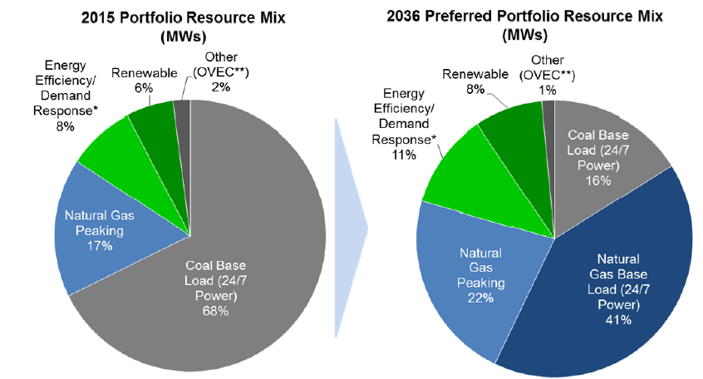
Source: Southern Indiana Gas & Electric Company 2016 IRP. Pg. 46

SIGECO is proposing in Cause No. 45052 to diversify its generation fleet based on its 2016 Integrated Resource Plan by investing in a new CCGT sized to replace certain coal-fired units that will be retired at the end of 2023. SIGECO is seeking a CPCN to construct a 2x1 F class technology CCGT with capacity of 800 to 900 MW, to be constructed on the ground adjacent to SIGECO’s Brown Generating Station.

Consistent with the 2016 IRP, SIGECO plans to retire Culley Unit 2 and the Brown Units 1 and 2 once the CCGT is operational. According to SIGECO Culley Unit 2’s age and efficiency will not justify further capital investment to allow it to continue to operate in the future. Brown Units 1 and 2 would require significant capital investment, including construction of a new scrubber, to allow them to continue to operate in the future. While SIGECO has agreed to continue its joint operation of Warrick Unit 4 through December 31, 2023, the continued operation of that unit is not economic and is further complicated because ALCOA, following its recent organizational and operational changes, is not able to unconditionally commit to use of the jointly owned unit as part of its future operations. Based on the 2016 IRP and updated IRP modeling completed in 2017, SIGECO plans to retire 73% of its current coal-fired generation fleet and diversify its generation portfolio by adding the CCGT at the end of 2023.

Wabash Valley Power Association – 2017 IRP

From 2018 to 2020, Wabash Valley expects to meet its incremental capacity needs primarily by purchasing capacity through the MISO’s capacity auctions or bilateral transactions. After 2020, Wabash Valley will seek a resource mix that closely aligns with its average load factor of approximately 55-65 percent. That is, Wabash Valley plans to attain a power supply resource ratio of approximately 60 percent baseload/intermediate capacity to 40 percent peaking capacity with a move toward a greater percentage of natural gas units (e.g. combined cycle gas turbines and peaking plants) (Wabash Valley Power Association 2017 IRP pg. 5).

Wabash Valley will purchase output from three wind projects from 2018 to 2020. Wabash Valley members will continue to run and enhance its energy efficiency programs and may choose to continue to build demand response resources in the near term. Past 2020, Wabash Valley’s resource plan anticipates building 600 MW of baseload combined cycle resources and 350 MW of peaking combustion turbine resources along with 50 MW of energy efficiency. The expiration of existing purchase power agreements drives the need for these resources. At the end of the 20-year plan horizon in 2036, Wabash Valley’s current base expansion plan forecasts that its energy and capacity needs will be served as depicted in the following charts.

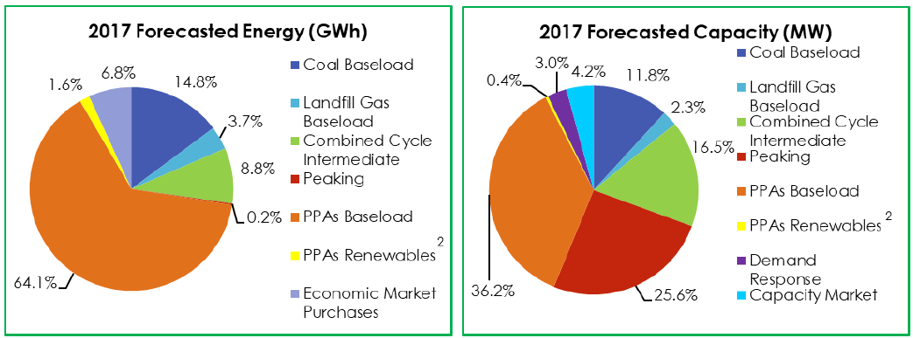
Source: Wabash Valley Power Association 2017 IRP. ES-Page 3

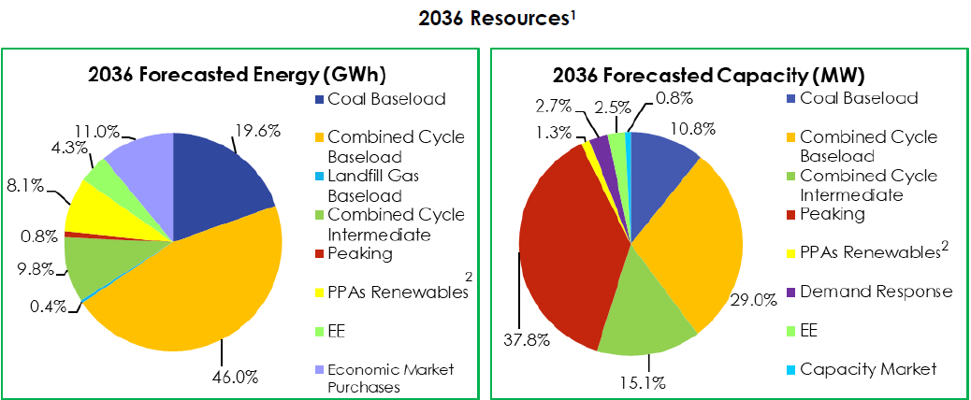
Source: Wabash Valley Power Association 2017 IRP. ES-Page 7

Each year Wabash Valley works with its Members to evaluate the power supply environment and to determine how to incorporate DR programs into the overall power supply portfolio. Demand Response programs continue to be an integral part of Wabash Valley’s power supply portfolio with the primary purpose to keep power supply costs as low as possible. The Company now approaches DR programs as a resource, just like a peaking plant. (Page 24)

In 2011, Wabash Valley created two rate riders that allowed end use commercial and industrial customers the ability to participate in MISO’s Emergency Demand Response Initiative and PJM’s Emergency Load Response Program. Since 2012, Wabash Valley has offered the PowerShift® program, an updated DLC program. To date, 19 of the 23 Members have signed agreements to participate in the PowerShift® program. The PowerShift® program includes participants’ water heaters (WH), air conditioners (AC), pool pumps (PP), field irrigators (FI), entire homes (EH), ditch pumps (DP) and grain dryers (GD). Please see the table below for details as of June 1, 2017. Page 23PowerShift® program, an updated DLC program. To date, 19 of the 23 Members have signed agreements to participate in the PowerShift® program. The PowerShift® program includes participants’ water heaters (WH), air conditioners (AC), pool pumps (PP), field irrigators (FI), entire homes (EH), ditch pumps (DP) and grain dryers (GD). Please see the table below for details as of June 1, 2017. (Page 23 of IRP)

Wabash Valley started offering EE programs to its Member cooperatives in 2008 with the Touchstone Energy® Home Program, a residential new construction program focused on helping builders and homeowners construct a high performance, comfortable, durable and low energy cost home. Since 2008, the Company has worked jointly with our Member cooperatives, retail members and our Power Supply staff to develop attainable savings goals that lessen baseload power supply costs and increase retail member satisfaction throughout the service territory (Page 27). In Wabash Valley’s 2017 IRP, the generation and transmission cooperative (G&T) said its members realized the following savings from energy efficiency. (Wabash Valley Power Association 2017 IRP, page 21).

Energy Efficiency MWh Savings 2010-2017
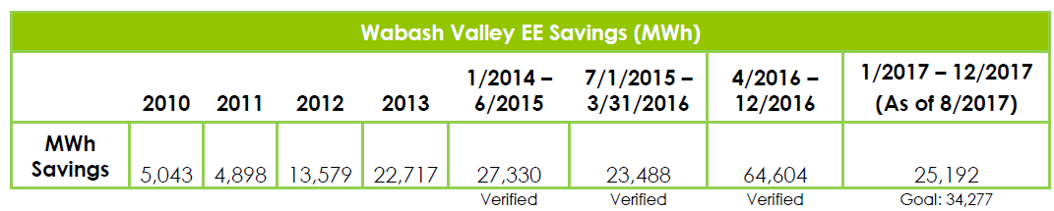
Source: Wabash Valley Power Association 2017 IRP. Pg. 31

Energy Efficiency Cumulative Program Highlights 2008-2017 (As of 8/2017)
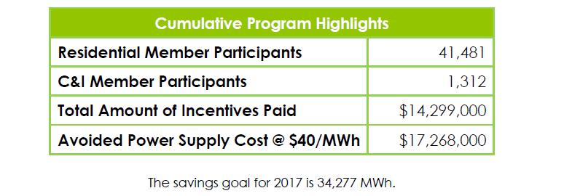
Source: Wabash Valley Power Association 2017 IRP. Pg. 31

Indiana Resource Mix Analysis

As stated earlier, Indiana’s electric resources are changing. Over the next 20 years, a significant number of coal-fired generation plants will likely be retired. Possible resource additions will most often consist of natural gas generation plants and renewable resources, as well as energy efficiency and demand response. While many of these changes started with increased federal environmental regulations regarding coal, the sustained lower prices for natural gas are a major factor, shifting the economics toward generation fueled by natural gas. Because IRPs look at the lowest cost options across multiple scenarios and risk factors, lower cost natural gas is often selected through the modeling as a preferred option for future resource additions.

Renewable Resources in Resource Mix

Indiana utilities’ resource mix show an increase in renewable resources, particularly wind. As the growth rate of wind and solar has been significant, the total amount of renewable resources, as a percent of all resources in Indiana is still very small but an increasing part of utility resource portfolios.

The total amount of installed wind capacity in Indiana is about 2,023 MW. This constitutes about 85% of all renewable installed resource capacity in Indiana. Much of this power is sold out of state. The amount of wind power under purchase power agreements by the five largest IOUs, is about 1,168 MW with about 301 MW purchased from out-of-state wind generators. As of May 2018, the five IOUs in Indiana have about 866 MW of purchased power agreements for wind, according to IURC data. Based on the IRPs, total wind resources are expected to grow as utilities build or contract for utility-scale wind resources as indicated in their most recent IRPs.

Net metering allows customers with small renewable facilities to receive a credit for excess electricity produced at the retail rate. As the following graph demonstrates, net metering has grown significantly, especially in terms of number of customers, but provides only a small percentage of the generation capacity in Indiana. In 2017 Senate Enrolled Act 309 became law, limiting how long eligible customers could qualify for net metering and creating a new compensation rate when net metering will no longer be available. The 2017 increase in both customer participation and net metering capacity is likely due to the new legislation.

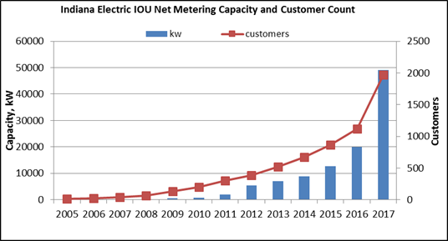

Another option for renewable resources is the Feed-in-Tariff or FIT ; however, as evidenced by the table below, this has a very limited application in Indiana. New customers cannot join the IPL FIT, and NIPSCO’s FIT is available until participation limits are reached.

 | Wind (kW) | Photovoltaic (kW) | Biomass (kW) | Total (kW)
IPL | 0 | 94,384 | 0 | 94,384
NIPSCO | 180 | 16,488 | 14,348 | 31,016
Total | 180 | 110,872 | 14,348 | 125,400

The following graph shows through 2015 the rapid growth in wind generation in Indiana as a share of the total electricity generation in the state. It should be noted this graph includes energy for total wind energy generated in Indiana, not just the energy from Indiana wind facilities with long term purchase power contracts with Indiana utilities. Despite the rapid growth in solar, it contributes a very small share to the total electricity generated in Indiana.

Renewables share of Indiana electricity generation (1960-2014) EIA May 2017
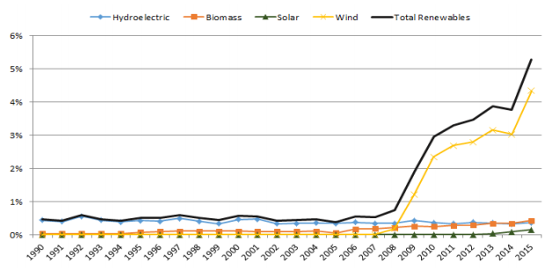

Utilities expect roof top and utility scale solar resources to increase (this includes Community solar and concentrating photovoltaic).

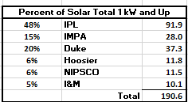

In addition, there is an expectation that distributed energy resources (“DERs”), including Combined Heat and Power as well as battery and other storage technologies, will increase their penetration over the 20 year planning horizon, which could be used to improve the reliable capacity of renewable resources. Newer technologies such as fuel cells may become economically feasible in the long-run. In the short-term, uncertainty about tax incentives may retard the growth in some technologies. In the longer-run, several projections suggest that increases in efficiency, combined with coupling intermittent technologies with back up generation or storage, will overcome the cost-effectiveness hurdle. Based on the IRPs, Indiana’s utilities are expecting DERs to be an increasing factor in future years.

Energy Efficiency and Demand Response

Collectively referred to as Demand Side Management (“DSM”), energy efficiency and demand response have a relatively small but important percentage of the total resource mix (the level of energy efficiency savings achieved by a utility in a year generally ranges from 0.7 percent to around one percent by those customers participating in energy efficiency programs. Energy efficiency also results in some demand reduction.) According to the SUFG, demand response is expected to increase from about 1,000 MW to almost 1,200 MW over the 20-year forecast horizon (State Utility Forecasting Group’s 2017 Electricity Projections. Pg. 3-1). Similarly, customer-owned resources, such as combined heat and power, have a small share of the total resource mix but it is growing in significance. These resources add important resource diversity and reliability, and have a positive influence on the timing, size, operational characteristics, and costs of new resources. That is, DSM minimizes risks for the utility and consumer. Moreover, in addition to lowering the cost to customers, these resources give customers greater control over their electric use and the attendant costs. As the sophistication and credibility of all aspects of IRP evolve, it seems certain that these resources will be increasingly essential to the operations of the electric power system.

Under Indiana law, the five investor-owned electric utilities must submit three-year energy efficiency plans to be approved by the Commission. All five utilities have energy efficiency plans that have been approved by the commission or in the review process. One of the basic determinations required by the law is that the Commission must find that the proposed three-year energy efficiency plan is reasonably achievable, consistent with the utility’s integrated resource plan, and designed to achieve an optimal balance of energy resources in the utility’s service territory.

The following graphs are from the SUFG’s 2017 statewide load forecast report and shows their projection of the kW impact of energy efficiency programs and demand response programs implemented through 2016.

2015 Embedded DSM and 2016 Incremental Peak Demand Reductions from Energy Efficiency and Annual Demand Response Program (MW)
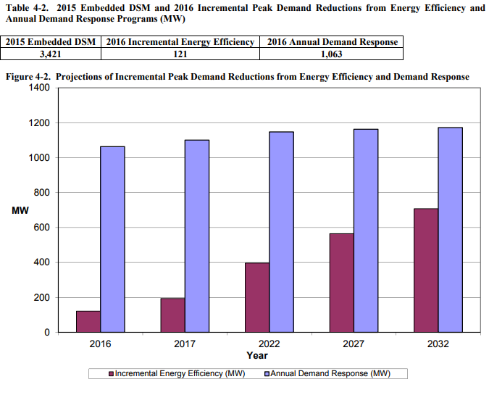
Source: State Utility Forecasting Group’s 2017 Electricity Projections. Pg. 4-5

Projections of Incremental Peak Demand Reductions from Energy Efficiency and Demand Response
Source: State Utility Forecasting Group’s 2017 Electricity Projections. Pg. 4-5

Resource and Operational Efficiencies Gained Through RTOs

With the reformation of the wholesale power markets in the late 1990s that resulted in the establishment of RTOs and Independent System Operators (“ISOs”) like the MISO in Carmel, Indiana, and PJM, it became possible to efficiently trade power over great distances due to elimination of artificial anticompetitive barriers and pricing reform. This provided for more efficient and reliable operation of the electric system that tempered retail price increases. Today, all the large investor owned utilities with rates regulated by the Commission have joined, with Commission approval, an RTO. I&M is a member of PJM and the others (Duke, IPL, SIGECO, and NIPSCO) are members of MISO. The following graphics illustrate the geographic scope of these RTOs.

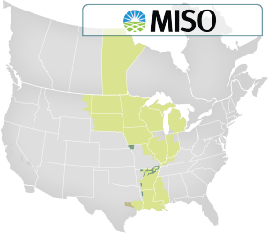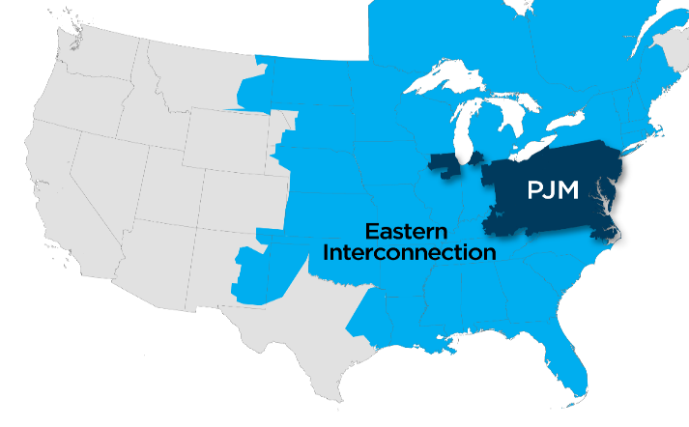

Fair and competitive access to a broadly diverse power supply meant that Indiana utilities no longer needed to plan their resources as if they were not interconnected to a vast and growing electrical grid. Understanding the current and future regional supply and demand for electric power is now an integral part of the Indiana IRP process.

Among other important functions, MISO and PJM facilitate the operations of the competitive wholesale power markets in a number of ways:
(1) Providing for regional control of generations resources that is much more cost effective than having individual utilities only use their own generation resources, which occurred before the RTOs.
(2) Transmission of electric power over vast distances, which is essential for reliability and the economic operation of the power system.
(3) A transmission planning process that allocates costs of new or upgraded transmission based on the principle that those that benefit pay their fair share of the costs.
(4) Increase in grid reliability, including assurances that utilities will have sufficient resources to meet their customers’ needs even in unexpected circumstances.
(5) Informing their member utilities of the short- and long-term regional resource availability, which, in turn, enables Indiana utilities to alter their resource decisions to reduce costs for their customers and provide increased diversity of resources.

MISO Region

MISO’s Value Proposition documents how the region benefits from its operation. In 2017, MISO calculated that its efforts provided between $2.9 billion and $3.7 billion in regional benefits, driven by enhanced reliability, more efficient use of the region’s existing transmission and generation assets, and a reduced need for new assets. This collective, region-wide approach to grid planning and management delivers efficiencies that could not be achieved through statewide power pooling alone.

The MISO region is undergoing a significant change in the generating fleet composition. This is due to the cumulative cost effects of environmental controls, the aging of the coal and nuclear generating fleets, the greater than expected penetration of renewable resources, declining cost of energy efficiency, and especially the declining cost of natural gas and projections for low natural gas prices for several years.

On April 25, 2018, the MISO said it will have adequate electricity resources to meet demand for this summer. The regional transmission operator, whose grid covers 15 states in the Midwest and southern U.S., expects demand to peak at 124,700 MW, below available supply of 148,600 MW. Beyond this summer and for the next several years, MISO expects that it will satisfy the reliability requirements promulgated by the North American Electric Reliability Corporation and approved by the Federal Energy Regulatory Commission to assure adequate supply to satisfy the forecasted demand and meet unforeseen contingencies.

Within the MISO region, coal-fired generation constituted 75% of total energy production in 2010 and is projected to decline to about 36% in 2030. From 2000 until April 2016, approximately 9.1 GW of coal-fired capacity has been retired in MISO, according to SNL. By 2030 natural gas-fired generation is projected to increase from 15% in 2014 to 35% in 2030. Increasingly, natural gas sets the market price (Locational Marginal Price – LMP). As the graphic below illustrates, the amount of gas-fired generation is expected to constitute 35% by 2030 compared to 36% for coal-fired power plants.

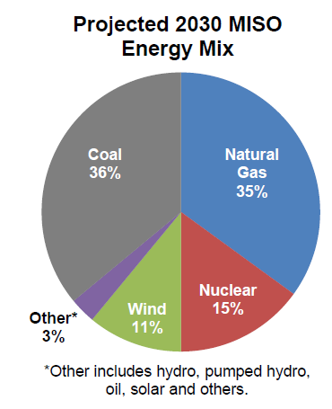

The majority of MISO states are traditionally regulated and the jurisdictional utilities are vertically integrated. Statutory authorities of most states in MISO require jurisdictional utilities to provide assurances to their respective regulatory commissions that they have adequate resources and plan to have sufficient resources to meet their customers’ electric needs reliably and economically. Indiana utilities, for example, have substantial assurance that prudent investment in resources will be recovered and investors will be adequately compensated.
Despite the significant changes in generation resource composition and the anticipated changes as projected by the MISO, the Midwest should have a well balanced portfolio of generation resources and technologies, thus avoiding undue reliance on any one technology or fuel type for the foreseeable future.

PJM Region

In contrast, the PJM is characterized by predominately restructured states that have little, if any, regulatory authority over the operation, construction and planning of generating resources. As a result, generation owners in those states are subject to market prices for economic viability. With the sharp decline in natural gas prices, projections for continued low-cost natural gas, and the relatively high capital cost of coal-fired (and nuclear) generating facilities, compared to natural gas generating facilities, a substantial amount of the coal-fired (and nuclear generation) is at considerable risk for continued economic viability. As a result, some states have or are considering additional out-of-market actions to subsidize the operations of coal and nuclear power plants. These PJM market issues do not affect I&M or its parent company, American Electric Power (“AEP”), as they do not participate in PJM’s capacity auction. Instead, AEP meets PJM’s Fixed Resource Requirement (“FRR”), in which AEP assures that it has sufficient resources to more than meet its customers’ needs.

Similar to MISO, PJM provides an annual value proposition, summarizing the benefit of a regional grid and market operations in ensuring reliability, providing the needed generating capacity and reserves, managing the output of generation resources to meet demand and procuring specialized services that protect grid stability. As with all RTOs, PJM reacts to changes in demand in real time, adjusting generation to be in balance with demand and maintain the transmission system at safe operating levels. PJM seeks to manage transmission constraints – limitations on the ability of the transmission system to move power – by adjusting the output of generators whenever possible to promote efficiency. PJM’s large footprint makes the transmission planning process more effective by considering the region as a whole, rather than individual states. The fact that PJM plans for resource adequacy over a large region results in a lower reserve margin than otherwise would be necessary.

Like the MISO, PJM is undergoing a significant change in the generating fleet composition. This is also due to the cumulative cost effects of environmental controls, the aging of the coal and nuclear generating fleets, the greater than expected penetration of renewable resources, declining cost of energy efficiency, and especially the declining cost of natural gas and projections for low natural gas prices for several years. Increasingly, distributed energy resources (DERs) are expected to be a factor in future years.

The following graph shows the percentage of PJM installed capacity (by fuel source) for June 1, 2007 through June 1, 2020 (PJM State of the Market Report 2018, Monitoring Analytics. Section 5, Page 240).
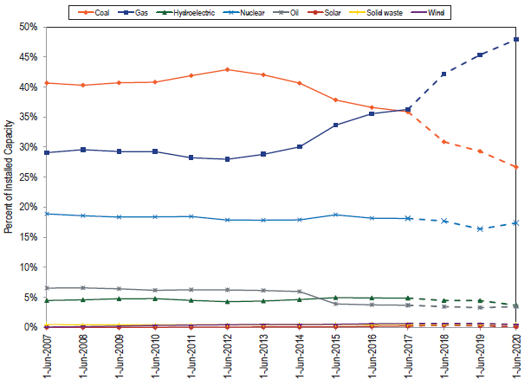
PJM is also expected to meet their anticipated demand without major concerns. Beyond this summer and for the next several years, PJM expects to have sufficient resources to satisfy the reliability requirements promulgated by the North American Electric Reliability Corporation and approved by the Federal Energy Regulatory Commission to assure adequate supply for satisfy the forecasted demand and meet unforeseen contingencies.

The National Perspective

The same factors that drive resource decisions in Indiana are also driving long-term resource decisions throughout the United States. Specifically, the projections for low natural gas prices relative to coal, continuing low forecasts for growth in energy use, projected costs of renewable resources, energy efficiency, demand response, higher maintenance costs for coal and nuclear generating units, and the relatively high cost of building new coal-fired and nuclear powered generating facilities compared to natural gas-fired generating units.

Comparative Costs of Other Means of Meeting Future Needs

Integrated resource planning considers all possible resources, including traditional resources such as coal, natural gas, and nuclear, as well as energy efficiency, demand response, wind, solar, customer-owned combined heat and power, hydro-electric and battery storage. An IRP considers all these resource options on a comparable basis.

A useful first way of estimating and comparing the potential cost of new resources is to consider the Levelized Cost of Electricity (“LCOE”). LCOE represents the per-megawatt hour (“MWh”) cost (in discounted real dollars) of building and operating a generating plant over an assumed financial life of the facility. The LCOE includes capital costs, fuel costs, fixed and variable operations and maintenance costs, financing costs, and an assumed utilization rate for different types of resources. The importance of these factors varies among the technologies. For technologies such as solar and wind generation that have no fuel costs and relatively small variable O&M costs, LCOE changes in rough proportion to the estimated capital cost of generation capacity. For technologies with significant fuel cost, both fuel cost and overnight cost estimates significantly affect LCOE. The availability of various incentives, including state or federal tax credits (e.g., the Production Tax Credit for new wind, geothermal, and biomass and Investment Tax Credit for new solar photovoltaic and thermal plants), also affect the calculation of LCOE.

As with any cost factors forecast over a long period—20 years for IRPs in Indiana—there is uncertainty about all of these factors, and their values can vary as technologies evolve and as fuel prices change. The projected utilization rate (e.g., capacity factor) depends on the forecasted demand for electricity and the existing resource mix in an area where additional capacity is to be added. For Indiana utilities, the expected RTO dispatch will affect the utilization rate. That is, the existing and projected comparison between resources in a region can directly affect the economic viability of those resources. The direct comparison of LCOE across technologies is, therefore, difficult and can be misleading as a method to assess the economic competitiveness of various generation alternatives. Still, in each IRP, the cost comparison over time of all resources is inherent in the modeling process. Below is a table showing comparisons among different resources using the LCOE.

Estimated Levelized Cost of Electricity (Capacity-Weighted Average) for New Generating Resources Entering Service in 2022 (2017 $/ MWh)

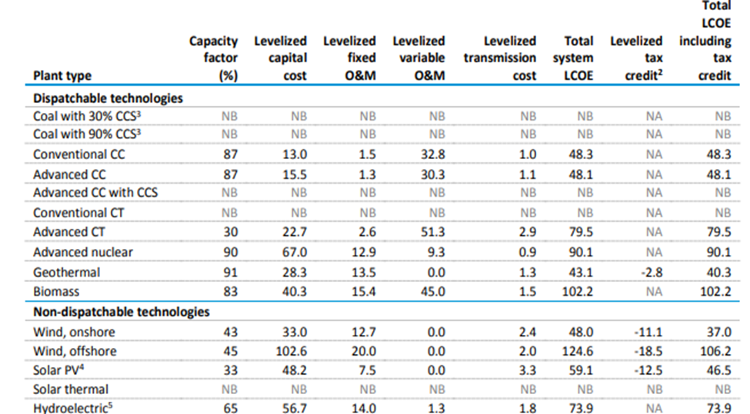

Source: Energy Information Administration – Annual Energy Outlook 2018

Fuel Price Projections Influence Comparative Costs

As the SUFG stated:
SUFG’s current assumptions are based on the January 2017 projections produced by the Energy Information Administration (EIA) for the East North Central Region. SUFG’s fossil fuel real price projections are as follows: Natural Gas Prices: Natural gas prices decreased significantly in 2009 relative to the high prices of 2008. Prices then rebounded somewhat in 2010 before declining again through 2012 before increasing back to 2010 levels by 2014. However, natural gas prices dropped again in 2015 to a level lower than that of 2012, followed by a slight decrease in 2016. They are projected to increase gradually for the remainder of the forecast horizon. Utility Price of Coal: Coal price projections are relatively flat in real terms throughout the entire forecast horizon as coal consumption decreases due to more natural gas and renewable generation observed in the electric power sector (Page 1-3).

Similarly in the Energy Information Administration’s Annual Energy Outlook 2018, March 26, 2018:
Future growth in U.S. crude oil and natural gas production is projected to be driven by the development of tight oil [1] and shale gas [2] resources. However, a great deal of uncertainty surrounds this result. In particular, future domestic tight oil and shale gas production depends on the quality of the resources, the evolution of technological and operational improvements to increase productivity per well and to reduce costs, and the market prices determined in a diverse market of producers and consumers, all of which are highly uncertain. [D]omestic dry natural gas production increases rapidly (more than 5% annually) through 2021 and then slows to an annual average growth rate of 1% through 2050, reaching 43.0 trillion cubic feet (Tcf) per year in 2050 in the Reference case.

Utility Real Fossil Fuel Prices
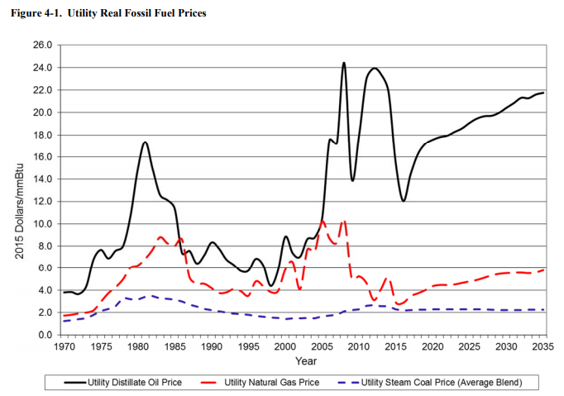

As noted by the SUFG:
The prices of fossil fuels such as coal, natural gas and oil affect electricity demand in separate and opposing ways. To the extent that any of these fuels are used to generate electricity, they are a determinant of average electricity prices. Around 65% of electricity generation for Indiana consumers was fueled by coal in 2016. Thus, when coal prices increase, electricity prices in Indiana rise and electricity demand falls, all else being equal. On the other hand, fossil fuels compete directly with electricity to provide end-use services, i.e., space and water heating, process use, etc. When prices for these fuels increase, electricity becomes relatively more attractive and electricity demand tends to rise, all else being equal. As fossil fuel prices change, the impacts on electricity demand are somewhat offsetting. The net impact of these opposing forces depends on their impact on utility costs, the responsiveness of customer demand to electricity price changes and the availability and competitiveness of fossil fuels in the end-use services markets (Indiana Electricity Projections: The 2017 Forecast, SUFG page 4-3).

The Changing Fuel used in Generation Resources in the United States

The following graphic prepared by the Energy Information Administration projects three different scenarios or possible futures. Specifically, better understand the potential risks, EIA constructed a “base case” (or “reference case” or “most expected case”), a high case that shows fewer coal retirements, and a lower case with more significant retirements of coal-fired generation. In these three potential outcomes, there are still significant decreases in the amount of coal-fired generating capacity in the United States in the first graph. In the second graph, while the utilization rate for coal-fired generation is lower than it was prior to the fracking boom, the remaining coal-fired power plants may have higher utilization rates than in the recent past, in large part depending on the price of natural gas relative to coal. In other words, the remaining coal fired fleet in 2019 and beyond may be dispatched more frequently. It is worth noting, however, that the low scenario shows a long-term decline in coal generation utilization (not being as frequently dispatched) if natural gas prices are lower than the base case projections.

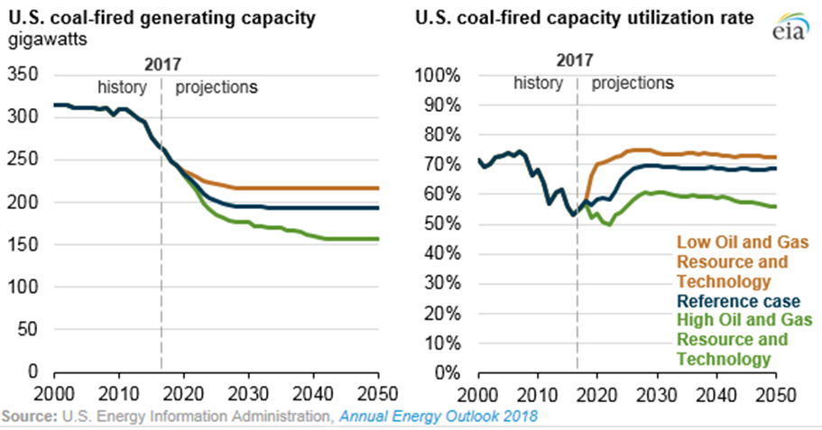

The following graph shows EIA’s Annual Energy Outlook 2018 reference case (or base case) shows the dynamics caused primarily by retirements of older and smaller coal-fired generating units and the continuing effect of environmental regulations. This graph is a projection of the change in baseload coal-fired generation (billion kWh) over the 2016-2050 planning horizon. While the production of electricity from coal-fired generation drops precipitously until 2022 the remaining coal-fired generating units shows a marked increase in projected output through 2026 and a gradual decline thereafter. Of course, this scenario is just one of several possible future outcomes.

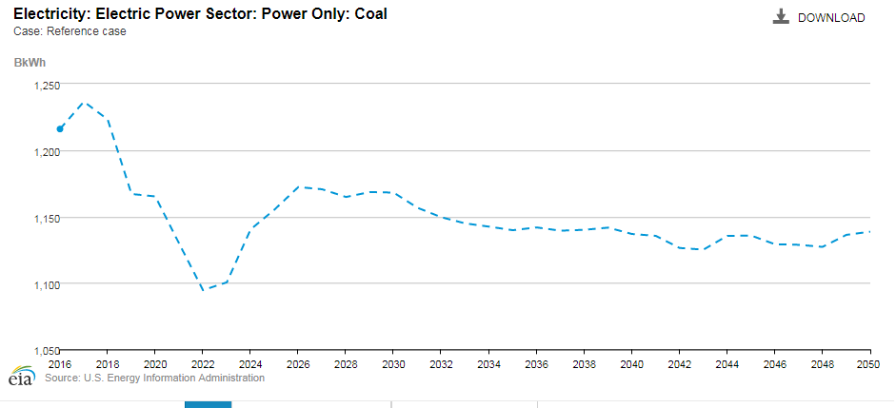
The following EIA “Reference Case” (or “Base Case”) graph shows a precipitous decline in the amount of coal-fired capacity (in MW) of the entire 2016-2050 planning horizon. Subsequent graphs layer in other resources to show the relative changes in the nation’s resource mix over the 2016-2050 planning horizon.

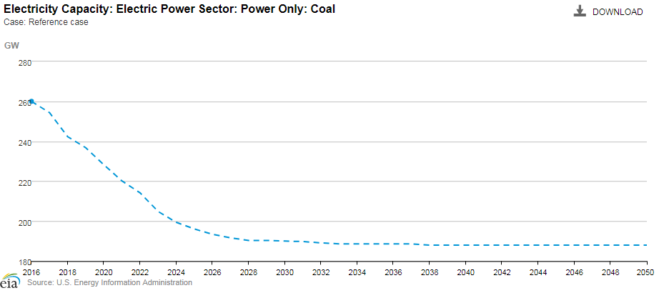
The graph below represents EIA’s reference scenario to depict the projected increases in the capacities (MW) of natural gas combined cycle generation compared to coal-fired generation over the 2016-2050 planning horizon.
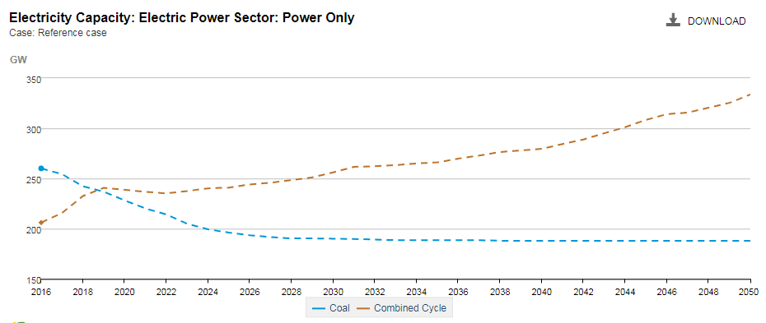
The following graph depicts the EIA’s reference case for the projected capacity (MW) supplied by several resources including coal, natural gas combined cycle, nuclear, and distributed generation.

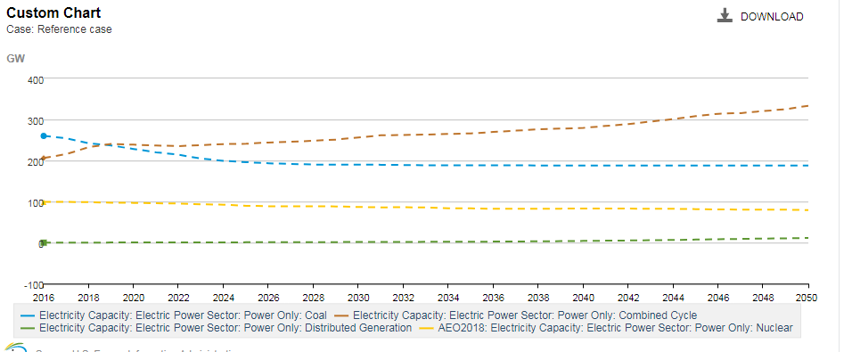

Conclusion

The importance of long-term planning is reflected in the commitment of the SUFG, MISO, PJM, and the EIA to continually conduct long-term resource planning that informs the Integrated Resource Planning conducted by Indiana utilities. The IRPs are intended to serve as objective guides for utilities, policymakers, and stakeholders to anticipate possible futures rather than a definitive plan of action. The credibility of the IRP analysis necessitates the use of state-of-the-art planning tools to construct a broad range of scenarios that reflect the dynamic nature of the environment for the electric utility industry. These scenarios, and the resulting resource portfolios, are intended to inform decision-makers of the risks and uncertainties inherent in the planning of future resources and the attendant costs and benefits. The credibility of the analysis is critical to the efforts of Indiana utilities to maintain as much optionality as possible - which includes off ramps - to react quickly to changing circumstances and make appropriate changes in the resources.

Based on the 2015 through 2017 IRPs, the SUFG report, information from MISO and PJM as well as information from the EIA, the expectation is that Indiana’s electric needs, as well as the electric requirements of the region and the nation will increase gradually over the next 20 years. Indiana utilities take their obligations to provide reliable and economical service very seriously and this commitment is consistent with their long-term resource planning processes. Due in large part to the likely retirement of additional coal-fired power plants, new resources (including traditional generation, energy efficiency, demand response, customer-owned resources / distributed energy resources, and new technologies) will be needed in the 2025-2035 timeframe. Indiana utilities procurement of future resources and maintaining optionality will be facilitated by MISO and PJM.

Appendices

APPENDIX 1
Cost and Performance Characteristics of New Central Station Electricity Generating Technologies
Overnight Construction Costs
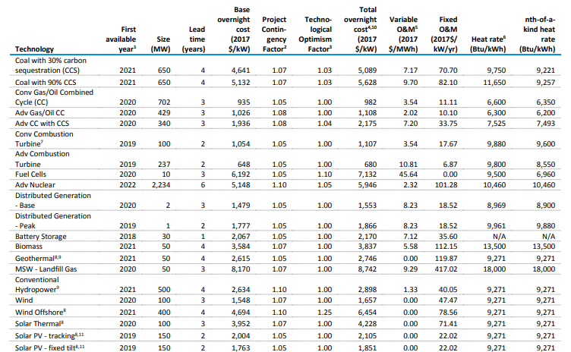

Source: Energy Information Administration – Annual Energy Outlook, April 2018
APPENDIX 2
Coal Fleet Retirements
 | Retired Coal Units Since 1-1-2010
 | Coal Unit (Year In-service) | Owner | Summer Rating (MW) | Retire Date | Age at Retire Date
1 | Edwardsport Unit 7 (1949) Unit 7 (1949) | Duke | 45 | 01-01-10 | 61
2 | Edwardsport Unit 8 (1951) Unit 8 (1951) | Duke | 75 | 01-01-10 | 59
3 | Mitchell Unit 5 (1959) | NIPSCO | 125 | 09-01-10 | 51
4 | Mitchell Unit 6 (1959) | NIPSCO | 125 | 09-01-10 | 51
5 | Gallagher Unit 1 (1959) | Duke | 140 | 01-31-12 | 53
6 | Gallagher Unit 3 (1960) | Duke | 140 | 01-31-12 | 52
7 | State Line Unit 1 (1929) | Merchant | 197 | 01-31-12 | 83
8 | State Line Unit 2 (1929) | Merchant | 318 | 01-31-12 | 83
9 | Harding Street Unit 3 (1941) | IPL | 35 | 07-01-13 | 72
10 | Harding Street Unit 4 (1947) | IPL | 35 | 07-01-13 | 66
11 | Mitchell Unit 9 (1966) | NIPSCO | 17 | 10-01-13 | 47
12 | Ratts Unit 2 (1970) Unit 2 (1970) | Hoosier | 121 | 12-31-14 | 44
13 | Ratts Unit 1 (1970) Unit 1 (1970) | Hoosier | 42 | 03-10-15 | 45
14 | Tanners Creek Unit 1 (1951) | I&M | 145 | 06-01-15 | 64
15 | Tanners Creek Unit 2 (1952) | I&M | 142 | 06-01-15 | 63
16 | Tanners Creek Unit 3 (1953) | I&M | 195 | 06-01-15 | 62
17 | Tanners Creek Unit 4 (1956) | I&M | 500 | 06-01-15 | 59
18 | Whitewater Valley 2 (1973) | IMPA | 57 | 12-31-15 | 42
19 | Eagle Valley 3 (1951) | IPL | 40 | 04-15-16 | 65
20 | Eagle Valley 4 (1953) | IPL | 55 | 04-15-16 | 63
21 | Eagle Valley 5 (1955) | IPL | 61 | 04-15-16 | 61
22 | Eagle Valley 6 (1956) | IPL | 100 | 04-15-16 | 60
23 | Wabash River Unit 2 (1953) | Duke | 85 | 04-15-16 | 63
24 | Wabash River Unit 3 ((1954) | Duke | 85 | 04-15-16 | 62
25 | Wabash River Unit 4 (1955) | Duke | 85 | 04-15-16 | 61
26 | Wabash River Unit 5 (1956) | Duke | 95 | 04-15-16 | 60
27 | Wabash River Unit 6 (1968) | Duke | 318 | 04-15-16 | 48
28 | Bailly Unit 7 (1962) | NIPSCO | 160 | 05-01-18 | 56
29 | Bailly Unit 8 (1968) | NIPSCO | 320 | 05-01-18 | 50

 | Coal to Gas Conversions 01-01-2010
 | Coal Unit (Year In-service) | Owner | Summer Rating (MW) | Conversion Date | Age at Retire Date
1 | Harding Street Unit 5 (1958) | IPL | 97 | 12-31-15 | 57
2 | Harding Street Unit 6 (1961) | IPL | 97 | 12-31-15 | 54
3 | Harding Street Unit 7 (1973) | IPL | 421 | 06-01-16 | 43

Coal Fleet Currently in Operation

Coal Units in Operation with Status Notes based on IRPs

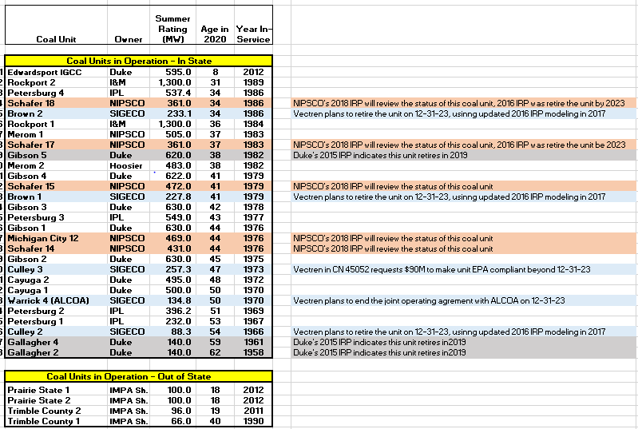

APPENDIX 3
Wind Purchased Power Agreements by Indiana’s Investor-Owned Utilities

APPENDIX 4
Solar Photovoltaic Generation Greater than 1 MW (ac)

APPENDIX 5
Renewable Resource Summary

Renewable Resource Summary with Details

APPENDIX 6
Generation by Fuel Type for Indiana Consumption

APPENDIX 7
Map of Generating Units

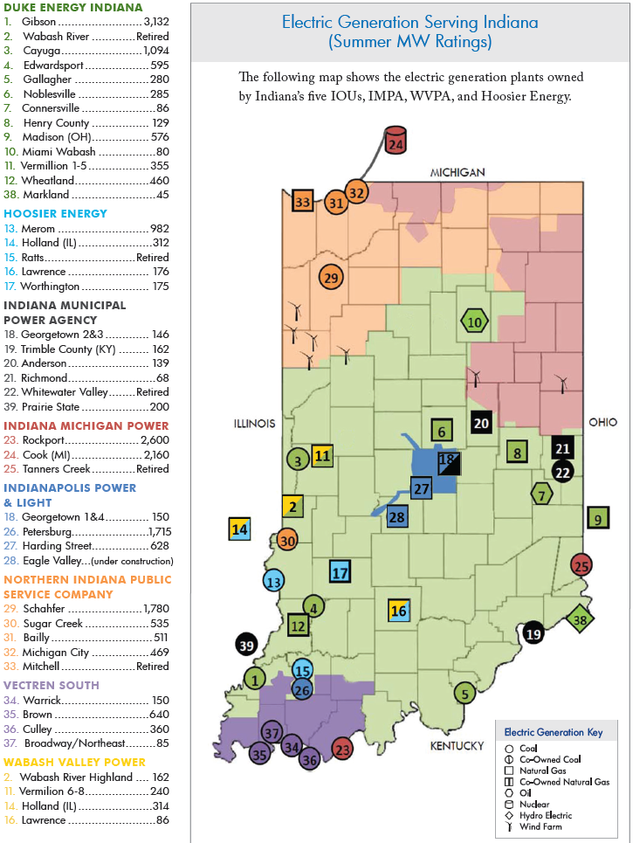

APPENDIX 8
DEFINITION OF TERMS and ACRONYMS
Base Load Generation: Traditoinally regarded as generating equipment that is normally operated to meet demand on continous bases (e.g., over a 24-hour basis). The North American Electric Reliability Corporation (NERC) characterization of Base Load: There is a distinction between baseload generation and the characteristics of generation providing reliable “baseload” power. Baseload is a term used to describe generation that falls at the bottom of the economic dispatch stack, meaning [those power plants] are the most economical to run. Coal and nuclear resources, by design, are designed for low cost O&M [operation and maintenance] and continuous operation […] However, it is not the economics nor the fuel type that make these resources attractive from a reliability perspective. Rather, these conventional steam-driven generation resources have low forced and maintenance outage hours traditionally and have low exposure to fuel supply chain issues. Therefore, “baseload” generation is not a requirement; however, having a portion of a resource fleet with high reliability characteristics, such as low forced and maintenance outage rates and low exposure to fuel supply chain issues, is one of the most fundamental necessities of a reliable BPS. These characteristics ensure that “baseload” generation is more resilient to disruptions. Staff Report to the Secretary on Electricity Markets and Reliability, Page 5, August 2017. It has been suggested that the term “baseload” generation is no longer a meaningful distinction since natural gas combined cycle facilities (NGCC), in particular, are increasingly displacing traditional large coal and nuclear generating units in economic dispatch.
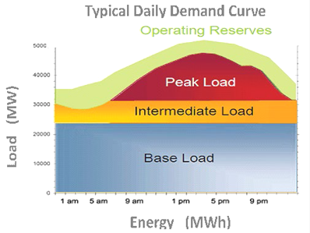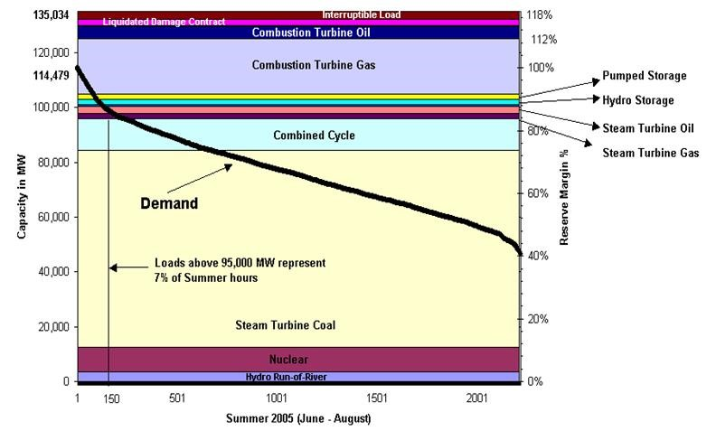
Battery Storage: Has been used as a generating resource, to support transmission, and to enhance reliability of the distribution system. That is, battery storage transcends the three segments. Batteries can facilitate integration of Distributed Energy Resources (DERs) –including solar and other renewable resources, microgrids, DSM, and future technologies.
Coincident Demand (CD): Mathematically, it is the sum of two or more demands that occur in the same time interval. Typically, used in planning resources such as generation, transmission, and demand response. So, the contribution by any entity to the RTOs / ISOs peak is that entity’s “Coincidence Factor (CF).” In regions not served by an RTOs / ISOs, the relevant peak is the contribution of each customer to their utility’s peak demand.

Coincident Peak Demand (CP): For example, in regions served by RTOs / ISOs, the relevant peak is the RTOs / ISOs peak demand rather than the peak demand of any utility or other entity. In regions not served by an RTOs / ISOs, the relevant peak is the contribution of each customer to their utility’s peak demand. For retail ratemaking CP typically refers to the utility’s peak demand since the timing of the RTO / ISO peak is difficult to predict, most Indiana utilities experience a peak that is close to the MISO’s and PJM’s peak. Therefore, Indiana utilities have a high coincidence factor with MISO and PJM.
Combined Heat & Power (CHP): A plant designed to produce both heat and electricity from a single heat source. Note: This term is being used in place of the term "cogenerator" that was used by EIA in the past. CHP better describes the facilities because some of the plants included do not produce heat and power in a sequential fashion and, as a result, do not meet the legal definition of cogeneration specified in the Public Utility Regulatory Policies Act (PURPA).
Congestion of the Transmission or Distribution Systems; Congestion: A condition that restricts the ability to add or substitute one source of electric power for another on a transmission grid or distribution system (more simply: congestion occurs when insufficient transfer capacity is available to implement all of the preferred schedules simultaneously). In regions served by RTO/ISO, this congestion is “cleared” by the use of economic price signals referred to as Locational Marginal Cost Pricing (LMP). Prior to RTO / ISOs and in areas not served by RTO / ISOs, transmission congestion is cleared by the use of “Transmission Line Loading Relief” (TLRs). TLRs, in extreme instances, curtail even firm transactions to prevent a blackout condition. Natural gas pipelines may also experience congestion.
Distributed Energy Resource (DER): DER is a resource sited close to customers that can provide all or some of their electric and power needs and can also be used by the system to either reduce customer demand or provide supply to satisfy the energy, capacity, or ancillary service needs of the distribution grid. The resources, if providing electricity or thermal energy, relatively small scale, connected to the distribution system, and close to load. Examples of different types of DER include solar photovoltaic (PV), wind, combined heat and power (CHP), energy storage, demand response (DR), electric vehicles (EVs), microgrids, and energy efficiency (EE).Note the IEEE Standard 1547 does not include Demand Response (DR) but this is a matter for policymakers. DER can provide back-up power, used to displace relatively high cost energy such as at the time of system peak demand, can stabilize the grid, firm up other resources, potentially reduce back-feed problems, and enhance power quality. Source: Grid Modernization Laboratory Consortium, U.S. Department of Energy.
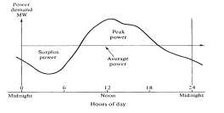
Some of the potential advantages of DER include: 1) reduced demand on system elements and peak demand which may result in a deferral of transmission and distribution upgades, 2) increase the diversity of the resource mix, 3) provides voltage and frequency support, 4) reduce line losses, 5) provides back-up power in emergencies and may provide spinning reserves and black start capabilities to help restore the system, 6) reduced emissions in heavily populated areasupgades, 2) increase the diversity of the resource mix, 3) provides voltage and frequency support, 4) reduce line losses, 5) provides back-up power in emergencies and may provide spinning reserves and black start capabilities to help restore the system, 6) reduced emissions in heavily populated areas
Diversity Factor: The electric utility system's load is made up of many individual loads that make demands upon the system usually at different times of the day. The individual loads within the customer classes follow similar usage patterns, but these classes of service place different demands upon the facilities and the system grid. The service requirements of one electrical system can differ from another by time-of-day usage, facility usage, and/or demands placed upon the system grid.
Demand Side Management (DSM): The planning, implementation, and monitoring of utility activities designed to encourage consumers to modify patterns of electricity usage, including the timing and level of electricity demand. It refers to only energy and load-shape modifying activities that are undertaken in response to utility-administered programs. It does not refer to energy and load-shaped changes arising from the normal operation of the marketplace or from government-mandated energy-efficiency standards. Demand-Side Management covers the complete range of load-shape objectives, including strategic conservation and load management, as well as strategic load growth.

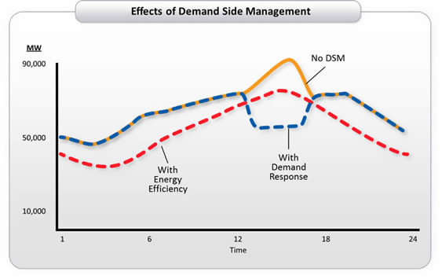
Fracking: The fracturing of rock by a pressurized liquid is Hydraulic fracturing. This is a technique in which water is mixed with sand and chemicals, and the mixture is injected at high pressure into a wellbore to create small fractures to extract oil and natural gas. Oil and Natural Gas Plays have been discovered in almost every state.
Integrated Resource Planning (IRP): The engagement in a systematic, comprehensive, and open utility / stakeholder analysis of loads and resources to enable planners and stakeholders to achieve greater optimality in the planning of a robust portfolio of resources including transmission, all forms of generation, demand-side management (including energy efficiency) and distribution planning with the aspiration of providing the lowest delivered cost of electricity.
Intermittent Resources: Sometimes referred to as Variable Resources. These are sources of power, such as wind and solar, that cannot operate continuously. These often require “back-up” or supplemental power sources to firm the supply of power.
Levelized Cost of Electricity (LCOE): The National Renewable Energy Laboratory defines LCOE as: The LCOE is the total cost of installing and operating a project expressed in dollars per kilowatt-hour of electricity generated by the system over its life. It accounts for: Installation costs; financing costs; taxes; operation and maintenance costs; salvage value; incentives; revenue requirements (for utility financing options only); and the quantity of electricity the system generates over its life. To use the LCOE for evaluating project options, it must be comparable to cost per energy values for alternative options.
Load Diversity: The difference between the peak of coincident and non-coincident demands of two or more individual loads. From a system planning perspective, diversity is the difference between the individual peak demand of a customer or customer class to the system peak demand of a utility.
Load Forecasting: This is the analytical process of estimating customer demand for electricity over a specified period of time (e.g., 1 day – 30 years) and as a basis for determining the resource requirements to satisfy customer requirements in a reliable and economic manner. Typically a utility will want to forecast maximum demand in the amount of Watts usually Megawatts (MW) or Gigawatts (GW) and energy use in Megawatt hours (MWh) or Gigawatt (GWh) hours. Forecasts that are well developed provide a higher degree of believability (confidence) and can, therefore, reduce the financial risks associated with planning resources over the forecast horizon.

Locational Marginal Cost Pricing (LMP): Determining the cost of power at any one point on the grid (including the opportunity costs created by congestion) is called location-based marginal costing. A Locational Marginal Price (LMP) is the market clearing price at a specific Commercial Pricing Node (CPNode) and is equal to the cost of supplying the next increment of load at that location. LMP values have three components for Settlement purposes: marginal energy component, marginal congestion component, and marginal loss component. The value of an LMP is the same whether a purchase or sale is made at that node.CPNode) and is equal to the cost of supplying the next increment of load at that location. LMP values have three components for Settlement purposes: marginal energy component, marginal congestion component, and marginal loss component. The value of an LMP is the same whether a purchase or sale is made at that node.
LOLE (also LOLP determination of Resource Adequacy): Used to set “Planning Reserve Margins.” LOLE is normally expressed as the number of days/year that generation resources will be insufficient to meet load. Most widely accepted level: 1 Day (or event) in 10 Years. This, like the “Loss of the Single Largest Generator” or a fixed percentage above forecasted peak demand (e.g., 15%) are all arbitrary measures for attempting to quantify the amount of capacity in excess of peak demand required to reliably serve customers.

Planning Horizon: For purposes of the IRP, utilities’ resource plans encompass 20 years. The 20 years is intended to avoid an unintentional bias of selecting lower cost resources when a more costly (capital intensive) resource might be preferable in the longer term due to offsetting costs such as lower fuel cost. Typically, utilities extend their planning horizon beyond 20 years to avoid the event horizon effect where resources that might be economically desirable for inclusion in the plan are omitted because their viability occurred just beyond the 20 years).
Planning Reserve Margin (PRM): The amount of forecast dependable resource (i.e., generation, demand-response) capacity required to meet the forecast demand for electricity and reasonable contingencies (e.g., loss of a major generating unit). “Dependable” should be used in preference to “Nameplate” because the Nameplate Rating of a resource may not be able to provide dependable capacity at the time of peak. Often established to meet a “Loss of Load Probability” (or Expectation) of one event (or day) in ten years. Typically this construct has resulted in Planning Reserve Margins of around 15% (i.e., 15% greater than the forecast peak demand). While a specified LOLP is arbitrary, it is generally regarded as a reasonable criteria.
Reserve Margin (RM): The percentage difference between rated capacity and peak load divided by peak load. Reserve Margin = [(Capacity-Demand)/Demand]. A 15 percent reserve margin is equivalent to a 13 percent capacity margin. Capacity Margin = [(Capacity-Demand)/Capacity].
Reserve Margin$=\frac{Resources-Peak Firm Demand}{Peak Firm Demand}$
Resource Adequacy (RA): Planning Coordinators such as RTOs / ISOs establish Resource Adequacy requirements (and the resulting long-term planning reserve margins for their member utilities) to ensure that sufficient resources such as electric generation, transmission, demand response, and customer-owned generation are available to allow Planning Coordinators to reliably meet its forecast requirements. For utilities in RTOs / ISOs, the allocated Reserve Margin and the estimated future prices of capacity, in turn, may be used by individual utilities in the development of their long-term Resource Plans.

Resource Diversity: In an electric system, resource diversity may be characterized as utilizing multiple resource types to meet demand. A more diversified system is intuitively expected to have increased flexibility and adaptability to: 1) mitigate risk associated with equipment design issues or common modes of failure in similar resource types, 2) address fuel price volatility, and 3) reliably mitigate instabilities caused by weather and other unforeseen system shocks. In this way, resource diversity can be considered a system-wide tool to ensure a stable and reliable supply of electricity. Resource diversity itself, however, is not a measure of reliability. Relying too heavily on any one fuel type may create a fuel security or resilience issue because the level of resource mix diversity does not correlate directly with a resource portfolio’s ability to provide sufficient generator reliability attributes. However, fuel and resource diversity are closely related. Resource diversity entails with more detailed information about the operational characteristics of each resource. Resource diversity is also related to load diversity. The value of resource diversity can change dramatically due to changes in the capital cost of different resources, the profitability of different resources in the dispatch, the of capital costs associated with alternative resources, and the dynamics of the pricing and projected prices of different fuels.
Security Constrained Economic Dispatch (SCED): When congestion occurs, least-cost generation often must be passed over for purposes of system security. For this reason, this market model – where the system operator acts as a clearing agent and manager of system security – is called bid-based, security-constrained economic dispatch.

ACRONYMS
AC Alternating Current
ASM Ancillary Services Market
CO₂ Carbon Dioxide
CCR Coal Combustion Residuals Rule
CPCN Certificate of Public Convenience and Necessity
CAA Clean Air Act (CAA)
CAAA Clean Air Act Amendments
CPP Clean Power Plan Power Plan
CF Coincidence Factor
CP Coincident Peak Demand (see also non-coincident peak demand)
CHP Combined Heat & Power
CC Combined Cycle generator
CS Community Solar
CPV Concentrating Photovoltaic
CSP Concentrating Solar Power
kW, MW, GW kilowatts, megawatts, and gigawatts
DR Demand Response
DSM Demand-Side Management
DER Distributed Energy Resources
ED Economic Dispatch
ELG Effluent Limitation Guidelines
kWh, MWh, GWh kilowatt hours, megawatt hours, gigawatt
EE Energy Efficiency Efficiency
EPA Environmental Protection Agency Protection Agency
EUR Estimated Ultimate Recovery of natural gas or oil
FERC Federal Energy Regulatory Commission
FGD Flue-Gas Desulfurization
ITC Investment Tax Credit
LRZ Local Resource Zones (part of MISO’s reliability construct)
LMP Locational Marginal Cost Pricing
LOLE Loss of Load Expectation
LOLP Loss of Load Probability
MPS Market Potential Studies
MATS Mercury and Toxic Standard
MTEP MISO’s Transmission Expansion Plan
MVP MISO’s Multi-Value Transmission Projects
NOx Nitrogen Oxide
NERC North American Electric Reliability Corporation
O&M Operations & Maintenance Costs
PRM Planning Reserve Margin
PPA Power Purchase Agreements
PVRR Present Value of Revenue Requirements
PTC Production Tax Credit
RTP Real Time Pricing
RTOs Regional Transmission Organizations (also Independent System Operators)
RPS Renewable Portfolio Standards
RM Reserve Margin
RA Resource Adequacy
RTEP Regional Transmission Expansion Plan (PJM)
SCED Security Constrained Economic Dispatch
SOx, SO₂, SO₃ Sulfur Oxides

IRPs are discussed in more detail on page 3. IRPs are submitted by Indiana’s eight largest electric utilities on a staggered three year cycle. IRPs comprehensively evaluate a broad range of feasible and economically viable resource alternatives over at least a 20 year planning period to assure electric power will be delivered to their customers at the lowest cost reasonably possible while providing safe and reliable service. Indiana utilities utilize state-of-the-art analysis and work with their stakeholders to develop credible Integrated Resource Plans (IRPs).
Fracking is the fracturing of rock by a pressurized liquid. Hydraulic fracturing is a technique in which typically water is mixed with sand and chemicals, and the mixture is injected at high pressure into a wellbore to create small fractures to extract oil and natural gas. Oil and Natural Gas Plays have been discovered in almost every state.
It is important to note that the IRP process typically takes more than one year to complete. In addition to obtaining a full year of data (i.e., the 2017 IRPs rely primarily on 2016 data) the stakeholder process entails a significant time commitment. The Commission considers a robust stakeholder process essential to understanding and expediting cases by narrowing a number of contentious issues.
FirstEnergy Solutions Corp (FES) filed for bankruptcy March 31, 2018 due to the dramatic changes in fuel prices, low load growth, increasing penetration of renewables. The bankruptcy protection was filed two days after asking the DOE to invoke an emergency declaration that would direct the PJM Interconnection to ensure full cost recovery for FES's at-risk coal and nuclear plants in the region and after FES notified the PJM it will retire its three nuclear plants next two to three years. FES President and board chairman Donald Schneider said: The significant increase in the availability of cheap natural gas due to fracking has given gas-fired generation an advantage. This has had a profound impact on companies that rely on coal and nuclear power. In addition to increased gas-fired output, the economic downturn of 2008 and 2009, improvements in energy efficiency, and more renewable generation have continued to place downward pressure on electricity prices and the value of certain generation resources such as coal burning and nuclear-generating units. He also said tougher emissions rules for coal-burning plants and the removal of federal restrictions on natural gas usage have undermined the coal and nuclear-generating fleets (emphasis added) (SNL April 2, 2018).
CNN (November 1, 2017) Armstrong Energy – filed for bankruptcy in October 2017; Business Insider (December 6, 2016) cited: Peabody Coal – March 2018 (court approved restructuring plan) for a bankruptcy that was filed in April 2016; Arch Coal – January 2018; Alpha Natural Resources – August 2015 (emerged from bankruptcy in July 2016); Patriot Coal (after losing money each year from 2010) – July 9, 2012 (the company filed for bankruptcy after recording $198.5 million in losses); James River Coal first filed for bankruptcy in 2004 and again on April 8, 2017 (James River was forced to close a dozen of its mines due to poor market conditions).
Reliance on Regulatory Effects and Electric Power Systems Research - Abstract, Sandia Laboratories, February 2017.
The FERC, in response to the DOE’s NOPR on resilience offered that resilience means the “ability to withstand and reduce the magnitude and/or duration of disruptive events, which includes the capability to anticipate, absorb, adapt to and/or rapidly recover from such an event.” Most, however, recognize that this definition is not distinct from the definition of reliability.
A FIT is a policy tool designed to encourage the development of renewable electricity generation by typically offering above market prices for output as well as the assurance that the utility will purchase the output. FITs are typically designed for small-scale renewable energy technologies that use solar, wind, and/or biomass.
SNL, April 25, 2018.
Prior to RTOs individual utilities were responsible for meeting their Resource Adequacy (RA includes adequate resources to meet expected needs and a reserve margin (RM) above the expected needs in the event of a contingency such as an unexpected outage at a large power plant). Reserve margins in excess of 20% were typical. The amount of reserve margins were based on a rule of thumb rather than rigorous analysis. With RTOs, the RA was based primarily on more rigorous mathmatical calcuations for the entire region. Setting RA for a large region afforded greater resource, fuel, and load diversity than was achievable by individual utilities. This reduced need for capacity due to RTO operations, results in savings for utilities and their customers. Generation resources located in the MISO region currently exceed the target level of RA. The current level of resources reflects the resource decisions made by the MISO market participants. These decisions are in reponse to a wide range of market forces and operational decisions besides the target level of RA set by the MISO on an annual basis.

