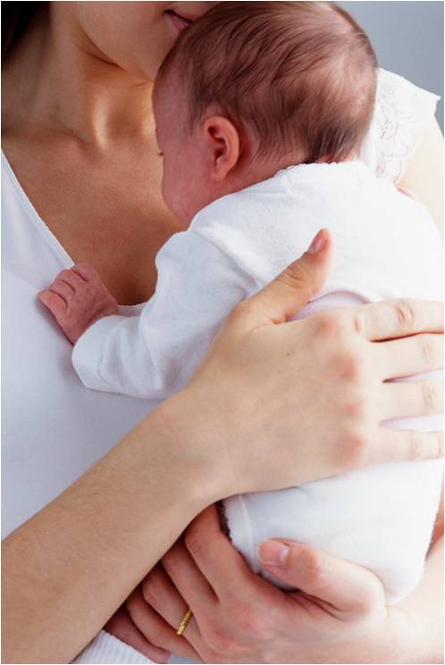
You and your doctor are a team working to get you and your baby as healthy as possible. So, when your doctor asks you what substances you are taking, share everything you are using. Your doctor will know how to help you decide what to do next. Your doctor may test you so that both you and your baby can receive the best care.
Substance Use During Pregnancy: How to Have a Healthier Baby

Almost every substance passes from the mother’s blood stream to the baby during pregnancy. Drugs that you take regularly may cause your baby to be born physically dependent on the substance you are using and experience withdrawal symptoms after birth.

What substances should I be worried about?
There are some substances that we know are addictive. Some substances may be risky during pregnancy – and can cause problems for both you and your baby if used:
- Alcohol: When you drink alcohol, so does your baby. No amount of alcohol is safe for baby during pregnancy and can result in lasting birth defects. Stop drinking as soon as you know you are pregnant.
- Tobacco: Smoking during pregnancy increases your chance of miscarriage, stillbirth, and preterm labor. As a result of the nicotine and toxins contained in tobacco, your baby is more likely to be born too small and has an increased risk of Sudden Infant Death Syndrome (SIDS).
- E-Cigarettes: Electronic smoking devices, including “e-cigs,” “vape pens,” and “hookah pens,” are designed to deliver nicotine without burning tobacco. These products are not recommended for quitting smoking. These products contains nicotine and toxin that are known to cause cancer.
- Marijuana: This drug increases your chance of preterm labor. It also puts your baby at risk for learning problems later in life.
- Opioids: (street drugs like heroin; prescription pain medications like codeine, morphine, methadone, Vicodin, Percocet, Oxycontin, Demerol, Suboxone, Subutex) Opioids are linked to increased risk of miscarriage and premature birth. Babies exposed to opioids may be smaller than normal and have learning and behavior problems. They may also go through withdrawal immediately after birth or in the first few weeks of life.
- Benzodiazepines: (prescription medications for anxiety and seizures, and sleeping pills, such as Xanax, Valium, Klonopin, Ativan) If you take this drug during pregnancy, your baby may go through withdrawal after birth.
- Barbiturates: Prescription medications used mainly for seizure control called Phenobarbital, Seconal, or Fioricet.
- Prescription medications: Drugs used to treat depression and anxiety, such as Prozac, Zoloft, etc.) Ask your doctor which medication is safest to use in pregnancy.
- Cocaine and crack: Taken during pregnancy, cocaine increases the risk of life-threatening problems for you and your baby. You can have seizures and breathing problems. Your pregnancy can end in miscarriage. Your baby may have an increased risk of birth defects, premature birth, and SIDS.
- Amphetamines: (street drugs like ecstasy and meth; prescription medications for ADD and ADHD such as Adderall, Ritalin, and Concerta). Babies exposed to these drugs may have learning and memory problems.
- Inhalants: Huffing puts you at risk for seizures, coma, and life-threatening breathing problems. It puts your baby at risk for birth defects, low birth weight, and learning problems.
- Hallucinogens: (PCP, LSD, Shrooms). Exposure to this type of drug may cause your baby to go through withdrawal after birth. It also increases the risk of learning, emotional, and behavior problems in your child.

What do I do if I’m using any of these substances?
The first thing to do is tell your doctor what you are using. That way, the doctor can work with you to come up with the safest plan for you and your baby, both during pregnancy and when your baby is born. If your doctor has prescribed something for you, make sure the doctor knows you are pregnant.

DO NOT stop taking illegal drugs or prescription medications without talking to your doctor. Stopping some substances suddenly can be more harmful than gradually reducing use or replacing the substance with something healthier for your pregnancy. Your doctor will help you decide.

If you are using tobacco, you can call the Indiana Tobacco Quitline at 800-784-8669 to get free help quitting.

Will my baby be born addicted?
Due to medications or substances that you have been taking during your pregnancy, your baby is at higher risk for being born physically dependent on the substance and experience withdrawal symptoms (also called neonatal abstinence syndrome or NAS).

How will withdrawal affect my baby and what can be done?
Babies may go through withdrawal after being born because they are no longer exposed to a substance. Withdrawal symptoms can vary from mild to severe. Immediately following birth up to 4-5 days later, a baby suffering from withdrawal can start showing symptoms like:
- Seizures and shaking;
- Constant crying that can’t be comforted;
- Trouble eating and sleeping;
- Frequent spit up;
- Upset stomach and diarrhea;
- Fever; and
- Trouble growing and gaining weight.

If your doctor thinks that your baby might be physically dependent and have withdrawal symptoms, your baby may need to be cared for in the hospital longer with special care and monitoring. The medical staff know how to comfort and help babies in withdrawal and will show you how to comfort your baby when your baby is ready to come home.
Indiana Perinatal Quality Improvement Collaborative

How do I stay as healthy as possible?
- See your doctor for regular prenatal care. Start early and go to all of your appointments.
- Do not quit any substance suddenly. Talk to your doctor.
- Consider a treatment program if you are not already in one. Your doctor’s office can help with this.
- Always talk to your doctor about drugs or prescribed medicines you take during pregnancy.
- Make healthy choices for you and your baby.
- Before your baby is born, choose a pediatrician or family doctor for follow-up after hospital discharge. Your baby may need special help so let your baby’s doctor know that you have used substances that may cause withdrawal symptoms for baby.

For more support and information:
- Indiana Family HelpLine or Your Local 211: Call 855-435-7178 or 211 for help finding a doctor or other services you need.
- The MothertoBaby phone line: 866-626-6847 Call this number to get immediate, free advice about the safety of any substance during pregnancy or breastfeeding.
- Substance Abuse and Mental Health Services Administration: 1-800-662-HELP (English, Spanish) www.findtreatment.samhsa.gov
Call or access this service to locate treatment programs (mental health, drug, alcohol) in your area.
- For nutrition help contact the Purdue Extension Service about the Have a Healthy Baby (HHB) program. 1-888-EXT-INFO (1-888-398-4636).

