

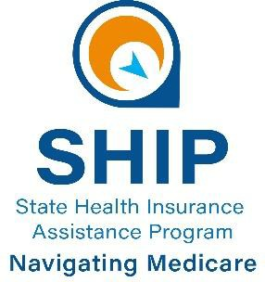

HEA 1260:
“Medigap Birthday Rule”
Fact Sheet

OVERVIEW

In previous years, those with Medicare Supplement (Medigap) policies were not guaranteed enrollment into a new policy without medical underwriting or only under specific scenario-based special circumstances.

- As of 1/1/26, Indiana law HEA 1226 (2025) went into effect. This may also be known more commonly as the Indiana Medigap Birthday Rule.
- Recent amendments were made to this law in the 2026 session of the general assembly, and the below regulations apply to a Medicare supplement policy or certificate delivered, issued, or renewed on or after March 15, 2026 (HEA 1260).
- Who does this effect? HEA 1226 (2025) allows those age 65 or older and currently enrolled into a Medigap policy the guaranteed right to change their policy from one carrier to another---without denial or medical underwriting. This is NOT an opportunity to join a Medicare Supplement with guaranteed rights, if you are not currently enrolled into one.
- How does it work? Those currently enrolled into a Medicare Supplement plan will be guaranteed enrollment into the SAME lettered plan but from a new insurance carrier. Example: Someone could go from a “Plan G” from Company 1 to a “Plan G” at Company 2. This does not allow guaranteed enrollment into a different lettered plan such as from Plan F to Plan G.
- When can you do this? An individual is able to use HEA 1260 as their right to change plans, guaranteed, during the period beginning one (1) month before the applicant's birthday and ending one (1) month after the applicant's birthday, EACH year.
- When does the new plan begin? Per HEA 1260, the new plan will start the 1st day of the next month after the signature date on the application for the Medicare supplement policy or certificate. Example: If you apply on June 15th, the new plan will begin July 1st.
- More information? To enroll into a new policy, contact the insurance carrier or a trusted insurance agent or broker. To discuss your rights to utilize this enrollment or for additional clarification, contact the State Health Insurance Assistance Program at 1-800-452-4800.

