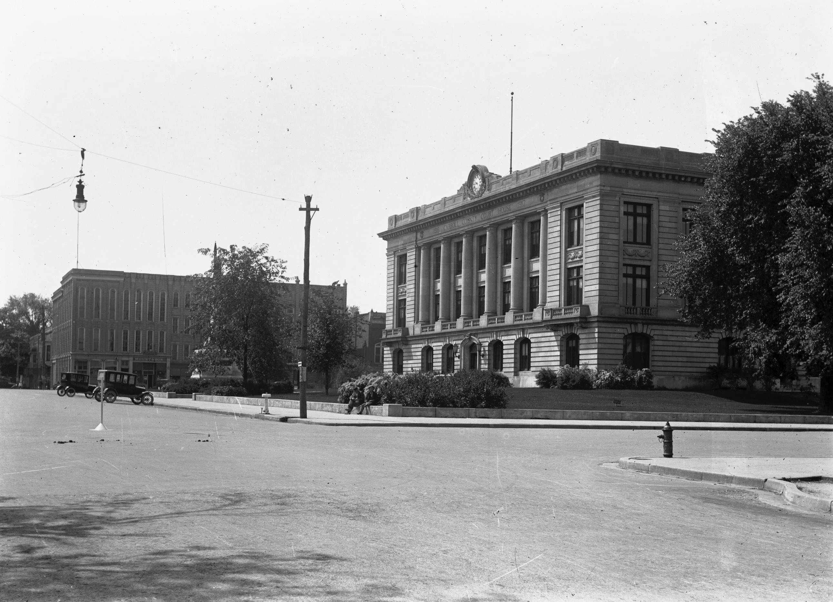

DEATH CERTIFICATE APPLICATION
WARNING: False application, altering, mutilating or counterfeiting an Indiana Birth Certificate is a criminal offense under I.C. 16-1-19-6.
NO DEATH CERTIFICATE WILL BE ISSUED WITHOUT PROPER IDENTIFICATION
CASH, CHECK or MONEY ORDER (made out to Carroll County Health Treasurer) for $15.00 per certified Death Certificate. For Genealogy purposes only it is $2.50.

You must have a signed form of identification. If submitting it by mail, you must send a photocopy of your Driver’s License.

DECEASED NAME: ____________________ __________________ ____________________/__________________
First Middle Last (Maiden)
DATE OF DEATH: _______/_______/_______ DIED IN _____________________________________________________
City or County
FATHER: _______________________________________________________ BIRTHPLACE: ____________
First Middle Last State
MOTHER: ______________________________________________________ BIRTHPLACE: ____________
First Middle Maiden State
Certified Death Certificates are issued to the individual named above (if over 18), their parents, grandparents, siblings, spouse, children or guardian.
TODAY’S DATE: ______/______/______ CONTACT TELEPHONE NUMBER: (______) __________________

RELATIONSHIP TO ABOVE PERSON:
Spouse: ____ Parent: ____ Grandparent: ____ Brother/Sister: ____ Son/Daughter: ____ Grandchild: ____ Sibling: ____
Aunt/Uncle: ____ Adult Niece/Nephew: ____ OR
Assigned Funeral Home/Director (must provide explanation of direct interest on letterhead): ____
Legal Interest (Must provide proof of legal relationship, i.e. contract, agreements, titles, court order): ____
Genealogy – Individual named on the certificate must be over 75 years old: ____

PRINT NAME: _______________________________ SIGNATURE: ________________________________________
ADDRESS: ______________________________________ ________________________ _______ ___________
Street City State Zip Code
OFFICE USE ONLY:
DRIVER’S LICENSE NUMBER: _________________________ OTHER FORM OF ID: __________________________

Dr. Samuel Anderson-Been
Health Officer

* If you are requesting for genealogy purposes, our records started in 1882.
* The information we have may not be complete or accurate as we have only that which was recorded from many years ago.
* The Vital Records in the State of Indiana began in 1907.

