Monroe County Community Health Improvement Plan (CHIP)
Substance Use and Mental Health main group
Date: 4.26.2023
Time: 12n-1p
Location: IU Health Community Health and Microsoft Teams
Facilitator: Melanie Vehslage
Notes: Melanie Vehslage and Lori Terrell

Attending in person: Lori Terrell – Family Vitality at IU Health, Steve Coover – Deputy Chief-CRR at Monroe Fire Protection District, Avery Thomas – Intern at Monroe County Health Department (MCHD), Melanie Vehslage – Sr. Community Health Specialist at MCHD
Attending online: Lindsay Potts – Director of Behavioral Health at IU Health, Shelby Wood – Bloomington Fire Department (BFD) Mobile Integrated Health (MIH) , Trisha Rademachir – BFD MIH, Lily Blackwell – BFD MIH, Aubrey Seader – Liaison for FindHelp/HelpingBloomingtonMonroe site at Community and Family Resources Department (CFRD) City of Bloomington (CoB), Kathy Hewett – Population Health and Outreach Manager at MCHD, Jackie Trueblood - Centerstone, Mallory Swanson – Social Worker at Bloomington Police Department, Margie Rice – local attorney, Amy Minix – IU Libraries, Tonda Radewan – Housing Evection Prevention Project & Human Rights Commission
Facilitating: Melanie Vehslage
Notes: Melanie and Lori Terrell
- Introductions/Agenda Review
  - Reminder that in addition to being uploaded to MCHD website, Melanie is working to ensure all Notes/Agenda items are also uploaded to the IU Health Teams application for another access point for members of this group. Let Melanie know if anything is missing online, any corrections to notes etc.
- Review Action Items from last meeting
  - Update Provider List
    - Thanks to anybody who has already added to the list.
    - When looking at what has been filled out on the providers list, some programs are not squarely in substance use or mental health category
      - For the purposes of this CHIP project, we want to make sure that this list is something that fits within our goal to get more SUMH programs taking Medicaid and Medicare on Find Help site.
  - Reach out to Ody/Melanie for questions about TASC mapping process as a part of the Connections sub-committee
  - Email llmeuser@me.com to be on email list for upcoming CARES lunch and learns.
  - Reach out to Steve Coover scoover@monroefd.org re: gun locks, med disposal
      - Success seen in Healthapalooza; expired med disposal was very popular – won’t wait for a pilot and can move forward on expanding related outreach within 6 months.
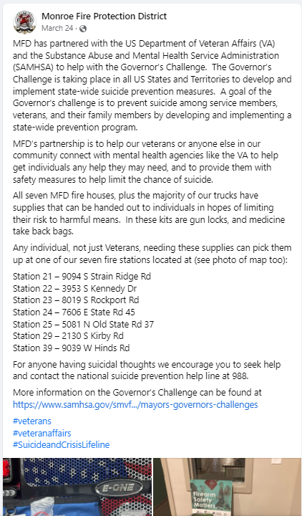
      - Med disposal packets are often easier than having to wait for a medication takeback day – MFD has been working with VA to ensure they are in county fire stations (map of Monroe Fire Protection District stations here)
      - Q: would he be able to add to HBM? A: Yes, this could be listed as covering SUMH
      - To Do: put contact information in Findhelp Provider list to funnel to Aubrey
      - Q: Would like to get out to providers; how can folks connect this service with providers: A: Email Steve at scoover@monroefd.org
      - Q: Can the med disposal packets be placed at providers offices? Right now just distributed through fire
        - To Do: Steve can ask about how to expand the service to other places in the community
      - See <- for Facebook post from MFPD to with info to share regarding gun locks and med take back bags

- CAPS Commission – stakeholder meeting held 4/11
  - Well attended; work will be ongoing
  - Link to large group sessions here (breakout rooms were not recorded)
  - CAPS is continuing to host stakeholder interviews, for those interested in learning more, can reach out or attend a meeting as seen on CAPS landing page on City’s website
Subcommittee Report outs
  - Resources – (See Review of Action items with above updates on Provider List )
  - Collaboration -Melanie Vehslage
    - Report on work
      - Starting process of interviewing people in Monroe County as a part of the TASC project in partnership with Purdue Extension. Looking to make a map of recovery supports, providers, and pathways in Monroe County to better identify gaps, areas that need strengthening, areas that are already strong.
    - Input/Advise from the team
    - Next steps
      - If you’re unable to attend the meetings but would like to participate, we could use you as an interviewer, as a person to help with distilling information down into the actual map, or as a person to be interviewed. Let Melanie/Ody know if you are interested in participating.
- General Updates
  - Melanie – Monroe County Health Department
    - Harm Reduction Community Health Educator position now vacant – has been posted on MCHD Facebook and Twitter; please share widely
      - HR CHS Job posting
      - Benefits brief
      - Insurance options
    - Opioid Settlement Match funding – expected to hear back 5/1. If funded will have expansion on training and distribution of naloxone downtown, expanding SSP, partnering with STRIDE to increase services and ability to provide transportation with ED/jail and generally expand overdose prevention projects in Monroe County
- Shelby Wood – Mobile Integrated Health program is now fully staffed
  - Program is governed by IDHS (more info here)
  - Staff all have to become certified community health workers and all are EMTs
- Margie – County Council will be forming a committee around financial issues around community justice reform (BSquare article here). Will be discussing further at May 9th meeting (also see link to recording on CATS) that will form a committee; might have people from outside the county as a part of the committee. Cheryl Munson and Peter Iversen are knowledgeable – if we can be helpful to them, might be a good way to leverage the work we are doing during budget requests for 2024.
  - Q: is there a deadline for budget requests? A: Will have hearings in the summer and accept the budget in the fall, so we have some time to produce recommendations.
  - Note to consider health levy to give MCHD more $ - if expanded it can affect other levy’s like general fund; may also consider how to leverage ARPA, general fund dollars, or money from governors order (TBD) as mental health will be a core requirement
  - Can send suggestions sent to Council and encourage development of interlocal team to work together on things, such as MCHD, jail, School of Public Health etc. to evolve and make more resources.
- Aubrey – Charles in CFRD had a collaboration with Centerstone to put on Mental health and suicide prevention training (QPR) training last week with turnout from across sectors.
  - Mental Health First Aid training in month of May will be entirely virtual.
  - Full 4 hour will be in June for MHFA and QPR – connect to Aubrey.
  - One of the great things about these trainings is getting an idea of what STRIDE and Mobile Rapid Response with MHFA can do, and how to use those services as a provider or community member, depending on a particular mental health condition.
  - (see email attachment for MHFA fliers and info on Centerstone STRIDE and Mobile Rapid Response)
- Jackie – looking into bringing Laura Stack from Johnny’s Ambassador’s to talk about high potency THC, delta 8 etc. and the impact on teens and mental health.
  - Laura is presenting in Indianapolis on June 29th in a breakout session at the National Association of School Resource Officers (see breakout descriptions).
  - Interested in booking Laura at Buskirk Chumley Theatre (BCT) for parents and families and is looking for connections with the BCT and advice on how to get the word out.
  - Lori just put on ‘The Addict’s Wake’ - has contact info. BCT have a lot of suggestions about what would be good or bad on campus to figure out when to schedule.
- Anything we need to change before next meeting?
- Action items?
  - No major action items, bring any SUMH related updates for the good of the group to next meeting
  - Review Provider List and add info/suggestions for additional Medicaid/Medicare SUMH providers
  - Review work in Connections Sub-Committee and reach out to Ody/Melanie with questions on how to participate if you cannot attend a meeting.
- Wrap Up – Next meeting May 24th 12-1 at IU Health Community Health and via Teams

