Monroe County CHIP – SUMH Connections Sub-Committee
Date: 4.19.2023
Time: 1-2 pm
Location: Zoom
Facilitators: Melanie Vehslage and Ody Ekwonwa
Notes: Melanie Vehslage

Present: Melanie Vehslage – Sr. Community Health Specialist, Monroe County Health Department (MCHD); Steve Coover – Deputy Chief Risk Reduction, Monroe Fire Protection District; Ody Ekwonwa – Health and Human Services Extension Educator, Purdue Extension; Lori Terrell – Clinic Manager, IU Health Family Vitality Initiative; Lee McKinley – IU School of Medicine and IU Hospice volunteer; Tonda Radewan Housing and Eviction Prevention Project, Serina, case worker - Perry Township, Anthony Williams – Adult Intake Supervisor & Alcohol/Drug Director, Circuit Court Probation; Raine O’day – Program Manager, STRIDE Center; Maci Valdez – Region 6 Prevention Coordinator DMHA, Kathy Hewett – Population Health and Outreach Manager, MCHD; Aubrey Seader - Offdice Manager and Program Assistant, Community and Family Resources Department; Lori Kelley – Administrator, MCHD
- Welcome and Introductions
- Review CHIP Timeline and projects
  - SUMH Timeline
    - Would like to have an initial plan drafted by June 2023
    - Timeline can be living document, but need a starting draft to move CHIP groups through first quarter 2025
  - Helping Bloomington Monroe Provider List
    - If you think you have a provider that should be on FindHelp that is not already there, so long as it does free/reduced cost or Medicare or Medicaid either add to Helping Bloomington Monroe Provider List or contact Aubrey directly
    - Q: Would we be looking at other from other counties?
      - A: For the purposes of this project, only looking for providers serving Monroe County
      - HBM is primarily to serve folks in Monroe County and since it’s the Monroe County Community Health Improvement Plan (CHIP) we are looking specifically to improve resources in Monroe County
      - If it is a service that is located outside of Monroe but serves folks in Monroe, that would count
- TASC
  - To Do: Please fill out demographic info survey each meeting for Purdue Extension’s programing purposes as TASC mapping is a Purdue Extension program/metehod pilot in partnership with our CHIP
  - Growing the Coalition handout
    - Are there additional people/groups that should be invited to attend that are not here right now?
  - To Do: Add any names/roles/agencies that should be invited to participate in meetings with this group) to Table 2 on the Growing the Coalition handout
    - Please do not put names/contact information for people with lived experience to protect their privacy. If you are unsure if you should put a name or contact, err on the side of being more general by using a category identifier.
    - If you do not have a relationship with the provider/individual, you can still jot their name/job title on the list of folks to reach out to. It’s possible someone else in this group could have a relationship with them and would be willing/able to invite to an upcoming meeting
    - If you are just going to interview a person and not invite them to meetings, use the Interview Sign up
  - Review ROSC mapping Model (see images below)
    - The goal is to take information we gather and map organizations/resources that exist so service providers can engage better on behalf of clients while identifying gaps or areas to strengthen
      - There is potential for this project to provide another set of evidence that would support requests for grants or other funding sources
    - Last meeting we talked about different maps – we are looking to build a complex adaptive systems (CAS) map versus a hub and spoke model. See below a simplified version of a CAS map and an example map from another pilot county, Tippecanoe
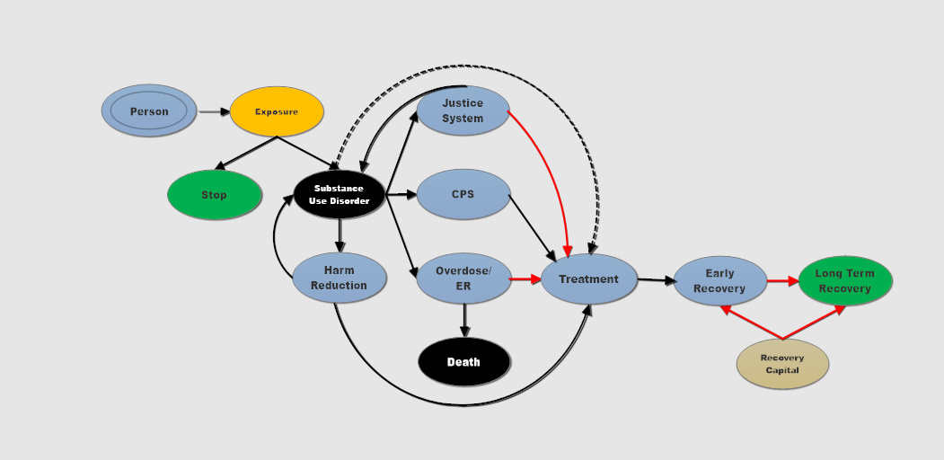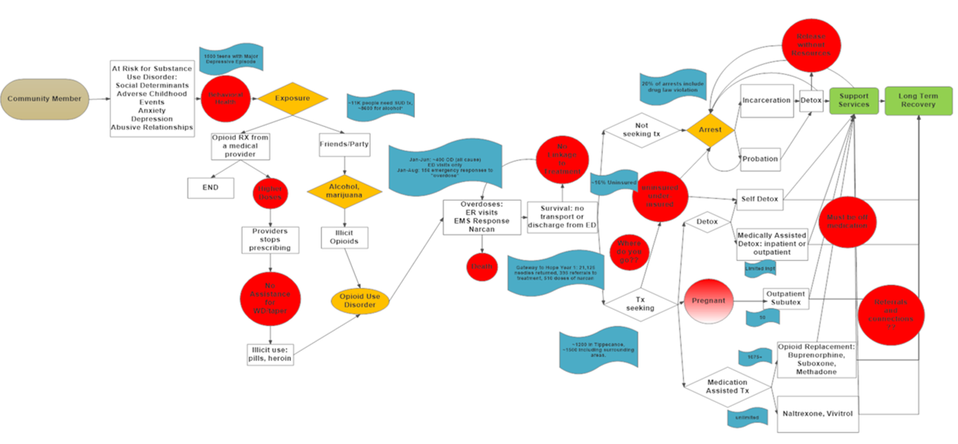
    - Different arrows can be utilized to show different types of connections – solid black line = strong connection, dotted lines = connections that exist but need strengthening, red line = no connection exists (but a connection is needed)
  - Description of creating the map
    - The way we are going to make the map is by conducting interviews with both service providers and people who have used substances, to help us better map out our recovery system, which includes social determinants of health/recovery capital that support a person’s recovery journey.
    - Health Assessments like the Monroe County CHA (or others internal to your agency) can supplement the map, but interviews remain essential to the process
    - Interviews should be anonymous (but categorized as type of service provider, person in non-abstinence based recovery, person in abstinence based recovery, friend of person, family member of person who passed away etc.)
    - People in this room can be interviewed. An interview is preferable over us as individuals writing an essay/sticky notes about our own experiences – sometimes other people listening could pick up on something we do not
    - Goal for interviewing people with lived experience/non-providers: At very minimum, the TASC creators suggest that we interview 2 people, but would prefer more to ensure a map that is reflective of people moving through the system, not just providers
    - When reviewing interview notes, try to keep key points on sticky notes at 3-5 words.
      - Example: During an interview, the individual describes how they went to the ER to get into treatment. The hospital helped them detox and then discharged them with a list of recovery facilities. The person tried calling a few recovery facilities and was told they could be put on the waitlist. One facility had space but the person had no ride. Not knowing where to go, they call their dealer for a ride. How would you break this down into sticky notes?
        - No PCP
        - Need a referral for treatment
        - No transportation to treatment center
        - Had a death in the family
        - Discharged with only a list of treatment options
        - Admitted to detox
        - Went to ER for treatment
  - Interview Resources
    - Interview Guide for Professionals
    - Interview Guide for person in recovery or family member
    - Jamboard to organize notes
  - This is a pilot project created by researchers in partnership with Purdue Extension, so if there are questions, let us know so we can relay to project developers for Monroe and other counties’ benefit
    - Q: Can we interview people outside of Monroe?
      - Needs to be someone with touchpoints in Monroe County, if they used to live in Monroe and used substances, recovery resources, were incarcerated here etc.. Stories of folks outside the county are important in general, but similar to HBM we are trying to map our local services and systems.
    - Q: would it be beneficial to provide historical information? Thinking of people to whom we have provided services in the past
      - A: If you/the person being interviewed has secondhand knowledge of historical information, so long as it relates to Monroe County, it is valid.
      - For example, Person X work[ed] with clients who have told their stories about challenges experienced getting the resources they needed, Person X could be interviewed as a service provider to recount the historical information described by their clients, so long as those experiences were reflective of touchpoints in Monroe County
- To Do Moving Forward:
  - Even if not attending the meetings, if you’re reading these notes, you can still participate by inviting or conducting an interview
  - Review SUMH Timeline
    - What needs to be added? What is irrelevant? Does this timeline reflect your understanding of how the projects can be measured moving forward?
    - Draft due June 2023.
  - Use Growing the Coalition handout to indicate at least one person to invite to May 17th Connections Subcommittee meeting (and then invite them )
  - Use the Interview Sign-Up to identify which category of person/agency you will interview before the May 17th Connections meeting
  - Interview at least one person by May 17th (can be another person who attends these Connections meetings) using the interview guide based on
    - Interview Guide for Professionals
    - Interview Guide for person in recovery or family member
  - Save your notes from the anonymous but categorized interview. Utilize paper or digital Jamboard to organize notes from interview
    - Suggested categories are pre-loaded and color coded in the Jamboard
      - Contacts/touchpoints
      - Barriers
      - Gaps
      - Enablers (resources that help a person reach their goal)
  - If there are questions about the process either before doing an interview or after, email Melanie and/or bring them to the next meeting to discuss/problem solve as a group
- Next meeting
  - May 17th 1-2pm
  - Hybrid
    - Same Zoom link
    - Option to join in person in room 2A at the downtown Bloomington Monroe County Public Library
  - In meeting goals:
    - Start reviewing categories/themes that come out of our interviews
    - Identify questions/problems/barriers in the process
    - Initiate the process again, inviting other relevant community members to participate and/or interviewing at least one more person before the following meeting in June.

