October 13, 2022
Monroe County Public Library, Meeting Room 2A & on Zoom, 3:30-4:30pm
Attendees:
In Person:
Zoom:
Facilitators:
Notes:

- Welcome & Introductions
- Agreements
  - Respectful
  - Ask with curiosity
- Reviewing affinity diagram (control vs no control, knowledge vs no knowledge) from September meeting
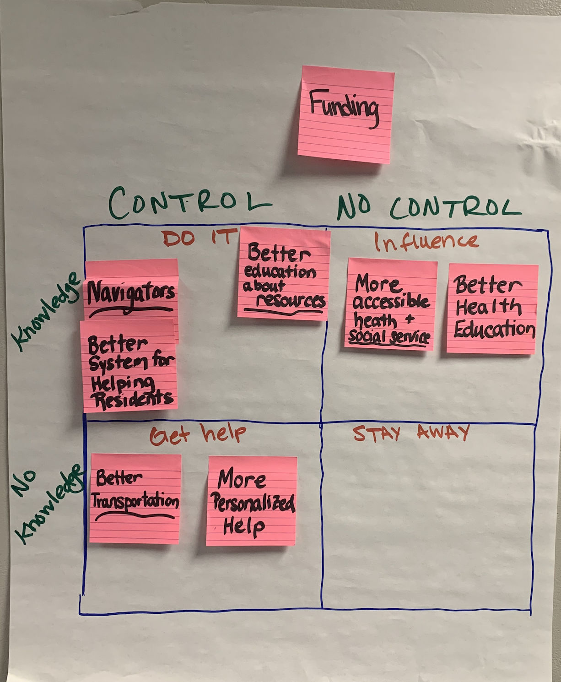

- Identifying strategies for actionable items
Link for live table : https://docs.google.com/document/d/1VPPse3Ch2UYDyqt7KKDVEPSjl8PD9w7anpXL8Zog3oM/edit?usp=sharing

Opportunity | Strategies | Who Can Help?  Me / Who is Missing? | Next Steps
Funding | (control & knowledge - do it)
Navigators / Better System for Helping Residents | (control & knowledge - do it)
Better Education About Resources | (control & knowledge - do it)
More Accessible Health & Social Services | (knowledge & no control – influence)
Better Health Education | (knowledge & no control – influence)
Better Transportation | (control & no knowledge – get help)
More Personalized Help | (control & no knowledge – get help)

- Defining success of outcomes

