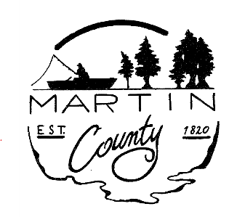

MEMBERS

Warren D. Albright
President
At Large
Term: 1/1/25 – 12/31/2028

Monty Gregory
Vice-President
District 3
Term: 1/1/2023 - 12/31/2026

Jordan Berry
District 1
Term: 12/11/2024 - 12/31/2026

Jim Hamby
District 2
Term: 1/1/2023 – 12/31/2026

Sheri Bowling
District 4
Term: 4/25/2024 – 12/31/2026

Gerald D. Montgomery
At Large
Term: 1/1/2025 – 12/31/2028

Jim Woody
At Large
Term: 1/1/2025 – 12/31/2028

TO: Council Members & Petitioners
FROM: Michelle Norris
DATE: September 11, 2025
RE: Council Meeting Agenda for September 15,2025
Time/Location: 6:30 p.m. Commissioners’ Room, Martin County Courthouse

Council Meeting Link
Dial In: 312 626 6799
Meeting ID: 894 9992 0094
Passcode: 654178

Opening Public Hearing 2026 Budget President Warren Albright

Reading of Notice to Taxpayers for Martin County

Reading of Notice to Taxpayers for Martin County Solid Waste

Close Public Hearing 2026 Budget

Open Regular Session

Minutes of August 4th Regular Meeting &

August 4th Department Budget Workshop

LIT Changes 2027 Loogootee Public Library
Director Darla Wagler

Review of Estimated Property Tax Levy Limits
And Estimated Reductions due to Circuit Breakers Auditor Michelle Norris

Transfer Request- Commissioners Budget
From: 1000.068.3000.61 Cyber Security Contract
To: 1000.068.4000.15 Equipment/Furniture

Fund Transfer Request- $140.19
From Fund: 1238 Unrestricted Opioid Settlement Fund
To Fund: 1237 Restricted Opioid Settlement Fund
OVER ----

ADDITIONAL APPROPRIATIONS Auditor Michelle Norris

Riverboat Revenue Sharing- Fund 7303
Building $100,000
Annex Build Out $35,000
TOTAL FOR FUND 7303 $135,000

Reassessment- Fund 1224
Computer Replacement $35,000

General Fund- Fund 1000
Prosecutor
Legal Assistant/Administrator $2,451

Other Essential Business

Next Council Meeting and Budget Adoption for 2026 Budgets – Monday, October 6th at 6:30 pm

PRESIDENT MAY MODIFY AGENDA

